**Developed By**

**Dipta Das (1104051)**

**Ariful Islam (1104048)**

**CUET CSE 11**

Attendence system

**TABLE OF CONTENTS**

1. IMPORTANCE 2
2. FEATURES 2
3. TECHNICAL OVERVIEW 2
4. APP UI DOCUMENTATION 3
5. LOGIN PAGE 3
6. REGISTRATION PAGE 3
7. NEVIGATION MENU 4
8. MY COURSES 4
9. STUDENT AND TEACHER LIST 5
10. COURSE REGISTRTION 5
11. TAKE ATTENDANCE 6
12. MODIFY ATTENDANCE 6
13. ADMIN PANEL 7
14. CHANGE PASSWORD 7
15. LOGOUT AND EXIT 8
16. ABOUT 8
17. CONCLISION 9
18. REFERENCES 9
19. **Importance:**

Attendance system currently available in educational institutions are manual. This requires lot of times to take attendance. Calculating percentage is also very time consuming and often there are many human errors. To solve this we require a digital attendance system.

Digital system can ease the task of taking attendance for teachers. This can also reduce the required time for calculations with hundred percent accuracy.

In manual system, most often students cannot check their current attendance status. Also teachers cannot check their course status. This can be implemented with a digitalized system.

Generating different types of reports and analyzing data are too much difficult in manual system which can be done through a digital system.

In manual system storing previous data are space consuming and most often data can be lost. A digital system with proper data management can solve this problem. It can store data for years that enables us to analyze history.

Sometimes students do cheating during attendance. A digital system can be easily extended to use barcode or biometric data to prevent this.

1. **Features:**
2. Complete digitalized system
3. Automatic and accurate percentage calculation
4. Course registration for students
5. Course assignment system for teachers
6. Students can check their current attendance status
7. Teachers can check status of their currently assigned courses
8. Automatic student list generation depending on registration
9. Data manipulation can be done only with authorized teachers (Admins)
10. Modular system and normalized database for future expansions
11. Feedback system
12. **Project Technical Overview:**

* **Platform:** Android
* **IDE:** Android Studio
* **Language:** JAVA and PHP
* **Database:** MySql

1. **App UI Documentation:**

**Login Page**

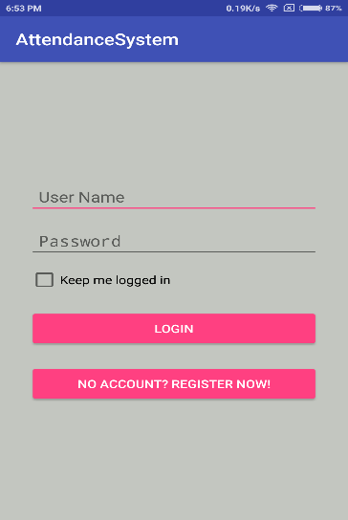

To login into the app user need to provide username and password. If keep me logged in is checked user will be logged in automatically next time. From this page there is also a link to registration page.

**Registration Page**

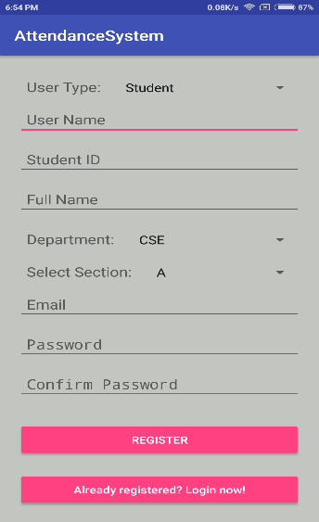 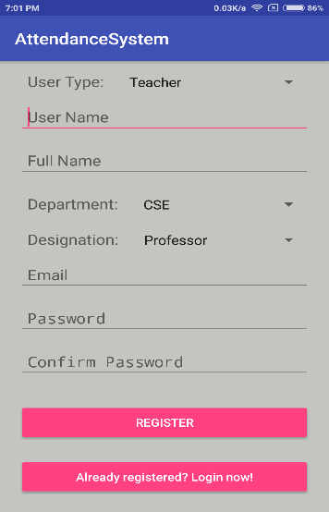 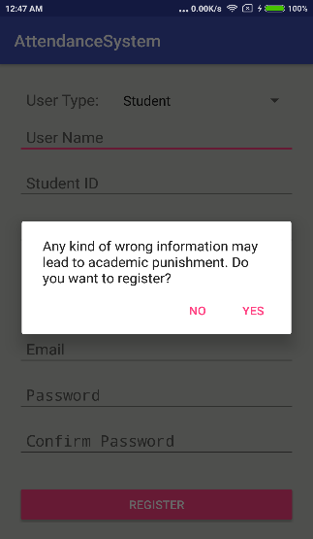

**Student Teacher Warning**

Type of the user (teacher or student) can be selected from drop down menu. The available fields for teachers and students are different. Student ID and section are available only for students. On the other hand designation field is available only for teachers. Before submitting data for user registration a warning is shown to confirm all provided information is correct. After successful registration user will be redirected to the login page.

**Navigation Menu**

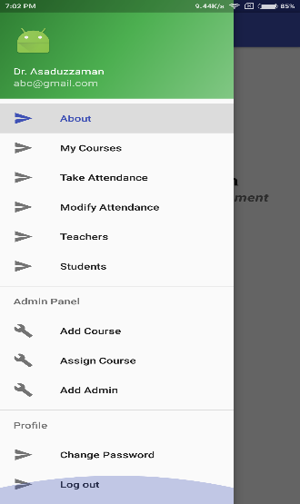 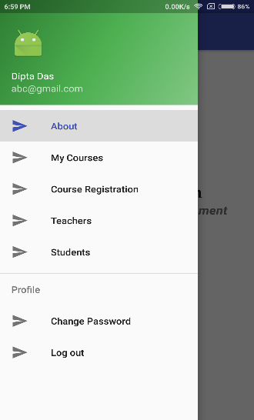 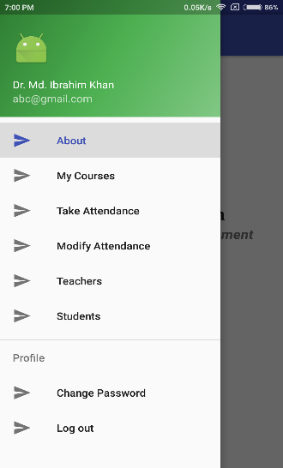

**Admin Student Teacher**

From navigation menu users can get access to specific features. Navigation menu are different for admins, students and teachers. Course registration is only available for students. Take and modify attendance is available only for teachers. Add course, assign course and add admin options are only visible to admins.

**My Courses**

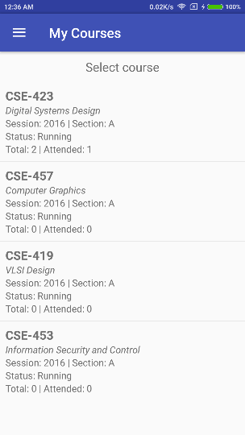 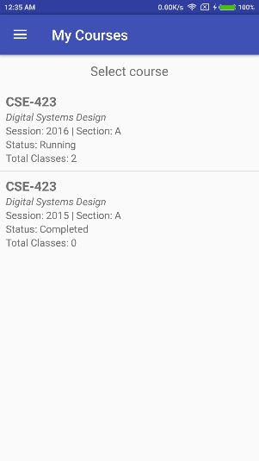 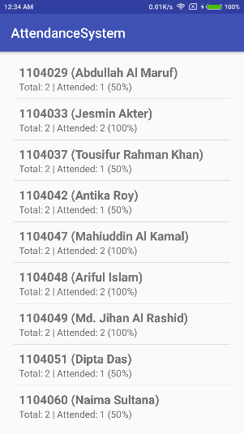

**Student Teacher Percentage**

For teachers this page will show the courses he is assigned. For students this page will show the courses he has registered. For every course it will show total classes, total attended classes and status (running or completed). For percentage report teachers need to select a course.

**Student and Teacher List**

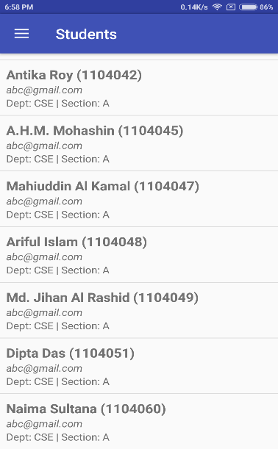 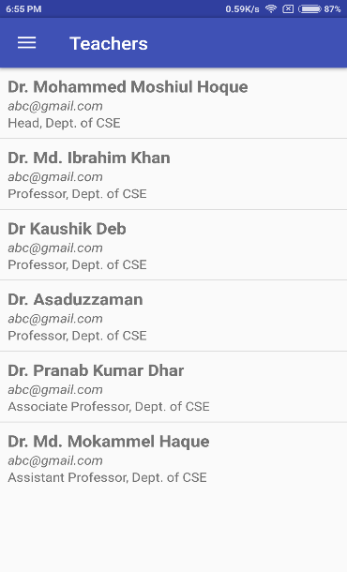

**Student List Teacher List**

This pages will show all the basic information about all the registered students and teachers. For students Student ID will be shown along with the full name. For teachers designation will be shown. Department name and email will be shown both for students and teachers.

**Course Registration (Student)**

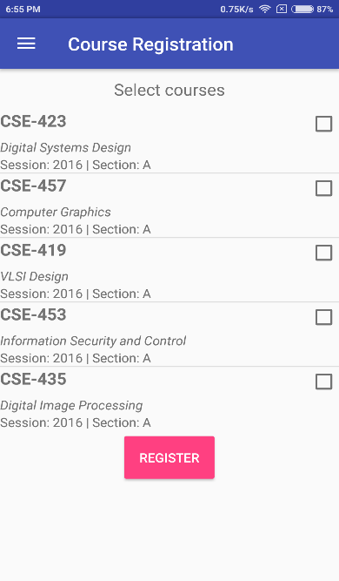

This page is only available for students. All available courses are shown in the list and selected course will be registered for the specific student. Previously registered course with same session will not be registered again.

**Take Attendance (Teacher)**

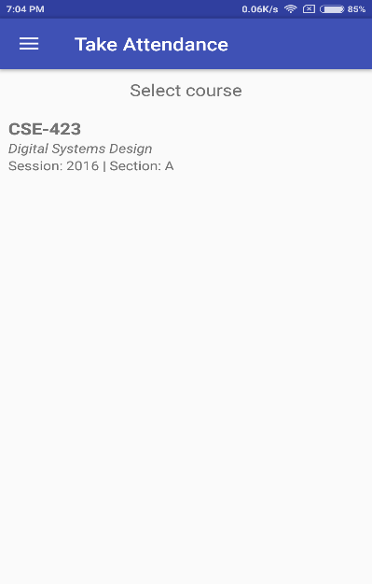 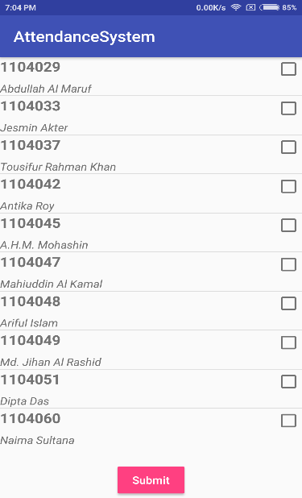

The first page will show all the courses that are assigned to the teacher. After selecting the course attendance sheet will appear. Teacher will then select the rows of attended student and submit the data.

**Modify Attendance (Teacher)**

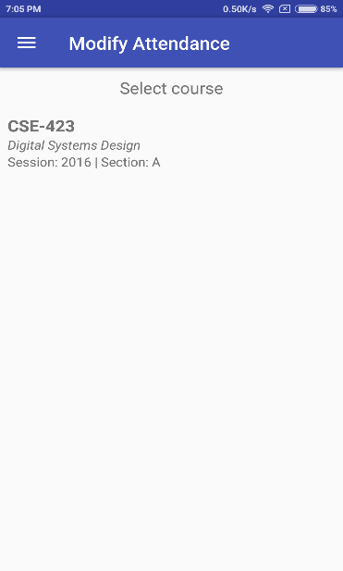 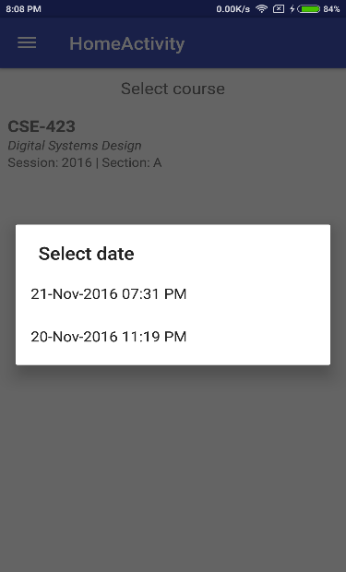 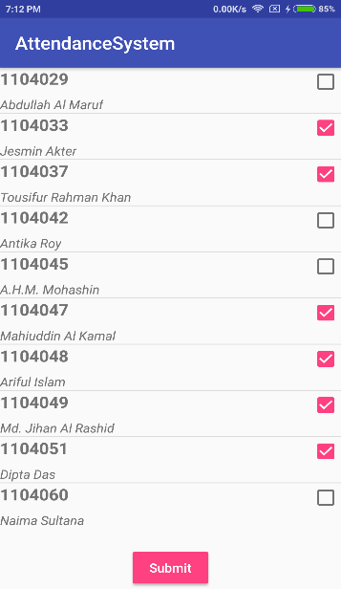

From this page teachers can modify the attendance that has taken previously. After selecting the course and date, attendance sheet with previous data will appear. Teacher can then perform modification and submit data. After summation previous data will be updated.

**Admin Panel**

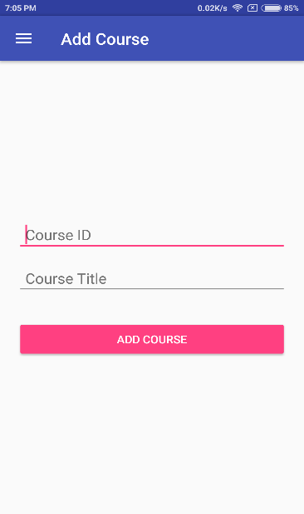 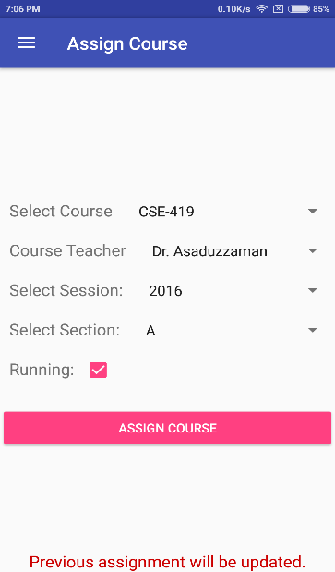 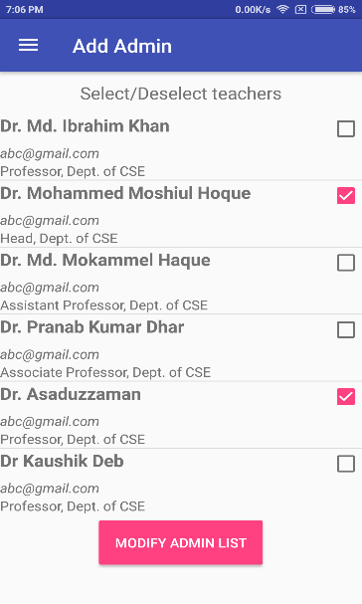

**Add Course Assign Course Add Admin**

This pages are only available for the admins. To add a new course we need to provide unique course ID and course title. To assign a course we need to select course ID, teacher name, section and session from the dropdown menu. Previously assigned courses can also be modified from this page.

**Change Password**

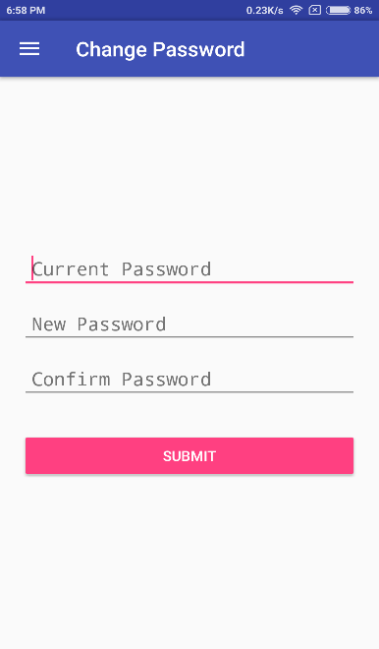

From this page user can change their password. To change password user must provide current password and confirm new password.

**Logout and Exit**

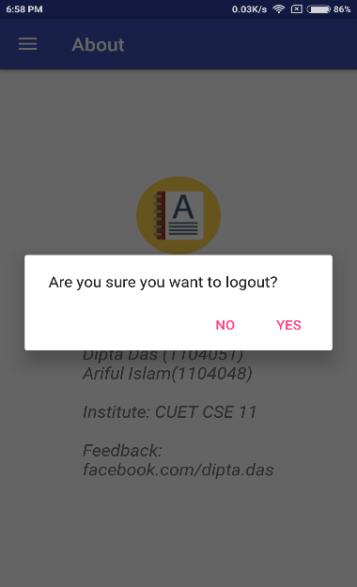 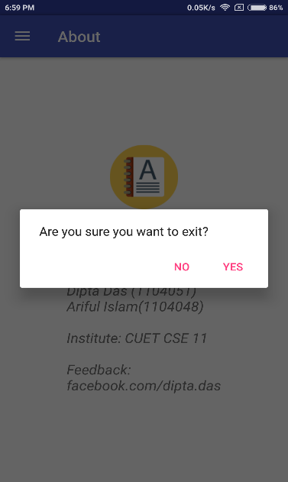

**Logout Exit**

Before logout and exit an alert dialog is shown for confirmation. After logout user will be redirected to login page.

**About**

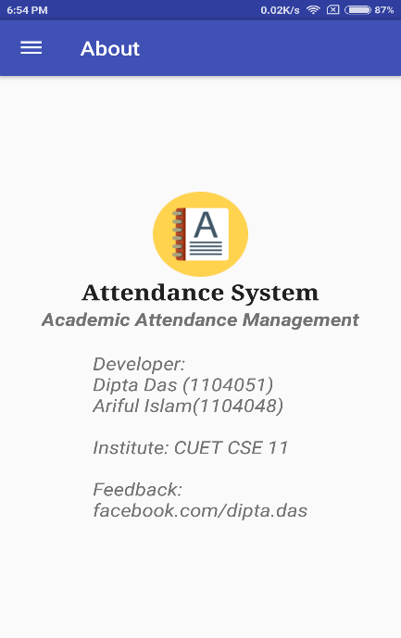

This the default page that will be shown when the app starts. This page contains the information about the developers and copyright of the application.

**Conclusion:**

A digital system can overcome many shortcomings of currently available manual system. This can make our educational system one step closer to the dream of “Digital Bangladesh”. To implement this system we have to overcome few challenges. In future this can be extended to use barcode or biometric systems.

**References:**

1. <https://developer.android.com>
2. <https://stackoverflow.com>
3. <https://www.androidhive.info>
4. <https://www.tutorialspoint.com/android>