

**A report on**

**Linux vs Windows operating system**

**Submitted to:**

**Course Instructor: Supta Richard Philip**

**Submitted by:**

**Name: Ariful Islam Marfy**

**ID: 19-40116-1**

**Course: Introduction to Computer Studies**

**Date: 11.12.19**

An Operating system is software that lets the user interface with the computer and also manages number of applications. **Windows** is a licensed operating system and its source code is inaccessible**.** It is designed for business owners, other commercial user and even individuals with no computer programming knowledge. It is simple and straightforward to use. [**Linux**](https://www.edureka.co/blog/linux-tutorial/) is a free and open source operating system based on Unix standards which provides a programming interface as well as user interface compatibility. It also contains many separately developed elements, free from proprietary code.

**Linux vs Windows**

**Installation**

A common feature of Linux OS' is the ability to live' boot them that is, booting from a DVD or USB image without having to actually install the OS on users’ machine.

Windows installations, by contrast, while lengthier and time consuming, are a lot simpler, requiring a minimum of user input compared to many distros.

**Price**

Most of the Linux operating systems are free and lower costing then windows.

Windows operating systems can be bought around the price of $50 to $150 per each license copy.

**Ease**

Linux has massively improved in their usability but windows are much easier for new computer users.

Microsoft have made lots of changes and have made it much more easier to use the operating system, but it still might not be the easiest software to use but is definitely easier than Linux.

**Users**

There are 3 types of users in Linux (Regular, Administrative(root) and Service users) whereas, in Windows, there are 4 types of user accounts (Administrator, Standard, Child and Guest).

**Usage**

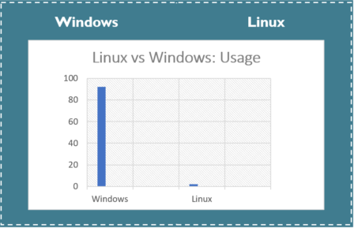

According to the market research data, on 92.63% of the world’s PCs, Windows is running, while hardly 1% of PC users use Linux. Many users say it is hard to use Linux as compared to Windows and so the appeal of Linux is very limited for household use. It is mostly meant for serious use such as server application. Hence, corporation servers are running on Linux, irrespective of the GUI. Also, due to the licensing agreement with Microsoft, various PC vendors are entitled to bundle Windows OS with their PC, enabling Windows to gain market popularity over Linux. Though these days many PC vendors such as Dell and HP have started to give Linux as the pre-installed OS, Windows still rules the market.

**Kernel**

Linux uses the monolithic kernel which consumes more running space whereas Windows uses the micro-kernel which takes less space but lowers the system running efficiency than Linux.

**File Systems**

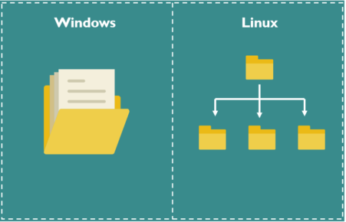

In Microsoft Windows, files are stored in directories/folders on different data drives like C: D: E: but, in Linux, files are ordered in a tree structure starting with the root directory, further branched out to various other sub-directories.

**Software**

Linux does have number of software, utilities and games available but it can’t compare to the large amount of software windows has.

Because there are more people using windows around the world there are more software, utilities and games available in windows.

**Software Cost**

Many of the software, utilities and games are freeware or open source. Most of them are free and some of them cost really less then compared to windows.

Windows also has software, utilities and games for free but majority of the programs will cost around $20 to $200.

**Hardware**

Linux and hardware manufactures have made great improvements for Linux and will support most hardware devices, whoever there are many different companies that still do not offer drivers for their hardware.

Windows has much more support from the hardware manufactures for windows hardware devices because of the large number of windows users.

**Source Code**

Linux is an open source operating system whereas Windows OS is commercial. Linux has access to source code and alters the code as per user need whereas Windows does not have access to the source code.

**License**

The Linux kernel in most distributions are entirely free and open source. Companies offer paid support for their distros, but the underlying software is still free to download and install.

Microsoft Windows is generally priced **between $99.00 and $199.00 USD** for each licensed copy.

**Security**

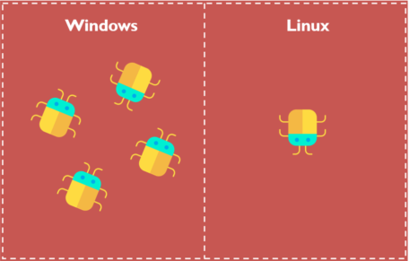

Linux always has been safe and secure but it can also be attacked but when compared it to windows Linux is much safer.

Although windows has made vast improvements to their security but still continues to be venerable to the viruses. Every Windows user has faced security and stability issues at some point in time. Since Windows is an extensively used OS, hackers, spammers target Windows frequently.

**Privacy**

If a person is a Linux user, he/she has an operating system that doesn’t spy on you. Having Linux means the system is users and users alone. Most Linux systems come with an option of built-in military-grade encryption. As a user, on can be sure that device theft poses no real problem to his data.

On the contrary, Windows has gotten more advert driven over the last few years. Users are definitely given the choice to opt out but then again, who can help the clever registry hacks which are clearly a part of Redmond’s plan. Windows can watch what users do, offering to sync to the Microsoft One-Drive service or to learn behavior to make Cortana (the Microsoft personal assistant) better. To be honest, I do not favor these tools, as they’re pretty intrusive. Though, some users like these features. Subjective opinion.

**Reliability**

Windows, as we all have come to know, becomes sluggish by the day. users have to re-install Windows after a while when someone encounters crashes or slowdowns on system.

A Linux user, do not have to re-install it just to experience a faster and a smoother system. Linux helps system to run smoothly for a longer period. Much longer! in fact.

Also, as a Windows user, user will have to develop a habit where he/she keep on rebooting the system for just about everything.

However, in the case of Linux, one can comfortably continue with work, and OS will not bother the user.

This is probably why we could observe that most of the Internet giants like Facebook and Google run on Linux. Even supercomputers run mostly on Linux.

So, the reason that Windows preferred over Linux in the industries is because Linux is far more reliable than Windows.

**Multimedia**

Both Linux and Windows OS are pretty rich in multimedia applications. Although, setting up the sound and video options in older versions of Linux can be relatively difficult for some users. A key advantage of Linux is that most of the multimedia applications are freely available. In the case of Windows, users may have to pay a hefty price to get the software although many Open Source/free versions are often available.

**Gaming**

A gamer needs 100% compatibility with a particular software or want a user-friendly system, Hands down, Windows wins. Steam, among other clients and options, provides a huge number of games both from publishers and small indie developers. Steam for Linux now allows user to install Windows games. But it is still in beta, and not all Windows games will work. It can be frustrating for Linux users, and no doubt the situation will change in the future.

But for now, in 2018, many Linux users miss out on the top games with their choice of OS. The graphics card vendors also tend to support Windows platforms rather than Linux. They provide timely updates and new features that don’t always filter to other OS.

**Programming**

Linux supports almost all of the major programming languages (Python, C/C++, Java, Ruby, Perl, etc.). Moreover, it portrays a vast range of applications useful for programming purposes.

The Linux terminal is far more superior to use over Window’s command line for developers. One would find many libraries natively developed for Linux. Also, a lot of programmers point out that they can do things easily using the package manager on Linux. The ability to script in [different shells](https://www.edureka.co/blog/types-of-shells-in-linux/) is also one of the most compelling reasons why programmers prefer using Linux OS.

One can include things like apt-get [commands](https://www.edureka.co/blog/linux-commands/) which further makes Linux a more popular choice of the programmers.

**Conclusion**

We can’t decide which is the best operating system Windows or Linux. Rather we should focus on our need of operation. We should use Windows and Linux in equal measure based on what we need to do either by dual boot or virtualization.