## **Issues List**

1. **Issues Title: Titles of the Projects**

**Issues Title: The titles of the project are not working properly. English alphabets can be written in Bangla option and vice-versa. Requirements are not met,but still can be submitted.**

**Reproducing Steps: Go to the correct URL -> then log in using the given**

**Username and Password -> Enter the dashboard -> Click on the menu named**

**"Project" on the left hand side menu bar -> Click on the sub-menu named "Add**

**Project" -> Fill the title(Bangla) with English alphabets and title(English) with**

**bangla alphabets-> Then fill the other fields correctly -> Tap on submit button**

**Priority: High**

**Issue Image:**

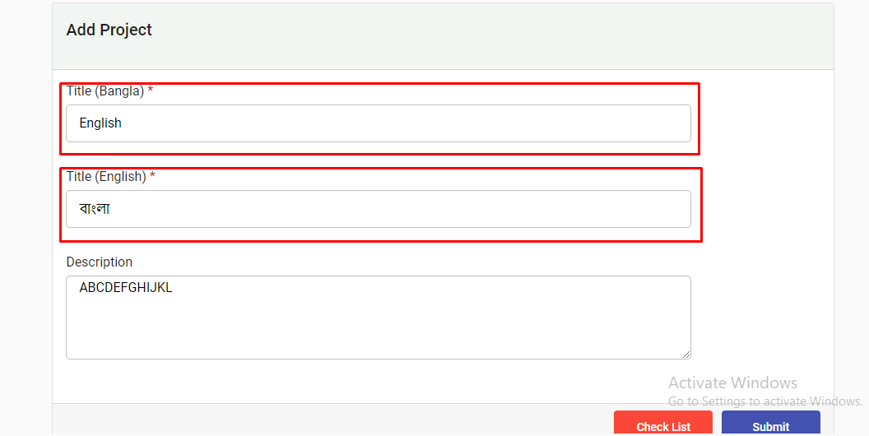

1. **Issues Title: Description Box**

**Issues Title: Without giving a description the system accepts it, whereas it was a requirement to give a description**

**Reproducing Steps: Go to the correct URL -> then log in using the given**

**Username and Password -> Enter the dashboard -> Click on the menu named**

**"Project" on the left hand side menu bar -> Click on the sub-menu named "Project**

**List" -> Click on pencil icon -> Fill requirements -> Go to description box and**

**write nothing -> Click on submit button**

**Priority: Mid**

**Issue Image:**

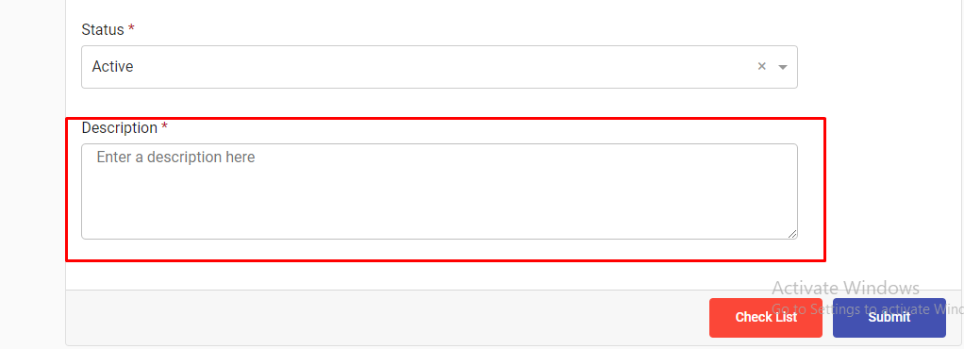

1. **Issues Title: Title(Bangla) Box**

**Issues Title: Inside the box it is written "Bengali" instead of bangla.**

**Reproducing Steps:**

**Go to the correct URL -> then log in using the given Username and Password ->**

**Enter the dashboard -> Click on the menu named "Project" on the left hand side**

**menu bar -> Click on the sub-menu "Add Project"**

**Priority: Low**

**Issue Image:**

