Vibration Monitoring and Analysis (12 KW motor)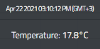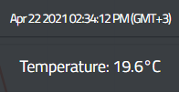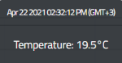

Min Temp

Max Temp

Motor start

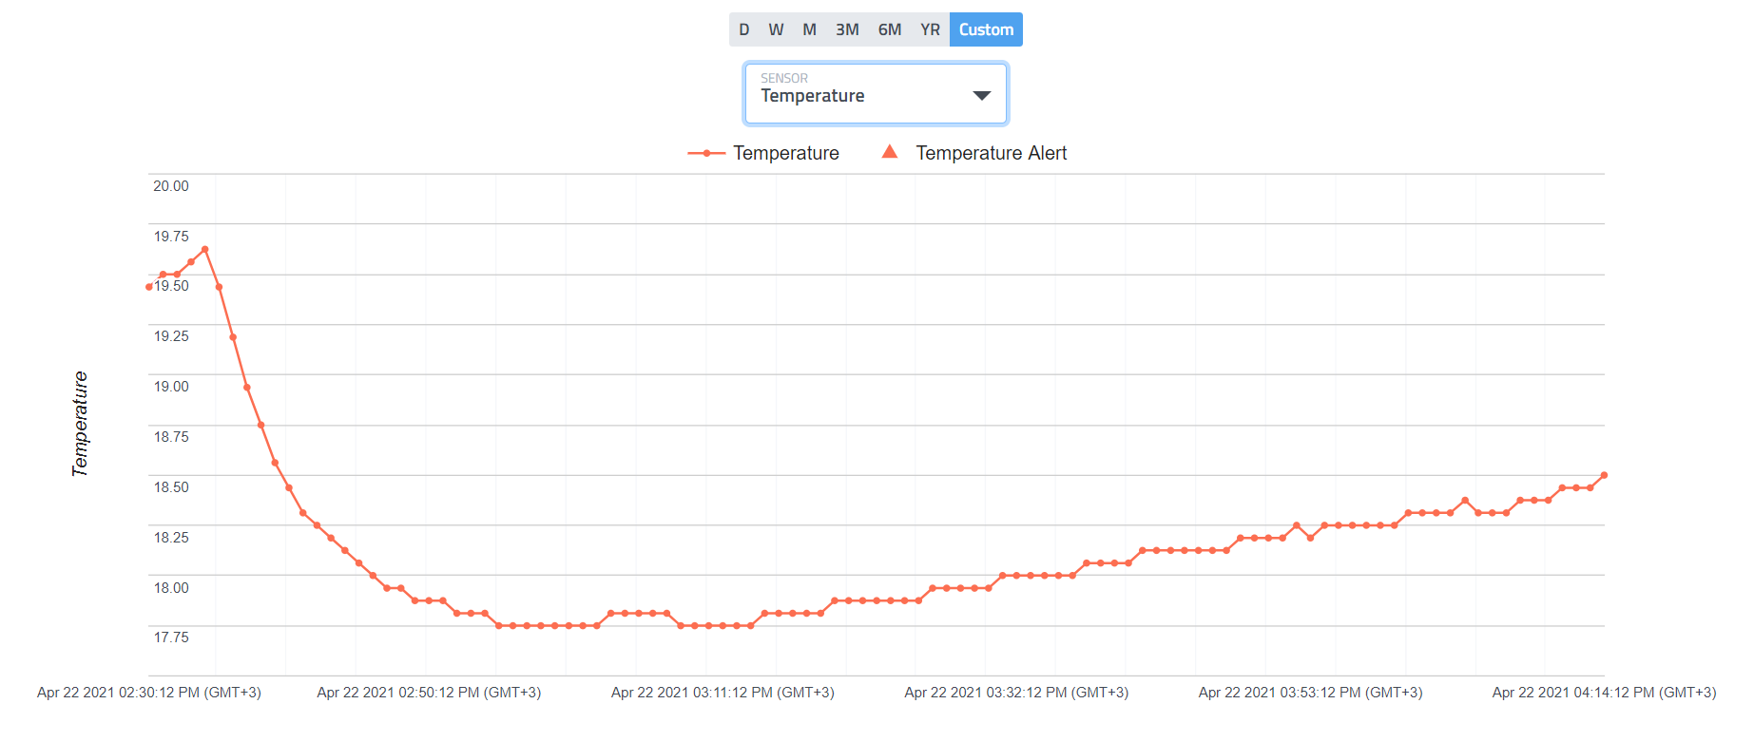

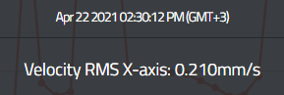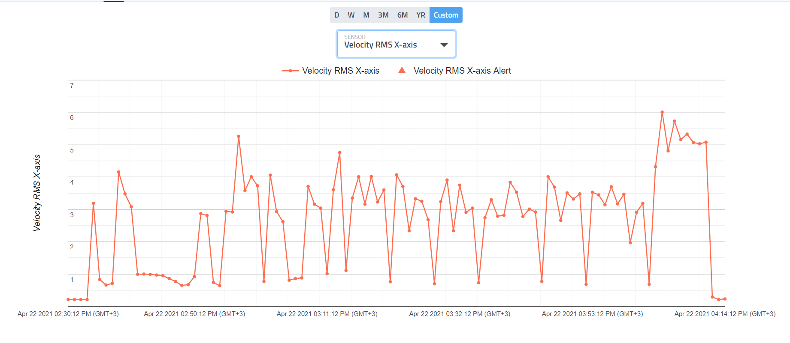

Start & Min VRMS

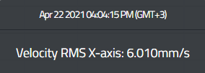

Max VRMS

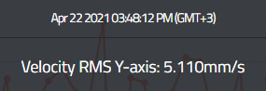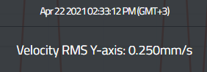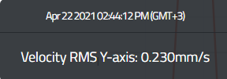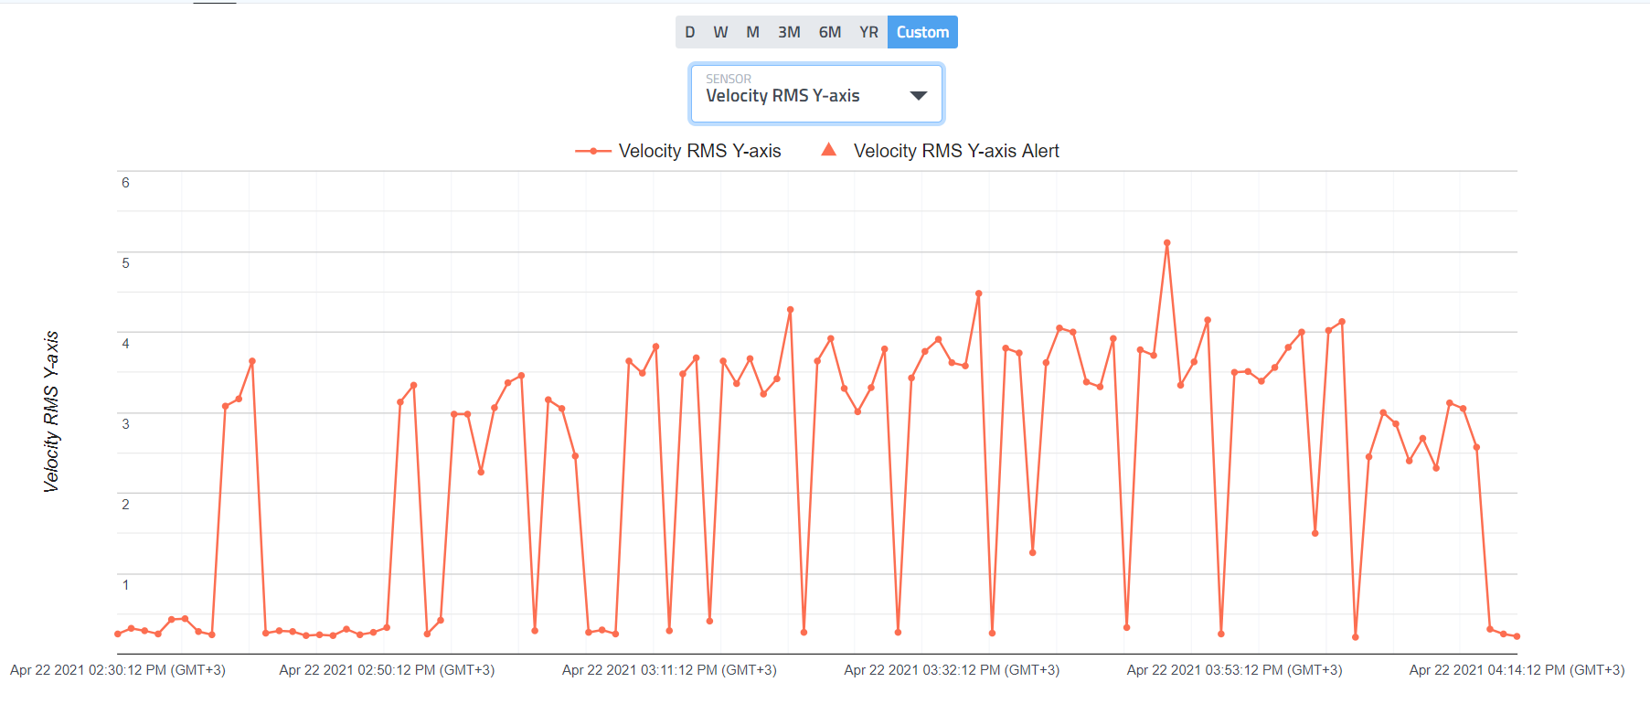

Max VRMS

Start VRMS

Min VRMS

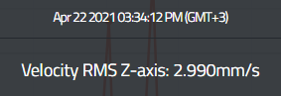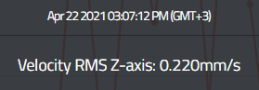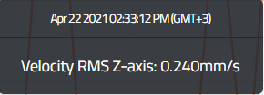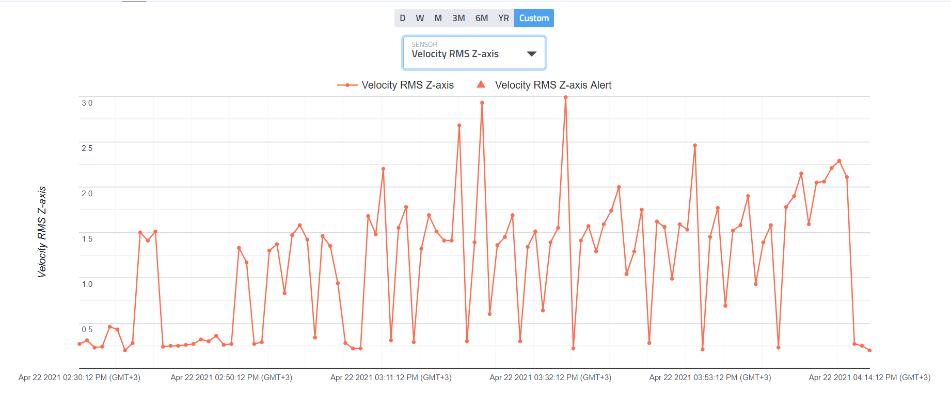

Max VRMS

Min VRMS

Start VRMS

Report for (Small Machine < 15KW)

|  |  |  |  |  |  |  |  |
| --- | --- | --- | --- | --- | --- | --- | --- |
|  | Temperature(C) | VRMS  X-axis(mm/s) | VRMS  Y-axis(mm/s) | VRMS  Z-axis(mm/s) | Condition according to ISO | | |
| Start point | 19.50 | 0.21 | 0.25 | 0.24 | X-axis | Y-Axis | Z-axis |
| Minimum | 17.80 | 0.21 | 0.23 | 0.22 | Unsatisfactory | Unsatisfactory | Unsatisfactory |
| Maximum | 19.60 | 6.01 | 5.11 | 2.99 |
| Delta | 1.80 | 5.80 | 4.88 | 2.77 |

