Vibration Monitoring and Analysis (1kw DC motor)

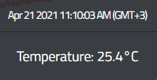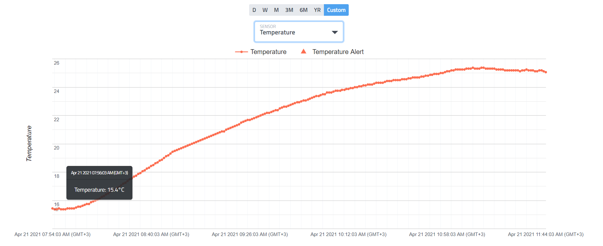

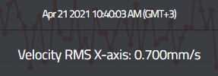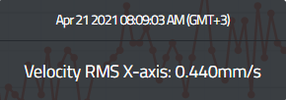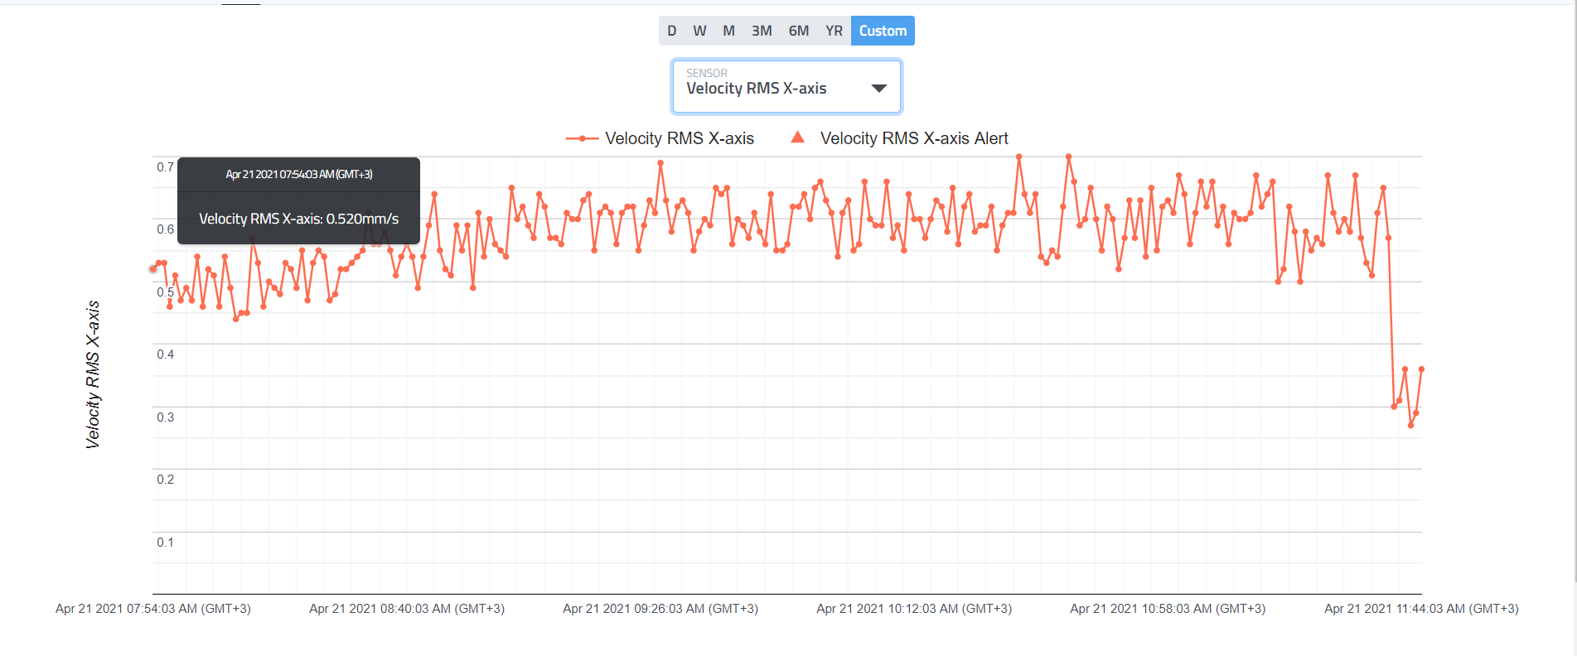

Max VRMS

Min VRMS

Motor start

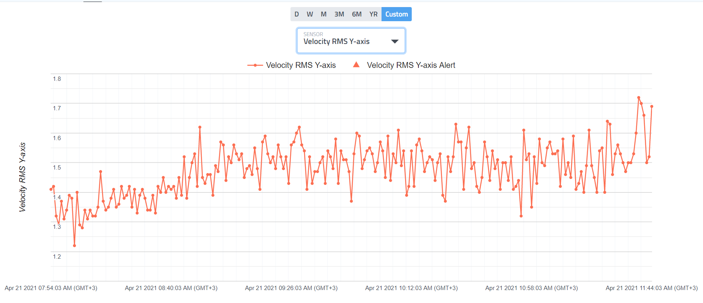

Max VRMS

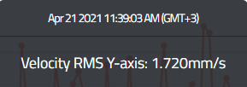

Motor start

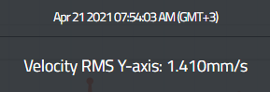

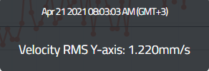

Min VRMS

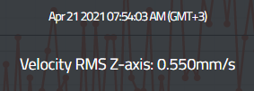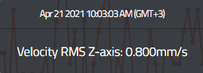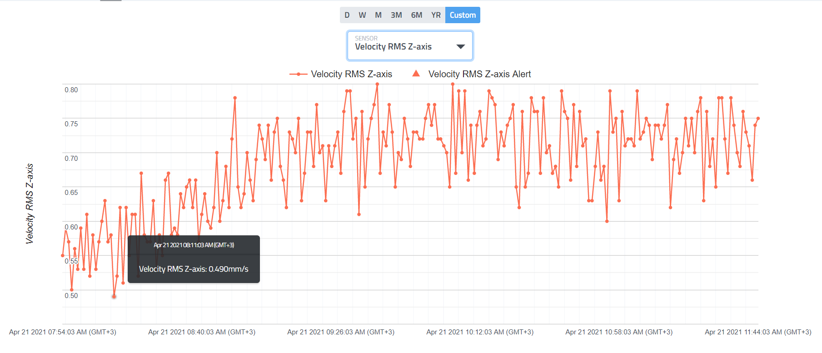

Report for (Small Machine < 15KW)

|  |  |  |  |  |  |  |  |
| --- | --- | --- | --- | --- | --- | --- | --- |
|  | Temperature(C) | VRMS  X-axis(mm/s) | VRMS  Y-axis(mm/s) | VRMS  Z-axis(mm/s) | Condition according to ISO | | |
| Start point | 15.4 | 0.52 | 1.41 | 0.55 | X-axis | Y-Axis | Z-axis |
| Minimum | 15.4 | 0.44 | 1.22 | 0.49 | Good | Satisfactory | Satisfactory |
| Maximum | 25.4 | 0.70 | 1.72 | 0.80 |
| Delta | 10 | 0.26 | 0.50 | 0.31 |

