CS 255 System Design Document
DriverPass System
Ariful Wadud
CS 255: System Analysis and Design

UML Diagrams

UML Use Case Diagram
The use case diagram below illustrates the interactions between the four primary actors in the DriverPass system — Student, Instructor, Administrator, and IT Staff — and the core functions each actor can perform.
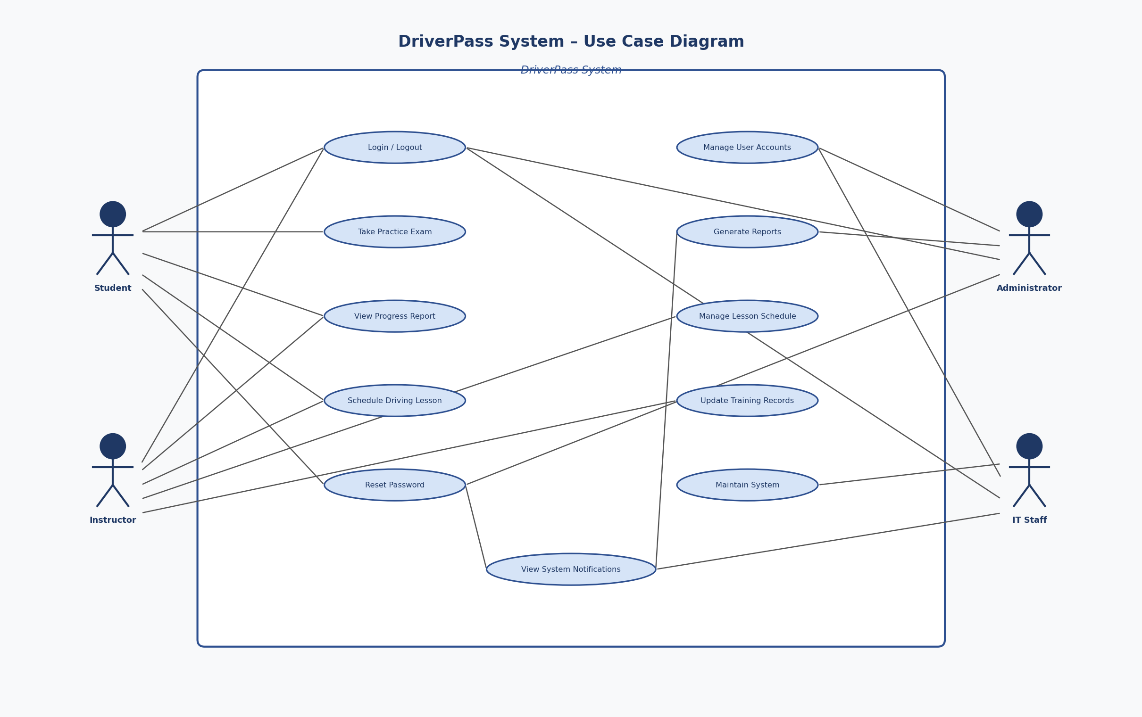
Key actors and their use cases:
- Student: Login, Take Practice Exam, Schedule Driving Lesson, View Progress Report, Reset Password
- Instructor: Login, View Student Progress, Manage Lesson Schedule, Update Training Records
- Administrator: Login, Manage User Accounts, Generate Reports, Reset Password
- IT Staff: Login, Maintain System, Manage User Accounts

UML Activity Diagrams
Two activity diagrams are presented below, each corresponding to a key use case in the DriverPass system.

Activity Diagram 1: Schedule a Driving Lesson
This diagram depicts the workflow a student follows when scheduling an on-road driving lesson.
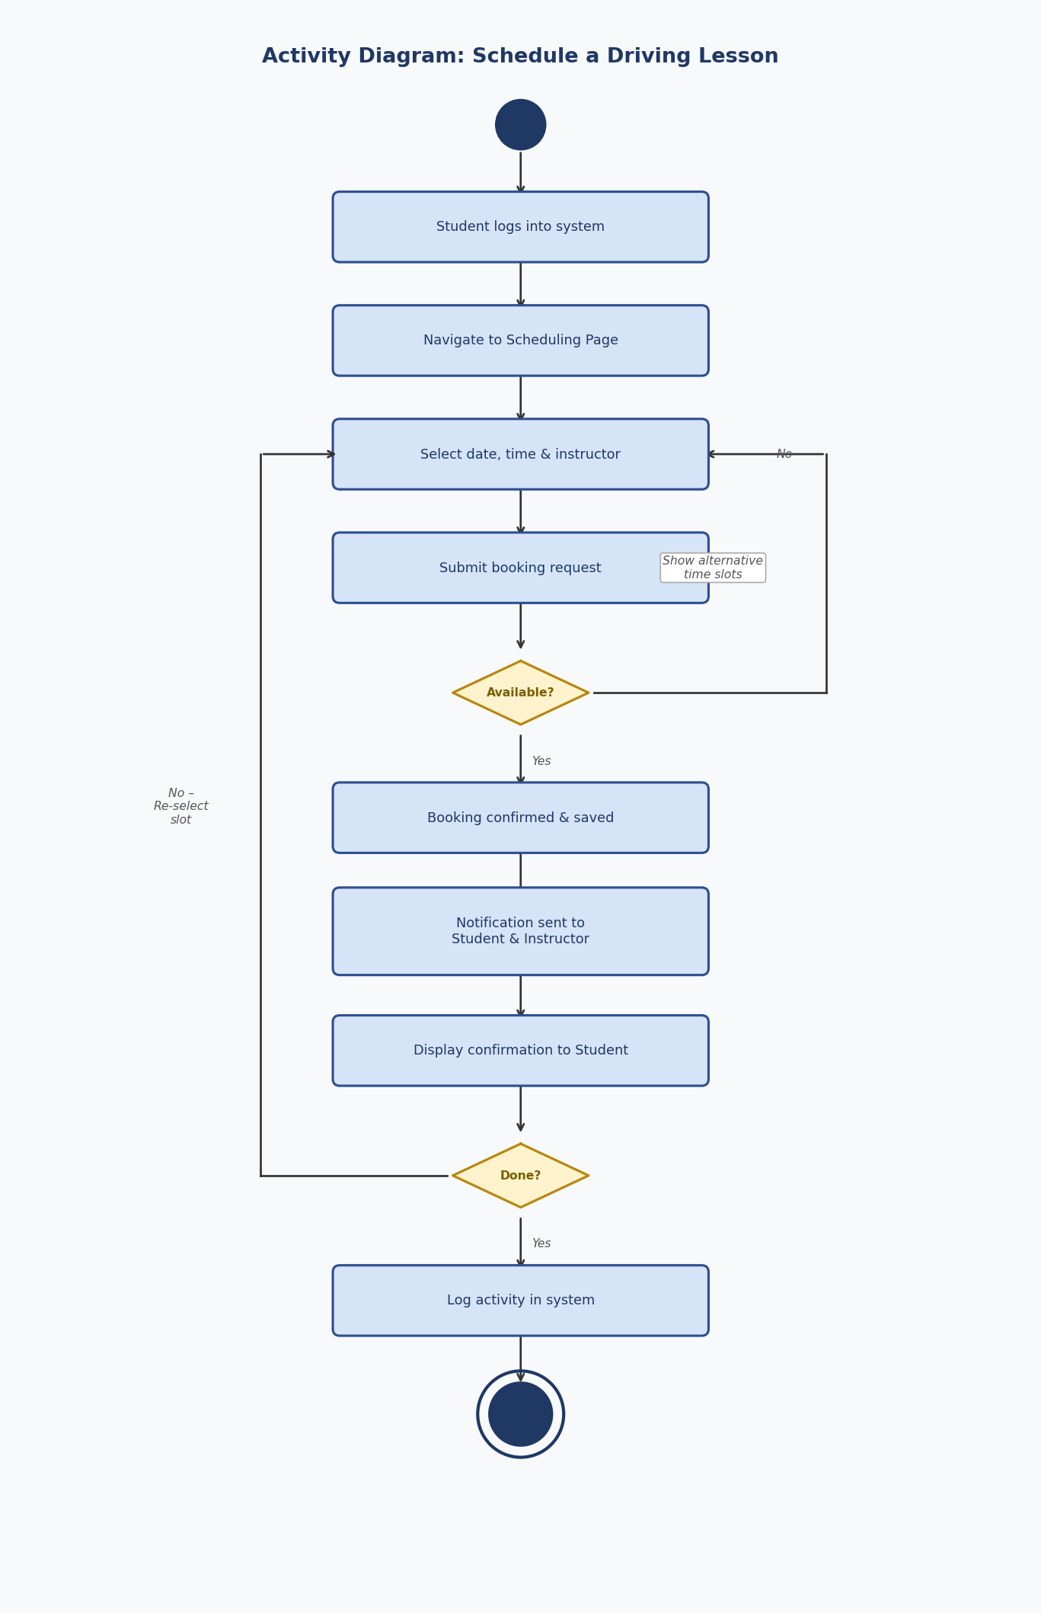

Activity Diagram 2: Take a Practice Exam
This diagram illustrates the workflow a student follows when accessing and completing an online practice exam.
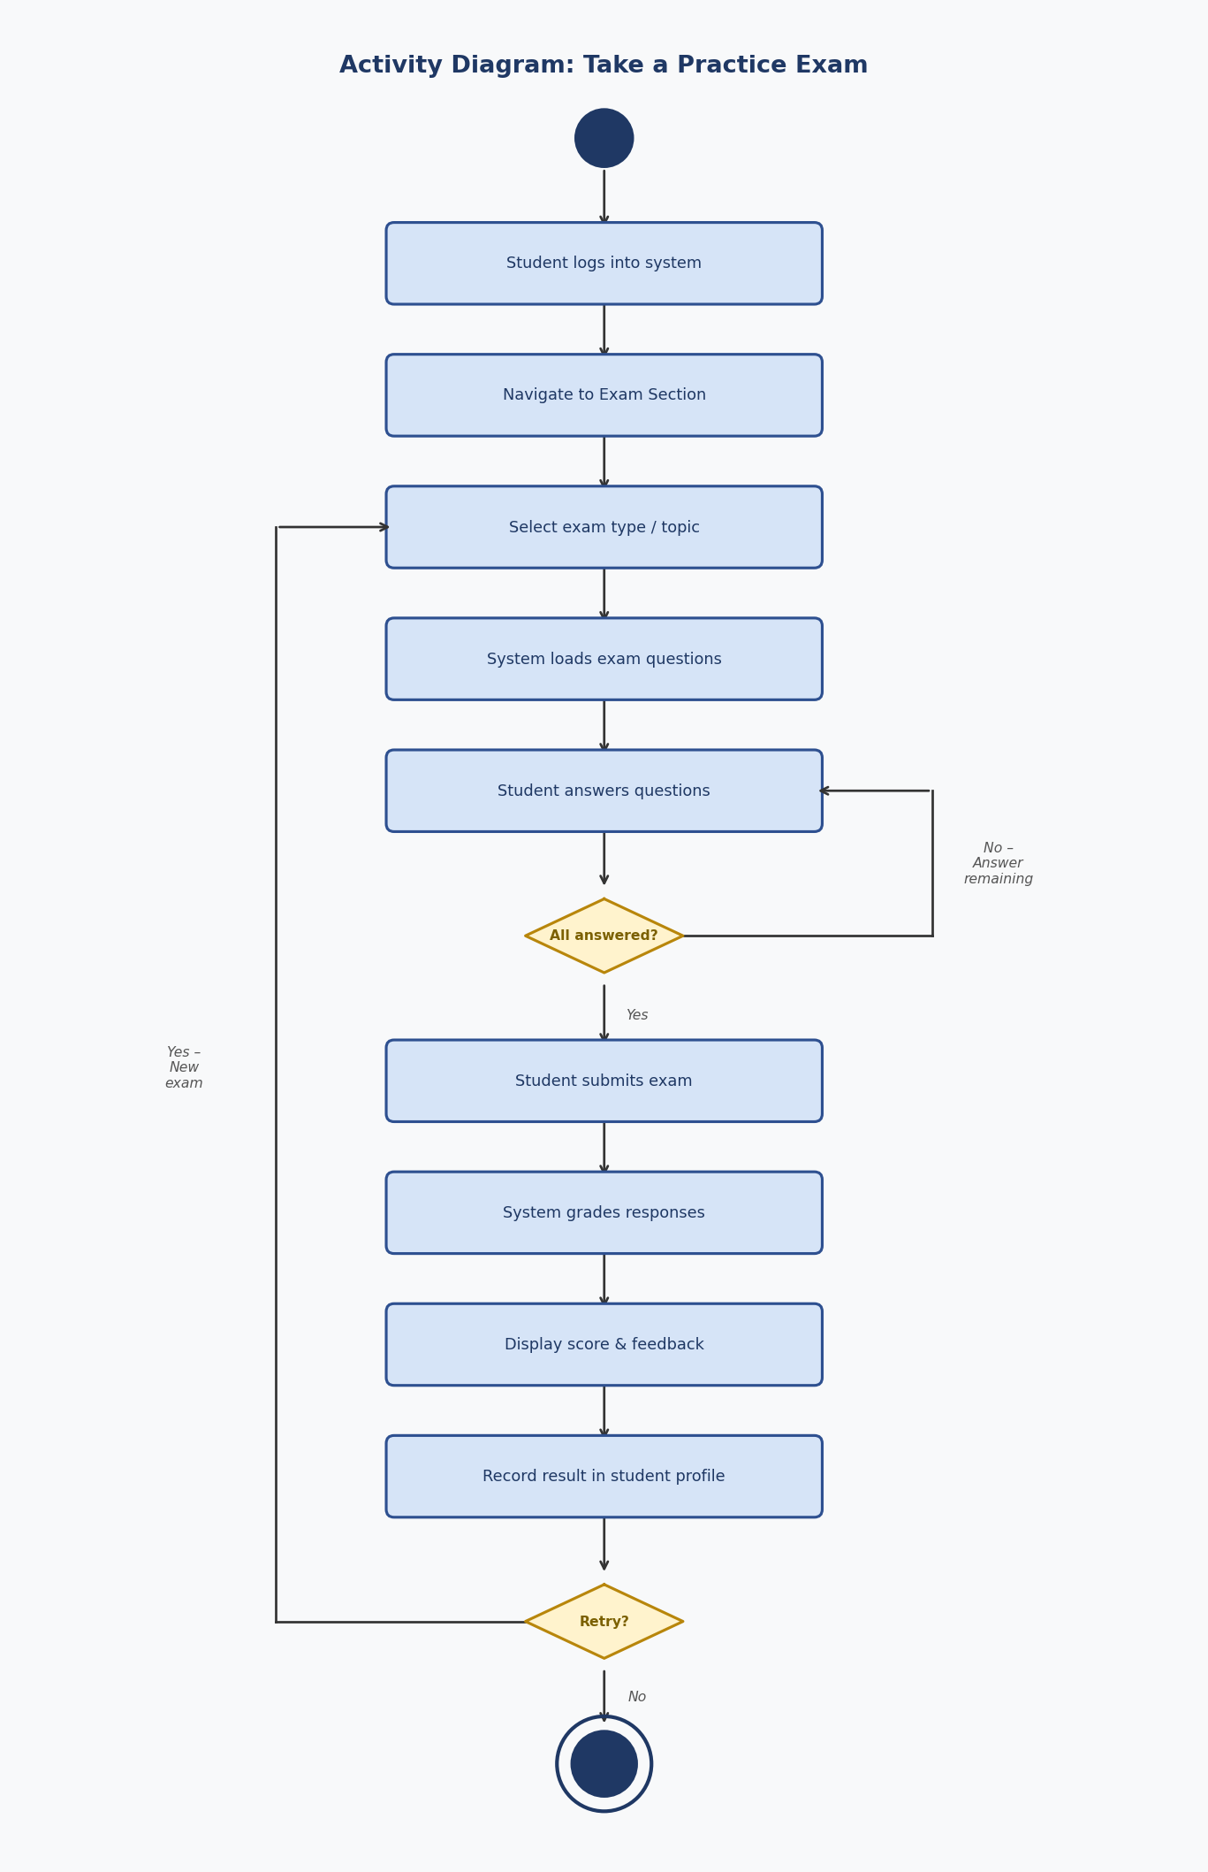

UML Sequence Diagram
The sequence diagram below shows the message exchanges between objects for the Schedule a Driving Lesson use case, tracing the interaction from the student through the UI, scheduling system, database, and notification service.
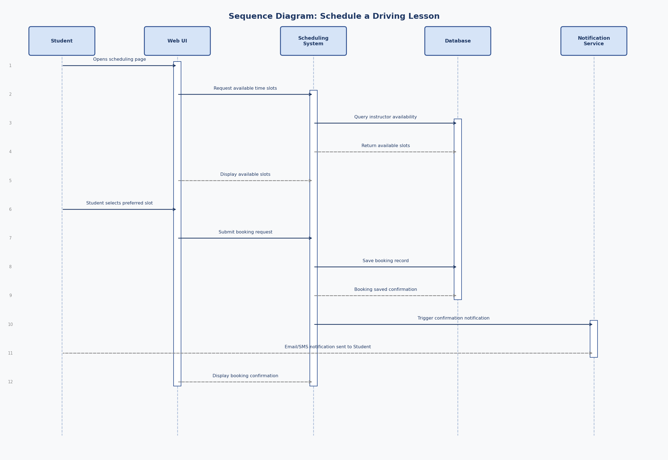

UML Class Diagram
The class diagram below defines the primary classes, their attributes, and the relationships between them in the DriverPass system. This diagram serves as the structural blueprint for the development team.
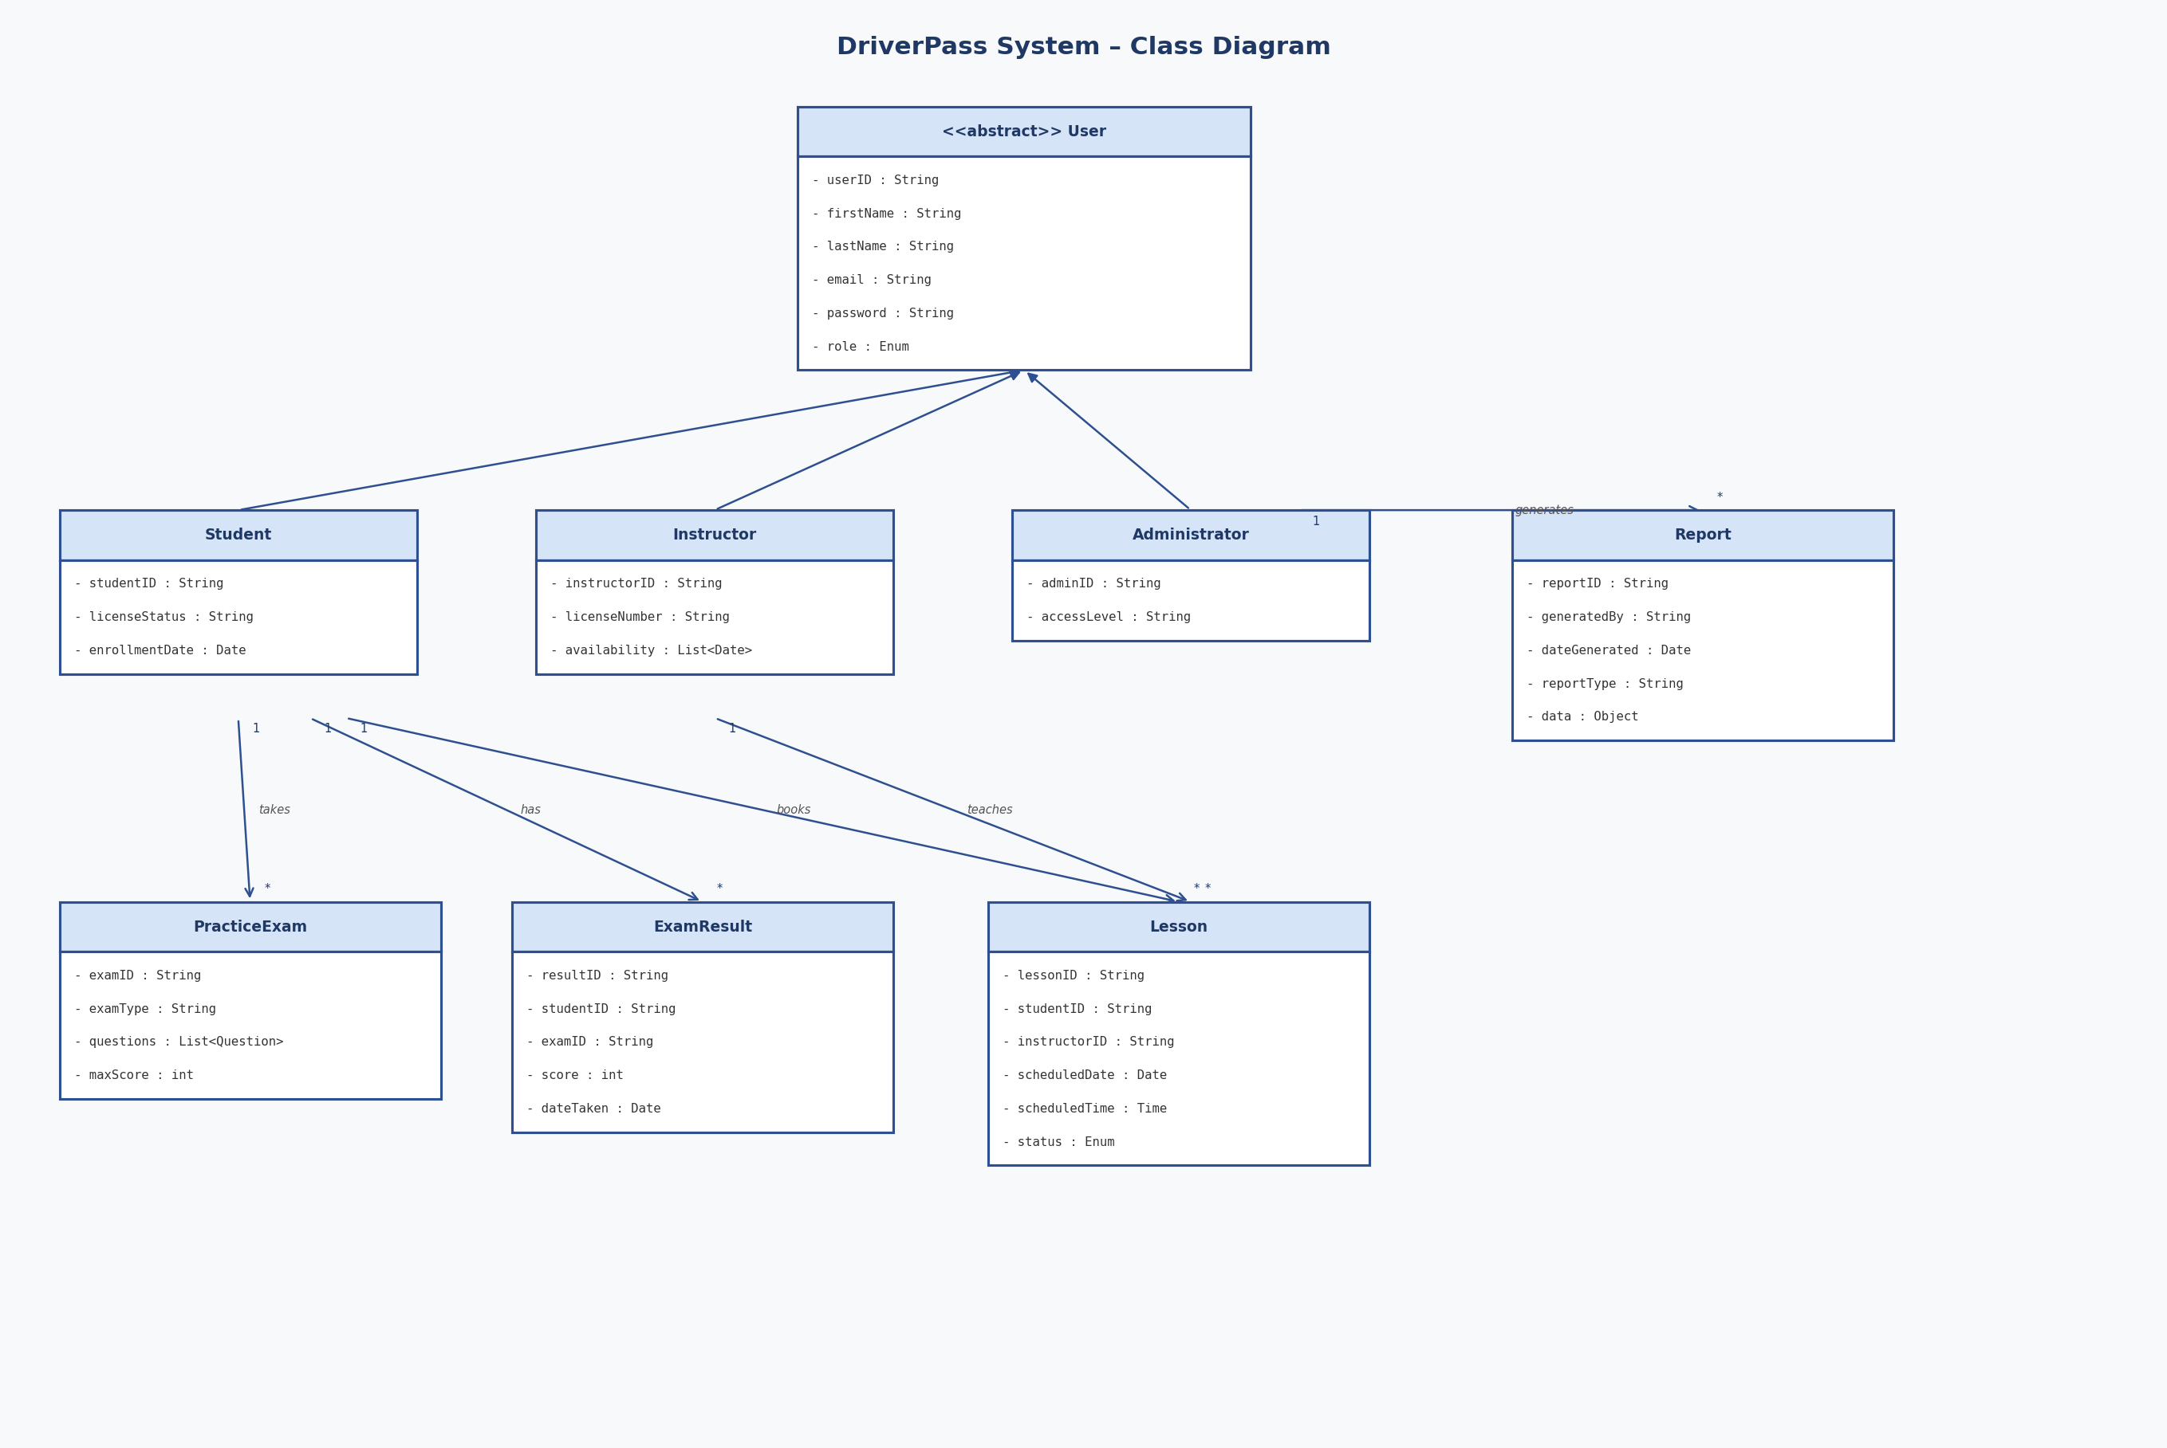

Technical Requirements
Based on the UML diagrams and the functional and nonfunctional requirements gathered from the DriverPass client interview, the following technical requirements define the hardware, software, tools, and infrastructure necessary to implement and operate the DriverPass system.

Hardware Requirements
- Web Server: Cloud-based hosting (e.g., AWS EC2) with minimum 8-core processor, 16 GB RAM, 500 GB SSD; scalable as user load grows.
- Database Server: Managed database service (e.g., Amazon RDS) with minimum 8 GB RAM and redundant storage for high availability.
- Client Devices: Any modern device — desktop, laptop, tablet, or smartphone — with a standard browser and internet connection.

Software Requirements
- Operating System: Linux server (Ubuntu Server 22.04 LTS or RHEL) for reliability and security.
- Web Framework: Node.js with Express or Java Spring Boot for routing, API endpoints, and business logic.
- Database: Relational DBMS such as MySQL or PostgreSQL for structured data storage.
- Front-End Framework: React.js or Angular for responsive, device-agnostic UI rendering.
- Browser Support: Current versions of Chrome, Firefox, Microsoft Edge, and Safari.

Security and Infrastructure Requirements
- SSL/TLS: All data encrypted via HTTPS using a valid certificate from a trusted certificate authority.
- Authentication: Encrypted password storage (bcrypt), session tokens, and account lockout after 5 failed login attempts.
- Role-Based Access Control (RBAC): Users restricted to authorized functions and data per their role.
- Firewall & WAF: Web application firewall and server-level rules restricting access to ports 80 and 443.
- Backup & Recovery: Automated daily backups with ability to restore within a defined recovery time objective.

Network and Connectivity Requirements
- Internet Connectivity: Minimum 10 Mbps server-side bandwidth; broadband connection for all users.
- CDN: Optional content delivery network to serve static assets from geographically closer servers.
- API Integration: RESTful API endpoints to support future integrations (e.g., DMV databases, payment processors).

Development and Deployment Tools
- Diagramming: Lucidchart for all UML diagram creation during the design phase.
- Version Control: Git hosted on GitHub or GitLab for source code management.
- Deployment: Cloud hosting (AWS/Azure) with Docker containerization for consistent environments.
- Testing: Automated unit and integration tests (Jest/JUnit) to validate functionality before each release.

