**1.Introduction:**

A Signal Processing Toolbox is a collection of software tools designed to analyze, modify, and synthesize signals. Signals can be anything from sound waves to radio waves, biomedical measurements, or any other form of data that varies over time or space.

This project covers the basics of signal generation, filtering, and visualization. Implementing it in both MATLAB and Python will help in understanding the similarities and differences between the two environments. You can extend the project by adding more complex signal processing techniques or by developing a user interface for real-time signal processing tasks.

**2.Problem Statement:**

This project involves basic signal processing tasks such as generating signals, applying filters, and visualizing the results

**3.Tools:**

1.Matlab

2.Python(Jupyer Notebook)

**4.Process:**

**4.1)** Signal Generation:

**Objective**: Generate basic signals such as sine waves, square waves, and white noise.

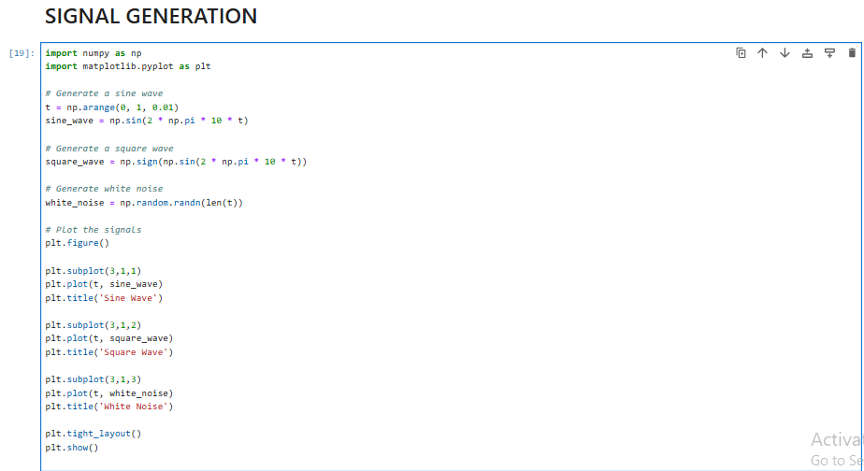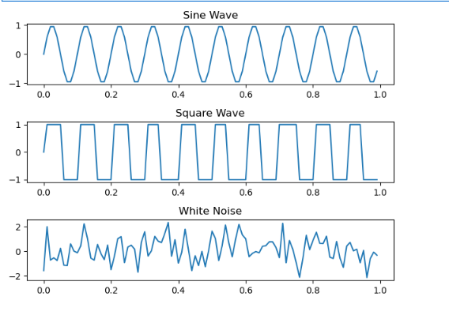

### 4.2) Signal Filtering:

**Objective**: Apply filters such as low-pass, high-pass, and band-pass to the generated signals.

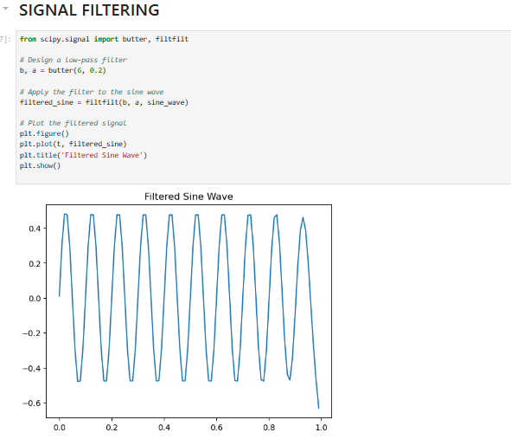

**4.3) Signal Visualization:**

**Objective**: Visualize the original and filtered signals using time-domain and frequency-domain plots.

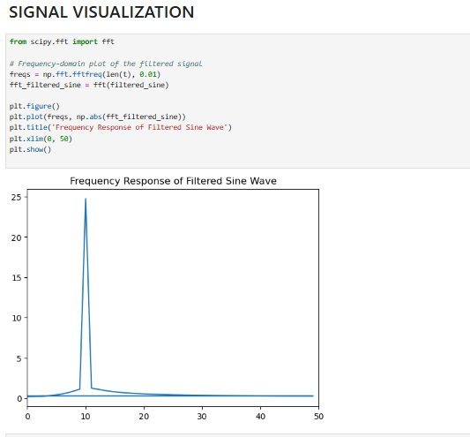

**Conclusion:**

This project covers the basics of signal generation, filtering, and visualization. Implementing it in both MATLAB and Python will help in understanding the similarities and differences between the two environments. You can extend the project by adding more complex signal processing techniques or by developing a user interface for real-time signal processing tasks.