**Innovations in Stroke Identification: A Machine Learning-Based Diagnostic Model Using Neuroimages**

**ABSTRACT**

The early and accurate diagnosis of stroke is critical for effective treatment and improved patient outcomes. Traditional diagnostic methods often face challenges in achieving high accuracy and efficiency. In this study, we propose an innovative machine learning-based diagnostic model utilizing ResNet and MobileNet architectures to classify neuroimages into normal and stroke categories. Our approach leverages the robust feature extraction capabilities of ResNet and the lightweight, efficient nature of MobileNet to create a comprehensive diagnostic tool. The model is trained on a diverse dataset of neuroimages, incorporating advanced preprocessing techniques to enhance its generalizability and performance. Initial experiments demonstrate that ResNet achieves a training accuracy of 94% with normal images, while MobileNet achieves an impressive 92% training accuracy with normal images. These results highlight the potential of our proposed model to significantly improve the accuracy and speed of stroke diagnosis, providing a valuable tool for clinicians and healthcare providers. Future work will focus on further validation with larger datasets and real-world clinical trials to establish the model's efficacy and reliability in clinical settings. This study underscores the transformative potential of deep learning models in advancing stroke diagnosis and enhancing patient care.

**Keywords:** Stroke Diagnosis, Machine Learning, Deep Learning, CNN, ResNet, MobileNet, Neuroimages, Medical Imaging, Stroke Classification, Diagnostic Model, Healthcare AI.

**Objective of the Project:**

The primary objective of this project is to develop a machine learning-based diagnostic model utilizing ResNet and MobileNet architectures to accurately classify neuroimages into normal and stroke categories. By leveraging the advanced feature extraction capabilities of ResNet and the efficiency of MobileNet, the project aims to create a robust and efficient diagnostic tool. This model seeks to enhance the accuracy and speed of stroke diagnosis, providing clinicians with a powerful tool for early detection and timely intervention, ultimately improving patient outcomes and quality of care.

**Motivation:**

The accurate and timely diagnosis of stroke is paramount in reducing the debilitating effects of this condition and improving patient outcomes. Traditional diagnostic methods, while effective, often fall short in terms of accuracy and speed, leading to delayed treatments and suboptimal patient care. The advent of machine learning and deep learning technologies presents a unique opportunity to revolutionize the field of medical diagnostics. Specifically, the application of advanced neural network architectures such as ResNet and MobileNet in analyzing neuroimages can significantly enhance diagnostic precision and efficiency. ResNet's robust feature extraction capabilities and MobileNet's lightweight design make them ideal candidates for developing a sophisticated diagnostic tool. The motivation behind this study is to harness these technologies to create a model that can swiftly and accurately classify neuroimages into normal and stroke categories. This innovation aims to bridge the gap between current diagnostic practices and the potential of AI-driven solutions, ultimately aiming to provide clinicians with a powerful tool that improves diagnostic accuracy and expedites the treatment process. By integrating these cutting-edge technologies into clinical workflows, we aspire to contribute to better healthcare outcomes, reduced morbidity, and enhanced quality of life for stroke patients worldwide.

**Problem Statement:**

The early and accurate diagnosis of stroke is critical for effective treatment, yet current diagnostic methods often lack the necessary accuracy and speed, leading to delayed interventions and suboptimal patient outcomes. Existing imaging techniques and traditional diagnostic tools can be inefficient and prone to errors. This study seeks to address these limitations by developing a machine learning-based diagnostic model using ResNet and MobileNet architectures. The goal is to create a robust, efficient tool that can accurately classify neuroimages into normal and stroke categories, thereby improving diagnostic precision, expediting treatment, and ultimately enhancing patient care and outcomes.

**Scope:**

This project encompasses the development and validation of a machine learning-based diagnostic model using ResNet and MobileNet to classify neuroimages into normal and stroke categories. The scope includes data collection, preprocessing, model training, and evaluation using a diverse dataset of neuroimages. Additionally, the project aims to optimize the model's performance and generalizability, ensuring it is robust and efficient for clinical use. Future work will involve real-world testing in clinical settings, integration with existing healthcare systems, and continuous improvement based on feedback. The ultimate goal is to provide a reliable tool that enhances the accuracy and speed of stroke diagnosis in medical practice.

**System Analysis:**

**Existing method:**

The current approach to stroke diagnosis heavily relies on manual interpretation of neuroimages by radiologists, supported by conventional imaging techniques such as CT scans and MRI. While effective, these methods are often time-consuming and susceptible to human error, potentially leading to delays in treatment and affecting patient outcomes. To enhance diagnostic accuracy and efficiency, deep learning techniques like **Convolutional Neural Networks** (**CNN**) are leveraged for their ability to extract intricate features from neuroimages, further enhancing the diagnostic capabilities of the system.

**Disadvantages:**

1. Time-consuming manual interpretation of neuroimages.

2. Susceptibility to human error, leading to diagnostic inaccuracies.

3. Limited scalability for large volumes of patient data.

4. Delays in treatment due to inefficient diagnostic processes.

5. Potential for variability in diagnostic outcomes among different radiologists.

**Proposed system:**

The proposed system leverages **ResNet** and **MobileNet** architectures to develop a machine learning-based diagnostic model for classifying neuroimages into normal and stroke categories. This approach aims to enhance diagnostic accuracy and speed, reduce human error, and provide a scalable, efficient solution for early stroke detection in clinical settings.

**Advantages:**

1. Increased Accuracy: Enhanced diagnostic precision through advanced neural network architectures.

2. Speed: Faster processing and classification of neuroimages, enabling timely interventions.

3. Consistency: Reduced variability in diagnostic outcomes, ensuring reliable results.

4. Scalability: Efficient handling of large volumes of patient data, suitable for widespread clinical use.

5. Reduced Human Error: Automated analysis minimizes the risk of diagnostic inaccuracies associated with manual interpretation.

**Block Diagram**

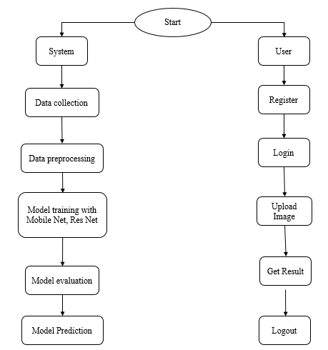

**Requirements Analysis**

**Hardware Requirements**

# Processor - I3/Intel Processor

Hard Disk - 160GB

Key Board - Standard Windows Keyboard

Mouse - Two or Three Button Mouse

Monitor - SVGA

RAM - 8GB

**Software Requirements:**

Operating System : Windows 7/8/10

Server side Script : HTML, CSS, Bootstrap & JS

Programming Language : Python

Libraries : Flask/Django, Pandas, Mysql.connector, Os, Smtplib, Numpy

IDE/Workbench : PyCharm

Technology : Python 3.6+

Server Deployment : Xampp Server

Database : MySQL

**Architecture:**

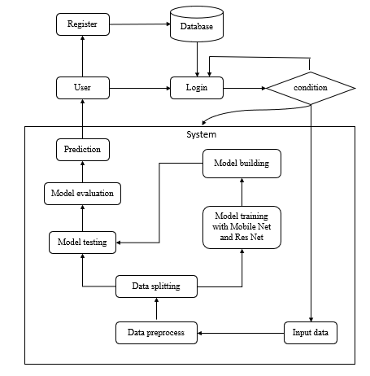

**MODULES:**

1. **System:**
   1. **Data Collection:** In this module, the dataset containing images for stroke identification is divided into two subsets: the training dataset and the testing dataset. This split is typically done with a test size of 20%. The training dataset is used to teach the model, while the testing dataset is used to evaluate its performance.

* 1. **Data Splitting:** The pre-processed dataset is split into two subsets:

1. Model Training: The training process involves fine-tuning the parameters of the auto-encoder model to minimize reconstruction errors and effectively enhance text clarity in noisy images. This process takes 80% of the data from the dataset.
2. Model Testing: The remaining 20% of the dataset is used for testing. In this process, the trained model makes predictions, and its performance is evaluated based on accuracy and other metrics.
   1. **Model Training:** The training process involves using 80% of the dataset to teach the model. The model parameters are fine-tuned to minimize reconstruction errors through iterative optimization techniques, such as gradient descent.
   2. **Model Testing:** The remaining 20% of the dataset is used for testing. The trained model predicts the segmentation of ischemic stroke lesions, and its performance is evaluated to determine the model's accuracy.
   3. **Model Saving:** Once trained, the model is saved in a .pt format, preserving its learned weights and biases.
   4. **Model Prediction:** Finally, we can input new images into the trained model to predict stroke.

**2. User:**

**2.1 Register:** Users should first register with their credentials to create an account in the system.

**2.2 Login:** Users can log in with their registered credentials to access the system.

**2.3 Upload Data:** Users can upload their images to predict whether it is stroke or normal.

**2.4 Viewing Results:** That uploaded image will going to the model part to predict and it will give the prediction and user can view the result.

**2.5 Logout:** Finally, users can log out of the system to secure their session and personal data.