2020-09-09: Core thermal Z at End of Stave

This is a prescription for extracting impedance values, Z[C/W] for segments near the end of Stave and for the EoS EAR. For simplicity it involves some assumptions and approximations, but should be OK for QC purposes as long as it is used to find Z from both the IR image and the FEA output.

I neglect both axial heat flow between adjacent modules and transverse heat flow between the flow and return sides of the stave.

Then the regions that need special treatment are limited to the existing segments 0 and 1 (large and small regions) *plus* the EoS Ear and the region adjacent to it:

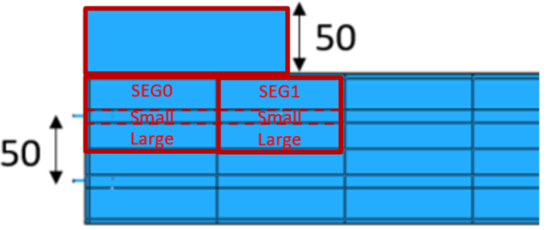

Seg0 and 1, large and small regions are the usual ones:

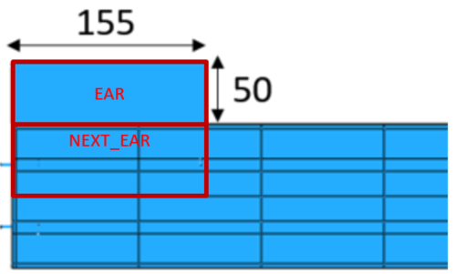Two new regions needed are:

* EAR, which refers to the whole EAR area, and
* NEXT_EAR which is a combination of Seg0(Large) and Seg1(Large) (over its 54mm length along the EAR):

(I have been sloppy about a small design change made recently: increase of the main stave surface width from 115 to 116mm – we could discuss this).

Fluid T (TF) Profile around the loop:

I ran the FEA model with constant heat transfer to ambient, adjusted to the conditions of IR image277 (Inlet TF = 39.8C, outlet = 39.2C, total estimated heat transfer: Qtot ≈46W). Integration of the thermal flux along the cooling pipe gives the profile of the normalised fluid T rise up to the downstream boundary of each segment (I’ve given it here with slightly higher precision than before):

|  |  |  |  |  |  |  |  |  |  |  |  |  |  |  |  |
| --- | --- | --- | --- | --- | --- | --- | --- | --- | --- | --- | --- | --- | --- | --- | --- |
|  | Module# | 13 | 12 | 11 | 10 | 9 | 8 | 7 | 6 | 5 | 4 | 3 | 2 | 1 | 0 |
|  | Segment | 0 | 1 | 2 | 3 | 4 | 5 | 6 | 7 | 8 | 9 | 10 | 11 | 12 | 13 |
| EoS |  | 0.0596 | 0.1080 | 0.1429 | 0.1777 | 0.2125 | 0.2472 | 0.2818 | 0.3163 | 0.3506 | 0.3849 | 0.4190 | 0.4530 | 0.4868 | 0.5216 |
| LP | Segment | 1.0000 | 0.9650 | 0.9308 | 0.8969 | 0.8629 | 0.8290 | 0.7952 | 0.7612 | 0.7273 | 0.6932 | 0.6591 | 0.6249 | 0.5907 | 0.5567 |
|  |  | 27 | 26 | 25 | 24 | 23 | 22 | 21 | 20 | 19 | 18 | 17 | 16 | 15 | 14 |

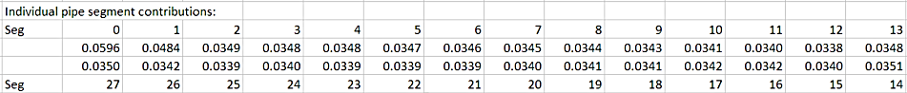The difference between consecutive values gives FQ , the fraction of total Q in flowing in each segment:

Estimate of Heat sharing

The actual heat exchanged with the *Large* surface regions can be taken as nearly the same as segment 2:

Qseg0 = Qseg1 = FQseg2 x Qtot/2 (/2 is for each surface . . . Top, Bottom)

The excess heat in segs 1 and 2 is attributed to heat exchanged with the ear (top or bottom surface) i.e:

Qear = [ FQseg0 + FQseg1 - 2xFQseg2 ] x Qtot/2

Temperature Corrections

We need to subtract the effect of heat exchanged with the Ear on the Temperature of the large and small regions of segments 0 and 1. The four coefficients quantifying this effect (tabulated below) were estimated by runnning the FEA with ambient exchange restricted to the Ear surfaces. [FEA: Core20LS_2 _var5]

For each of segments (0, 1) and regions (large,small) the corrected thermal impedance is given by:

Zseg,reg = [ TFseg - Tseg,reg – Qear x dTseg,reg/dQear] / Qseg

where TF = fluid temperature (≈ inlet T, or segment boundary) and T is averaged over the surface.

The coefficients dTseg,reg / dQear:

large small

seg0 1.193 0.591

seg1 0.716 0.251

For the Ear impedance, the heat exchanged between ambient and the region Qnext_ear (see above) is given approximately by:

Qnext_ear = (1 + 54/98) x FQ2 x Qtot/2.

Then:

Zear = [ TF – Tear – Qnext_ear x dTear/dQnext_ear] / Qear

where:

TF = Fluid temperature (not critical. e.g. taken at the boundary of seg0 and seg1? )

Tear = the stave surface T averaged over the Ear area. Although this is ~ 155mm x 50mm the averaging should be taken over an appreciably smaller area, to allow for camera resolution and barrel distortion of the image.).

The coefficient: dTear/dQnext_ear = 1.152 C/W [from FEA _var4 and _var5].

NOTE: The above coefficients were derived from FEA for *warm* *water* testing of a *long strip* stave core. I expect them to be useful over a range of fluid temperatures around +40C. However, it is likely that a different set of coeffs. will be needed for *hfe7100* and for *cold* testing: so it would be as well to collect them in a labelled block.

COMMENT: I expect that the FEA model describes the temperatures and thermal flux reasonably accurately, i.e. it is a reasonable model of what happens in the real experiment. However, the system is non-linear in that the thermal resistance between the stave surface and ambient depends on the difference between the two temperatures. The extaction of the coefficients (hence Z) is therefore not completely rigorous: for this reason the algorithm used to extract Z should be used on the FEA output as well as the IR data, in order to make a meaningful QC comparison between data and the FEA prediction.