Exploratory Data Analysis Report
Superstore Global Sales Dataset (2011–2014)
Data Analytics Internship — Task 2
51,290  Rows | 21  Columns | 147  Countries | 24.5%  Orders at a Loss

1. Meaningful Questions Asked Before Analysis
Before exploring the data, the following business questions guided the analysis:
- Which regions and product categories generate the most sales and profit?
- Does discounting affect profitability, and if so, how strongly?
- Are there seasonal or year-over-year trends in sales?
- Which product sub-categories are consistently unprofitable?
- Are there data quality issues that need to be addressed before deeper analysis?

2. Data Structure and Variable Types
The dataset contains 51,290 orders across 21 columns, spanning January 2011 to December 2014, covering 147 countries grouped into 7 markets.
Variable Type | Count | Examples
Identifiers | 3 | order_id, product_id, customer_name
Dates | 2 | order_date, ship_date
Categorical | 10 | category, region, segment, ship_mode…
Numeric | 6 | sales, profit, discount, quantity…

Data quality check: 0 missing values and 0 duplicate rows were found across all 51,290 records — the dataset is structurally clean.

3. Trends, Patterns, and Anomalies

3.1 Sales Trend Over Time
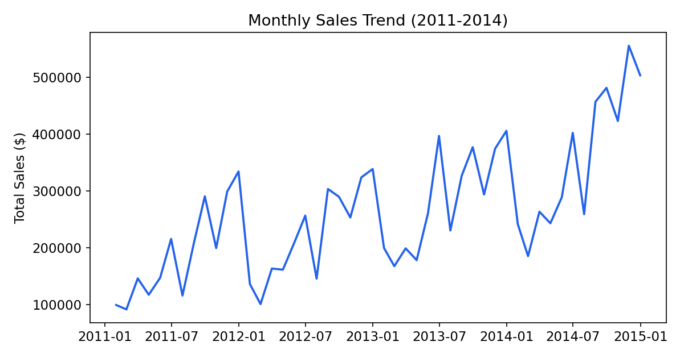
Figure 1. Monthly total sales, 2011–2014
Sales show a clear upward trend across the four years with strong seasonal spikes at the end of each year (Nov–Dec), consistent with holiday shopping patterns.

3.2 Profit by Category and Market
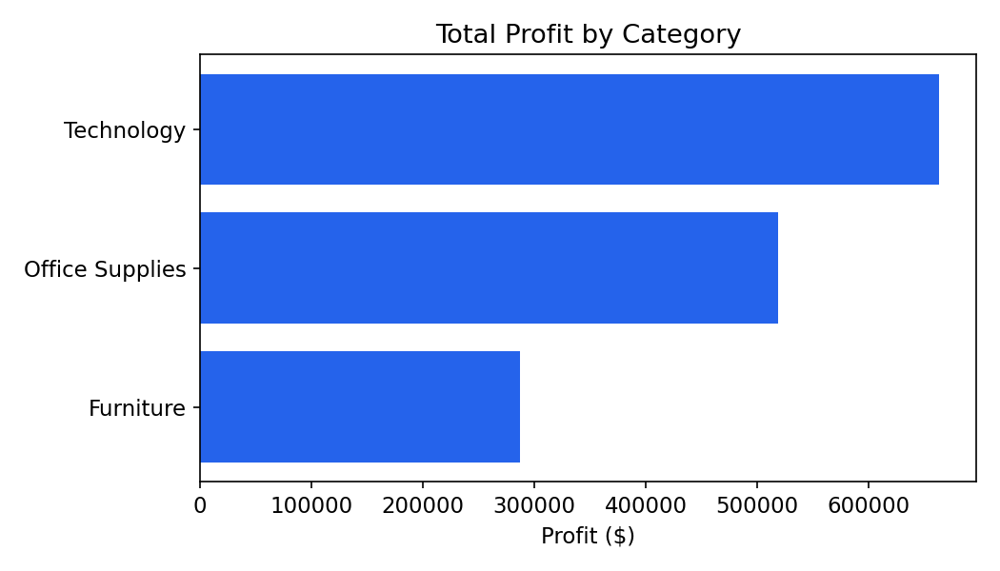
Figure 2. Total profit by product category
Technology generates the highest average profit per order ($65.45), followed by Furniture ($29.04) and Office Supplies ($16.58 — the lowest).
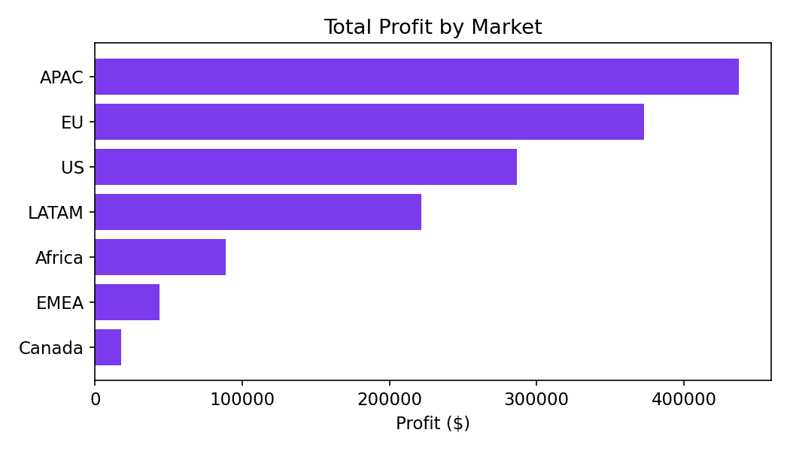
Figure 3. Total profit by market

3.3 Discount vs. Profit Relationship
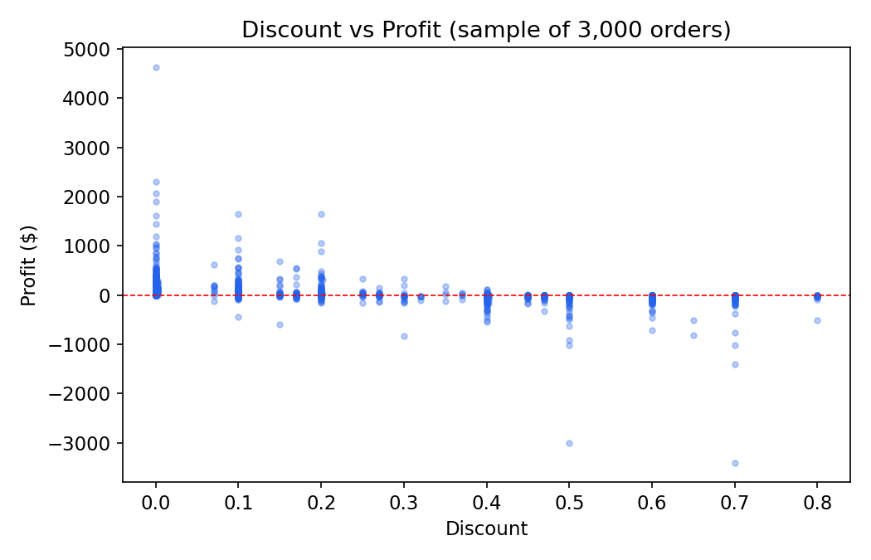
Figure 4. Discount level vs. profit (sample of 3,000 orders)
A clear negative relationship is visible: as discount increases, profit drops below zero more frequently. This pattern is investigated formally in Section 4.

3.4 Anomalies — Outliers and Losses
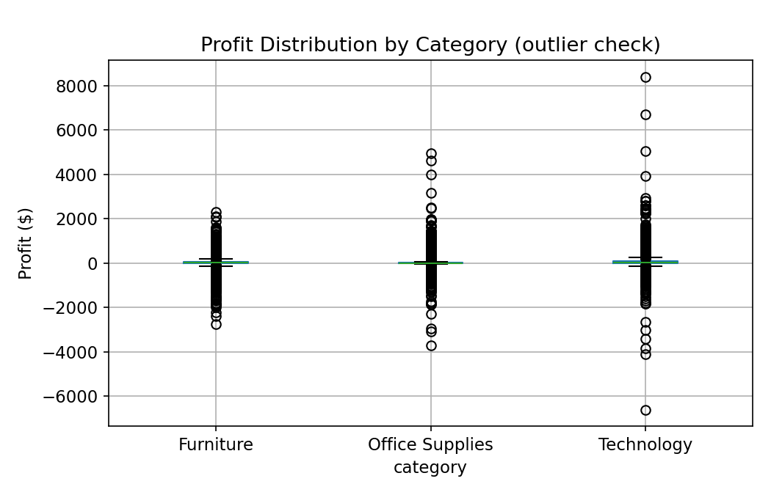
Figure 5. Profit distribution and outliers by category
- 24.46% of all orders (12,548 orders) resulted in a net loss.
- The “Tables” sub-category is the only one with a negative total profit overall (−$64,083), making it a priority area to investigate.
- Loss-making orders carry an average discount of 45.1%, compared to 14.3% across all orders — a strong signal that heavy discounting is linked to losses.

4. Hypothesis Testing and Statistical Validation

4.1 Hypothesis 1: Discount is negatively correlated with profit
Test: Pearson correlation between discount and profit.
- r = −0.32, p < 0.001
Result: Statistically significant negative correlation. Higher discounts are associated with lower profit. The effect is moderate in strength, confirming discount is a meaningful driver of profit — but not the only one.

4.2 Hypothesis 2: High-discount orders (>20%) are less profitable than low-discount orders
Test: Welch's t-test comparing mean profit between high-discount (>20%) and low-discount (≤20%) orders.
Group | Mean Profit | n
High discount (>20%) | −$71.92 | 11,328
Low discount (≤20%) | +$57.15 | 39,962

Result: t = −64.20, p < 0.001. The difference is highly statistically significant — high-discount orders lose money on average, while low-discount orders are profitable on average.

4.3 Hypothesis 3: Mean profit differs across product categories
Test: One-way ANOVA comparing mean profit across Furniture, Office Supplies, and Technology.
- F = 304.23, p < 0.001
Result: Statistically significant difference in mean profit across categories. Technology is the most profitable category per order; Office Supplies the least, confirming the pattern seen in Figure 2.

5. Data Issues to Address in Further Analysis
- Structural quality is high: no missing values and no duplicate rows were found, so no imputation or de-duplication is required.
- Negative profit values are legitimate business outcomes (loss-making sales), not data errors — but they should be modeled separately from profitable orders in any predictive analysis, since they follow a different pattern (driven heavily by discount).
- country (147 categories) is very high-cardinality for direct use in grouped analysis or modeling; market or region (6–7 categories) are more practical grouping levels.
- The “Tables” sub-category's large negative total profit is concentrated risk — worth a dedicated drill-down (e.g., by discount level and region) before drawing conclusions about the whole Furniture category.
- Order_date and ship_date should be checked for consistency (ship_date should never precede order_date) before any shipping-time analysis.

6. Summary of Key Findings
- Sales grew steadily from 2011–2014 with consistent year-end seasonal peaks.
- Discount level is a statistically significant driver of profit loss (r = −0.32, p < 0.001).
- Orders discounted above 20% lose money on average (−$71.92); orders at or below 20% are profitable on average (+$57.15).
- Profit differs significantly by category (p < 0.001): Technology is most profitable, Office Supplies least.
- 24.5% of all orders are unprofitable, concentrated among heavily discounted orders and the Tables sub-category.

