Superstore Data Visualization
Data Analytics Internship — Task 3: Data Visualization

1. Overview
This project turns raw sales data from the Superstore Global Sales Dataset (2011–2014) into clear, insight-driven visualizations that support business decisions. The goal is to reveal useful business insights, not just display numbers.
Item | Detail
Dataset | Superstore Global Sales (Orders sheet)
Period | 2011 to 2014
Size | 51,290 orders, 21 columns
Coverage | 147 countries, 7 markets
Missing values | None

Tools used
- Python — main programming language
- Pandas — data loading, aggregation and preparation
- Matplotlib — chart generation and styling
- Seaborn — themed styling and heatmap

2. Visualizations

2.1 Monthly sales growth trend
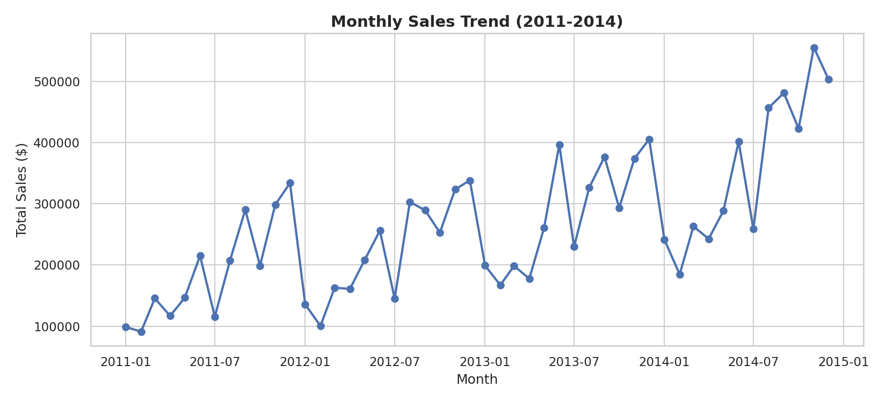
Monthly sales grow steadily from 2011 to 2014. Sales peak every November and December, which shows a clear holiday-season pattern.

2.2 Executive dashboard
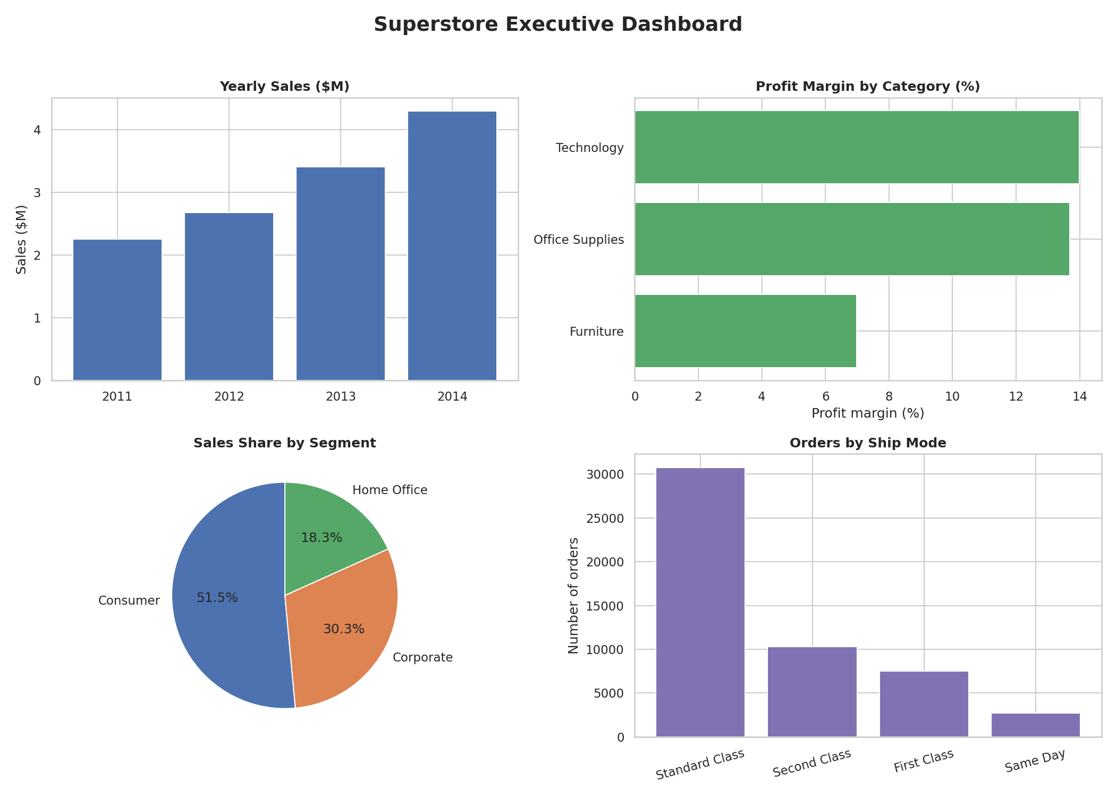
Four panels give a quick business summary: yearly sales, profit margin by category, sales share by segment, and orders by ship mode. Yearly sales rise from about $2.26M in 2011 to about $4.30M in 2014, which is growth of roughly 90%. Technology and Office Supplies have the highest margins, Furniture has the lowest, the Consumer segment brings in about half of all sales, and Standard Class is the most used shipping mode.

2.3 Best and worst sub-categories
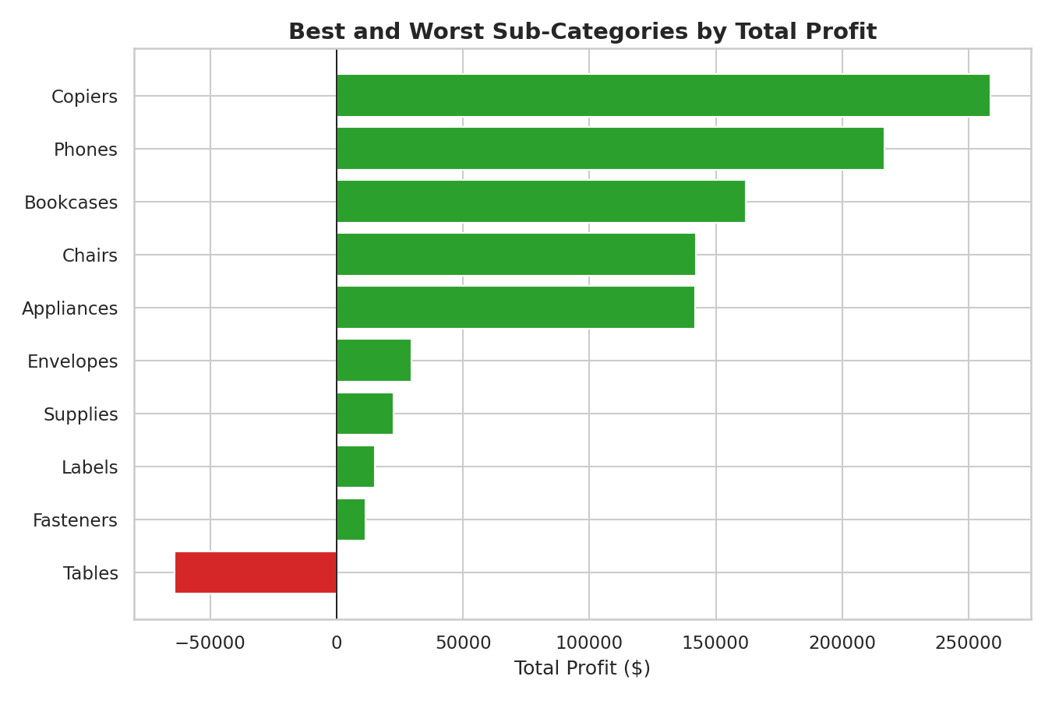
Copiers and Phones are the most profitable sub-categories. Tables is the only sub-category that loses money overall.

2.4 Discount vs profit
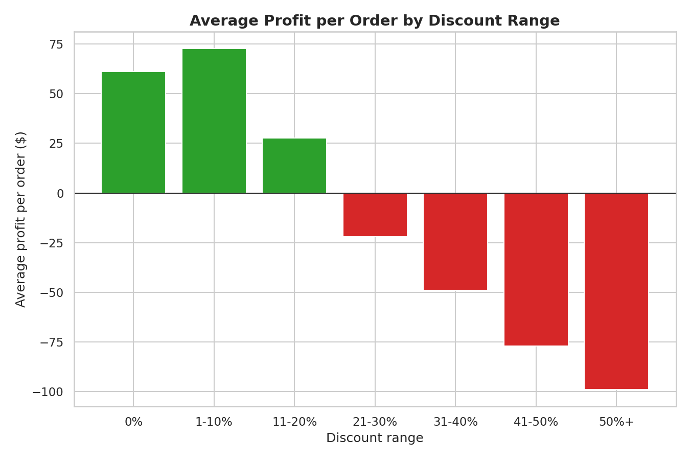
Average profit per order falls as discounts increase. Orders with discounts of up to 20% still make a profit, but above 20% the average profit per order turns negative (about -$22 for 21–30% discounts, getting worse at higher discounts).

2.5 Profit heatmap: category and market
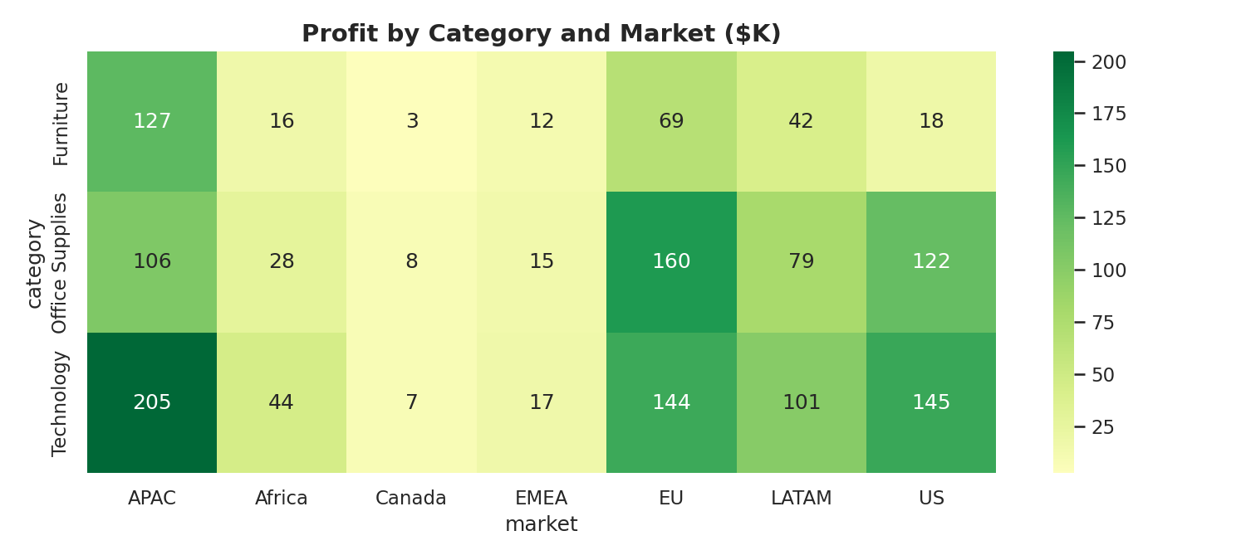
The heatmap shows profit ($K) for each category in each market. APAC and the EU are the strongest markets, while Canada and EMEA are the weakest.

3. Key Insights
- Strong growth: sales grew about 90% from 2011 to 2014, with predictable peaks every November and December.
- Discount limit: discounts above about 20% make the average order unprofitable, which gives a data-backed threshold for discount policy.
- Product performance: Technology is the most profitable category, and Tables is the only sub-category losing money.
- Market performance: APAC (about $438K profit) and the EU (about $373K) lead. Canada (about $18K) and EMEA (about $44K) lag behind and need further investigation.

4. Recommendations
- Limit discounts to 20% or below, unless there is a clear reason to go higher.
- Review pricing, costs and discounts for Tables, since it loses money.
- Prepare stock and marketing for the November–December peak.
- Investigate why Canada and EMEA earn so little profit compared with APAC and the EU.

Appendix: Python Code
The script below creates all five charts. Keep superstore_sales.xlsx in the same folder and run: python superstore_visualization.py
"""
Superstore Sales - Data Visualization
Run: python superstore_visualization.py
Needs: pandas, matplotlib, seaborn, openpyxl
Put superstore_sales.xlsx in the same folder as this script.
"""
import os
import pandas as pd
import matplotlib.pyplot as plt
import seaborn as sns

sns.set_theme(style="whitegrid", palette="deep")
os.makedirs("charts", exist_ok=True)

df = pd.read_excel("superstore_sales.xlsx", sheet_name="Orders")
df["month"] = df["order_date"].dt.to_period("M").dt.to_timestamp()

# ---------- 01. Monthly sales growth trend ----------
monthly = df.groupby("month")["sales"].sum()
plt.figure(figsize=(11, 5))
plt.plot(monthly.index, monthly.values, marker="o", linewidth=2)
plt.title("Monthly Sales Trend (2011-2014)", fontsize=14, weight="bold")
plt.xlabel("Month")
plt.ylabel("Total Sales ($)")
plt.tight_layout()
plt.savefig("charts/01_sales_growth_trend.png", dpi=150)
plt.close()

# ---------- 02. Executive dashboard (4 panels) ----------
fig, ax = plt.subplots(2, 2, figsize=(14, 10))
fig.suptitle("Superstore Executive Dashboard", fontsize=18, weight="bold")

yearly = df.groupby("year")["sales"].sum() / 1e6
ax[0, 0].bar(yearly.index.astype(str), yearly.values, color=sns.color_palette("deep")[0])
ax[0, 0].set_title("Yearly Sales ($M)", weight="bold")
ax[0, 0].set_ylabel("Sales ($M)")

cat = df.groupby("category")[["sales", "profit"]].sum()
margin = (cat["profit"] / cat["sales"] * 100).sort_values()
ax[0, 1].barh(margin.index, margin.values, color=sns.color_palette("deep")[2])
ax[0, 1].set_title("Profit Margin by Category (%)", weight="bold")
ax[0, 1].set_xlabel("Profit margin (%)")

seg = df.groupby("segment")["sales"].sum()
ax[1, 0].pie(seg.values, labels=seg.index, autopct="%1.1f%%", startangle=90)
ax[1, 0].set_title("Sales Share by Segment", weight="bold")

ship = df["ship_mode"].value_counts()
ax[1, 1].bar(ship.index, ship.values, color=sns.color_palette("deep")[4])
ax[1, 1].set_title("Orders by Ship Mode", weight="bold")
ax[1, 1].set_ylabel("Number of orders")
ax[1, 1].tick_params(axis="x", rotation=15)

plt.tight_layout(rect=[0, 0, 1, 0.96])
plt.savefig("charts/02_executive_dashboard.png", dpi=150)
plt.close()

# ---------- 03. Best and worst sub-categories ----------
sub = df.groupby("sub_category")["profit"].sum().sort_values()
picked = pd.concat([sub.head(5), sub.tail(5)])
colors = ["#d62728" if v < 0 else "#2ca02c" for v in picked.values]
plt.figure(figsize=(9, 6))
plt.barh(picked.index, picked.values, color=colors)
plt.axvline(0, color="black", linewidth=0.8)
plt.title("Best and Worst Sub-Categories by Total Profit", fontsize=14, weight="bold")
plt.xlabel("Total Profit ($)")
plt.tight_layout()
plt.savefig("charts/03_best_worst_subcategories.png", dpi=150)
plt.close()

# ---------- 04. Discount vs average profit per order ----------
bins = [-0.01, 0, 0.1, 0.2, 0.3, 0.4, 0.5, 1.0]
labels = ["0%", "1-10%", "11-20%", "21-30%", "31-40%", "41-50%", "50%+"]
df["discount_range"] = pd.cut(df["discount"], bins=bins, labels=labels)
avg = df.groupby("discount_range", observed=True)["profit"].mean()
colors = ["#d62728" if v < 0 else "#2ca02c" for v in avg.values]
plt.figure(figsize=(9, 6))
plt.bar(avg.index.astype(str), avg.values, color=colors)
plt.axhline(0, color="black", linewidth=0.8)
plt.title("Average Profit per Order by Discount Range", fontsize=14, weight="bold")
plt.xlabel("Discount range")
plt.ylabel("Average profit per order ($)")
plt.tight_layout()
plt.savefig("charts/04_discount_vs_profit.png", dpi=150)
plt.close()

# ---------- 05. Profit heatmap: category x market ($K) ----------
pivot = df.pivot_table(index="category", columns="market", values="profit", aggfunc="sum") / 1000
plt.figure(figsize=(10, 4.5))
sns.heatmap(pivot, annot=True, fmt=".0f", cmap="RdYlGn", center=0)
plt.title("Profit by Category and Market ($K)", fontsize=14, weight="bold")
plt.tight_layout()
plt.savefig("charts/05_profit_heatmap_category_market.png", dpi=150)
plt.close()

print("Done! 5 charts saved in the 'charts' folder.")

