1. Last element of list.

last([X],X).

last([_|Rest],X):-

last(Rest,X).

// last([1,2,3],X)

1. Samelen of list

samelen([],[]).

samelen([_X|L],[_Y|M]):-

samelen(L,M).

1. Last but one

lbo(X,[X,_]).

lbo(X,[_|T]):-

lbo(X,T).

1. Kth ele

k_ele(X,[X|_],1).

k_ele(X,[_|T],Y) :- Y > 1,Y is Y - 1, k_ele(X,T,Y).

1. Sum ele list

sum([],0).

sum([H|T],N):-

sum(T,N1), N is N1+H.



1. Maximum in list

Maxlist([],0).

maxlist([Head|Tail],Max) :-

maxlist(Tail,TailMax),

Head > TailMax,

Max is Head.

maxlist([Head|Tail],Max) :-

maxlist(Tail,TailMax),

Head =< TailMax,

Max is TailMax.

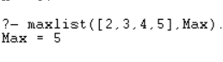

1. GCD

gcd(0, X, X):- X > 0, !.

gcd(X, Y, Z):- X >= Y, X1 is X-Y, gcd(X1,Y,Z).

gcd(X, Y, Z):- X < Y, X1 is Y-X, gcd(X1,X,Z).



1. Prime or not.

divisible(X,Y) :- 0 is X mod Y, !.

divisible(X,Y) :- X > Y+1, divisible(X, Y+1).

isPrime(2) :- true,!.

isPrime(X) :- X < 2,!,false.

isPrime(X) :- not(divisible(X, 2)).



1. Not doubleton

not_doubleton([]):-

write('Not').

not_doubleton([_]):-

write('Not').

not_doubleton([_,_|_]):-

write('Not').

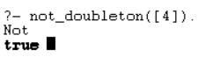

1. If 2 ele of list are same

double([X|[X|_Rest]]).



1. Is palindrome list

pal([]).

pal([_]).

pal(Pal) :-

append([H|T], [H], Pal),

pal(T).

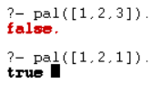

1. Co prime / relatively prime

relatively_prime(X, Y) :-

gcd(X, Y) =:= 1.

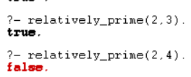

1. Count elements greater than N

:- use_module(library(clpfd)).

count_elems([],_,0).

count_elems([X|Xs],Z,Count) :-

X #=< Z,

count_elems(Xs,Z,Count).

count_elems([X|Xs],Z,Count) :-

X #> Z,

Count #= Count0 + 1,

count_elems(Xs,Z,Count0).

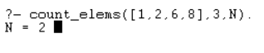

1. Factorial

(0, 1).

factorial(N, Result) :-

N > 0,

N1 is N - 1,

factorial(N1, SubResult),

Result is N * SubResult.

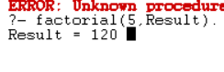

1. N Fibonacci series

fib_seq(0,[0]).

fib_seq(1,[0,1]).

fib_seq(N,Seq) :-

N > 1,

fib_seq_(N,SeqR,1,[1,0]),

reverse(SeqR,Seq).

fib_seq_(N,Seq,N,Seq).

fib_seq_(N,Seq,N0,[B,A|Fs]) :-

N > N0,

N1 is N0+1,

C is A+B,

fib_seq_(N,Seq,N1,[C,B,A|Fs]).

