# My Event-ful internship at Solace

It has been an eventful summer for me at Solace as a pre-sales intern. As an Information Systems undergraduate, majoring in Smart City Management and Technology at Singapore Management University, I heard about some of the ways solace has been helping to make Singapore smarter and more event driven, and I was excited to be to learn from and be part of the team at Solace.

Coming into Solace, I had very little understanding as to messaging, events brokers and eventing as a whole. However, thanks to the Udemy courses on solace development and administration, I was able to quickly pick up a basic understanding about messaging and the events driven solutions provided by Solace. Often as interns, sometimes you may feel apprehensive in asking others in the team for help or clarification, as you may feel like you are disturbing their work. In retrospect, this was something that I did not ever have to worry about here at Solace, the team was always willing to help in whatever way they could and constantly took time to walk us through our queries and always checked in to ensure that we were not lost and are sufficiently challenged to explore on our own as well.

One of the main tasks that was assigned to my fellow intern Giem Teck and I, was to understand, scope, design and build a smart data exchange prototype that can be used to demonstrate the concepts of event driven exchange of information. The main challenge in this project was to showcase how solace can provide central exchange that can be utilised by other users (“agencies”) to share, monitor and consume data.

An example use case, in the context of a smart city, is the exchange of data between different government agencies. Agencies can share the data that they collect via the central exchange in real time (eg. CCTV footage, sensor data) and can further utilise data that is shared to them by other agencies. A Machine Learning or Analytics application can also be subscribed to the events being published by agencies. For example, a Machine Learning application can take in raw traffic camera footage from the Land Transport agency, the model can then generate description tags about the footage that can be used to trigger events, like start of fire, that other agencies like fire and rescue can subscribed to.

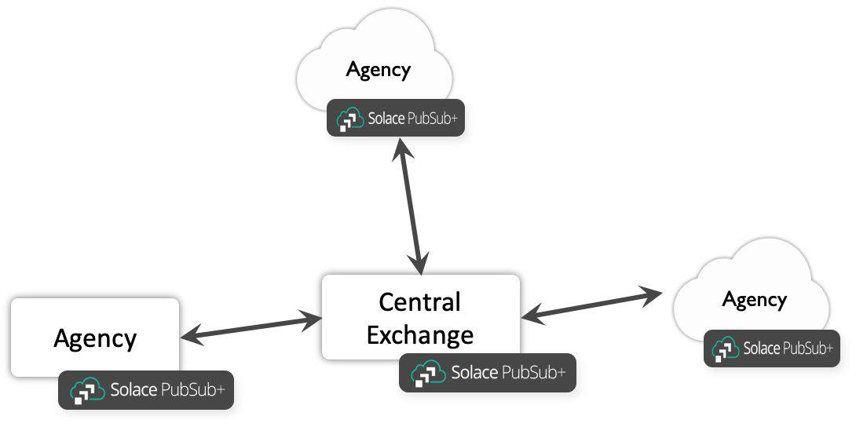

Through brainstorming and whiteboarding sessions with our supervisor Phil and further discussions with other members of the team. We came up with a front facing JavaScript web application that utilises the Solace Javascript API and various SEMP calls to, create bridges between the central exchange broker and the agency broker. So as to allow agencies to view event streams available to them from other agencies as well as to publish events that can be accessed by other agencies, the access control for this publishing and subscribing will be centrally managed via Access Control Lists on the Central Exchange broker.