Prerequisite knowledge

Rust Core
- Ownership/borrowing/lifetimes, Result/Option, error handling (thiserror for libraries, anyhow for the binary)
- Traits, trait objects (dyn), generics & bounds — you'll abstract "a thing that produces samples" and "a thing that consumes samples”
- Closures and move (audio callbacks are 'static closures that capture state)

Concurrency (heavily used)
- Arc, Mutex/RwLock, and why you must not lock inside an audio callback - Atomics (AtomicBool, AtomicUsize, Ordering) for lock-free signaling - Channels: std::sync::mpsc vs crossbeam-channel - Lock-free SPSC ring buffers — the central data structure (ringbuf or rtrb crate) - The real-time audio rule: the callback runs on a high-priority OS thread; no allocation,
no locking, no I/O, no println! inside it

Digital audio fundamentals
- PCM, sample rate (44.1/48 kHz), bit depth, f32 vs i16 samples - Channels, interleaved vs planar layout, "frame" = one sample per channel - Buffer/period size, latency, underrun/overrun (xruns) - Resampling and clock drift (the rubato crate handles the DSP)

Platform/stack
- Roughly how WASAPI shared vs exclusive mode works, and how cpal maps onto it

Suggested phases (each is independently runnable/testable
1. Explore & prototype — enumerate devices with cpal, print their supported configs. Generate a sine wave and play it to one chosen device. Goal: understand the callback model. 2. Single passthrough — capture from one input, play to one output via a ring buffer. Now you understand the producer/consumer split and xruns. 3. Fan-out to N outputs — same source → N ring buffers → N output streams. Works only if all devices share the sample rate. This is your MVP. 4. Handle format mismatch — per-output resampling with rubato so a 44.1 kHz source can feed a 48 kHz device. 5. Clock-drift correction — monitor each output ring buffer's fill level and nudge its resampler ratio to keep it. This is what makes it robust for hours. 6. Config, CLI, robustness — device selection by name, config file, graceful device-unplug handling, logging.
7. (Optional) GUI — live device toggles, per-output volume, level meters.

Proposed architecture (types, traits, fields)

Folder structure of a typical binary+library split:
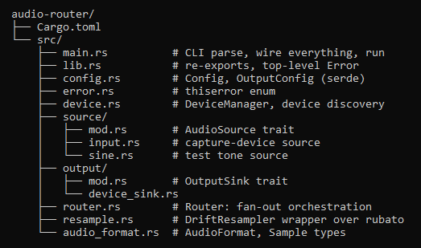

Core value types
- AudioFormat { sample_rate: u32, channels: u16, sample_format: SampleFormat } - SampleFormat enum (F32, I16, …) — mirrors what cpal reports - Sample buffers as Vec<f32> (normalize everything to f32 internally — much simpler)

Traits (the abstraction seams)
trait AudioSource {
fn format(&self) -> AudioFormat;
fn start(&mut self) -> Result<()>;
fn stop(&mut self);
// produces frames into a shared ring buffer / broadcast
} trait OutputSink {
fn id(&self) -> &str;
fn format(&self) -> AudioFormat;
fn producer_handle(&self) -> RingProducer; // where the router writes
fn start(&mut self) -> Result<()>;
fn stop(&mut self); }

Key structs
- DeviceManager — wraps cpal::Host; methods list_inputs(), list_outputs(), find_output_by_name(&str)
- DeviceSink — one output device: owns the cpal::Stream, a ringbuf consumer (read in the callback), a DriftResampler, an AtomicUsize for fill-level telemetry, volume atomic
- Router — owns the source + Vec<DeviceSink>; the source thread writes each frame into every sink's ring producer (with per-sink resampling); a control loop monitors drift - DriftResampler — wraps rubato, exposes set_ratio_adjustment(f64) for drift correction - Config / OutputConfig — deserialized from TOML (device names, target latency, volumes) — thiserror enum (DeviceNotFound, UnsupportedFormat, StreamError, Config, …)

Threading model
- One capture callback thread (owned by cpal) → writes to a distribution point
- N output callback threads (one per device, owned by cpal) → each drains its own ring buffer
- One control/monitor thread → watches fill levels, adjusts resampler ratios, handles device add/remove
- Communication: audio data via lock-free ring buffers; control messages via crossbeam-channel; telemetry via atomics

Capturing "what the PC is playing"
- "Stereo Mix" virtual device — if you enable it in Windows sound settings, system audio shows up as a normal input device. cpal then treats it like any microphone. This is by far the best learning path because it requires zero special code — your capture logic is identical to a mic. (Not every sound card exposes it, though.)
2. cpal WASAPI loopback — mainline cpal support for true loopback has historically been limited/patchy. I'd want to verify the current state against whatever cpal version you pin rather than trust my memory here — I can look that up when we get there.
3. The wasapi crate directly — bypasses cpal for capture, gives you real loopback, but you hand-write more Windows-specific code. Good later, as a "peek under the abstraction" exercise — which fits a learning-focused goal nicely.
A line like 2ch, 44100-44100 Hz, F32 describes an audio format — three things:

Technicalities of a Audio
2ch — channels. How many separate sound streams. 1 = mono (one speaker's worth), 2 = stereo (left and right).
44100 Hz — sample rate. Digital audio is just a long list of numbers, each one measuring the air pressure at an instant. 44100 Hz means 44,100 of those measurements per second. CD quality. 48000 is the other common one.
F32 — sample format. How each individual measurement is stored in memory. F32 = a 32-bit floating point number. I16 = a 16-bit whole number. U8 = an 8-bit unsigned whole number. Same sound, different storage.
So 2ch, 44100-44100 Hz, F32 reads as: "stereo, 44,100 measurements per second, each stored as a 32-bit float."

Sound Mechanism
Speaker is just a paper cone glued to a magnet, and the position of that cone at each instant is the only thing that matters.
If we can control where the cone is at every moment in time, you can produce any sound in existence.
Amplitude – how far does the cone travels
Pitch – how fast does it travel, (440Hz means, 440 times in a second)
Sine – purest possible tone – a single frequency with nothing else mixed in.
Value = aplitude * sin(2π * frequency * time)
1. sin(...) by itself oscillates smoothly between −1 and +1 forever. That's the cone swinging in and out.
2. amplitude * scales that swing down to ±0.15 → sets the volume.
3. frequency inside controls how fast we march through the sine's cycle → sets the pitch. Bigger frequency = we race through the wiggles faster = higher note.
4. 2π (that's TAU in the code) is a units converter. One full trip around a circle is 2π radians in math. Multiplying by 2π makes "1 cycle" line up with "one full sine wave," so that frequency means actual cycles-per-second and not something scaled weirdly. Think of it as the gear that translates "440 cycles" into the math's native units.
5. time is the current instant. As time marches forward, the sine sweeps through its cycle, and the cone traces the wave.
Put together: "at this instant in time, the cone should be at height 0.15 × sin(2π × 440 × time)." Compute that number, hand it to the speaker, done.

In real world, time is smooth – the cone position is defined at every infinitely-fine instant. But a computer cant store infinitely many numbers.
So digital audio cheats: it only describes the cone’s positions at a rapid series of snapshots. And trusts that snapshots are frequent enough, our ears can’t tell.
Each snapshot is called a sample.
Sample rate = how many snapshots per second.
Our device said 48000Hz -> it wants 48k cone positions numbers every second.
(Note: Hz again – 48,000 times per second, same unit as frequency different thing being counted.)
Nyquist Rule – we need at least double the highest frequency we want to produce. Humans hear upto ~20k Hz, so we need >40k snapshots/sec.
From “time” to “sample number” - what sample_index really is
Code never talks about time in seconds directly. Instead, it counts which snapshot num we are on:
sample_index = 0, 1, 2, 3, …
But snapshot-number is time, just measured in different unit:
time (in seconds) = sample_index / sample_rate
Snapshot #48,000 happens exactly 1 second in, because there are 48,000 per second. So plugging that into the formula:
Value = amplitude * sin ( 2π * frequence * sample_index / sample_rate )
The step is just “how much further around the sine circle we move with each single snapshot.”
Each time we do sample_index += 1, we nudge the cone one snapshot forward in time. So the whole callback is answering, 48,000 times a second: “snapshot number N – where’s the cone” Compute the sine, write the number, move to the next snapshot.
An audio callback is a function you hand to cpal, and cpal calls it repeatedly on the sound card's schedule to either get audio from you or give audio to you.
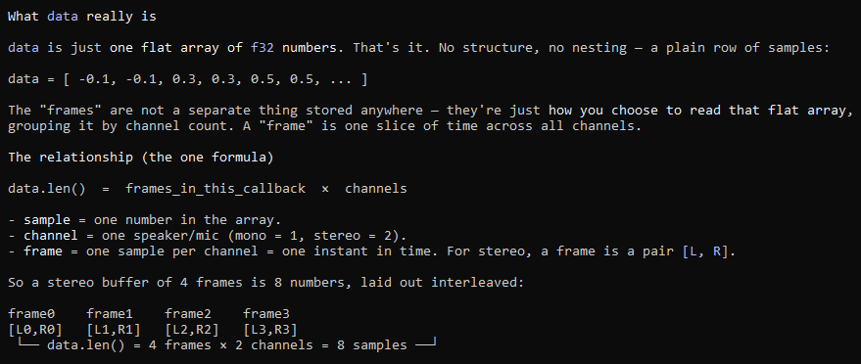
How many frames/samples are in data? it varies per callback - cpal decides. It's not fixed by us. Each time cpal calls you, it might hand you a buffer of a few hundred frames, and the size can even differ call to call.
Data is a flat interleaved array; data.len() = frames × channels; the frame count is chosen by cpal and can change every callback, so you always loop over whatever length you're handed.

Ordering argument is you telling the CPU: "how much reordering am I willing to tolerate around this operation?" It's not about the atomic value itself — it's about how this operation relates to other memory operations around it.
- Relaxed — weakest. Guarantees only atomicity (no torn reads/writes) for this one value. Makes no promises about the order of other memory operations. Cheapest, fastest.
- Acquire/Release — stronger. Create a "happens-before" link. Used when the atomic is a signal that guards other data — e.g. "I've set the ready flag to true, and you can trust that the buffer I filled before setting it is now safely visible to you." The flag orders the other work around it.
- SeqCst — strongest, one single global order everyone agrees on. Simplest to reason about, most expensive.
Why Relaxed is exactly right for our meter
The callback writes "current loudness," main reads "current loudness." There's no other data that must be visible in a particular order relative to it.
Relaxed = "just give me the latest torn-free number, I don't care about anything else."
How the meter (the #### bar) works
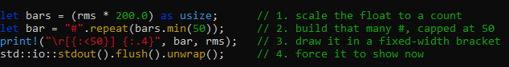
Step 1 — scale the float to a count. rms is a small decimal, roughly 0.0 (silent) to maybe 0.3 (loud speech). You can't repeat a character 0.2 times — you need a whole number of #s. So you multiply by a scale factor to turn it into a usable count, then as usize chops it to a whole number:
- rms = 0.20 → 0.20 × 200 = 40.0 → 40 bars
- rms = 0.05 → 0.05 × 200 = 10.0 → 10 bars
- rms = 0.00 → 0 bars
The 200.0 is arbitrary — it's just a sensitivity knob. Bigger number = bar reacts to quieter sounds (fills up faster); smaller = you need to be louder to fill it. You tune it by eye until the bar uses its full range for normal sound. Nothing physical, just "how many # per unit of loudness."
Step 2 — build the string, capped. "#".repeat(40) produces "########################################" (40 #s). The .min(50) is a safety cap: if a very loud sound gave bars = 73, 73.min(50) = 50, so the bar never exceeds 50 characters and never overflows the box. It clamps the top end.
Step 3 — draw it in a fixed-width slot. {:<50} means "print this string left-aligned, padded to 50 characters wide." So a 40-# bar gets 10 trailing spaces to fill out to 50. That fixed width is what keeps the closing ] in the same spot every frame — otherwise the bracket would jump left/right as the bar grows and shrinks, looking messy. The {:.4} prints rms itself as a number with 4 decimals, next to the bar.
The \r at the front is the carriage return - it moves the cursor back to the start of the current line without going to a new line. So each print! overwrites the previous bar in place, giving the illusion of a live, animated meter instead of thousands of scrolling lines. flush() forces the terminal to display it immediately (otherwise it'd sit buffered and you'd see nothing move).
So the whole meter is: loudness → multiply to a count → cap it → repeat # that many times → left-pad to fixed width → overwrite the same line. A "graph" made of text.
Picture it:
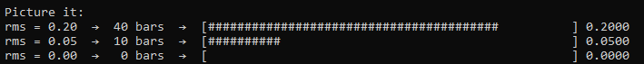

Rung4 – Fan Out
Producers vector explained
A ring buffer is a tube that holds audio samples in order: you push samples in one end, they come out the other end in the same order.
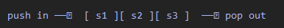
When you create one and call .split(), you get two handles to that same tube:
- prod (producer) = the push-in handle. Its only job: push_slice(...) — drop samples into the tube.
- cons (consumer) = the pop-out handle. Its only job: pop_slice(...) — take samples out of the tube.
Two handles, one tube. They go to two different threads so those threads can share the tube safely without locking — each touches only its own end
Who holds which handle in Chorus
- The producer end (prod) goes to the loopback capture — the thing reading your system audio. Every time it captures a chunk, it pushes it into the tube.
- The consumer end (cons) goes to an output device's stream — every time that device needs samples to play, it pops them from the tube.
So one tube = one pipe from "system audio" to "one output device."

Fan-out: many tubes
We mirror to several devices, and a tube only has one consumer. we make one tube per output device:
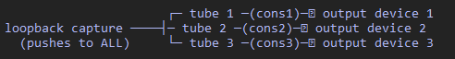
- Each tube's cons lives inside that device's playback callback (each device drains its own tube).
- All the tubes' prods are collected into one list, held by the capture callback. Each captured chunk gets pushed into every prod → the same audio flows to every device.
Example Trace
Say the tube holds [10, 11] right now:
1. Capture fires, hands you [12, 13, 14] → prod.push_slice([12,13,14]) → tube is now [10,11,12,13,14].
2. Device needs 3 samples → cons.pop_slice(buf) fills buf = [10,11,12], tube now [13,14].
3. Device plays [10,11,12].
Samples come out in the exact order they went in (it's a queue) — just delayed by however long they sat in the tube. That delay is the buffer's cushion (your capacity).

Why two separate handles at all
The producer and consumer run on different threads at slightly different speeds. Giving each its own dedicated handle (prod for pushing, cons for popping) means they never touch the same end of the tube, so no locks are needed — that's what makes it safe and real-time-friendly. If the tube ever runs empty when the consumer pops (producer fell behind), that's the underrun you pad with silence.

Capacity is the size of the ring buffer — the tube/conveyor belt from before. It's literally the number in HeapRb::<f32>::new(capacity): how many samples the belt can hold at once. Let me connect it to sound quality using the belt picture.
If the belt is short and the consumer momentarily gets ahead of the producer, the belt runs empty — the consumer reaches for a sample and there's nothing there. That's an underrun. Your code handles it by filling the gap with silence (data[n..] = 0.0).
Now here's the sound-quality link: each underrun is a tiny drop-out — a sliver of silence spliced into the audio. One is a faint click. Hundreds per second (which is what you get when the belt is chronically too small) sound like crackling, choppiness, gritty "low quality." It's not that the samples are wrong — it's that the stream keeps getting interrupted.
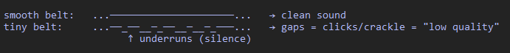
Why the sample rate changed everything
Capacity counts samples, but what actually matters is how much time those samples represent — and that depends on the rate:
Time on belt = capacity / (sample_rate × channels)
- 3200 samples at 48 kHz stereo = 3200 / (48000×2) = ~33 ms of cushion → comfortable.
- 3200 samples at 384 kHz stereo = 3200 / (384000×2) = ~4 ms of cushion → far too thin.


