

Report File
Information Technology

Submitted By-
Arihant Pratap Singh
Class Xth -A
Session 2022-23

Submitted To-
Mr. Kapil Sharma Sir

Index

Program-1: Demonstrating Heading Tag

<!DOCTYPE html>
<html>
<head>
<title>Demonstrating Heading Tags</title>
</head>
<body>
<h1>Arihant Pratap Singh -(h1)</h1>
<h2 align="right">Arihant Pratap Singh -(h2)</h2>
<h3 align="center">Arihant Pratap Singh -(h3)</h3>
<h4>Arihant Pratap Singh -(h4)</h4>
<h5 align="right">Arihant Pratap Singh -(h5)</h5>
<h6 align="center">Arihant Pratap Singh -(h6)</h6>
</body>
</html>

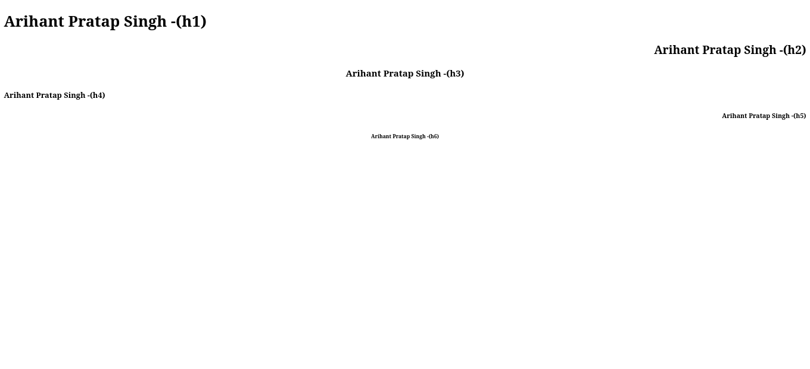

Program-2: Demonstrating Superscript and Subscript tags
<!DOCTYPE html>
<html lang="en">
<head>
<title>Demonstrating superscript and subscript tags</title>
</head>
<body>
USING CHEMICAL AND MATHEMATICAL FORMULAE <br>
<b><u>Chemical Formulae</u></b><br>
CO<sub>2</sub><br>
H<sub>2</sub>O <br>
<b><u>Dispaying Mathematical Formulae</u></b><br>
(a+b)<sup>2</sup> = a<sup>2</sup> + b<sup>2</sup> + 2ab <br>
(a-b)<sup>2</sup> = a<sup>2</sup> + b<sup>2</sup> - 2ab
</body>
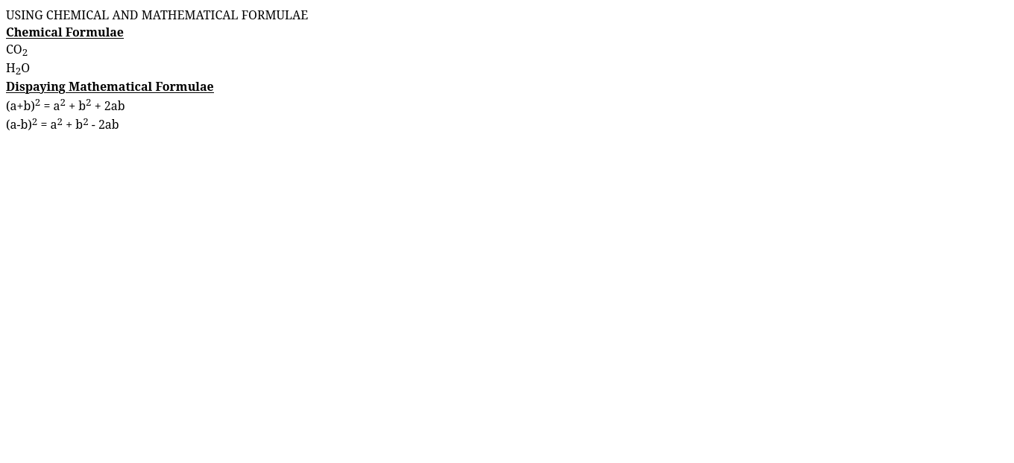
</html>
Program-3: Demonstrating <font> tag

<!DOCTYPE html>
<html>
<head>
<title>Demonstrating "<font>" tag</title>
</head>
<body>
<font face="monospace" size="5">Demonstrating the font tag!</font><br>
Demonstrating the font tag!
</body>
</html>
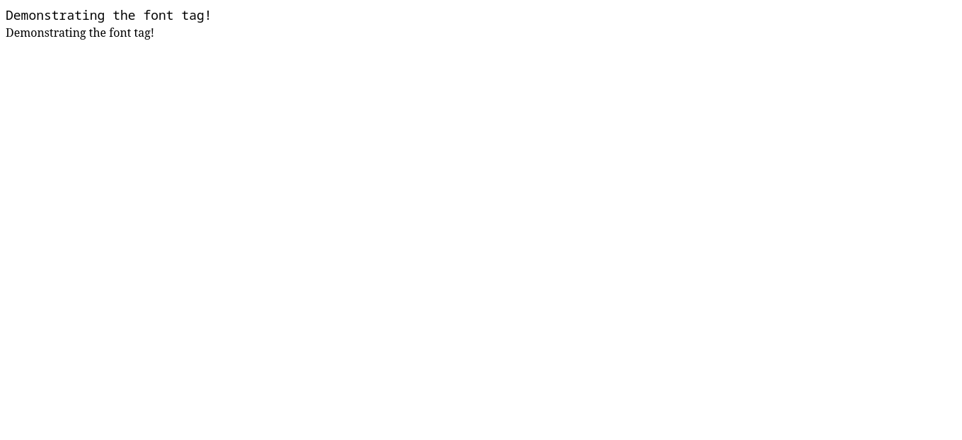
Program-4: Demonstrating table tags
<!DOCTYPE html>
<html>
<head>
<title>Demonstrating Table Tags</title>
</head>
<body>
<table border="all">
<tr><td>Row1Col1</td><td>Row1Col2</td></tr>
<tr><td>Row2Col1</td><td>Row2Col2</td></tr>
<tr><td>Row3Col1</td><td>Row3Col2</td></tr>
<tr><td>Row4Col1</td><td>Row4Col2</td></tr>
</table>
</body>
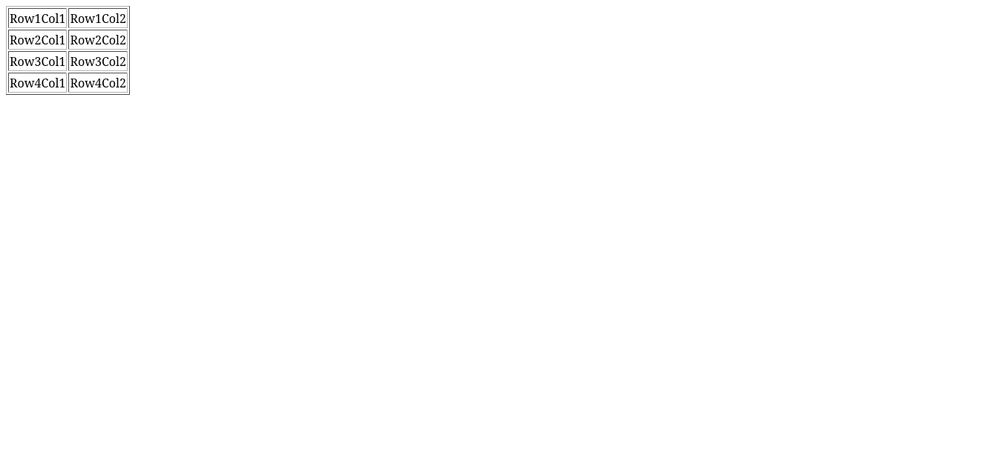
</html>
Program-5: Demonstrating Text Box
<!DOCTYPE html>
<html>
<head>
<title>Adding a text box</title>
</head>
<body>
Enter your name : <input type="text" name="box" id="1">
</body>
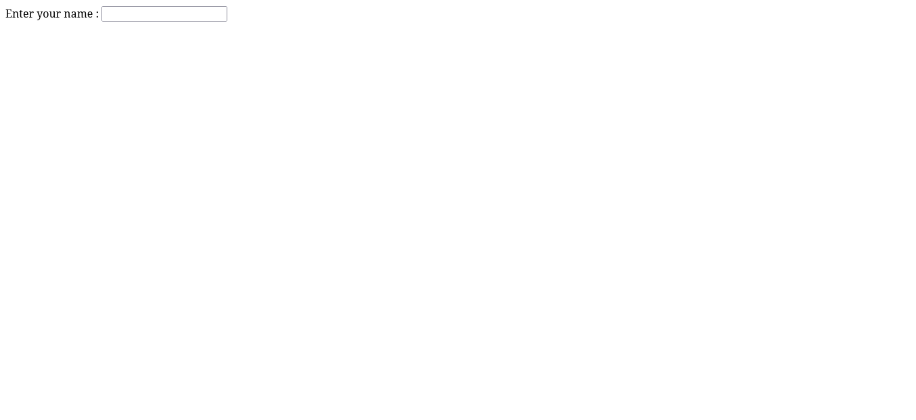
</html>
Program-6: Demonstrating Check Boxes
<!DOCTYPE html>
<html>
<head>
<title>Adding a checkbox</title>
</head>
<body>
Select your qualifications - <br>
<input type="checkbox" name="phd" id="1">Phd <br>
<input type="checkbox" name="Bsc" id="2">Bsc <br>
<input type="checkbox" name="B.Tech" id="3">B.Tech <br>
</body>

</html>
Program-7: Demonstrating Radio Button
<!DOCTYPE html>
<html>
<head>
<title>Adding a Radio button</title>
</head>
<body>
Select your gender :
<input type="radio" name="gender" id="Male">Male
<input type="radio" name="gender" id="Female">Female
</body>
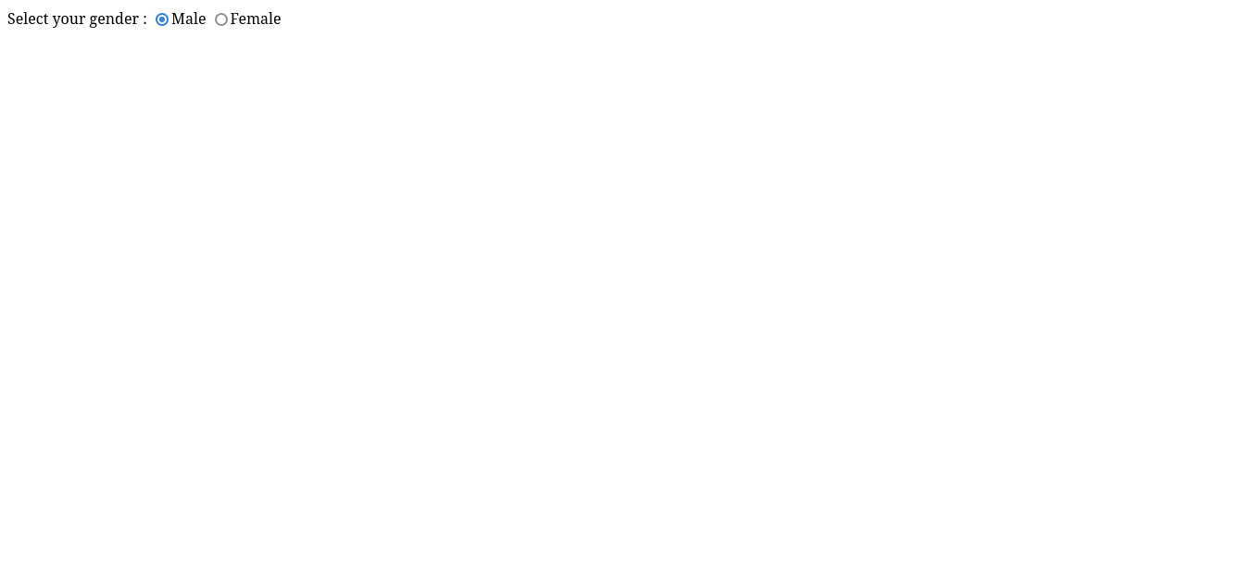
</html>

Program-8: Demonstrating Password Field
<!DOCTYPE html>
<html>
<head>
<title>Adding a Password Field</title>
</head>
<body>
<table>
<tr><td>Your Id :</td><td><input type="text"></td></tr> <br>
<tr><td>Your Password :</td><td> <input type="password"></td></tr>
</table>
</body>
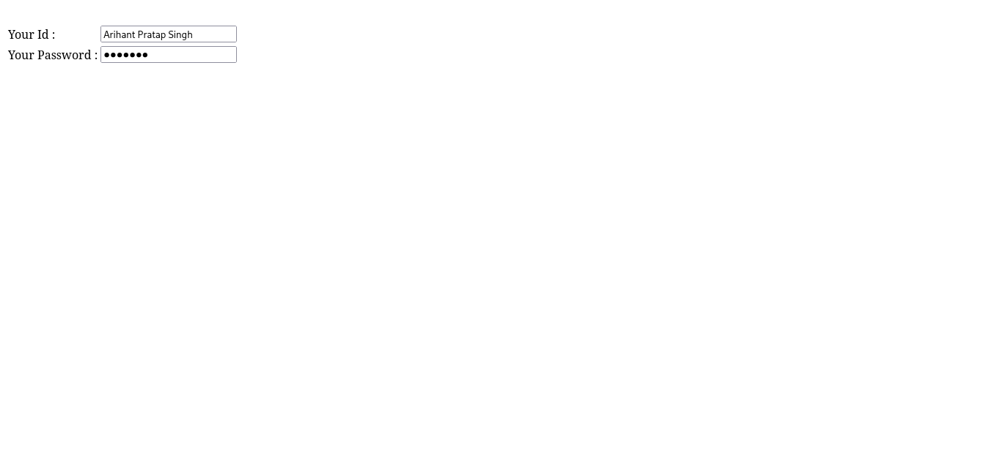
</html>
Program-9: Demonstrating <hr> tag
<!DOCTYPE html>
<html>
<body>
This is some text.
<hr>
This is some other text.
<hr>
This is some different text.
</body>
</html>
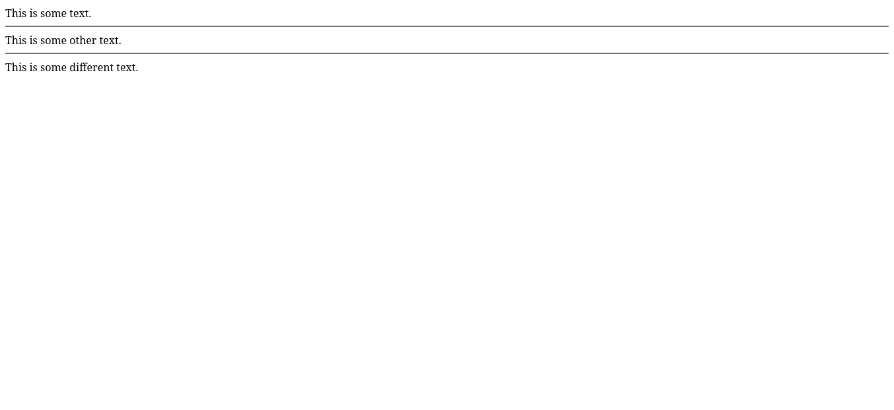
Program-10: Demonstrating Font-family
<!DOCTYPE html>
<html>
<body>
<h1 style="font-family:”Liberation Mono”;">Sample Text</h1>
<p style="font-family:monospace;">Different Sample Text.</p>
</body>
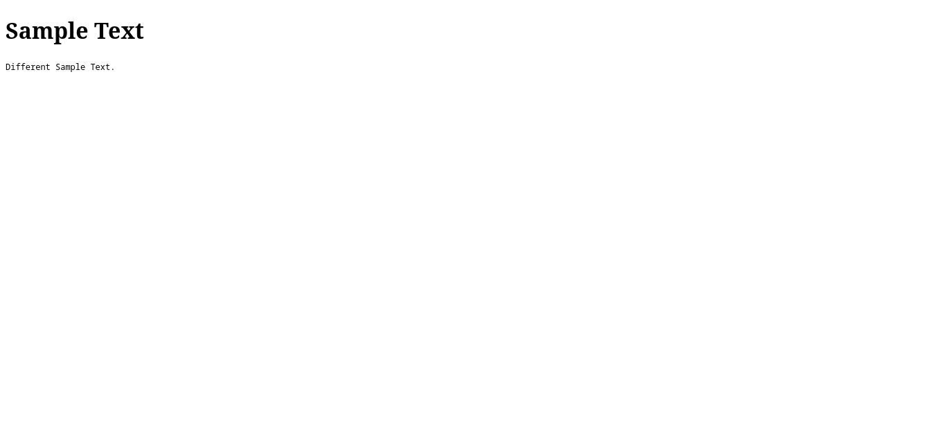
</html>

