Mini Weather Forecasting Station

Arihant Bedagkar, Rohan Pednekar and Gaurav Raje

*Department of Computer Science and Engineering*

*Walchand College Of Engineering*

Sangli, India

[arihantbedagkar@gamil.com](mailto:arihantbedagkar@gamil.com), [rohanpednekar10@gmail.com](mailto:rohanpednekar10@gmail.com), [iamgauravraje9@gmail.com](mailto:iamgauravraje9@gmail.com)

***Abstract* — "Mini Weather Forecasting Station" focuses on monitoring and forecasting of the weather conditions. The System is developed using three different technologies viz. Internet of Things, Machine Learning and Web. Weather Forecasting is usually done for large areas, reducing accuracy of prediction. Collecting weather data from small regions and forecasting weather will definitely increase accuracy of prediction. Thus the system is designed to collect weather data from small regions and then predict weather conditions accordingly. The system is accessible only to the weather station engineer but the results are public. It is autonomous and secured through abstraction. The system predicts near accurate weather conditions for the next seven days**

***Index Terms* — Weather Prediction, Machine Learning, Internet of Things.**

1. INTRODUCTION

Forecasting is making predictions of the future based on past and present data and also, by analysis of trends and seasonality. In weather forecasting input parameters changes to different weather conditions such as temperature, dew point, humidity, pressure, precipitation, etc. In a weather forecasting station, data reading and data forecasting happens at the same time. Large scale weather forecasting stations are inadequate in forecasting weather conditions for small regions. They use large scale and expensive sensors, which are available and affordable only to large organizations. Handling and maintenance of machinery requires skilled laborers and is complex.

Our system provides small-scale forecasts, which helps to provide accurate results for small regions. Thus, reducing chances of natural calamities to some extent. Also, data collected from many small regions may help to provide better predictions for large areas. Our system consists of inexpensive sensors which are easily portable, and available and affordable to everyone. Our system is completely autonomous and requires no expertise. It is easily manageable and is less complex.    Our aim is to predict weather conditions in small regions for up to seven days by providing innovative, sustainable solutions using the Internet of Things, Machine Learning and Web Technologies.

1. LITERATURE STUDY

Recently the flood situation in some areas of Sangli and Kolhapur district lead us to find its causes. And one of its main causes mentioned by senior officials was ‘unable to predict rain situations for smaller villages’. So, there wasn’t any machine to predict weather conditions for smaller regions hence we decided to go for this project.

1. METHODOLOGY

Approach we followed is as follows:

**Step 1:** Our system captures data using different sensors such as temperature and humidity sensor (DHT11), pressure sensor (BMP180) and precipitation sensor.

**Step 2:** Data captured from sensors are collected by Arduino and sent to local machines via Wi-Fi module.

**Step 3:** This data captured is in .csv format. So, we clean that .csv file and use it to predict results using machine learning algorithms. We used ARIMA model to predict weather conditions for the next seven days because of its accuracy and low MSE.

**Step 4:** The data is divided into 80% training set and 20% validation set.

**Step 5:** Predictions are stored in separate .csv file, which is then used to publish weather conditions on the web page.

**Step 6:** Prediction file will be continuously updated throughout the cycle.  Eventually the updated file will be read by a web page when you refresh it.

IV. CONTRIBUTION OF WORK

Large organizations predict weather conditions for large areas that cover almost an entire city using heavy machinery and expensive tools. The machinery is large and heavy and is not portable. In case of any failure, replacement or maintenance of the machine is complex and requires skilled labor.

Our system predicts weather conditions for a small area that covers an area of approximately 200 sq.m. Our system consists of small-scale sensors and inexpensive tools. The machinery is small and portable. In case of any failure, replacement or maintenance of any component is easy and doesn’t require any expertise.

V. SYSTEM ARCHITECTURE

Temperature and Humidity Sensors, Barometric Sensor connected to Arduino boards which are connected wirelessly to the Raspberry Pi for data transmission and logging. Raspberry Pi is connected to the Internet and results displayed on local web-server.

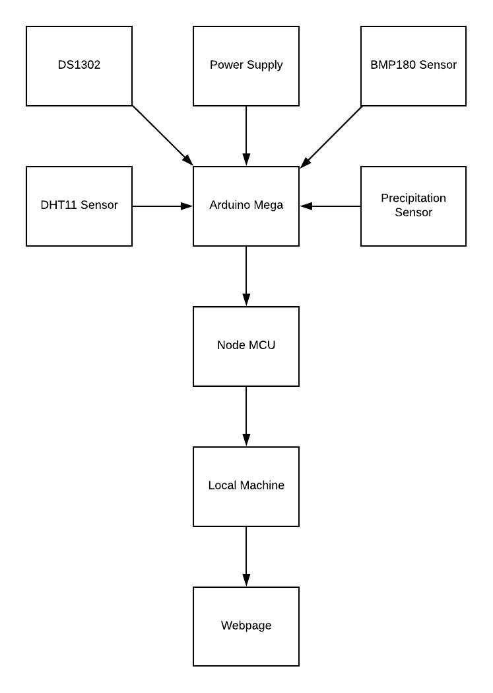

VI. REQUIREMENT SPECIFICATION

1. System Side
2. DHT11 Temperature and Humidity Sensor
3. Precipitation Sensor
4. BMP180 Barometric Pressure Sensor
5. NodeMCU
6. Arduino Mega 2560
7. DS1302 Real-time Clock
8. Local Machine 8. Power Supply

2. User Side

1. Active Internet Connection
2. Smartphone or Computer to access Webpage

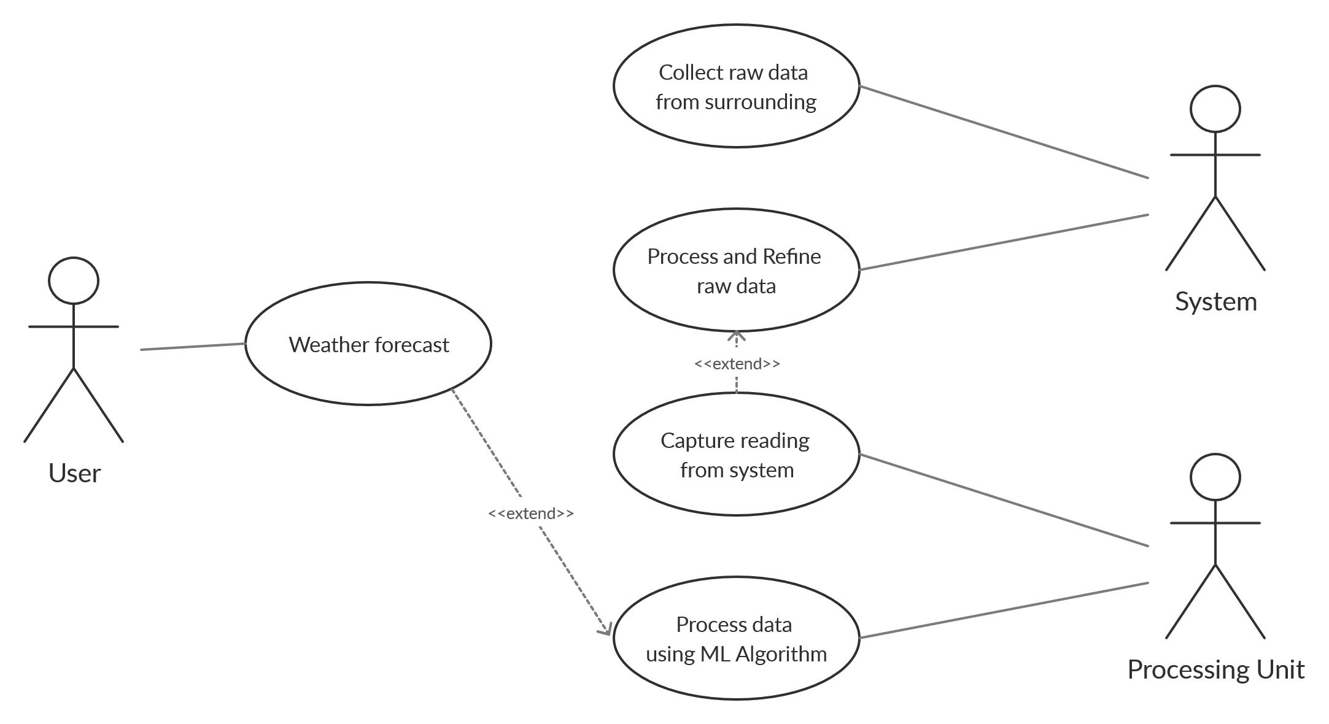

VII. DESIGN AND TEST STEPS

1. Arduino captures continuous readings through sensors.
2. Arduino is connected to NodeMCU serially.
3. Arduino sends this raw data to Local Machine through wireless MQTT communication via NodeMCU.
4. Local Machine refines the raw data.
5. The properly formatted data is sent to the machine learning model.
6. The model uses this data to forecast and display it on the webpage.

..

VIII. ALGORITHM AND PSEUDO CODE

1. Setting up Arduino:

setup()

INIT dht

INIT bmp

INIT RTC

INIT Rain

1. Capturing readings:

capture()

readHumidity()

readTemperature()

readPressure()

analogRead(Rain)

1. Setting up NodeMCU:

setup()

connect to WiFi using ssid and password

1. Transmitting readings using MQTT:

WHILE True

IF client is connected

IF data is ready

read serial character-wise

form a string of characters

IF character is null

publish the string to MQTT server

ENDIF

ENDIF

ENDIF

ENDWHILE

1. Local Machine receiving readings using MQTT:

INIT client as MQTT client

IF file doesn’t exist

create new file with headers

onConnect()

subscribe to client

onMessage()

decode the message and append it to the file

1. Algorithm for testing model:

INIT training

SET predictions = []

FOR i = 0,…,length of test

SET pred = prediction from arima(training, order)

APPEND pred to predictions

APPEND test[i] to training

1. Algorithm for forecasting:

SET forecast = []

SET conf_int = []

INIT testing

FOR i = 0,…, days to forecast

SET model = arima(testing, order)

SET pred = forecast from model

APPEND confidence interval to conf_int

APPEND pred to forecast

APPEND pred to testing

IX. RESULT AND ANALYSIS

* Prediction of weather conditions.
* Predictions include Temperature, Humidity, Pressure, Precipitation, Dew Point Temperature and Wind Speed.
* Decrease in flood disaster possibilities.

Forecast graph for 7 days:

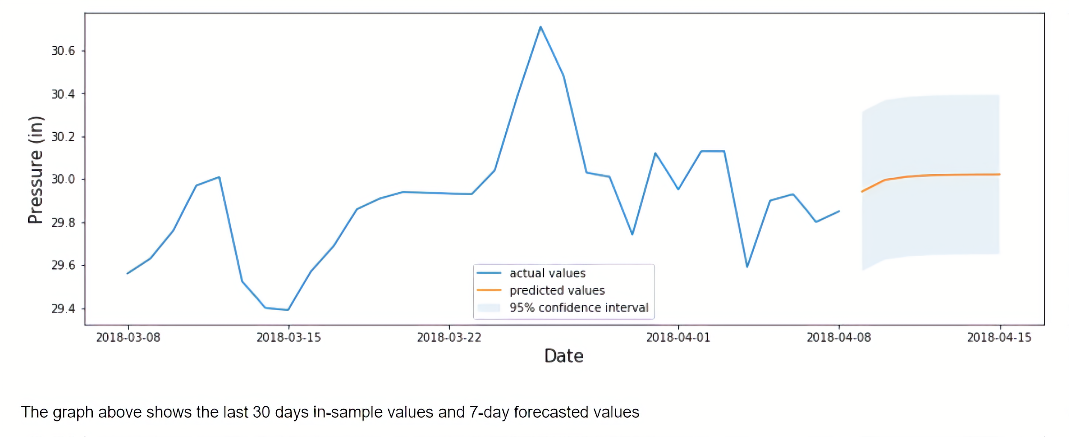

Results displayed on webpage:

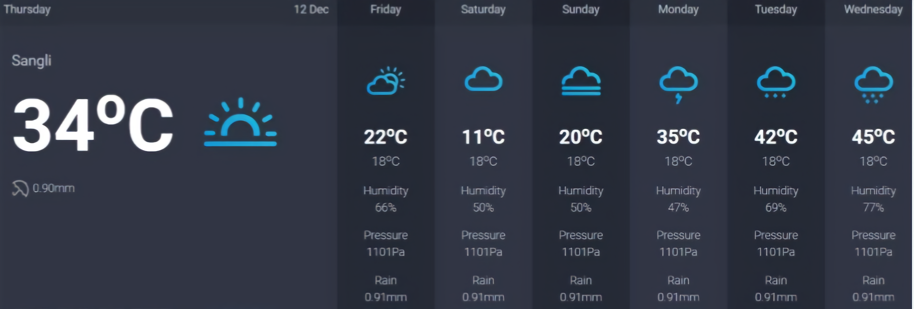

X. SUMMARY AND PERFORMANCE STUDY

The system uses the ‘ARIMA’ model for predicting weather situations in future which is one of the best available machine learning algorithms available for time dependent predictions. It surely takes more time than other available algorithms like but it gives the most accurate results for the different parameters of weather.

XI. CONCLUSION AND FUTURE WORK

‘Mini Weather Forecasting Station’ is a very useful application for predicting weather conditions in the near future for smaller areas. Previously, the weather forecasting station was only for bigger areas so weather predicting for small regions was difficult. Our user interface is too easy to understand for normal users. Hereby, we conclude our brief report regarding our mini project. In future work, one can use powerful sensors to record the readings of temperature, humidity, pressure etc. Also, one can use these predictions for calculating the amount of water to be discharged from the dam to avoid floods like situations in villages like areas where weather predictions are not for particular areas.

ACKNOWLEDGEMENT

This project would not have been possible without the kind support and help of many individuals and organizations. We would like to extend our sincere thanks to all of them. We are highly indebted to Miss. A.V. Terkhedkar for the guidance and constant supervision as well as for providing necessary information regarding the project and also for their support in completing the project. We would also like to express our gratitude towards faculty members of CSE dept. WCE,sangli for their kind cooperation and encouragement which provided help in completion of this project

REFERENCES

1. [https://www.firstpost.com/long-reads/western-maharashtra-floods-activists-blame-state-government-for-the-recent-deluge-in-kolhapur-7461331.html](https://www.firstpost.com/long-reads/western-maharashtra-floods-activists-blame-state-governm)
2. <https://machinelearningmastery.com/arima-for-time-series-forecasting-with-python/>
3. <https://machinelearningmastery.com/findings-comparing-classical-and-machine-learning-methods-for-time-series-forecasting/>
4. <https://machinelearningmastery.com/time-series-seasonality-with-python/>
5. <https://engineeringprojectshub.com/serial-communication-between-nodemcu-and-arduino/>
6. <https://www.baldengineer.com/mqtt-tutorial.html>