🛡️Network Monitoring Dashboard using Prometheus and Grafana
1. Introduction
Network monitoring is essential for maintaining the performance, availability, and security of computer networks. Modern monitoring systems collect real-time metrics from servers and network interfaces and visualize them through dashboards.
This project implements a real-time network monitoring dashboard using:
- Prometheus – metrics collection and storage
- Prometheus Node Exporter – system and network metrics exporter
- Grafana – visualization dashboard
The dashboard monitors network traffic, packet rates, system performance, and interface utilization.

2. Project Objectives
The main objectives of this project are:
- Monitor network traffic in real time
- Visualize network bandwidth usage
- Track packet transmission rates
- Detect network errors
- Monitor system performance metrics (CPU, memory)
- Provide a graphical dashboard for analysis

3. Future Improvements
Possible enhancements include:
- Alerting system for traffic spikes
- Integration with intrusion detection systems
- Monitoring multiple hosts
- Network topology visualization

4. System Architecture
The monitoring system follows a metrics-based architecture.
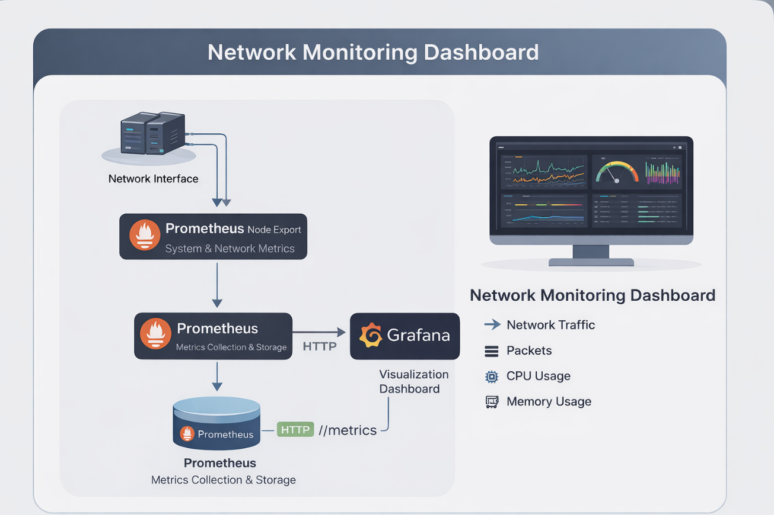
Components:
Component | Function
Node Exporter | Collects system and network metrics
Prometheus | Stores and queries metrics
Grafana | Displays metrics through dashboards

5. Tools and Technologies
Tool | Purpose
Linux (Ubuntu VM) | Monitoring environment
Prometheus | Metrics collection
Node Exporter | System metric exporter
Grafana | Dashboard visualization

6. Network Interfaces Monitored
The system monitors two network interfaces:

Interface | Description
enp0s3 | Lab network interface
enp0s8 | Internet network interface

A dropdown variable allows selecting the interface dynamically.

7. Installation and Setup
- Install Prometheus
sudo apt update
sudo apt install prometheus
sudo systemctl start Prometheus
sudo systemctl status Prometheus

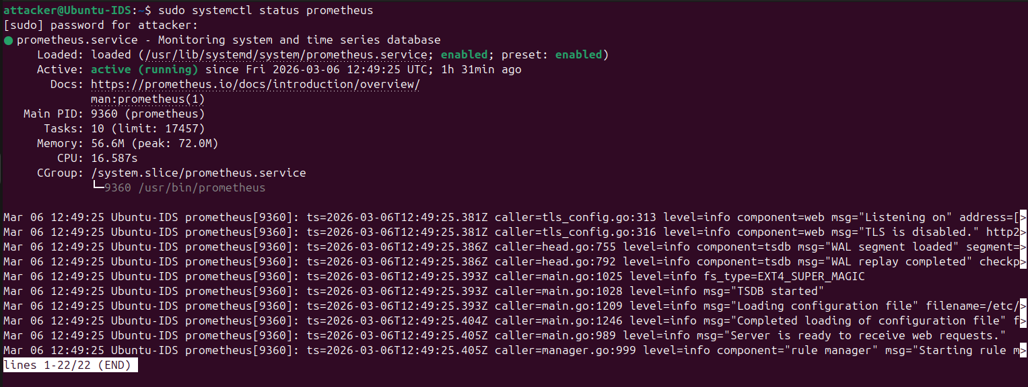

- Install Node Exporter
sudo apt install prometheus-node-exporter
sudo systemctl start prometheus-node-exporter
sudo systemctl enable prometheus-node-exporter

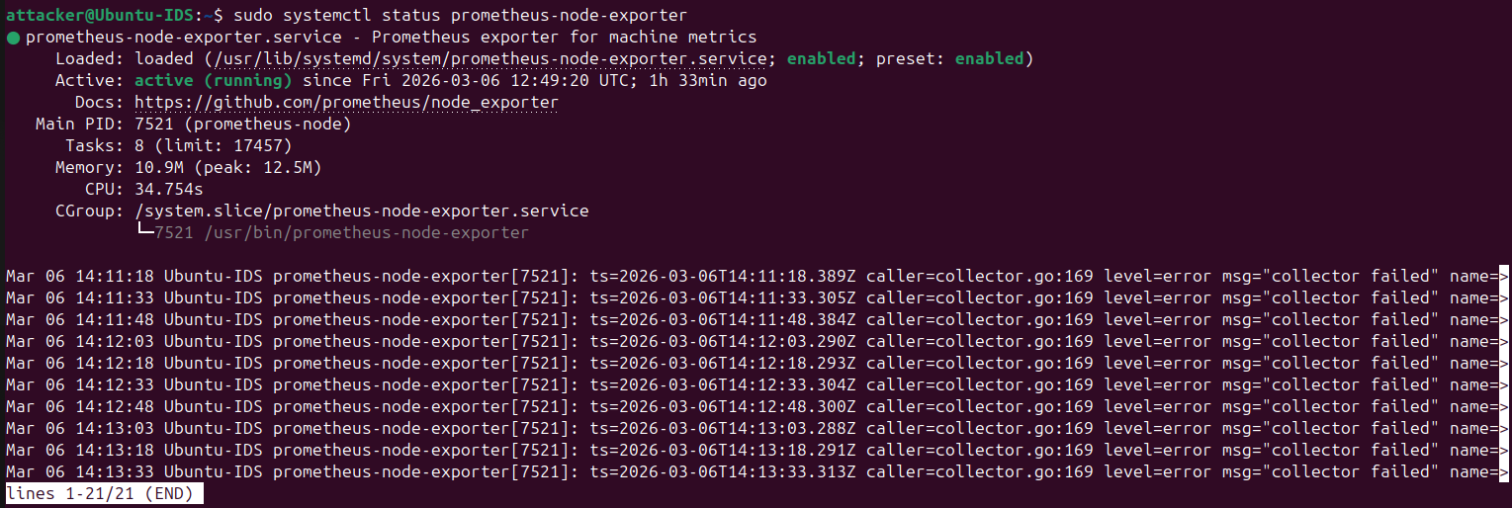

Metrics endpoint: http://localhost:9100/metrics

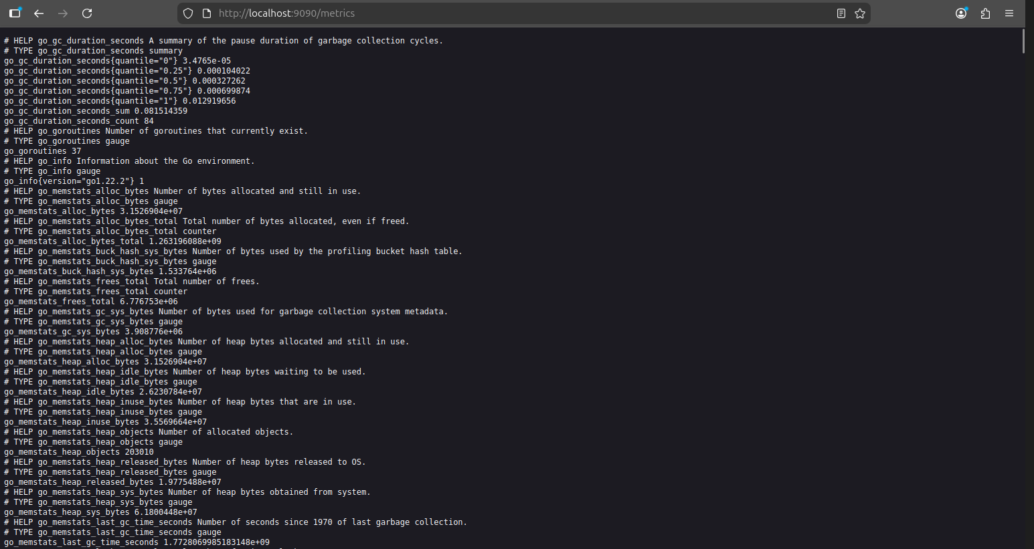

- Install Grafana
Add repository and install:
sudo apt install grafana
sudo systemctl start grafana-server
sudo systemctl enable grafana-server
sudo systemctl status grafana-server

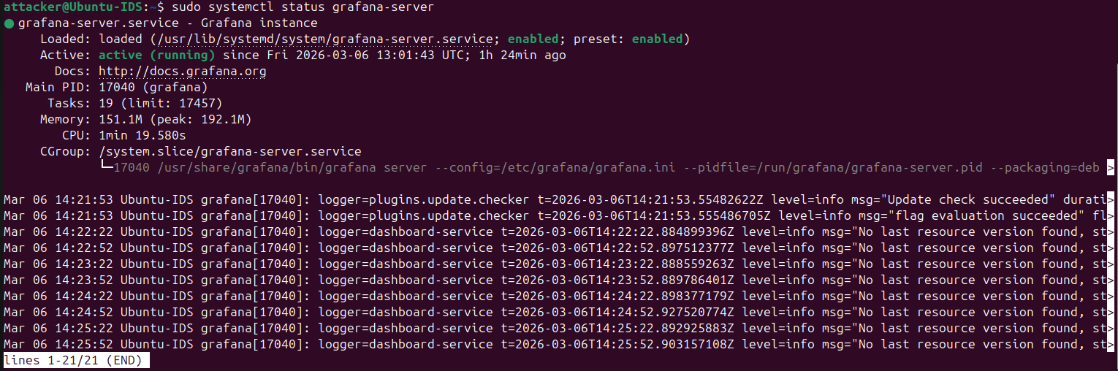

Dashboard access: http://localhost:3000

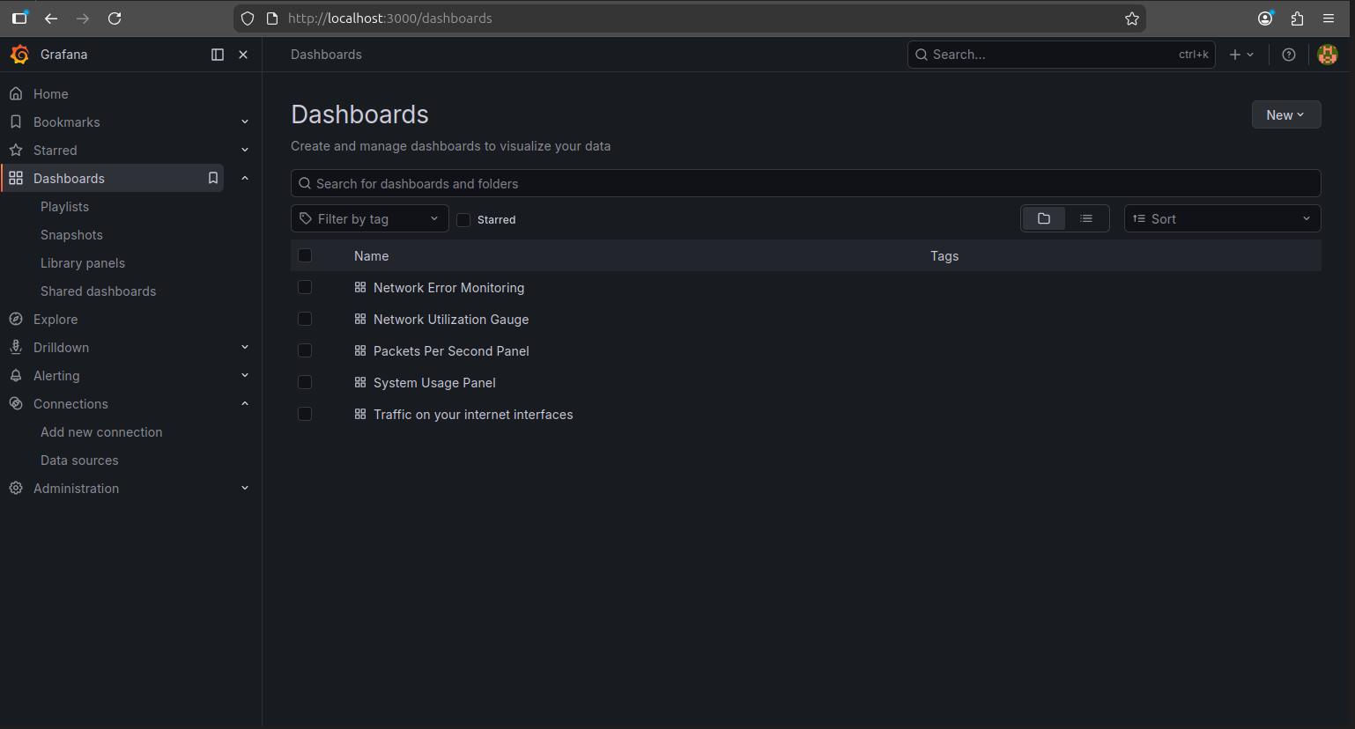

7. Dashboard Panels Implemented
The monitoring dashboard includes multiple panels.
- Network Monitoring Panels
Panel | Description
Incoming Traffic | Network receive bandwidth
Outgoing Traffic | Network transmit bandwidth
Packet Rate | Incoming packets per second
Total Bandwidth | Combined traffic rate
Network Errors | Packet error monitoring

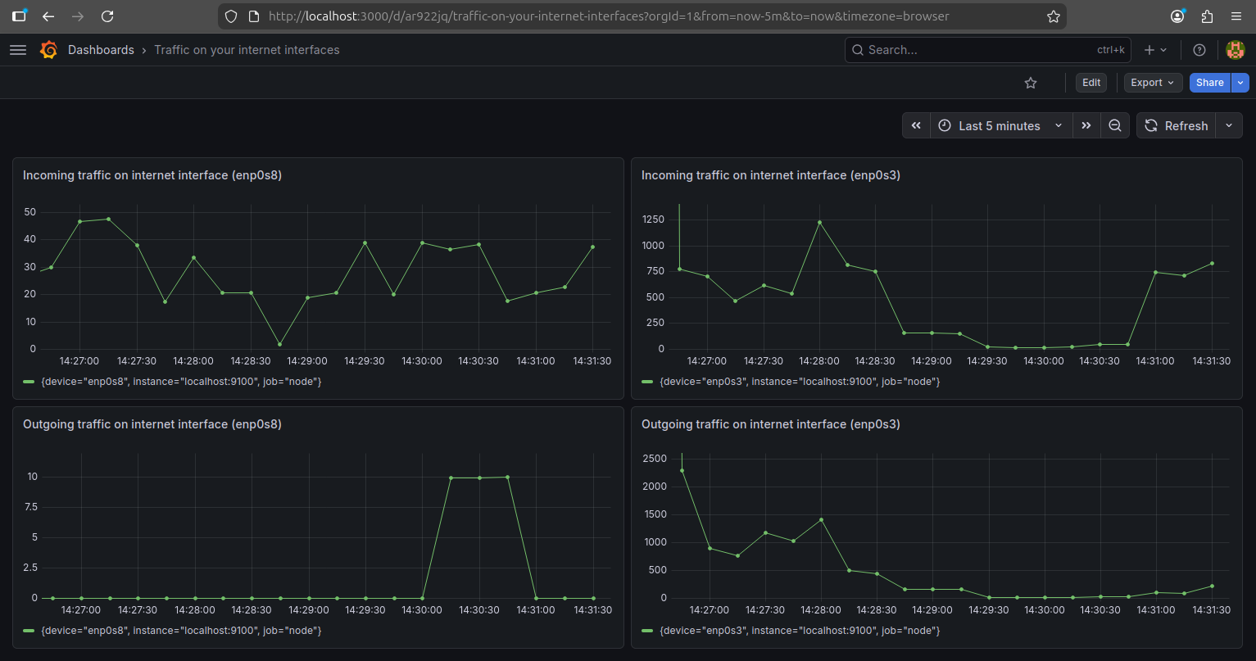
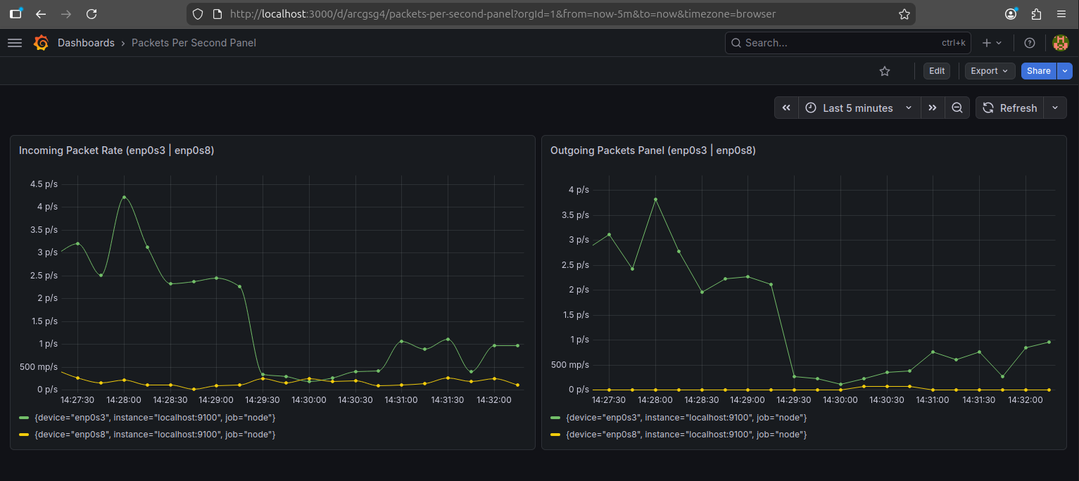

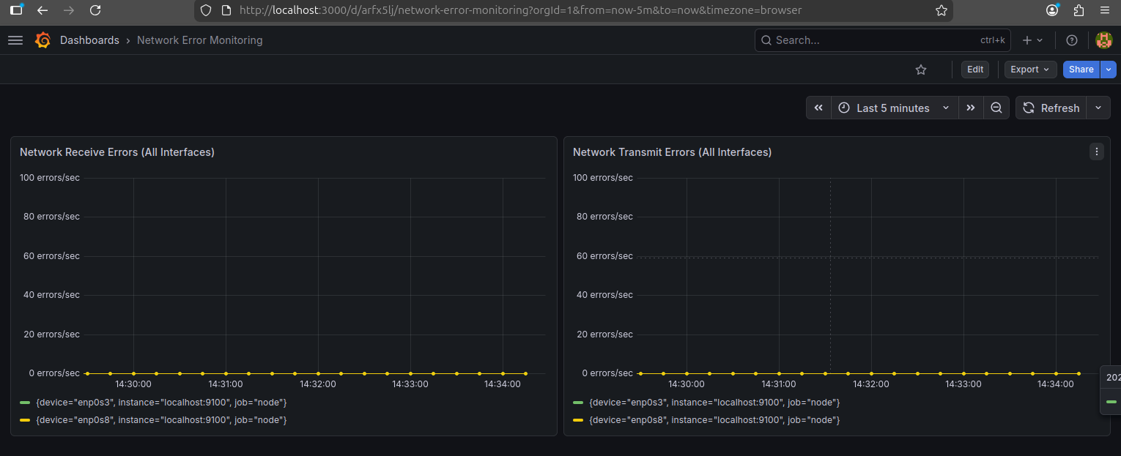

- System Monitoring Panels
Panel | Description
CPU Usage | CPU utilization percentage
Memory Usage | RAM utilization

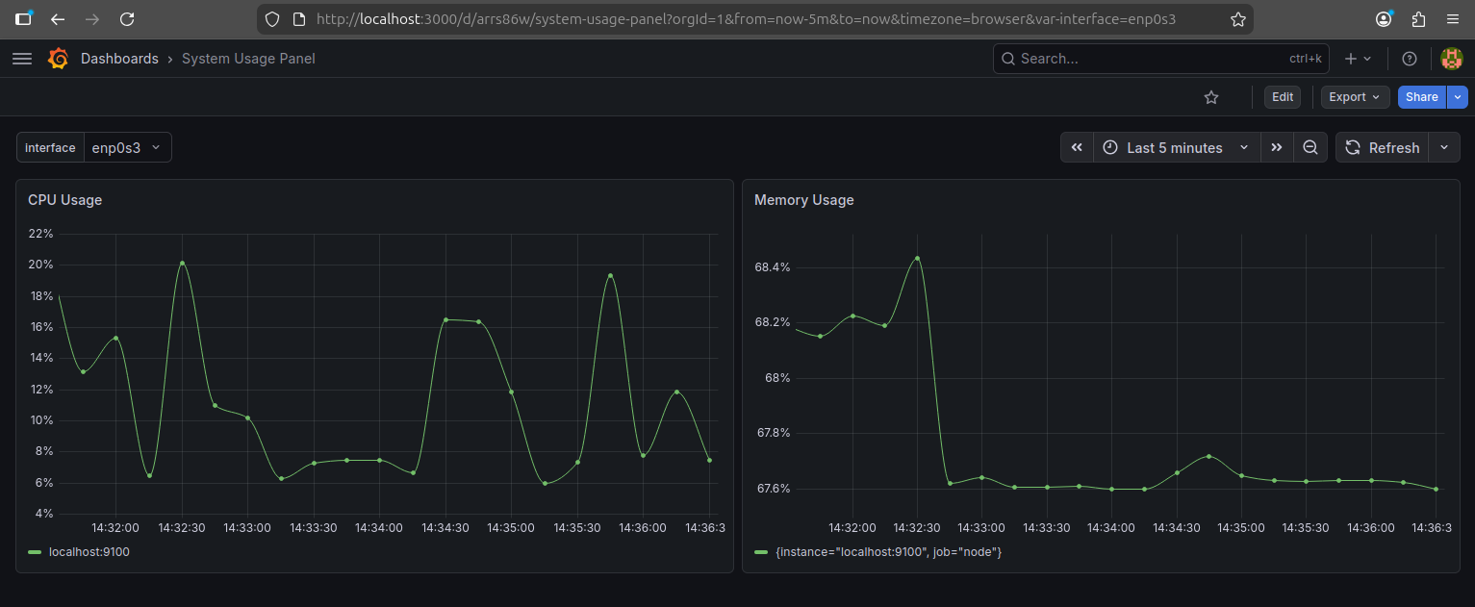

- Advanced Visualization
Additional visualization panels include:
- Network utilization gauge
- Traffic comparison graph
- Interface selector dropdown
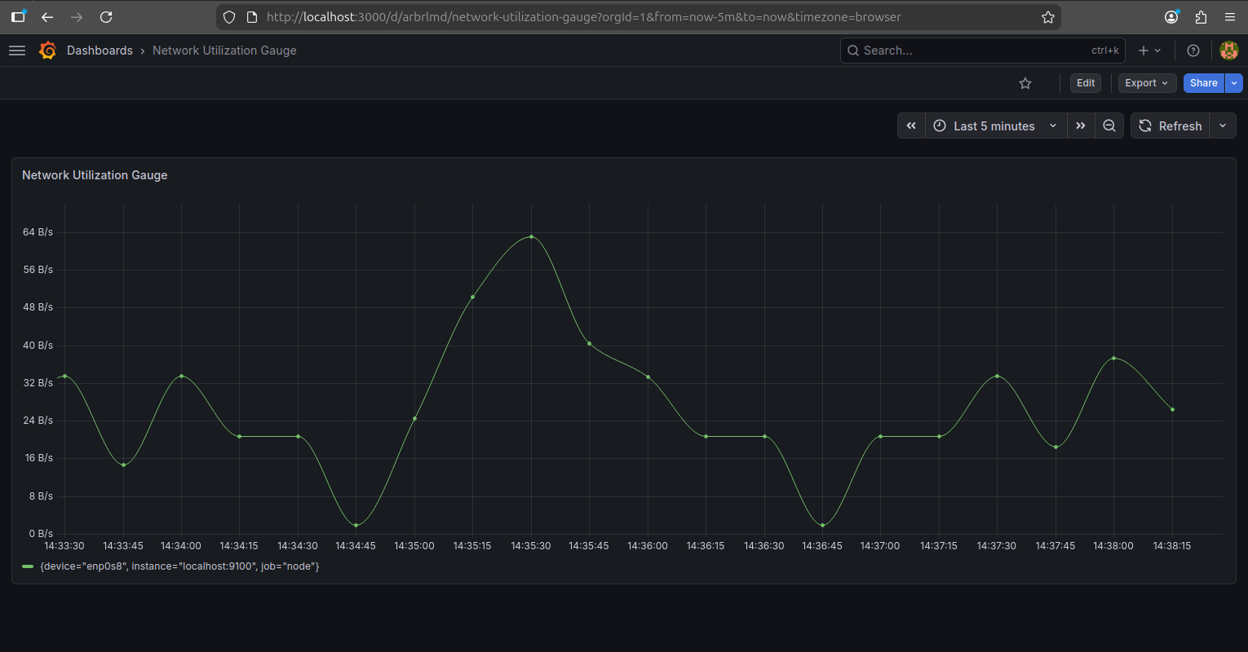

8. Example Prometheus Queries
Incoming Network Traffic
rate(node_network_receive_bytes_total{device="$interface"}[1m])

Outgoing Network Traffic
rate(node_network_transmit_bytes_total{device="$interface"}[1m])

Packet Rate
rate(node_network_receive_packets_total{device="$interface"}[1m])

CPU Usage
100 - (avg by(instance)(irate(node_cpu_seconds_total{mode="idle"}[5m])) * 100)

Memory Usage
(node_memory_MemTotal_bytes - node_memory_MemAvailable_bytes)
/ node_memory_MemTotal_bytes * 100

9. Testing the Monitoring System
Network traffic can be generated using tools such as:
Ping
Sudo ping -f google.com

Download test
wget http://speedtest.tele2.net/100MB.zip
These commands create traffic spikes visible on the Grafana dashboard.

10. Results
The monitoring dashboard successfully visualizes:
- Network bandwidth usage
- Packet transmission rates
- System resource utilization
- Interface-specific traffic
The system provides real-time insights into network and host performance.

11. Conclusion
This project demonstrates how modern monitoring tools can be used to build a real-time network monitoring system. By integrating Prometheus, Node Exporter, and Grafana, administrators can visualize system and network metrics efficiently.
The implemented dashboard provides an effective way to monitor network activity and detect performance issues.

