Wireless Deauthentication Detection Dashboard
Project Overview:
The Wireless Deauthentication Detection Dashboard is a wireless intrusion detection system designed to monitor WiFi networks and identify potential Deauthentication attacks. The system captures 802.11 management frames in monitor mode, analyses disconnect patterns, and alerts administrators when suspicious activity is detected. It also provides a graphical dashboard for real-time monitoring and logs events for forensic analysis.
This project demonstrates packet-level wireless analysis, anomaly detection, and real-time visualization for WiFi security monitoring.

Objectives:
- Capture 802.11 wireless frames in monitor mode
- Detect deauthentication and disassociation frames
- Identify abnormal disconnect patterns
- Track affected clients
- Provide real-time GUI dashboard
- Visualize attack activity
- Log events for forensic analysis
- Demonstrate WPA3/PMF awareness

Technologies Used:
- Python 3
- Scapy
- Matplotlib
- Aircrack-ng
- Linux (Ubuntu)
- 802.11 Monitor Mode

System Architecture:

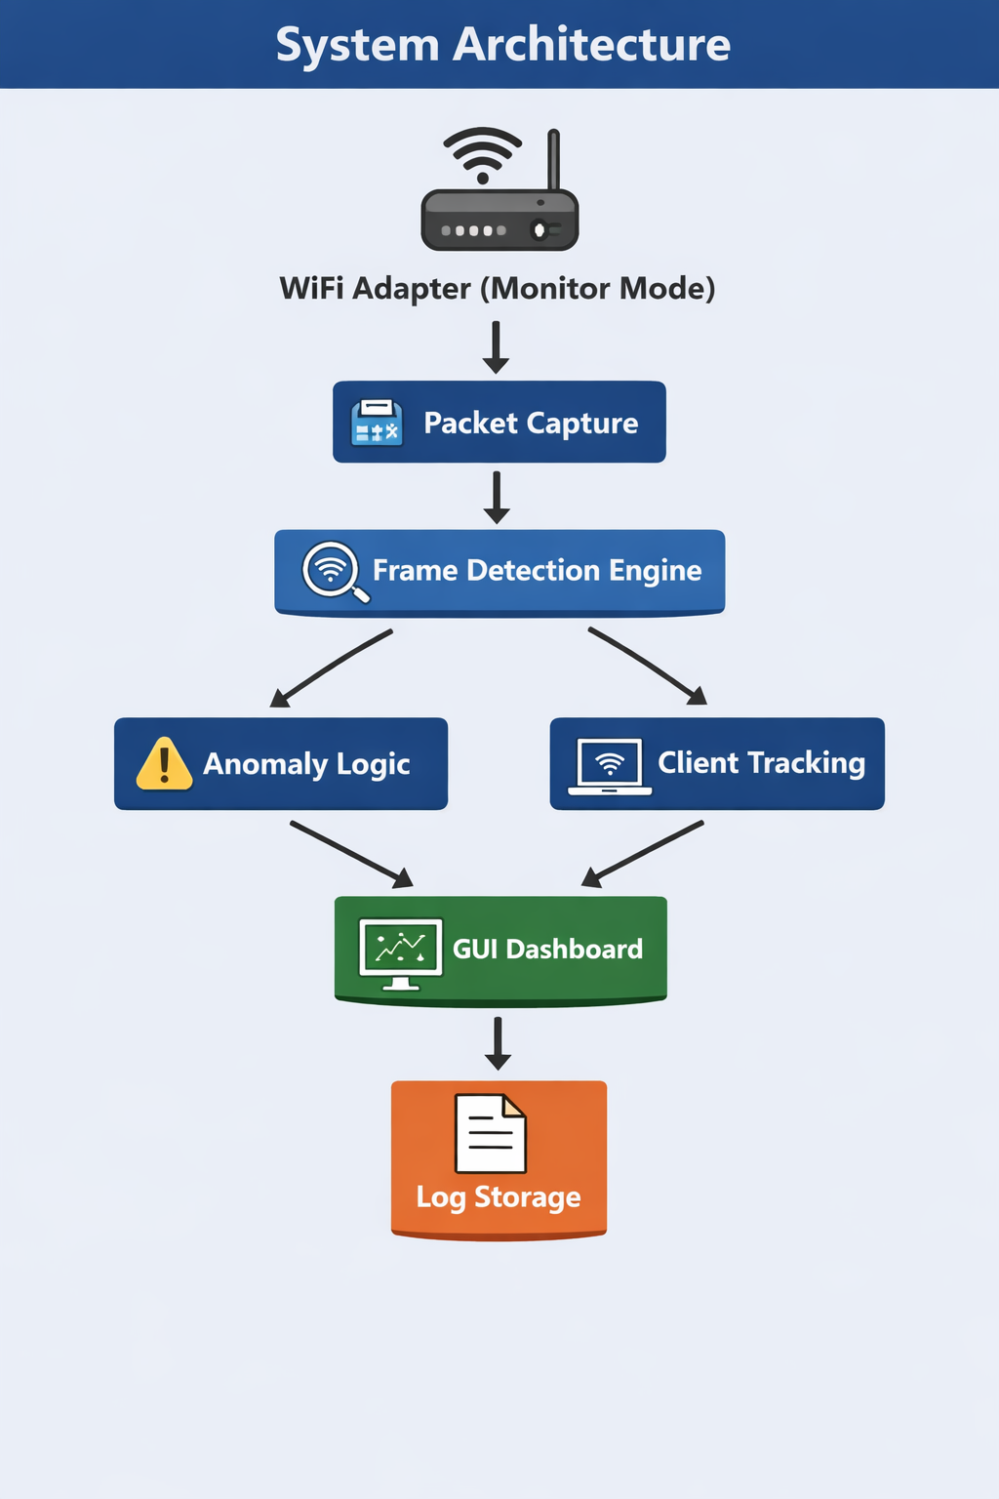

Features:
- Real-time wireless packet capture
- Deauthentication detection
- Disassociation detection
- Anomaly-based attack detection
- Client impact tracking
- GUI dashboard visualization
- Real-time event logging
- WPA3 / WiFi 6 compatibility awareness

Requirements:
- Ubuntu Linux
- Python 3
- WiFi adapter supporting monitor mode
- Aircrack-ng
- Scapy
- Matplotlib

Installation:
sudo apt update
sudo apt install aircrack-ng python3-venv python3-full
Create environment:
mkdir wifi-ids
cd wifi-ids
python3 -m venv venv
source venv/bin/activate
pip install scapy matplotlib

Running the Project:
Enable monitor mode:
sudo airmon-ng check kill
sudo airmon-ng start wlp2s0
Lock channel:
sudo ip link set wlp2s0mon down
sudo iw dev wlp2s0mon set channel 149
sudo ip link set wlp2s0mon up
Run dashboard:
sudo ./venv/bin/python gui_logging_detector.py

How It Works:
- The WiFi adapter is switched to monitor mode.
- Scapy captures raw 802.11 frames.
- The system filters deauthentication and disassociation frames.
- Anomaly detection identifies repeated disconnect patterns.
- Alerts are displayed on GUI dashboard.
- Events are logged to file for analysis.

Output:
The dashboard displays:
- Real-time disconnect events
- Alert counter
- Attacker MAC address
- Target client MAC address
- Timestamp of event
Example Log:
[2026-03-22 15:40:11] ALERT
Attacker: a4:ce:da:30:d7:13
Client: 48:55:5e:03:1d:d2
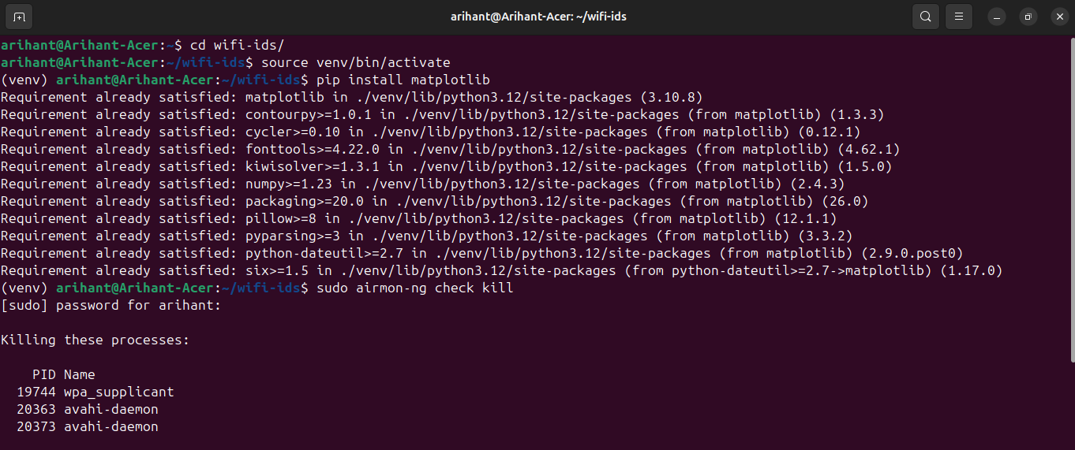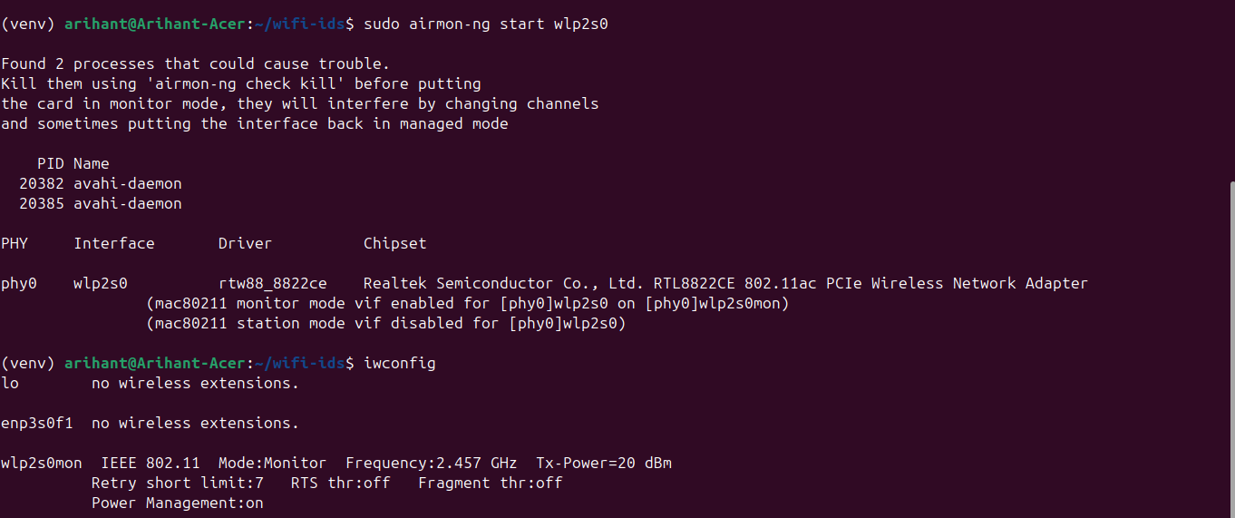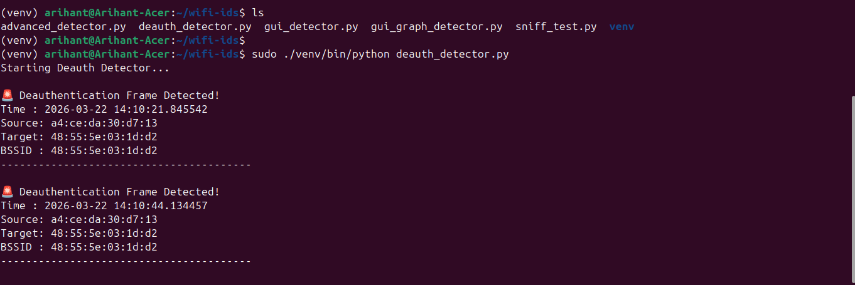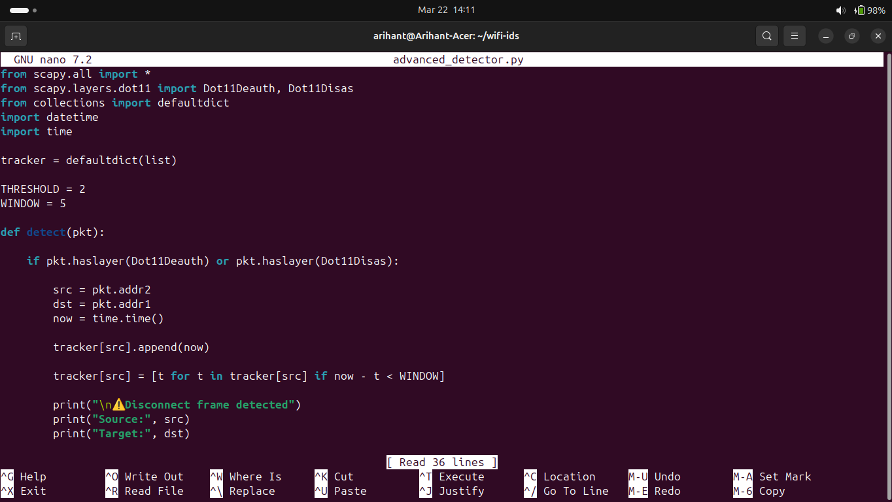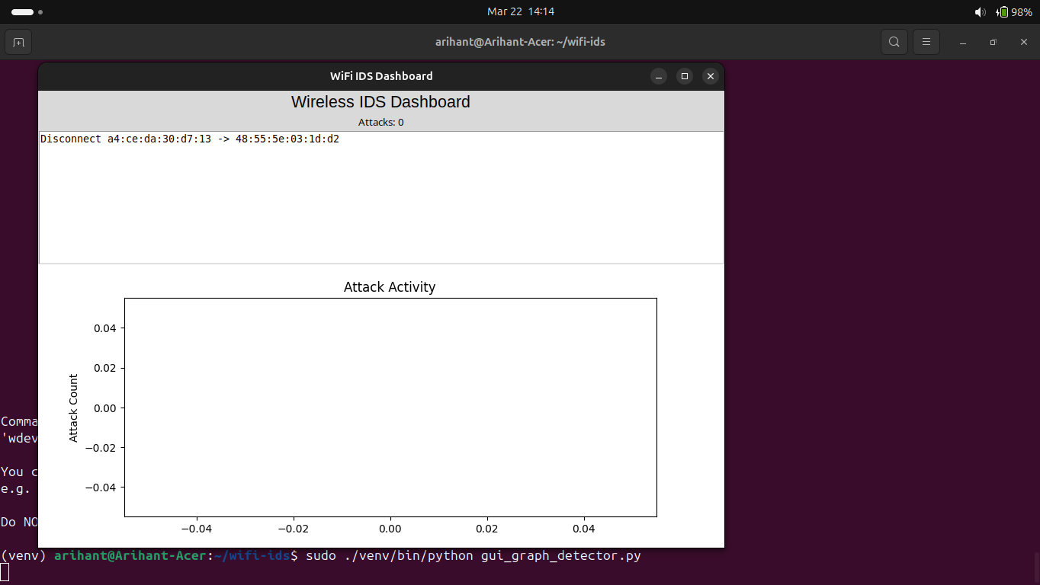

Testing Method:
The system was tested using:
- Windows laptop as client
- Mobile phone as client
- WiFi toggle to generate disconnect events
- WPA3 WiFi 6 network environment

Limitations:
- WPA3 Protected Management Frames reduce visible deauth frames
- Some devices disconnect silently
- Requires monitor mode supported adapter
Future Enhancements:
- Web dashboard interface
- Prometheus integration
- Email alerting
- Multi-graph analytics
- Attacker localization using RSSI

Conclusion:
This project successfully demonstrates a wireless intrusion detection system capable of monitoring WiFi networks and detecting suspicious disconnect behaviour. It provides real-time visualization, logging, and analysis of wireless management frames, making it useful for WiFi security monitoring and research.

Demo Commands:
cd ~/wifi-ids
source venv/bin/activate
sudo airmon-ng check kill
sudo airmon-ng start wlp2s0
sudo ip link set wlp2s0mon down
sudo iw dev wlp2s0mon set channel 149
sudo ip link set wlp2s0mon up
sudo ./venv/bin/python gui_logging_detector.py

