# Table Of Contents

Category Of Project1

Client Server1

1. Introduction 2

2. Existing System3-4

2.1 How Existing System Works 3

2.2 Limitations of Existing System4

3. Proposed System5-6

3.1 Advantages5

3.2 Features6

**4. Database Layer7-10**

4.1 Diagrams7-8

4.2 Tables9-10

5. Technologies & Requirments 11

6. Graphical User Interface ( GUI )12-65

**7. Output (Reports)66-71**

8.Testing72-73

**Refrences74**

**CATEGORY OF PROJECT**

* **Client- Server**

Client-server describes the relationship between two computer programs in which one program, the client program, makes a service request to another, the server program. Standard networked functions such as email exchange, web access and database access, are based on the client-server model. For example, a web browser is a client program at the user computer that may access information at any web server in the world. To check your bank account from your computer, a web browser client program in your computer forwards your request to a web server program at the bank. That program may in turn forward the request to its own database client program that sends a request to a database server at another bank computer to retrieve your account balance. The balance is returned to the bank database client, which in turn serves it back to the web browser client in your personal computer, which displays the information for you.

1. **INTRODUCTION**

Today’s world is very fast and competitive. To achieve the success in this competitive world, one should be aware of the computer and the information related to the concerned business because computer and the information plays an important weeks manually. Right information available at the right place makes the decision process efficient. Hence the identification of the current and future requirement becomes a basic need of any flexible information system

Courier management system is software which is used manage the work regarding the services of the courier in an effective & efficient manner. Basically it stores the information regarding the customer and his material, which has to be couriered.

1. **EXISTING SYSTEM**

The courier system involves a lot of the employees at the office. The data for a particular courier maintained in a proper file. A person summarizes all the data of the courier in a register, this work require a high-level of attention since it has to be taken care that no wrong entry goes into the register. This repetitive work may lead to errors in the entry thus resulting in the wrong entry of courier packed data.

Since the data is maintained in the registers, the modification of data cannot done easily. The previous information has to be erased and overwritten or a new page has to be allocated so that both the old and new information can be written on the same page.

The summarizing of the data i.e. preparation of an up to data report is very complex, it require a lot of hard work and searching through the different register so as to condense the data for presentation

**2.1 How Existing System Works: -**

The present courier system involves a lot of the employees at the office.

The data of a particular courier maintained in a proper file. A person summarizes all the data of the courier in a register, this work of making a summary of the courier in the register require a high-level of attention since it has to be taken care that no wring entry goes into the register. This repetitive work may lead to errors in the entry thus resulting in the wrong entry of courier packed data.

Since the data is maintained in the registers, the modification of data cannot do easily. The previous information has to be erased and overwritten or a new page has to be allocated so that both the old and new information can be written on the same page.

The summarizing of the data i.e. preparation of an up to data report is very complex, it require a lot of hard work and searching through the different register so as to condense the data for presentation.

**2.2 Limitations of Existing System:-**

From the client site, the entire work was achieved manually and they manage all their billing and services manually. Because of the manual system there are so many problems occurred in the existing system: -

* It involves managing a huge amount of data each having separate data items.
* All the work is done at a very large volume, so we have a possibility of loosing the data.
* To look for a particular problem the entire system is searched, so the process becomes more time consuming.

In Today’s fast and competitive WORLD to achieve the success in this, one should be aware of the computer and the information related to the concerned business because computer and the information play an important work. Right information available at the right place makes the decision process efficient. Hence the identification of the current and future requirement becomes a basic need of any flexible information system. So there is a need of a courier management system that can overcome the limitations of the existing courier system.

Courier management system is software which is used manage the work regarding the services of the courier in an effective & efficient manner. Basically it stores the information regarding the customer and his material, which has to be couriered.

1. **PROPOSED SYSTEM**

After a detailed study of the existing system, it is evident that is does not fulfill the objective of the organization. To make the objective possible for the organization, it is required to have a computerized information system with the help of which all tasks can be processed more accurately and quickly. To achieve this, it is necessary to design and develop a new system. Proposed system is being designed in such a way that many users can have a view with the system simultaneously. it makes effective and perfect utilization of man power and resources.

**3.1 Advantages**

* ***Easy in maintaining information***: As new in formation is being added to and released from their respective courses every year, it will be highly user friendly to track and maintain the presentation of all students.
* ***User satisfaction*:** The system is such that is stands up to the user expectations like easy and faster retrieval of in formation.
* ***Safety*:** The system will be accessible by only the authorized users. As information being the most crucial for the organization, then the safety of information is importation.
* ***Highly accurate*:** resources being used by the system will be compatible with the latest technologies available in the market, as proposed system. uses highly technically compatible resources, there will be very very lass wear and tear.
* ***Less time consuming*** : work carried out by the staff at various stages will be less time consuming

**3.2 Features**

* Rate is easily & quickly computed.
* Fast access.
* Bill issued procedure become fast.
* Consignment note is easily generated by using preprinted stationary.
* Manifest is prepared fastly.
* Better storage capacity.
* Accuracy in work.
* Easy & fast retrieval of information.
* Well designed report.
* Works become very speedy

1. **Database Layer**
   1. **Diagrams**
      1. **Context Flow Diagram**

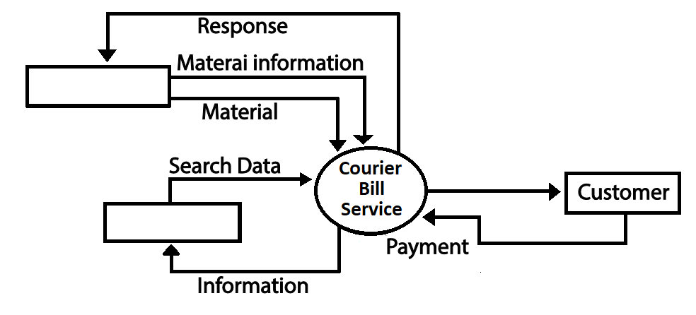

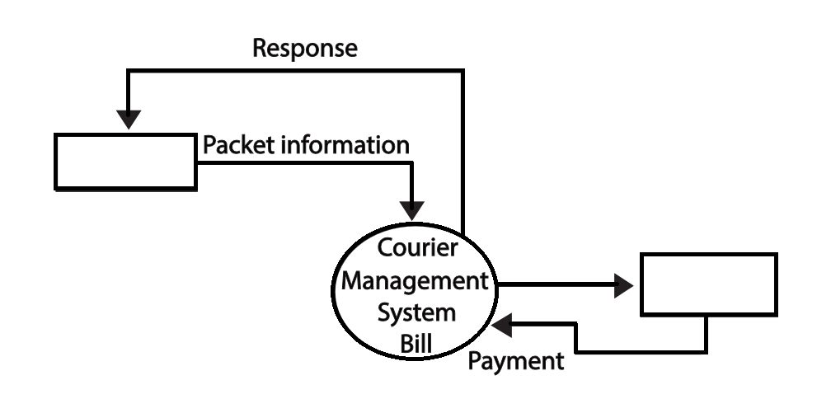

* + 1. **Data Flow Diagram**

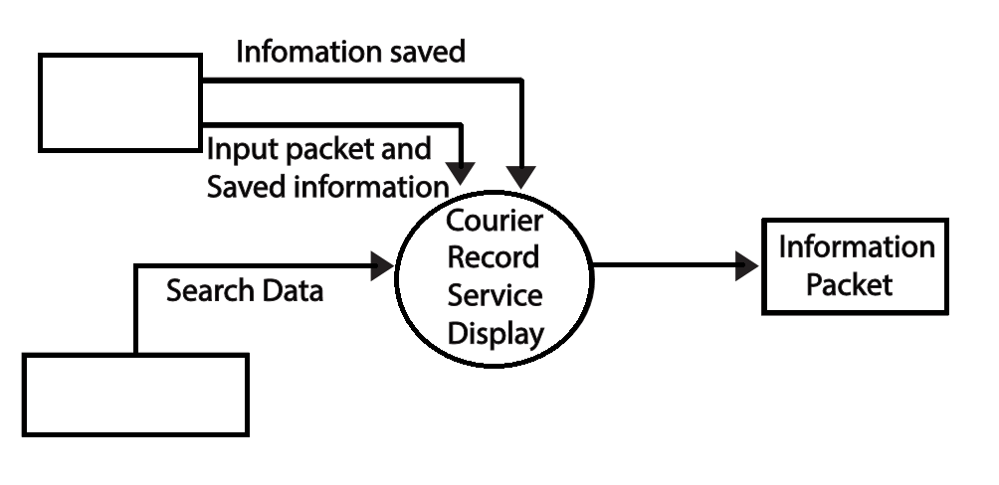

* 1. **Tables**

**4.2.1 Consignment details Table**

|  |  |  |  |
| --- | --- | --- | --- |
| ***Field name*** | ***Data type*** | ***Require data entry*** | ***Description*** |
| ***Consignor code*** | *Number* | *No* | *It stores a unique code which is given to the consignor* |
| ***Consignor no*** | *Number* | *No* | *It stores a given number for consignor* |
| ***C type*** | *Text* | *Yes* | *It stores the type of consignment (document or non document)* |
| ***Destination*** | *Text* | *Yes* | *Stores location of delivery* |
| ***R date*** | *Date/Time* | *Yes* | *Stores reciving date* |
| ***Consignee name*** | *Text* | *Yes* | *Stores name of consignee(courier reciever)* |
| ***W kilo*** | *Number* | *Yes* | *Stores weight of package in kilograms* |
| ***W grms*** | *Number* | *Yes* | *Stores weight of package in grams* |
| ***Amount*** | *number* | *Yes* | *Stores amount of courier delivery charge* |

**4.2.2 Consignor Info Table**

|  |  |  |  |
| --- | --- | --- | --- |
| ***Field name*** | ***Data type*** | ***Require data entry*** | ***Description*** |
| ***Consignor code*** | *Number* | *No* | *Stores a unique code given to consignor (also works a primary key)* |
| ***Consignor name*** | *Text* | *Yes* | *Stores consignor’s name* |
| ***Address*** | *Memo* | *Yes* | *Stores address of consignor* |
| ***City*** | *Text* | *Yes* | *Stores city where consignor lives* |

**4.2.3 Destination Consignment Details Table**

|  |  |  |  |
| --- | --- | --- | --- |
| ***Field name*** | ***Data type*** | ***Require data entry*** | ***Description*** |
| ***D_consignment code*** | *Number* | *Yes* | *Stores a unique code given to consignor (also works a primary key)* |
| ***D_date*** | *Date/Time* | *Yes* | *Stores Date of Arrival of Consignment At Destination* |
| ***D_pcs*** | *Number* | *Yes* | *Stores number of packages* |
| ***Origin*** | *Text* | *Yes* | *Stores origin location of package* |
| ***D_consignee name*** | *Text* | *Yes* | *Stores consignee name* |
| ***D_address*** | *Memo* | *Yes* | *Stores address of consignee* |

**4.2.4 Login Table**

|  |  |  |  |
| --- | --- | --- | --- |
| ***Field name*** | ***Data type*** | ***Require data entry*** | ***Descriotion*** |
| ***User name*** | *Text* | *No* | *Stores Username* |
| ***Password*** | *Memo* | *No* | *Stores Password* |

**4.2.5 Rate Table**

|  |  |  |  |
| --- | --- | --- | --- |
| ***Field name*** | ***Data type*** | ***Require data entry*** | ***Description*** |
| ***Tran_method*** | *Text* | *No* | *Stores Transportation Methods i.e Airways , Roadways , Railways* |
| ***R_weight*** | *Number* | *No* | *Stores* |
| ***Raj_rs*** | *Number* | *No* | *Stores delivery charge for rajasthan* |
| ***Mumbai_rs*** | *Number* | *No* | *Stores delivery charge for Mumbai* |
| ***Others_rs*** | *Number* | *No* | *Stores delivery charge for other states* |

1. **TECHNOLOGY & REQUIRMENTS**

* **Technologies Used**

* Windows 10
* Visual Basic (6.0) as front end.
* MS Access (2007) as back end.
* **Software Requirements**
* **Operating system :** Windows XP, Windows 7, Windows 10
* **Front end:** Microsoft visual basic 6.0
* **Back end:** MS Access (2007)
* **Hardware Requirements**
* **Processor :** Pentium IV or higher version.
* **Ram :** 2GB Minimum
* **Hard Disk :** 150 MB
* **Monitor**
* **Keyboard**
* **Printer**

1. **GRAPHICAL USER INTERFACE**

User Interface is the visual layout of the system made for human-computer interaction. It allows the user to control and interact with the system, while the system provides back simultaneous outputs to the user's commands.

**6.1** **frmWelscr** :- This is the **Welcome Page** of the Software. With Company’s Logo and Tagline.



**Coding**

Private Sub cmdExit_Click()

End

End Sub

Private Sub cmdNxt_Click()

Me.Hide

frmLogin.Show

End Sub

**6.2** **frmLogin** :- This is the **Login Page** of the Software. Before Start Working on this Software the Employee must have to Login with the correct User Name and Password.

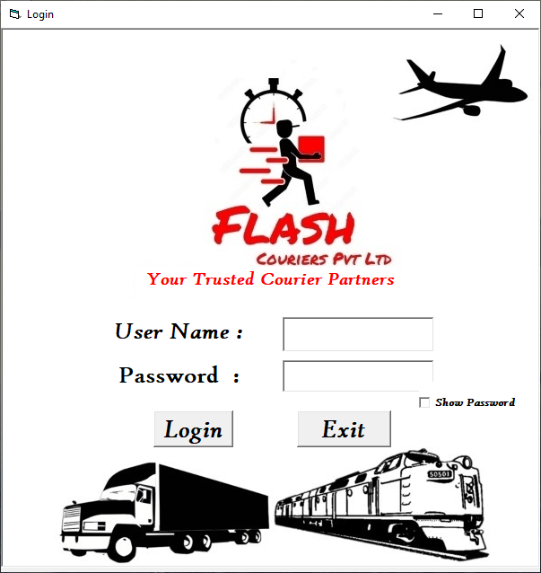

**Coding**

Option Explicit

'Declaraing Variables and its Data types

Dim adocn As New ADODB.Connection

Dim adorecord As New ADODB.Recordset

Private Sub chkShowPass_Click()

If chkShowPass.Value = 1 Then

txtPassword.PasswordChar = "" 'Shows Password as Normal Text

ElseIf chkShowPass.Value = 0 Then

txtPassword.PasswordChar = "*" 'Show Password as Star (*)

End If

End Sub

Private Sub cmdExit_Click()

adorecord.Close

End

End Sub

Private Sub cmdLog_Click()

'Checking from Database Login Info. is Correct or Not

If UCase(adorecord.Fields(0)) = UCase(txtUserName.Text) And UCase(adorecord.Fields(1)) = UCase(txtPassword.Text) Then

MsgBox "Login Success Welcome"

adorecord.Close

Me.Hide

frmMenu.Show

Else

MsgBox "Invalid ...try again"

txtUserName.SetFocus

txtUserName.Text = ""

txtPassword.Text = ""

End If

End Sub

Private Sub Form_Load()

'Connecting and Opening ADODB Connection & Recordset

adocn.Open "Provider=Microsoft.Jet.OLEDB.4.0;Data Source=" & App.Path & "\COURIER_DB.MDB;Persist Security Info=False"

adorecord.Open "login", adocn, adOpenDynamic, adLockOptimistic, adCmdTable

End Sub

**6.3** **frmMenu** :- This is the **Menu page** of this software . With 3 Option Buttons According to His\Her Need He\She (Employee) can select one of the following option at a time.

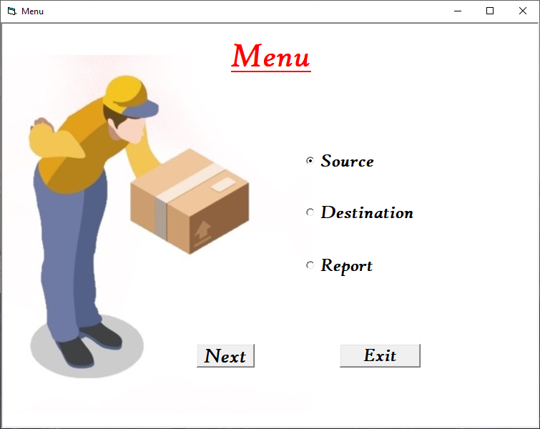

**Coding**

Private Sub cmdExit_Click()

End

End Sub

Private Sub cmdNxt_Click()

If optSource.Value = True Then

frmSource.Show

ElseIf optDest.Value = True Then

frmDest.Show

ElseIf optReport.Value = True Then

frmReport.Show

End If

Me.Hide

End Sub

Private Sub Form_Activate()

'On Form Activation option Source is selected by Default

optSource.Value = True

End Sub

**6.4** **frmSource** :- This Page has 2 Option Buttons. One to Create or Modify **Consignment Note** And the Other one to **Create Manifest**.

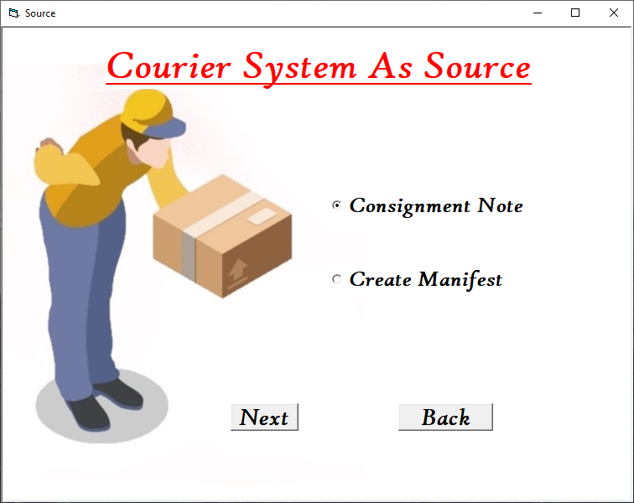

**Coding**

Private Sub cmdBack_Click()

Me.Hide

frmMenu.Show

End Sub

Private Sub cmdNxt_Click()

If optCnote.Value = True Then

frmCnote.Show

ElseIf optManifest.Value = True Then

frmManifest.Show

End If

Me.Hide

End Sub

Private Sub Form_Activate()

optCnote.Value = True

'On Form Activation option Consignment Note is selected by Default

cmdNxt.SetFocus

'Set Focus on Command Next

End Sub

**6.5** **frmReport** :- This Page have 3 Option Buttons . First **“Invoice”** to Create invoice Report of a Consignment Code , Second **“Destination Wise”** to Create a Particular Destination/Location Wise Report & Third one is **“Summary”** shows Summary Report of all Consignments.

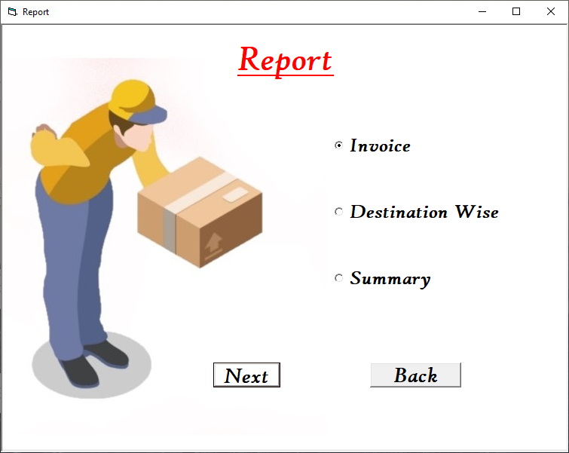

**Coding**

Private Sub cmdBack_Click()

Me.Hide

frmMenu.Show

End Sub

Private Sub cmdNxt_Click()

Me.Hide

If optInvoice.Value = True Then

frmInvoice.Show

ElseIf optDestwise.Value = True Then

FrmDestwise.Show

Else

drtSummary.Show

End If

End Sub

Private Sub Form_Activate()

optInvoice.Value = True

'On Form Activation option Invoice is selected by Default

End Sub

**6.6** **frmDest** :- This Page of the Software have 2 Options, First **“Entry Form”** its Consignee (Receiver) Entry Form and Second **“Create Delivery Runsheet”** to create Delivery Runsheet of a Particular Consignment.

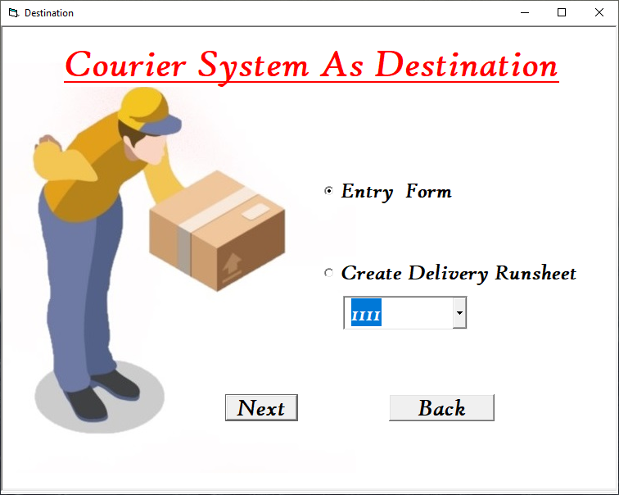

**Coding**

Option Explicit

'Declaraing Variables and its Data types

Dim adocn As New ADODB.Connection

Dim adorec As New ADODB.Recordset

Dim adorecord As New ADODB.Recordset

Dim ccode As Integer

Dim ddate As String

Dim dpcs As Integer

Dim origin As String

Dim conName As String

Dim conAdd As String

Dim i As Integer

Private Sub cmdBack_Click()

Me.Hide

frmMenu.Show

End Sub

Private Sub cmdNxt_Click()

adorecord.Close

adorecord.Open

If optEntry.Value = True Then

frmDestconsignment.Show

Else

'Checking from Database Con. Code is Correct or Not, If its Correct Storing Data in Variables

Do While Not adorecord.EOF

If RTrim(adorecord.Fields(0)) = RTrim(cmbCcode.List(cmbCcode.ListIndex)) Then

ccode = RTrim(adorecord.Fields(0))

ddate = adorecord.Fields(1)

dpcs = adorecord.Fields(2)

origin = adorecord.Fields(3)

conName = adorecord.Fields(4)

conAdd = adorecord.Fields(5)

adorecord.MoveLast

adorecord.MoveNext

Else

adorecord.MoveNext

End If

Loop

'Logic for Sending data to Report (drtDrs)

drtDrs.Sections(2).Controls(40).Caption = ccode

drtDrs.Sections(2).Controls(41).Caption = ddate

drtDrs.Sections(2).Controls(42).Caption = dpcs

drtDrs.Sections(2).Controls(43).Caption = origin

drtDrs.Sections(2).Controls(44).Caption = conName

drtDrs.Sections(2).Controls(45).Caption = conAdd

drtDrs.Show

End If

Me.Hide

End Sub

Private Sub Form_Activate()

optEntry.Value = True

adorec.Close

adorec.Open

cmbCcode.Locked = True

adorecord.Close

adorecord.Open

'Checking if there is data in Database

If adorecord.EOF = True Then

MsgBox " There is no data in master table"

Me.Hide

frmIrccode.Show

Else

i = 0

'Logic for Retriving data from Database into Combo box (cmbCcode)

Do While Not adorecord.EOF

cmbCcode.List(i) = adorecord.Fields(0)

adorecord.MoveNext

i = i + 1

Loop

cmbCcode.ListIndex = 0

cmbCcode.SetFocus

adorecord.MoveFirst

End If

End Sub

Private Sub Form_Load()

'Connecting and Opening ADODB Connection & Recordset

adocn.Open "Provider=Microsoft.Jet.OLEDB.4.0;Data Source=" & App.Path & "\COURIER_DB.MDB;Persist Security Info=False"

adorecord.Open "select *from dest_consignment_details", adocn, adOpenDynamic, adLockOptimistic, adCmdText

adorec.Open "temp", adocn, adOpenDynamic, adLockPessimistic, adCmdTable

End Sub

Private Sub optDrs_Click()

If optEntry.Value = True Then

cmbCcode.Locked = True

Else

cmbCcode.Locked = False

End If

End Sub

**6.7** **frmCnote** :- **“Is There Any Consignor\Consignment Code” ,** if the Consignor Already have a Consignment Code And He\She Wanted to Update\Modify Details About Consignment then they choose Option **“Yes”.** Else they choose Option **“No”** and then they can Create/Genrate New Consignment Code.

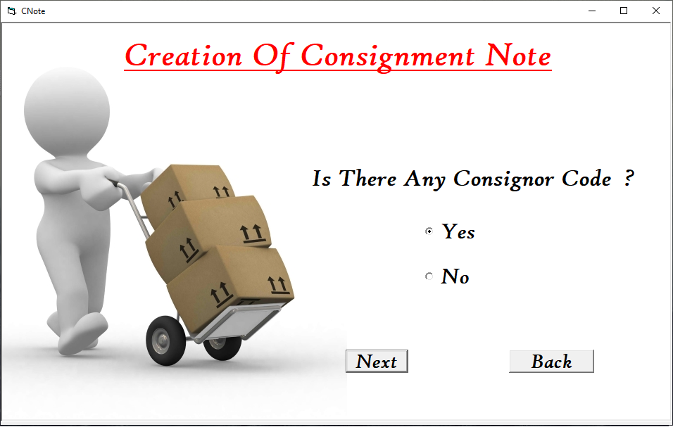

**Coding**

Private Sub cmdBack_Click()

Me.Hide

frmSource.Show

End Sub

Private Sub cmdNxt_Click()

Me.Hide

If optYes.Value = True Then

frmCCode.Show

Else

frmIrccode.Show

End If

End Sub

Private Sub Form_Activate()

optYes.Value = True

End Sub

**6.8.** **frmCcode** :- Select which **“Consignment Code Details”** Consignor wants to Modify.

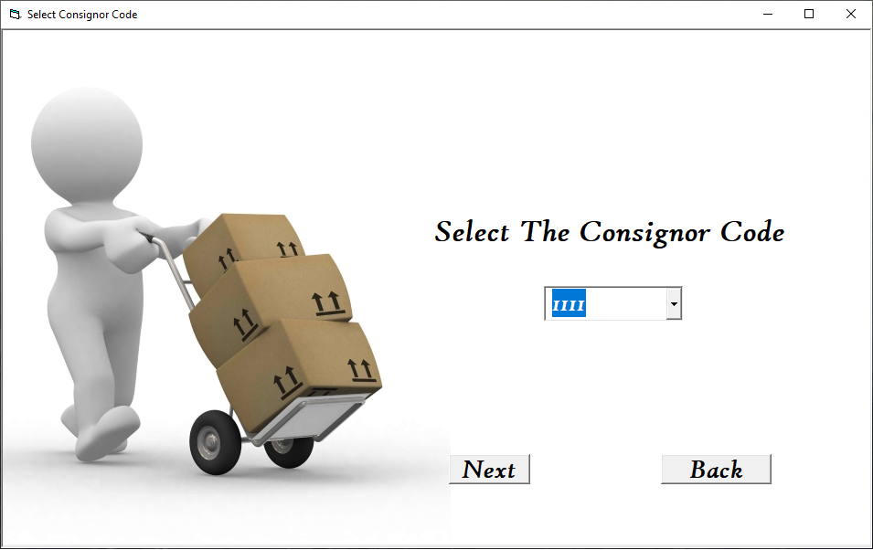

**Coding**

Option Explicit

'Declaraing Variables and its Data types

Dim i As Integer

Dim adocn As New ADODB.Connection

Dim adorecord As New ADODB.Recordset

Private Sub cmdBack_Click()

Me.Hide

frmSource.Show

End Sub

Private Sub cmdNxt_Click()

adorecord.MoveFirst

'Sending Data to Form frmCne

Do While Not adorecord.EOF

If RTrim(adorecord.Fields(0)) = RTrim(UCase(cmbCcode.List(cmbCcode.ListIndex))) Then

frmCne.txtCcode = adorecord.Fields(0)

frmCne.txtName = adorecord.Fields(1)

frmCne.txtAdd = adorecord.Fields(2)

frmCne.txtCity = adorecord.Fields(3)

adorecord.MoveLast

adorecord.MoveNext

Else

adorecord.MoveNext

End If

Loop

Me.Hide

frmCne.Show

frmCne.txtConame.SetFocus

End Sub

Private Sub Form_Activate()

adorecord.Close

adorecord.Open

'Checking if Data is Available or not

'If not

If adorecord.EOF = True Then

MsgBox " There is no data in master table"

Me.Hide

frmIrccode.Show

Else

i = 0

'If Available ,Retriving data from Database into Combo box (cmbcode)

Do While Not adorecord.EOF

cmbCcode.List(i) = adorecord.Fields(0)

adorecord.MoveNext

i = i + 1

Loop

cmbCcode.ListIndex = 0

cmbCcode.SetFocus

adorecord.MoveFirst

End If

End Sub

Private Sub Form_Load()

'Connecting and Opening ADODB Connection & Recordset

adocn.Open "Provider=Microsoft.Jet.OLEDB.4.0;Data Source=" & App.Path & "\COURIER_DB.MDB;Persist Security Info=False"

adorecord.Open "select *from consignor_info order by consignor_code", adocn, adOpenDynamic, adLockOptimistic, adCmdText

End Sub

Private Sub cmbCcode_KeyPress(KeyAscii As Integer)

Select Case KeyAscii

Case 13

cmdNxt.SetFocus

Case Else

KeyAscii = 0

End Select

End Sub

**6.9** **frmIrcode** :- **“Consignor Entry Form”** This require Details about Consignor Like, Consignor Name , Consignor Permanent Address . This Page Auto Generates Consignor Or Consignment Code .

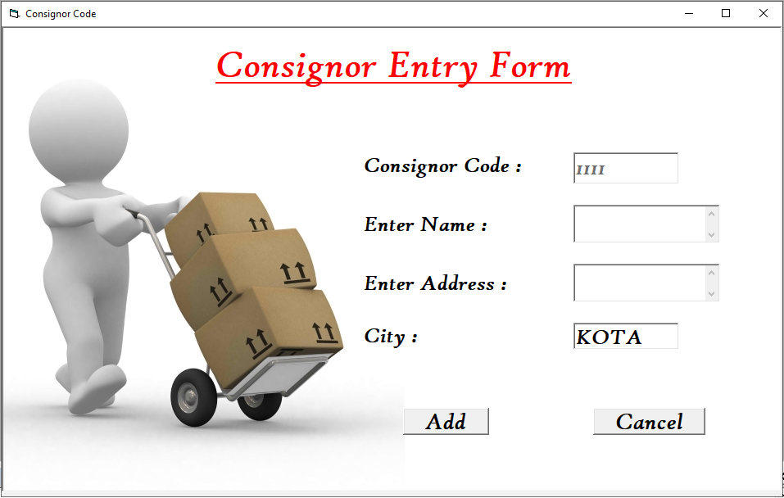

**Coding**

Option Explicit

'Declaraing Variables and its Data types

Dim adocn As New ADODB.Connection

Dim adorecord As New ADODB.Recordset

Dim adorecas As New ADODB.Recordset

Dim flag As Boolean

Dim tcode As String

Dim tl As String

Dim tr As Integer

Private Sub cmdAdd_Click()

If txtCname.Text = "" Then

MsgBox "Empty field"

txtCname.SetFocus

ElseIf txtCadd.Text = "" Then

MsgBox "Empty field"

txtCadd.SetFocus

ElseIf txtCity.Text = "" Then

MsgBox "Empty field"

txtCity.SetFocus

Else

If MsgBox("Do you want to add?", vbYesNo) = vbYes Then

'Sending Data to Database

adorecord.AddNew

adorecord.Fields(0) = RTrim(txtCcode.Text)

adorecord.Fields(1) = RTrim(txtCname.Text)

adorecord.Fields(2) = RTrim(txtCadd.Text)

adorecord.Fields(3) = RTrim(txtCity.Text)

adorecord.Update

'Sending Data to Form frmCne

frmCne.txtCcode.Text = RTrim(txtCcode.Text)

frmCne.txtName.Text = RTrim(txtCname.Text)

frmCne.txtAdd.Text = RTrim(txtCadd.Text)

frmCne.txtCity.Text = RTrim(txtCity.Text)

Me.Hide

frmCne.Show

frmCne.txtConame.SetFocus

Else

txtCcode.Text = ""

txtCname.Text = ""

txtCadd.Text = ""

txtCity.Text = "KOTA"

txtCcode.Text = tcode

txtCname.SetFocus

End If

End If

End Sub

Private Sub cmdCancel_Click()

txtCname.SetFocus

Me.Hide

frmSource.Show

End Sub

Private Sub Form_Activate()

adorecas.Close

adorecas.Open

txtCcode.Text = ""

txtCname.Text = ""

txtCadd.Text = ""

txtCity.Text = "KOTA"

txtCcode.Enabled = False

txtCname.SetFocus

tcode = ""

'logic for Consignor Code

If adorecas.EOF = True Then

tcode = "1111"

Else

adorecas.MoveLast

tcode = adorecas.Fields(0)

tl = Left(tcode, 1)

tr = Right(tcode, Len(tcode) - 1)

If tr = 9999 Then

tr = 1

tl = Asc(tl) + 1

tl = Chr(tl)

End If

tr = tr + 1

tcode = tl & tr

End If

txtCcode = tcode

End Sub

Private Sub Form_Load()

'Connecting and Opening ADODB Connection & Recordsets

adocn.Open "Provider=Microsoft.Jet.OLEDB.4.0;Data Source=" & App.Path & "\COURIER_DB.MDB;Persist Security Info=False"

adorecord.Open "Consignor_info", adocn, adOpenDynamic, adLockOptimistic, adCmdTable

adorecas.Open "select *from Consignor_info order by consignor_code", adocn, adOpenDynamic, adLockOptimistic, adCmdText

End Sub

Private Sub txtCity_KeyPress(KeyAscii As Integer)

If KeyAscii = 13 Then

If txtCity.Text = "" Then

MsgBox "Empty field"

txtCity.SetFocus

Else

cmdAdd.SetFocus

End If

ElseIf Not ((KeyAscii >= vbKeyA And KeyAscii <= vbKeyZ) Or KeyAscii =

vbKeyBack Or (KeyAscii >= 97 And KeyAscii <= 122)) Then

KeyAscii = 0

End If

End Sub

Private Sub txtCadd_GotFocus()

If txtCname.Text = "" Then

MsgBox "Empty field"

txtCname.SetFocus

End If

End Sub

Private Sub txtCity_GotFocus()

If txtCname.Text = "" Then

MsgBox "Empty field"

txtCname.SetFocus

ElseIf txtCadd.Text = "" Then

MsgBox "Empty field"

txtCadd.SetFocus

End If

End Sub

Private Sub txtCname_KeyPress(KeyAscii As Integer)

If KeyAscii = 13 Then

txtCadd.SetFocus

ElseIf Not ((KeyAscii >= vbKeyA And KeyAscii <= vbKeyZ) Or KeyAscii = 46 Or KeyAscii = 32 Or KeyAscii = vbKeyBack Or (KeyAscii >= 97 And KeyAscii <= 122)) Then

KeyAscii = 0

End If

End Sub

**6.10 frmCne** :- This is The **“Main Page”** of the Software Contain everything About **Consignment** like Consignment Code, Type, Weight in Kg & Grams, Transportation Method , Charges & Taxes Details As well as Details about Consignor & Consignee.

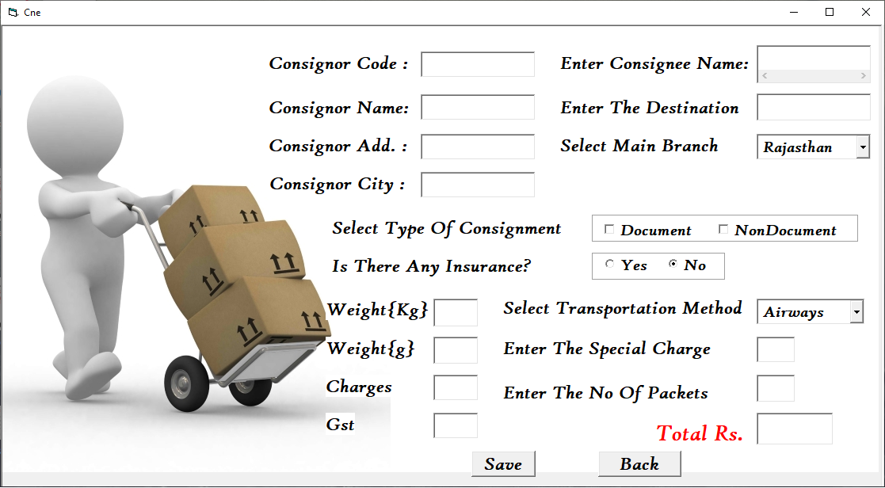

**Coding**

Option Explicit

'Declaraing Variables and its Data types

Dim adocn As New ADODB.Connection

Dim adorecord As New ADODB.Recordset

Dim adorecr1 As New ADODB.Recordset

Dim adorecr2 As New ADODB.Recordset

Dim str As String

Dim flag As Boolean

Dim wt As Integer

Dim i As Integer

Private Sub chkDoc_GotFocus()

If cmbDest.Text = "" Then

MsgBox "Cant' be left empty field"

cmbDest.SetFocus

End If

End Sub

Private Sub ChkNdoc_Click()

If txtConame.Text = "" Then

MsgBox "Cant' be left empty field"

txtConame.SetFocus

End If

End Sub

Private Sub ChkNdoc_GotFocus()

If cmbDest.Text = "" Then

MsgBox "Cant' be left empty field"

cmbDest.SetFocus

End If

End Sub

Private Sub cmbDest_KeyPress(KeyAscii As Integer)

Select Case KeyAscii

Case 13

ChkDoc.SetFocus

Case 103, 71

KeyAscii = 0

cmbDest.Text = cmbDest.List(0)

Case 109, 77

KeyAscii = 0

cmbDest.Text = cmbDest.List(1)

Case 111, 79

KeyAscii = 0

cmbDest.Text = cmbDest.List(2)

Case Else

KeyAscii = 0

End Select

End Sub

Private Sub cmbTm_GotFocus()

If txtWgms.Text = "" Then

MsgBox "Can't left empty field"

txtWgms.SetFocus

End If

End Sub

Private Sub cmbTm_KeyPress(KeyAscii As Integer)

Select Case KeyAscii

Case 13

txtSchg.SetFocus

Case 65, 97

KeyAscii = 0

cmbTm.Text = cmbTm.List(0)

Case 67, 99

KeyAscii = 0

cmbTm.Text = cmbTm.List(1)

Case 115, 83

KeyAscii = 0

cmbTm.Text = cmbTm.List(2)

Case Else

KeyAscii = 0

End Select

End Sub

Private Sub cmdBack_Click()

Me.Hide

frmSource.Show

End Sub

Private Sub cmdSave_Click()

If txtNpa.Text = "" Then

MsgBox "Can't be left empty field"

txtNpa.SetFocus

Else

If MsgBox("Do you want to save?", vbYesNo) = vbYes Then

'Checking from Database Con. Code is Already Exists or not

'If Yes Updating Database

Do While Not adorecord.EOF

If RTrim(adorecord.Fields(0)) = RTrim(txtCcode.Text) Then

adorecord.Delete

GoTo Update

Else

adorecord.MoveNext

End If

Loop

Update:

'If No Adding New

'Sending Data to Database

adorecord.AddNew

adorecord.Fields(0) = UCase(RTrim(txtCcode.Text))

If ChkDoc.Value = Checked And ChkNdoc.Value = Unchecked Then

adorecord.Fields(2) = "D"

drtPcne.Sections(1).Controls(1).Caption = "DOC."

ElseIf ChkNdoc.Value = Checked And ChkDoc.Value = Unchecked Then

adorecord.Fields(2) = "ND"

drtPcne.Sections(1).Controls(1).Caption = "NON-DOC."

Else

adorecord.Fields(2) = "D,ND"

drtPcne.Sections(1).Controls(1).Caption = "DOC."

drtPcne.Sections(1).Controls(2).Caption = "& NON-DOC."

End If

adorecord.Fields(1) = RTrim(txtCcode.Text) - 1110

adorecord.Fields(3) = UCase(txtDest.Text)

adorecord.Fields(4) = Date

adorecord.Fields(5) = UCase(txtConame.Text)

adorecord.Fields(6) = txtWk.Text

adorecord.Fields(7) = txtWgms.Text

adorecord.Fields(8) = txtTot.Text

adorecord.Update

MsgBox "Data Updated Successfully"

Me.Hide

'Sending data to Report (drtPcne)

'org,dest,date

drtPcne.Sections(1).Controls(3).Caption = UCase("Kota")

drtPcne.Sections(1).Controls(4).Caption = UCase(txtDest)

drtPcne.Sections(1).Controls(5).Caption = Date

'consignor

drtPcne.Sections(1).Controls(6).Caption = UCase(txtName)

drtPcne.Sections(1).Controls(7).Caption = UCase(txtAdd)

'consignee

drtPcne.Sections(1).Controls(8).Caption = UCase(txtConame)

drtPcne.Sections(1).Controls(9).Caption = UCase(txtDest)

'kgs,gms,pkgs,charge,spchg,stax,total,date

If txtWk >= 0 Then

drtPcne.Sections(1).Controls(10).Caption = txtWk

End If

If txtWgms >= 0 Then

drtPcne.Sections(1).Controls(11).Caption = txtWgms

End If

drtPcne.Sections(1).Controls(12).Caption = txtNpa

drtPcne.Sections(1).Controls(13).Caption = txtChg

drtPcne.Sections(1).Controls(14).Caption = txtSchg

drtPcne.Sections(1).Controls(15).Caption = txtTax

drtPcne.Sections(1).Controls(16).Caption = txtTot

drtPcne.Show

'Reset

Else

txtConame.Text = ""

txtWk.Text = ""

txtWgms.Text = ""

txtNpa.Text = ""

txtSchg.Text = ""

ChkDoc.Value = Unchecked

ChkNdoc.Value = Unchecked

optNo = True

optYes = False

cmbDest.ListIndex = 0

cmbTm.ListIndex = 0

txtDest.Text = ""

txtChg = ""

txtTax = ""

txtTot = ""

txtConame.SetFocus

End If

End If

End Sub

Private Sub Form_Activate()

txtConame.Text = ""

txtWk.Text = ""

txtWgms.Text = ""

txtNpa.Text = ""

txtSchg.Text = ""

optNo = True

optYes = False

ChkDoc.Value = Unchecked

ChkNdoc.Value = Unchecked

cmbDest.ListIndex = 0

cmbTm.ListIndex = 0

txtDest.Text = ""

txtChg = ""

txtTax = ""

txtTot = ""

txtCcode.Enabled = False

txtName.Enabled = False

txtCity.Enabled = False

txtAdd.Enabled = False

txtTot.Enabled = False

txtTax.Enabled = False

txtChg.Enabled = False

End Sub

Private Sub Form_Load()

'Connecting and Opening ADODB Connection & Recordsets

adocn.Open "Provider=Microsoft.Jet.OLEDB.4.0;Data Source=" & App.Path & "\COURIER_DB.MDB;Persist Security Info=False"

adorecord.Open "consignment_details", adocn, adOpenDynamic, adLockOptimistic, adCmdTable

adorecr1.Open "select * from rate_table ", adocn, adOpenDynamic, adLockOptimistic, adCmdText

End Sub

Private Sub optNo_KeyPress(KeyAscii As Integer)

If KeyAscii = 13 Then

txtWk.SetFocus

End If

End Sub

Private Sub txtConame_KeyPress(KeyAscii As Integer)

If KeyAscii = 13 Then

txtDest.SetFocus

ElseIf Not ((KeyAscii >= vbKeyA And KeyAscii <= vbKeyZ) Or KeyAscii = 46 Or KeyAscii = 32 Or KeyAscii = vbKeyBack Or (KeyAscii >= 97 And KeyAscii <= 122)) Then

KeyAscii = 0

End If

End Sub

Private Sub cmbDest_GotFocus()

If txtConame.Text = "" Then

MsgBox "Can't be left empty field"

txtConame.SetFocus

ElseIf txtDest.Text = "" Then

MsgBox "Can't be left empty field"

txtDest.SetFocus

End If

End Sub

Private Sub txtDest_GotFocus()

If txtConame.Text = "" Then

MsgBox "Can't be left empty field"

txtConame.SetFocus

End If

End Sub

Private Sub txtDest_KeyPress(KeyAscii As Integer)

If KeyAscii = 13 Then

cmbDest.SetFocus

ElseIf Not ((KeyAscii >= vbKeyA And KeyAscii <= vbKeyZ) Or KeyAscii = vbKeyBack Or (KeyAscii >= 97 And KeyAscii <= 122)) Then

KeyAscii = 0

End If

End Sub

Private Sub txtNpa_GotFocus()

adorecord.Close

adorecr1.Close

adorecord.Open

adorecr1.Open

If txtSchg.Text = "" Then

MsgBox "Can't be left empty field"

txtSchg.SetFocus

'logic for amount

Dim twt As Integer

Dim amt As Integer

Dim tamt As Integer

Dim tm As String

Dim c As Integer

Dim charge As Double

Dim totamt As Double

ElseIf txtWk.Text > 30 Then

MsgBox "Maximum Limit is 30 kg "

txtWk.SetFocus

ElseIf txtWgms.Text > 900 Then

MsgBox "Maximum Limit is 900 gms "

txtWgms.SetFocus

Else

amt = 0

tamt = 0

c = 0

wt = (txtWk * 1000) + txtWgms

'Transportation Method

If cmbTm.Text = "Airways" Then

tm = "A"

ElseIf cmbTm.Text = "Roadways" Then

tm = "RO"

Else

tm = "RA"

End If

Do While Not adorecr1.EOF

If adorecr1.Fields(0) = tm Then

If cmbDest.Text = "Rajasthan" Then

amt = adorecr1.Fields(2)

ElseIf cmbDest.Text = "OTHERS" Then

amt = adorecr1.Fields(4)

Else

amt = adorecr1.Fields(3)

End If

If (txtWgms.Text <> 0) Then

c = txtWk.Text + 1

Else

c = txtWk.Text

End If

amt = amt * c

adorecr1.MoveNext

Else

adorecr1.MoveNext

End If

Loop

'Logic for Calculating Tax,Charges,TotalAmt

charge = (amt * 0.05) + txtSchg.Text

totamt = charge + amt

txtTax.Text = (amt * 0.05)

txtChg.Text = amt

txtTot.Text = totamt

End If

End Sub

Private Sub txtNpa_KeyPress(KeyAscii As Integer)

If KeyAscii = 13 Then

cmdSave.SetFocus

ElseIf Not ((KeyAscii >= 48 And KeyAscii <= 57) Or KeyAscii = vbKeyBack) Then

KeyAscii = 0

End If

End Sub

Private Sub txtSchg_GotFocus()

Dim flag As Boolean

Dim wt As Integer

If txtWgms.Text = "" Then

MsgBox "Can't be left empty field"

txtWgms.SetFocus

End If

End Sub

Private Sub txtSchg_KeyPress(KeyAscii As Integer)

If KeyAscii = 13 Then

txtNpa.SetFocus

ElseIf Not ((KeyAscii >= 48 And KeyAscii <= 57) Or KeyAscii = 46 Or KeyAscii = vbKeyBack) Then

KeyAscii = 0

End If

End Sub

Private Sub txtWgms_GotFocus()

If txtWk.Text = "" Then

MsgBox "Can't be left empty field"

txtWk.SetFocus

End If

End Sub

Private Sub txtWgms_KeyPress(KeyAscii As Integer)

If KeyAscii = 13 Then

cmbTm.SetFocus

ElseIf Not ((KeyAscii >= 48 And KeyAscii <= 57) Or KeyAscii = vbKeyBack) Then

KeyAscii = 0

End If

End Sub

Private Sub txtWk_KeyPress(KeyAscii As Integer)

If KeyAscii = 13 Then

txtWgms.SetFocus

ElseIf Not ((KeyAscii >= 48 And KeyAscii <= 57) Or KeyAscii = vbKeyBack) Then

KeyAscii = 0

End If

End Sub

Private Sub txtYes_KeyPress(KeyAscii As Integer)

If KeyAscii = 13 Then

txtWk.SetFocus

ElseIf (KeyAscii >= vbKeyA And KeyAscii <= vbKeyZ) Then

KeyAscii = 0

End If

End Sub

**6.11 frmInvoice** :- Select the Consignor Code To get **“Invoice Report”.**

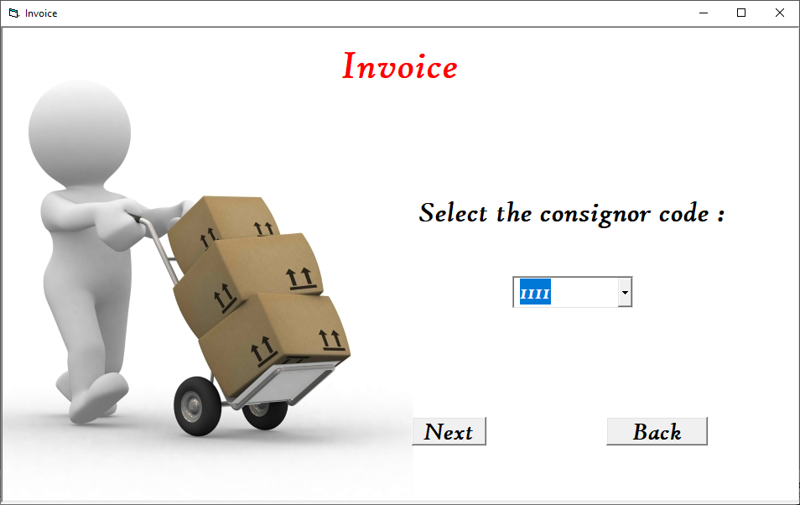

**Coding**

Option Explicit

'Declaraing Variables and its Data types

Dim adocn As New ADODB.Connection

Dim adorecord As New ADODB.Recordset

Dim ADORECTEMP As New ADODB.Recordset

Dim adorecamt As New ADODB.Recordset

Dim tamt As Double

Dim cname As String

Dim cadd As String

Dim cdest As String

Dim rdate As String

Dim wtkg As Integer

Dim wtgm As Integer

Dim totwt As Integer

Dim totamount As Double

Dim chk1 As Boolean

Dim SEQ As Integer

Dim flag As Boolean

Dim flag1 As Boolean

Dim i As Integer

Dim sdate As String

Private Sub cmdBack_Click()

Me.Hide

frmReport.Show

End Sub

Private Sub cmdNxt_Click()

adorecord.MoveFirst

adorecamt.MoveFirst

'Checking from Database Con. Code is Correct or Not, If its Correct Storing Data in Variables

Do While Not adorecord.EOF

If RTrim(adorecord.Fields(0)) = UCase(RTrim(cmbCcode.Text)) Then

cname = adorecord.Fields(1)

cadd = adorecord.Fields(2)

adorecord.MoveLast

adorecord.MoveNext

Else

adorecord.MoveNext

End If

Loop

'Checking from Database Con. Code is Correct or Not, If its Correct Storing Data in Variables

Do While Not adorecamt.EOF

If RTrim(adorecamt.Fields(0)) = UCase(RTrim(cmbCcode.Text)) Then

cdest = adorecamt.Fields(3)

rdate = adorecamt.Fields(4)

wtkg = adorecamt.Fields(6)

wtgm = adorecamt.Fields(7)

totamount = adorecamt.Fields(8)

adorecamt.MoveLast

adorecamt.MoveNext

Else

adorecamt.MoveNext

End If

Loop

'Logic for Sending data to Report (drtInvoice)

drtInvoice.Sections(2).Controls(3).Caption = cname

drtInvoice.Sections(2).Controls(4).Caption = cadd

drtInvoice.Sections(2).Controls(12).Caption = UCase(RTrim(cmbCcode.Text))

drtInvoice.Sections(2).Controls(13).Caption = cdest

drtInvoice.Sections(2).Controls(15).Caption = rdate

totwt = (wtkg * 1000) + wtgm

drtInvoice.Sections(2).Controls(16).Caption = totwt

drtInvoice.Sections(2).Controls(17).Caption = totamount

drtInvoice.Sections(2).Controls(18).Caption = UCase(RTrim(cmbCcode.Text))

Me.Hide

drtInvoice.Show

End Sub

Private Sub Form_Activate()

adorecord.MoveFirst

adorecamt.MoveFirst

adorecord.Close

adorecord.Open

i = 0

'Logic for Retriving data from Database into Combo box (cmbCcode)

Do While Not adorecord.EOF

cmbCcode.List(i) = adorecord.Fields(0)

adorecord.MoveNext

i = i + 1

Loop

cmbCcode.ListIndex = 0

adorecord.MoveFirst

flag = False

flag1 = False

cmbCcode.SetFocus

End Sub

Private Sub Form_Load()

'Connecting and Opening ADODB Connection & Recordset

adocn.Open "Provider=Microsoft.Jet.OLEDB.4.0;Data Source=" & App.Path & "\COURIER_DB.MDB;Persist Security Info=False"

adorecord.Open "select *from consignor_info", adocn, adOpenDynamic, adLockOptimistic, adCmdText

adorecamt.Open "select *from consignment_details ", adocn, adOpenDynamic, adLockOptimistic, adCmdText

End Sub

**6.12** **frmManifest** :- Select the Location\Manifest To get **“Manifest Report”.**

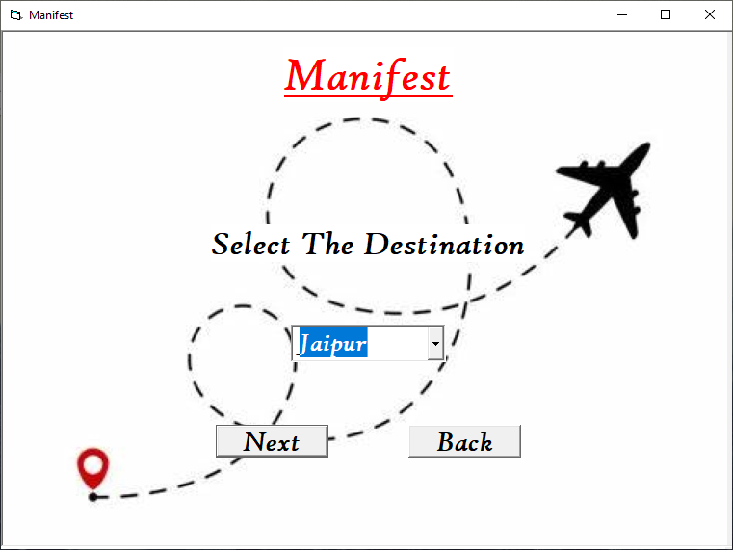

**Coding**

Option Explicit

'Declaraing Variables and its Data types

Dim adocn As New ADODB.Connection

Dim adorecord As New ADODB.Recordset

Dim adorecwt As New ADODB.Recordset

Dim i As Integer

Dim ccode As Integer

Dim twt As Double

Dim count1 As Integer

Dim flag As Boolean

Private Sub cmdBack_Click()

Me.Hide

frmSource.Show

End Sub

Private Sub cmdNxt_Click()

adorecwt.Close

adorecwt.Open

twt = 0

count1 = 0

'Checking from Database Destination is Correct or Not (cmbMdest)

Do While Not adorecwt.EOF

If RTrim(adorecwt.Fields(3)) = RTrim(cmbMdest.Text) Then

twt = twt + adorecwt.Fields(6) + adorecwt.Fields(7) * 0.001

count1 = count1 + 1

ccode = RTrim(adorecwt.Fields(0))

End If

adorecwt.MoveNext

Loop

'Sending data to Report (drtManifest)

drtManifest.Sections(2).Controls(19).Caption = ccode

drtManifest.Sections(2).Controls(5).Caption = cmbMdest.Text

drtManifest.Sections(2).Controls(20).Caption = count1

drtManifest.Sections(5).Controls(4).Caption = twt

drtManifest.Sections(5).Controls(2).Caption = count1

cmbMdest.RemoveItem cmbMdest.ListIndex

If cmbMdest.ListCount > 0 Then

cmbMdest.ListIndex = 0

End If

Me.Hide

drtManifest.Show

End Sub

Private Sub Form_Activate()

adorecord.Close

adorecwt.Close

adorecord.Open

adorecwt.Open

i = 0

'Retriving data from Database into Combo box (cmbMdest)

Do While Not adorecord.EOF

flag = True

cmbMdest.List(i) = adorecord.Fields(0)

adorecord.MoveNext

i = i + 1

Loop

'If no Data is Available in Database

If flag = False Then

MsgBox " No Appropriate Data Is Available"

Me.Hide

frmMenu.Show

Else

cmbMdest.ListIndex = 0

End If

twt = 0

count1 = 0

flag = False

End Sub

Private Sub Form_Load()

'Connecting and Opening ADODB Connection & Recordsets

adocn.Open "Provider=Microsoft.Jet.OLEDB.4.0;Data Source=" & App.Path & "\COURIER_DB.MDB;Persist Security Info=False"

adorecord.Open "select distinct destination from consignment_details ", adocn, adOpenDynamic, adLockOptimistic, adCmdText

adorecwt.Open "select *from consignment_details ", adocn, adOpenDynamic, adLockOptimistic, adCmdText

End Sub

**6.13 frmDestConsignment** :- **“Consignee Entry Form”** This require Details about Consignee Like, Consignee Or Consignment Code , Consignee Name , Consignee Permanent Address , and No. of Packets in the Consignment.

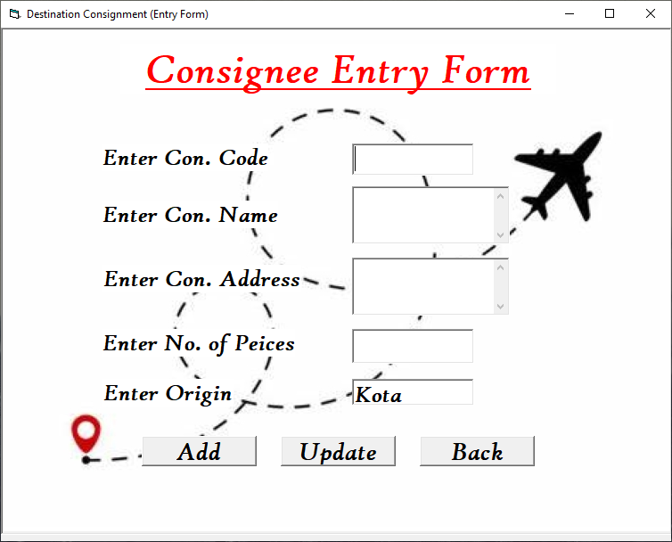

**Coding**

Option Explicit

'Declaraing Variables and its Data types

Dim adocn As New ADODB.Connection

Dim adorecord As New ADODB.Recordset

Dim flag As Boolean

Private Sub cmdAdd_Click()

If MsgBox("Do you want to Save?", vbYesNo) = vbYes Then

Do While Not adorecord.EOF

If RTrim(adorecord.Fields(0)) = RTrim(txtCno.Text) Then

MsgBox "Duplicate data....try agian"

txtCno.SetFocus

txtCno.Text = ""

GoTo Reset

Else

adorecord.MoveNext

End If

Loop

'Logic for Sending Data to Database

adorecord.AddNew

adorecord.Fields(0) = RTrim(txtCno.Text)

adorecord.Fields(1) = Date

adorecord.Fields(2) = RTrim(txtPiece.Text)

adorecord.Fields(3) = RTrim(txtOrigin.Text)

adorecord.Fields(4) = RTrim(txtName.Text)

adorecord.Fields(5) = RTrim(txtAddress.Text)

adorecord.Update

Me.Hide

frmDest.Show

End If

Reset:

txtCno.Text = ""

txtName.Text = ""

txtAddress.Text = ""

txtPiece.Text = ""

txtCno.SetFocus

End Sub

Private Sub cmdBack_Click()

Me.Hide

frmDest.Show

End Sub

Private Sub cmdAdd_GotFocus()

If txtOrigin.Text = "" Then

MsgBox "Empty field"

txtOrigin.SetFocus

End If

End Sub

Private Sub cmdUpdate_Click()

If MsgBox("Do you want to Update?", vbYesNo) = vbYes Then

Do While Not adorecord.EOF

If RTrim(adorecord.Fields(0)) = RTrim(txtCno.Text) Then

MsgBox "Update Success"

adorecord.Delete

GoTo Update

Else

adorecord.MoveNext

End If

Loop

Update:

'Logic for Sending Data to Database

adorecord.AddNew

adorecord.Fields(0) = RTrim(txtCno.Text)

adorecord.Fields(1) = Date

adorecord.Fields(2) = RTrim(txtPiece.Text)

adorecord.Fields(3) = RTrim(txtOrigin.Text)

adorecord.Fields(4) = RTrim(txtName.Text)

adorecord.Fields(5) = RTrim(txtAddress.Text)

adorecord.Update

End If

Me.Hide

frmDest.Show

End Sub

Private Sub Form_Activate()

txtCno.Text = ""

txtName.Text = ""

txtAddress.Text = ""

txtPiece.Text = ""

txtOrigin.Text = "Kota"

txtCno.SetFocus

End Sub

Private Sub Form_Load()

'Connecting and Opening ADODB Connection & Recordset

adocn.Open "Provider=Microsoft.Jet.OLEDB.4.0;Data Source=" & App.Path & "\COURIER_DB.MDB;Persist Security Info=False"

adorecord.Open "dest_consignment_details", adocn, adOpenDynamic, adLockOptimistic, adCmdTable

End Sub

Private Sub txtAddress_GotFocus()

If txtCno.Text = "" Then

MsgBox " Empty Field"

txtCno.SetFocus

ElseIf txtName.Text = "" Then

MsgBox " Empty Field"

txtName.SetFocus

End If

End Sub

Private Sub txtCno_KeyPress(KeyAscii As Integer)

If KeyAscii = 13 Then

txtName.SetFocus

ElseIf Not ((KeyAscii >= 48 And KeyAscii <= 57) Or KeyAscii = vbKeyBack) Then

KeyAscii = 0

End If

End Sub

Private Sub txtName_GotFocus()

If txtCno.Text = "" Then

MsgBox "Empty Field"

txtCno.SetFocus

End If

End Sub

Private Sub txtName_KeyPress(KeyAscii As Integer)

If KeyAscii = 13 Then

txtAddress.SetFocus

ElseIf Not ((KeyAscii >= vbKeyA And KeyAscii <= vbKeyZ) Or KeyAscii = 46 Or KeyAscii = 32 Or KeyAscii = vbKeyBack Or (KeyAscii >= 97 And KeyAscii <= 122)) Then

KeyAscii = 0

End If

End Sub

Private Sub txtPiece_GotFocus()

If txtCno.Text = "" Then

MsgBox " Empty Field"

txtCno.SetFocus

ElseIf txtName.Text = "" Then

MsgBox " Empty Field"

txtName.SetFocus

ElseIf txtAddress.Text = "" Then

MsgBox " Empty Field"

txtAddress.SetFocus

End If

End Sub

Private Sub txtPiece_KeyPress(KeyAscii As Integer)

If KeyAscii = 13 Then

txtPiece.SetFocus

ElseIf Not ((KeyAscii >= 48 And KeyAscii <= 57) Or KeyAscii = vbKeyBack) Then

KeyAscii = 0

End If

End Sub

**6.14 frmDestwise** :- Select the Location\Destination To get **“Destination Wise Report”.**

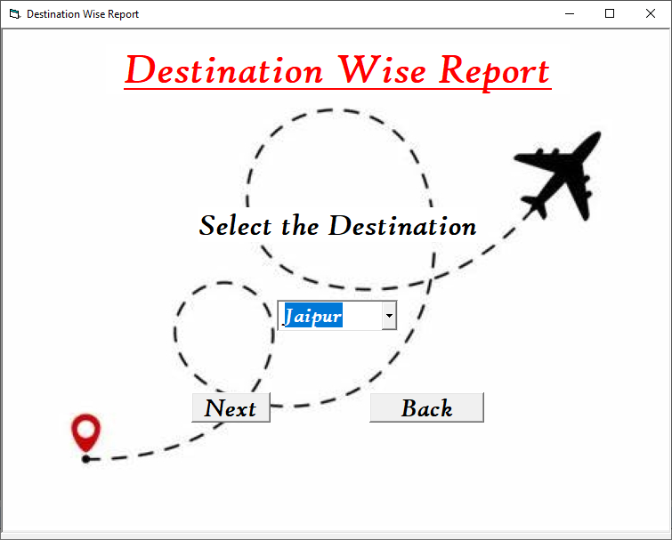

**Coding**

Option Explicit

'Declaraing Variables and its Data types

Dim adocn As New ADODB.Connection

Dim adorecamt As New ADODB.Recordset

Dim totamount As Double

Dim sdate As String

Dim flag As Boolean

Dim flag1 As Boolean

Dim cname As String

Dim ccode As Integer

Dim rdate As String

Dim wtkg As Integer

Dim wtgm As Integer

Dim totwt As Integer

Dim totamt As Double

Dim i As Integer

Private Sub cmdBack_Click()

Me.Hide

frmReport.Show

End Sub

Private Sub cmdNxt_Click()

If cmbDest.Text = "" Then

MsgBox "Select The Destination"

End If

adorecamt.MoveFirst

'Checking from Database location is Correct or Not, If its Correct Storing Data in Variables

Do While Not adorecamt.EOF

If RTrim(adorecamt.Fields(3)) = RTrim(cmbDest.Text) Then

cname = adorecamt.Fields(5)

ccode = adorecamt.Fields(0)

rdate = adorecamt.Fields(4)

wtkg = adorecamt.Fields(6)

wtgm = adorecamt.Fields(7)

totamt = adorecamt.Fields(8)

adorecamt.MoveLast

adorecamt.MoveNext

Else

adorecamt.MoveNext

End If

Loop

'Logic for Sending data to Report (drtDestwise)

drtDestwise.Sections(2).Controls(9).Caption = cname

drtDestwise.Sections(2).Controls(2).Caption = RTrim(cmbDest.Text)

drtDestwise.Sections(2).Controls(11).Caption = rdate

totwt = (wtkg * 1000) + wtgm

drtDestwise.Sections(2).Controls(12).Caption = totwt

drtDestwise.Sections(2).Controls(13).Caption = totamt

drtDestwise.Sections(2).Controls(10).Caption = ccode

Me.Hide

drtDestwise.Show

End Sub

Private Sub Form_Activate()

i = 0

'Logic for Retriving data from Database into Combo box (cmbDest)

Do While Not adorecamt.EOF

cmbDest.List(i) = adorecamt.Fields(3)

adorecamt.MoveNext

i = i + 1

Loop

cmbDest.ListIndex = 0

cmbDest.SetFocus

flag = False

flag1 = False

End Sub

Private Sub Form_Load()

'Connecting and Opening ADODB Connection & Recordset

adocn.Open "Provider=Microsoft.Jet.OLEDB.4.0;Data Source=" & App.Path & "\COURIER_DB.MDB;Persist Security Info=False"

adorecamt.Open "select *from consignment_details ", adocn, adOpenDynamic, adLockOptimistic, adCmdText

End Sub

1. **Output**

**7.1 drtDestwise** **:-** Shows **“Destination Wise Report”**

It Contains Consignee Name , Consignment Code , Date ,Total Weight in Grams & Total Amount .

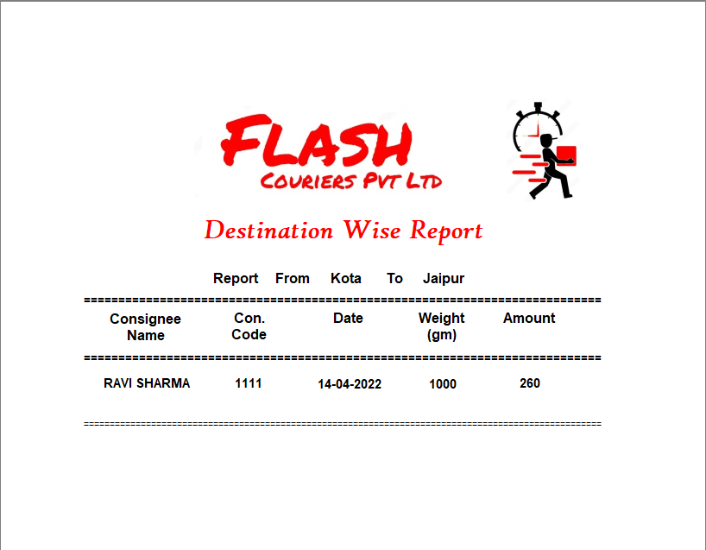

**7.2** **Drtdrs** **:- “ Delivery Runsheet ”**

It Contains Consignment Code , Date , Number of Pieces in Consignment , Origin Location , Consignee Name & Address . And Contain Columns of Consignee (Receiver) Signature & Remarks As well.

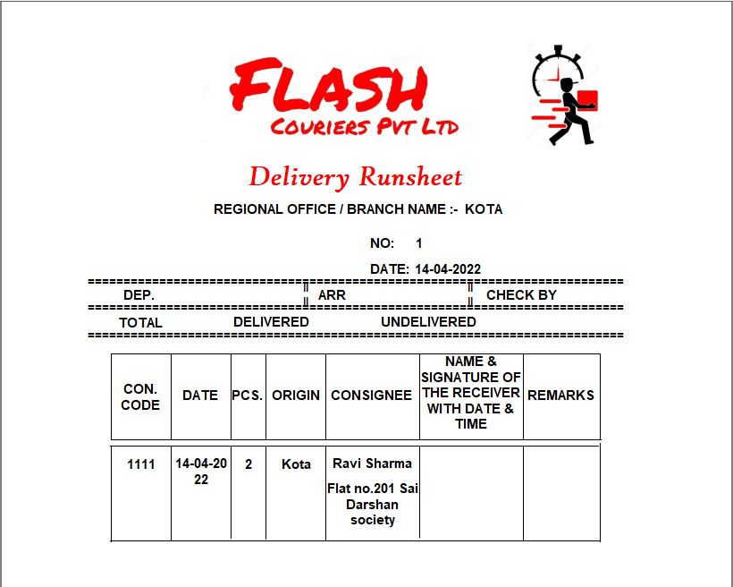

**7.3 DrtInvoice :- “ Invoice Report ”**

It Contains Consignee Name & Address , Consignment Code , Destination , Date , Weight in Grams & Total Amount.

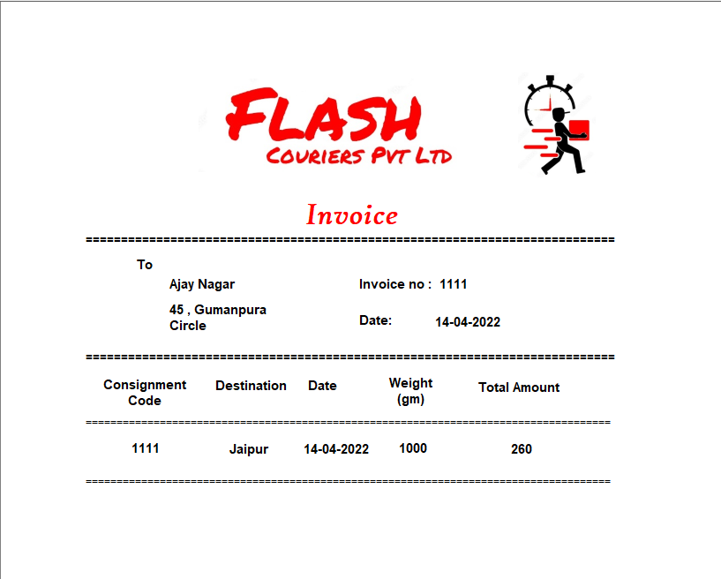

**7.4 DrtManifest :- “ Manifest Report ”**

It Contains Details about All Consignment of a Particular Location , All consignment Codes , Total Numbers Of Consignments ,Total Weight of all Cosignments & Other Information Of a Particular Location Selected.

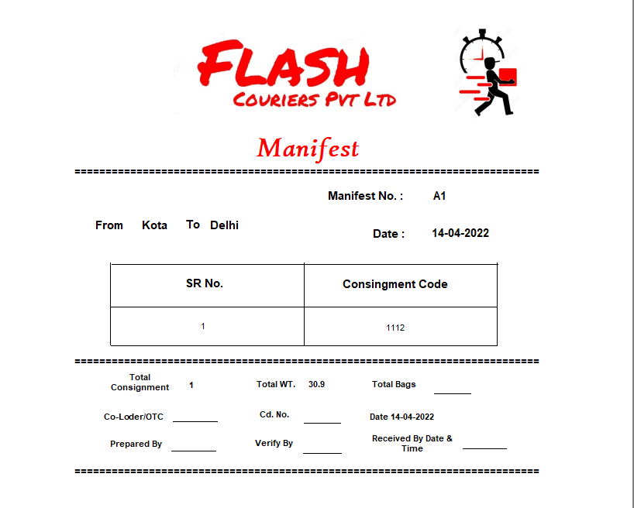

**7.5** **DrtPcne :- “ Receipt ”**

It Contains Consignment Type “ Document Or Non- Document ” , Consignor Name & Address , Consignee Name & Destination , Numbers of Packets , Date , Weight in (Kg and g) , Charges & Special Charges & Gst.

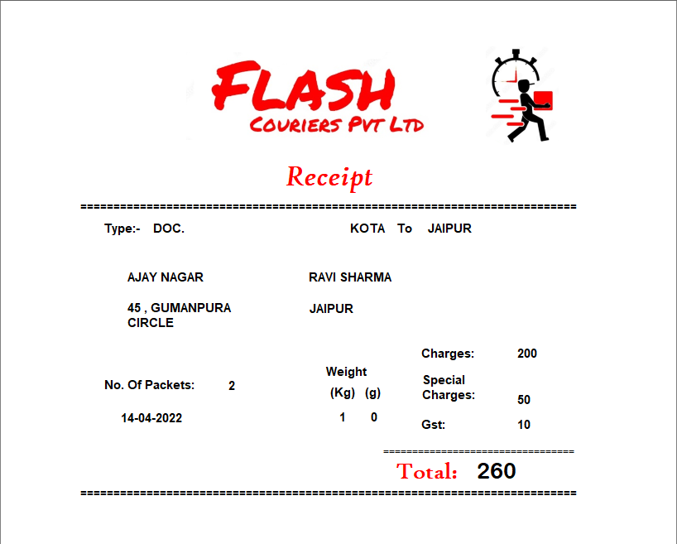

**7.6** **DrtSummary** **:- “ Summary ”**

It Contains Summary ( Consignment Code , Consignee Name , Date , Consignment Type , Weight & Total Amount ) of all Consignments.

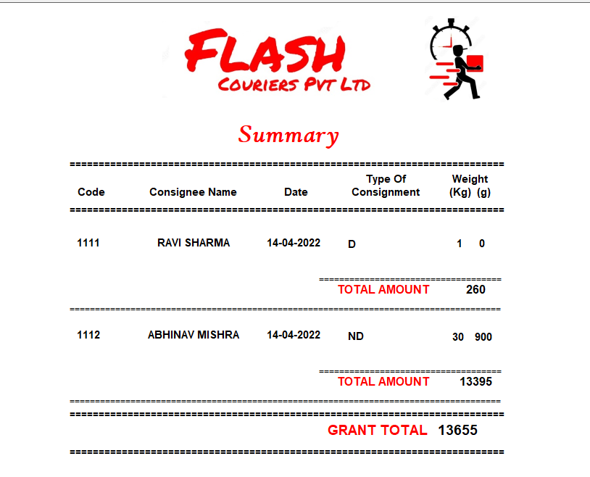

1. **TESTING**

**8.1. Unit Testing:**

Unit testing focuses on verification effort of the smallest unit of software design- the module. Using the detail design description as a guide, important control paths are tested to uncover errors within the boundary of the module. The module interface is tested to ensure the information properly follows into and out of the program under test. Boundary conditions are tested to ensure that all modules operate properly at boundaries established to limit or exercised to ensure that all statements in the module have been executed at least once. And finally all error-handling paths are tested.

**8.2 Module Testing:**

Module testing deals with testing of each module separately. Each module is tested to check whether it works according to the requirement and performs the desired results. Module testing tells about errors in each module and if each module works properly then the whole system will also work properly. Module testing saves a lot of time in detecting errors at a later stage. In integration testing we combine different modules, which may be getting called, from one another and then they are tested together so as to check whether they are working properly or not.

**8.3 Integration Testing:**

Integration testing deals with the problem of interfacing. Data can be lost across an inteface,one module can have an in advertent,adverse effect on another;subfunctions,when combined may not produce the desired major function;individually acceptable imprecision may be magnified to unacceptable levels, Global data structures can present problems. The entire program is tested as a whole.

**8.4 System Testing:**

System testing is actually a series of different tests whose primary purpose is to fully exercise the computer base systems. Although each test has a different purpose, all work should verify that system elements have been properly integrated and performs allocates functions.

**Bibliography**

* **Youtube.com**

Visual Basic tutorial-Create Data Report using Data Environment|Print and Export report Step by Step

<https://youtu.be/vjQDtKMUCKk>

HOW TO CONNECT VB6 TO ACCESS | USING ADODB Connection | Save code

<https://youtu.be/1AC0duaWous>

ADD DATA ENVIRONMENT IN VB6 WINDOWS10

<https://youtu.be/zOScoki9NLk>

visual basic 6.0 Simple DataReport

<https://youtu.be/pXlxXxo13g8>

* **VbTutor.net**

<https://www.vbtutor.net/lesson7.html>