

VIVEKANANDA INSTITUTE OF PROFESSIONAL STUDIES - TECHNICAL CAMPUS
Grade A++ Accredited Institution by NAAC
NBA Accredited for MCA Programme; Recognized under Section 2(f) by UGC; Affiliated to GGSIP University, Delhi; Recognized by Bar Council of India and AICTE An ISO 9001:2015 Certified Institution

SCHOOL OF ENGINEERING & TECHNOLOGY

BTECH Programme: CSE (7th Semester)

Course Title:
Distributed System and Cloud Computing

Course Code: CIE-407P

Submitted to: Submitted By:
Mr. Akshit Thakur, Name: Arihant Jain
Assistant Professor Enrollment no: 03417702722



VIVEKANANDA INSTITUTE OF PROFESSIONAL STUDIES
Grade A++ Accredited Institution by NAAC
NBA Accredited for MCA Programme; Recognized under Section 2(f) by UGC;
Affiliated to GGSIP University, Delhi; Recognized by Bar Council of India and
AICTE An ISO 9001:2015 Certified Institution
SCHOOL OF ENGINEERING & TECHNOLOGY

VISION OF INSTITUTE

To be an educational institute that empowers the field of engineering to build a sustainable future by providing quality education with innovative practices that supports people, planet and profit.

MISSION OF INSTITUTE

To groom the future engineers by providing value-based education and awakening students' curiosity, nurturing creativity and building
capabilities to enable them to make significant contributions to the world.

INDEX

S.  No | EXP. | Date | Marks |  |  | Remark | Updated  Marks | Faculty  Signature
S.  No | EXP. | Date | Labor atory Asses sment (15  Mark s) | Class Participati on (5  Marks) | Viva (5  Marks)
1 | Write a Program in Java to implement RPC.
2 | Implement the concept of Remote Method Invocation  in Java.
3 | Write a java program to implement  Lamport’s Logical clock.
4 | Implement mutual exclusion service using Lamport’s Mutual Exclusion  Algorithm.
5 | Install Hadoop on Windows.
6 | Run a simple application on  single node Hadoop Cluster.
7 | Install Google App Engine / AWS and develop a simple web application.

8 | Launch Web application using Google App Engine  / AWS.
9 | Install Virtualbox / VMware Workstation with different flavours of  linux on windows.
10 | Simulate a cloud scenario using CloudSim and run a scheduling  Algorithm.

Experiment – 1

Aim: Write a Program in Java to implement RPC

Theory:

Remote Procedure Call (RPC) is a protocol that enables a program to execute code on a remote server as if it were a local function call. The main purpose of RPC is to abstract the complexities of network communication, allowing developers to build distributed systems without explicitly managing sockets, streams, or low-level networking details.

In a typical RPC system, a client makes a call to a procedure that resides on a server. The system then handles the communication between the two processes. This includes marshaling (packing) the parameters on the client side, transmitting them over the network, and unmarshaling (unpacking) them on the server side. The server executes the requested procedure and sends the result back to the client through the same channel.

RPC systems can be either synchronous (the client waits for a response) or asynchronous (the client continues executing and checks for the response later). They can be implemented using various transport mechanisms, such as TCP/IP or HTTP, and are language-independent — meaning a client written in one language can communicate with a server in another if both understand the same data serialization format.

In Java, RPC-like behavior can be achieved through RMI (Remote Method Invocation), which extends RPC principles into the object-oriented world. Java RMI allows invoking methods on remote objects residing in different JVMs (Java Virtual Machines). The RMI architecture involves three key components:

Stub – Acts as a proxy on the client side.

Skeleton – Receives calls on the server side (used in earlier Java versions).

RMI Registry – Maintains references to remote objects so clients can look them up by name.

Thus, RPC (and RMI) enables distributed computing by allowing seamless method execution across networked systems, simplifying client-server interactions and promoting modular design in distributed architectures.

Code:

- Server

import java.net.*;
import java.io.*;

public class server {
public static void main(String[] args) {
try (ServerSocket serverSocket = new ServerSocket(6000)) {
System.out.println("\nServer listening on port 6000\n");
while (true) {
Socket clientSocket = serverSocket.accept();
new Thread(() -> {
try (BufferedReader in = new BufferedReader(new InputStreamReader(clientSocket.getInputStream()));
PrintWriter out = new PrintWriter(clientSocket.getOutputStream(), true)) {

String request = in.readLine();
System.out.println("Received password from client: " + request);

if ("password123".equals(request)) {
out.println("Access granted\n");
System.out.println("Access granted to client\n");
} else {
out.println("Access denied\n");
System.out.println("Access denied to client - incorrect password\n");
}

} catch (IOException e) {
System.err.println("Client error: " + e.getMessage());
}
}).start();
}
} catch (IOException e) {
System.err.println("Server error: " + e.getMessage());
}
}
}

- Client
import java.net.*;
import java.io.*;
import java.util.Scanner;

public class client {
public static void main(String[] args) {
try (Socket socket = new Socket("localhost", 6000)) {
PrintWriter out = new PrintWriter(socket.getOutputStream(), true);
BufferedReader in = new BufferedReader(new InputStreamReader(socket.getInputStream()));
Scanner scanner = new Scanner(System.in);

System.out.print("\nEnter password: ");
String password = scanner.nextLine();

out.println(password);

String response = in.readLine();
System.out.println("Server response: " + response);

scanner.close();
} catch (IOException e) {
System.err.println("Client error: " + e.getMessage());
}
}
}

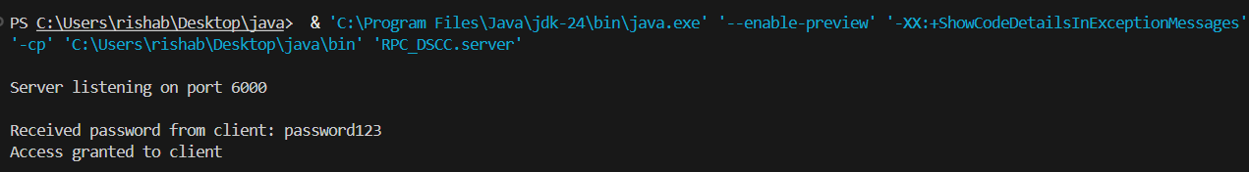
Output:

Learning Outcomes:

Experiment – 2

Aim: Implement the concept of Remote Method Invocation in Java

Theory:

Remote Method Invocation (RMI) is a Java mechanism that allows an object on one machine to invoke methods of an object running on another machine. It extends the idea of Remote Procedure Call (RPC) into the object-oriented world by enabling communication between distributed Java objects.

The RMI system hides the complexity of network communication, automatically handling object serialization, method invocation, and return value transmission. It uses a remote interface to define accessible methods, a server implementation to provide functionality, and an RMI registry to register and locate remote objects.

When a client calls a remote method, the stub on the client side communicates with the skeleton on the server side (automatically handled in modern Java versions). This process allows distributed Java applications to behave as if all objects were local, simplifying the design of networked systems such as chat servers, online banking, and multiplayer games.

Code:

- AddInterface.java

import java.rmi.*;

public interface AddInterface extends Remote {
int addNumbers(int a, int b) throws RemoteException;
}

- AddServer.java

import java.rmi.*;
import java.rmi.server.*;
import java.rmi.registry.*;

public class AddServer extends UnicastRemoteObject implements AddInterface {

protected AddServer() throws RemoteException {
super();
}

public int addNumbers(int a, int b) throws RemoteException {
System.out.println("Server adding: " + a + " + " + b);
return a + b;
}

public static void main(String[] args) {
try {
AddServer server = new AddServer();
LocateRegistry.createRegistry(1099); // Start RMI registry
Naming.rebind("AddService", server);
System.out.println("Server is ready...");
} catch (Exception e) {
System.out.println("Server error: " + e);
}
}
}

- AddClient.java

import java.rmi.Naming;

public class AddClient {
public static void main(String[] args) {
try {
AddInterface stub = (AddInterface) Naming.lookup("rmi://localhost/AddService");
int result = stub.addNumbers(15, 25);
System.out.println("Client: The sum is " + result);
} catch (Exception e) {
System.out.println("Client error: " + e);
}
}
}

Output:
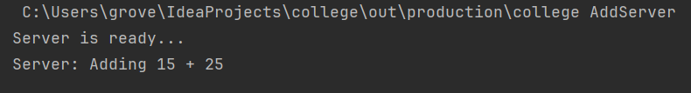
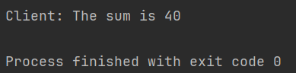

Learning Outcomes:

Experiment – 3

Aim: Write a Program in Java to implement Lamport’s Logical Clock

Theory:

In a distributed system, there is no global clock to provide a common notion of time among processes. Lamport’s Logical Clock, introduced by Leslie Lamport in 1978, provides a method for ordering events in such systems based on causality rather than real time.

Each process in the system maintains a logical clock — a counter that increments for every internal event. When a process sends a message, it includes its current clock value. Upon receiving a message, the receiver updates its clock to be greater than both its current value and the received timestamp. This ensures that if an event a causally affects event b, then the logical time of a is less than that of b (denoted as a → b ⇒ C(a) < C(b)).

Lamport’s algorithm thus enforces a partial ordering of events in a distributed system, ensuring consistency without the need for physical time synchronization. It is a foundational concept for understanding causal relationships in distributed algorithms such as mutual exclusion, checkpointing, and synchronization protocols.

Code:
import java.util.*;

public class LamportClock {
static class Process {
int id;
int clock;

Process(int id) {
this.id = id;
this.clock = 0;
}

void internalEvent() {
clock++;
System.out.println("Process " + id + " - Internal event, clock: " + clock);
}

int sendEvent() {
clock++;
System.out.println("Process " + id + " - sends message, clock: " + clock);
return clock;
}

void receiveEvent(int msgClock) {
clock = Math.max(clock, msgClock) + 1;
System.out.println("Process " + id + " - receives message, clock: " + clock);
}
}

public static void main(String[] args) {
Process p1 = new Process(1);
Process p2 = new Process(2);
Process p3 = new Process(3);

// Simulate events
p1.internalEvent();
int msg1 = p1.sendEvent();
p2.receiveEvent(msg1);

p2.internalEvent();
int msg2 = p2.sendEvent();
p3.receiveEvent(msg2);

p3.internalEvent();
int msg3 = p3.sendEvent();
p1.receiveEvent(msg3);

// Final clocks
System.out.println("\nFinal Clock Values:");
System.out.println("Process 1 Clock: " + p1.clock);
System.out.println("Process 2 Clock: " + p2.clock);
System.out.println("Process 3 Clock: " + p3.clock);
}
}

Output:
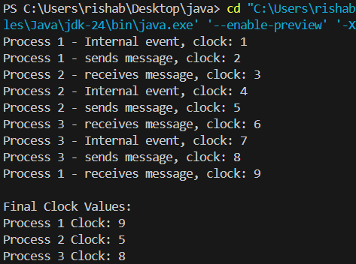

Learning Outcomes:

Experiment – 4

Aim: Implement mutual exclusion service using Lamport’s Mutual Exclusion Algorithm.

Theory:
Mutual exclusion in distributed systems ensures that when one process is executing in its critical section, no other process is allowed to enter its own critical section. Lamport’s Mutual Exclusion Algorithm achieves this without using a central coordinator or shared memory.
It is based on Lamport’s Logical Clock and uses message passing for coordination. Each process maintains a timestamped request queue. When a process wants to enter its critical section, it sends a request message with its timestamp to all other processes. A process grants permission if it is not interested in entering its own critical section or if the requesting timestamp is earlier than its own request.
Once a process receives permission (a reply message) from all other processes, it enters its critical section. After finishing, it sends a release message to notify others to update their request queues. This ensures fair ordering and no starvation, as requests are granted strictly based on their timestamps.

Code:

import java.util.*;

class LamportMutexExclusion {
static class Process implements Comparable<Process> {
boolean requestingCS = false;
int clock = 0;
int id;
Process(int id) {
this.id = id;
}
void incrementClock(int received) {
clock = Math.max(clock, received) + 1;
}
void requestCS(List<Process> processes) {
requestingCS = true;
clock++;
System.out.println("Process " + id + " requests CS with clock " + clock);
for (Process p : processes) {
if (p.id != this.id) p.receiveRequest(clock, this.id);
}
}
void receiveRequest(int receivedClock, int senderId) {
incrementClock(receivedClock);
System.out.println("Process " + id + " received request from " + senderId + ", clock updated to " + clock);
}
void releaseCS(List<Process> processes) {
requestingCS = false;
clock++;
System.out.println("Process " + id + " releases CS with clock " + clock);
for (Process p : processes) {
if (p.id != this.id) p.receiveRelease(clock, this.id);
}
}
void receiveRelease(int receivedClock, int senderId) {
incrementClock(receivedClock);
System.out.println("Process " + id + " received release from " + senderId + ", clock updated to " + clock);
}
@Override
public int compareTo(Process o) {
if (this.clock != o.clock) return Integer.compare(this.clock, o.clock);
return Integer.compare(this.id, o.id);
}
}
public static void main(String[] args) {
Process p1 = new Process(1);
Process p2 = new Process(2);
Process p3 = new Process(3);

List<Process> processes = Arrays.asList(p1, p2, p3);

p1.requestCS(processes);
p2.requestCS(processes);

// p2 enters CS before p1 because it has lower timestamp
System.out.println("Process 2 enters CS");
p2.releaseCS(processes);
p1.requestCS(processes);
System.out.println("Process 1 enters CS");
p1.releaseCS(processes);
}
}

Output:
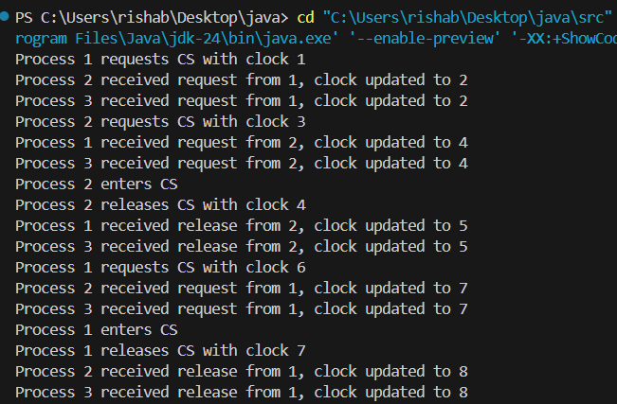

Learning Outcomes:

EXPERIMENT – 5

AIM: Install Hadoop on Windows

THEORY:
Hadoop is an open-source framework developed by Apache that allows for distributed processing of large data sets across clusters of computers using simple programming models. It is designed to scale up from a single server to thousands of machines, each offering local computation and storage.
Hadoop consists mainly of two components:
- Hadoop Distributed File System (HDFS): Provides high-throughput access to application data.
- MapReduce: A programming model for processing large data sets in parallel.
To install Hadoop on Windows, we set up a single-node pseudo-distributed cluster. This means Hadoop runs on a single machine but simulates distributed behaviour.
Steps to Install Hadoop on Windows:-

- Install Java
• Download and install JDK (Java 8 or Java 11).
• Set environment variables:
JAVA_HOME = C:\Program Files\Java\jdk1.8.0_xx
PATH = %JAVA_HOME%\bin

- Download Hadoop
• Visit https://hadoop.apache.org/releases.html
• Download the latest stable Hadoop binary.
• Extract the folder to:
C:\hadoop

- Set Hadoop Environment Variables
Open System Properties → Environment Variables → Add:
HADOOP_HOME = C:\hadoop
PATH = %HADOOP_HOME%\bin
Then edit the file:
C:\hadoop\etc\hadoop\hadoop-env.cmd
Add this line:
set JAVA_HOME=C:\Program Files\Java\jdk1.8.0_xx

- Configure Hadoop XML Files
Open files inside C:\hadoop\etc\hadoop and make the following changes:
<configuration>
<property>
<name>fs.defaultFS</name>
<value>hdfs://localhost:9000</value>
</property>
</configuration>

<configuration>
<property>
<name>dfs.replication</name>
<value>1</value>
</property>
<property>
<name>dfs.namenode.name.dir</name>
<value>file:/C:/hadoop/data/namenode</value>
</property>
<property>
<name>dfs.datanode.data.dir</name>
<value>file:/C:/hadoop/data/datanode</value>
</property>
</configuration>

<configuration>
<property>
<name>mapreduce.framework.name</name>
<value>yarn</value>
</property>
</configuration>

<configuration>
<property>
<name>yarn.nodemanager.aux-services</name>
<value>mapreduce_shuffle</value>
</property>
</configuration>

- Format the Hadoop NameNode
Open Command Prompt and run:
hdfs namenode –format

- Start Hadoop Services
Run the following commands one by one:
start-dfs.cmd
start-yarn.cmd

EXPERIMENT – 6
AIM: Run a simple application on single node Hadoop Cluster.

THEORY:

Hadoop is an open source framework used to store and process large datasets using a distributed computing model. A single node Hadoop cluster means that all the Hadoop daemons such as NameNode, DataNode, ResourceManager, and NodeManager run on a single machine. This is useful for learning, testing, and development.
To run a simple application on a single node Hadoop cluster, we first need to set up Hadoop and configure it for single node operation. Then we can write a simple MapReduce program in Java. MapReduce is a programming model used for processing large datasets in parallel. It consists of two main functions: Mapper and Reducer. Mapper processes input data and produces key-value pairs, while Reducer aggregates the values corresponding to each key.

CODE:

import java.io.IOException;
import org.apache.hadoop.conf.Configuration;
import org.apache.hadoop.fs.Path;
import org.apache.hadoop.io.IntWritable;
import org.apache.hadoop.io.Text;
import org.apache.hadoop.mapreduce.Job;
import org.apache.hadoop.mapreduce.Mapper;
import org.apache.hadoop.mapreduce.Reducer;
import org.apache.hadoop.mapreduce.lib.input.FileInputFormat;
import org.apache.hadoop.mapreduce.lib.output.FileOutputFormat;
import java.util.StringTokenizer;

public class WordCount {
public static class TokenizerMapper
extends Mapper<Object, Text, Text, IntWritable> {
private final static IntWritable one = new IntWritable(1);
private Text word = new Text();
public void map(Object key, Text value, Context context
) throws IOException, InterruptedException {
StringTokenizer itr = new StringTokenizer(value.toString());
while (itr.hasMoreTokens()) {
word.set(itr.nextToken());
context.write(word, one);
}
}
}
public static class IntSumReducer
extends Reducer<Text, IntWritable, Text, IntWritable> {
private IntWritable result = new IntWritable();

public void reduce(Text key, Iterable<IntWritable> values,
Context context
) throws IOException, InterruptedException {
int sum = 0;
for (IntWritable val : values) {
sum += val.get();
}
result.set(sum);
context.write(key, result);
}
}
public static void main(String[] args) throws Exception {
Configuration conf = new Configuration();
Job job = Job.getInstance(conf, "word count");
job.setJarByClass(WordCount.class);
job.setMapperClass(TokenizerMapper.class);
job.setCombinerClass(IntSumReducer.class);
job.setReducerClass(IntSumReducer.class);
job.setOutputKeyClass(Text.class);
job.setOutputValueClass(IntWritable.class);
FileInputFormat.addInputPath(job, new Path(args[0]));
FileOutputFormat.setOutputPath(job, new Path(args[1]));
System.exit(job.waitForCompletion(true) ? 0 : 1);
}
}

OUTPUT:
Input.txt:
hello world hello hadoop

output:
hadoop 1
hello 2
world 1

LEARNING OUTCOME:

EXPERIMENT – 7
AIM: Install Google App Engine / AWS and develop a simple web application.

THEORY:

Google App Engine (GAE) and AWS (Amazon Web Services) provide cloud platforms to deploy and run applications without managing physical servers. They allow scalable, reliable, and managed hosting for web applications.
A simple web application can be built using Python (Flask) or Java (Spring Boot) and deployed on GAE or AWS. The workflow is:
- Develop the application locally using your preferred framework.
- Set up the cloud environment (GAE or AWS Elastic Beanstalk / AWS Lambda).
- Deploy the application to the cloud using the provided CLI tools.
- Access the application via a public URL.
Google App Engine supports standard and flexible environments. AWS Elastic Beanstalk automates deployment, scaling, and monitoring.

CODE:

mkdir MyWebApp
cd MyWebApp

# Create main.py
echo "from flask import Flask

app = Flask(__name__)

@app.route('/')
def home():
return \"Hello World! Welcome to my first Google App Engine web app.\"

if __name__ == '__main__':
app.run(host='0.0.0.0', port=8080, debug=True)" > main.py

# Create requirements.txt
echo "Flask==2.3.2" > requirements.txt

# Create app.yaml
echo "runtime: python39

handlers:
- url: /.*
script: auto" > app.yaml

echo "Project MyWebApp created successfully!"
To deploy on Google App Engine:
gcloud auth login
gcloud config set project PROJECT_ID
gcloud app deploy
gcloud app browse

OUTPUT :

Hello World! Welcome to my first Google App Engine web app.

LEARNING OUTCOME :

