Image resolution is heavily dependent on the hardware limitations. To increase image resolution we have been using traditional interpolation techniques like linear and cubic interpolation. Advance frequency-based techniques are also utilized like Discrete wavelet transformation where high accuracy is desired.

However, with the advancement in deep learning, a technique to improve the resolution of images has been developed which is knows and Super Resolution GANs. A variant of Generative Adversarial Network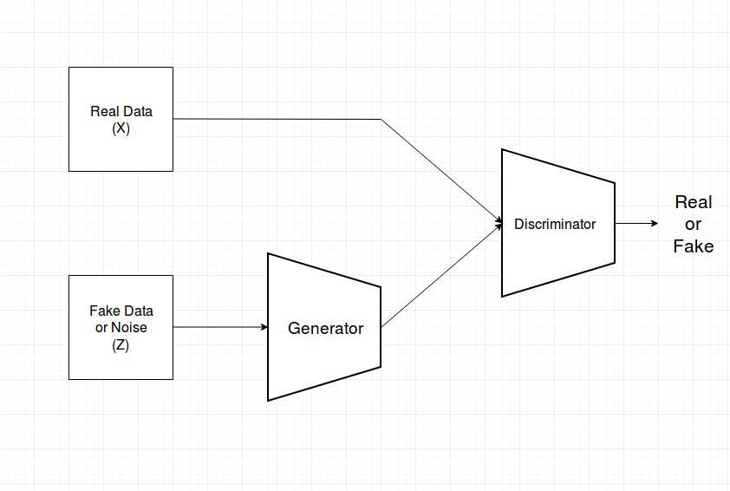

GANs basically have two components, one is Generators which will generate data from Fake input. The aim of the generator is to generated data as close as possible to the real data. The other component Discriminator, the discriminator will try to distinguish between the generated output by the generator and the real output. The original Paper of GANs is provided in the links below

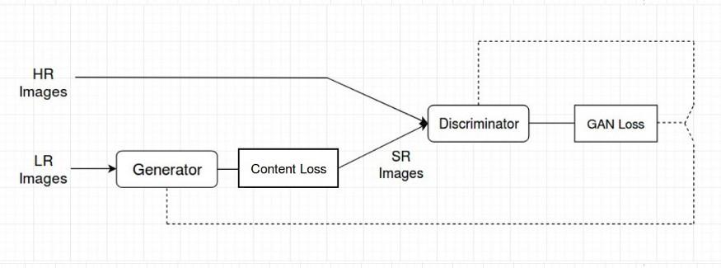

For SRGANs we are converting a low-resolution input image to a high-resolution image (aka super-resolution image). For this purpose, we require to train the network on images. We want the generator to produce a super-resolution image from a low-resolution image. We would give input to the generator out a low-resolution image and the output would be a super-resolution image. Now the discriminator acts as a classifier that would classify between the generated image and the high-resolution image.

The architecture of both Generator network and Discriminator network which is used for this Article is described below.

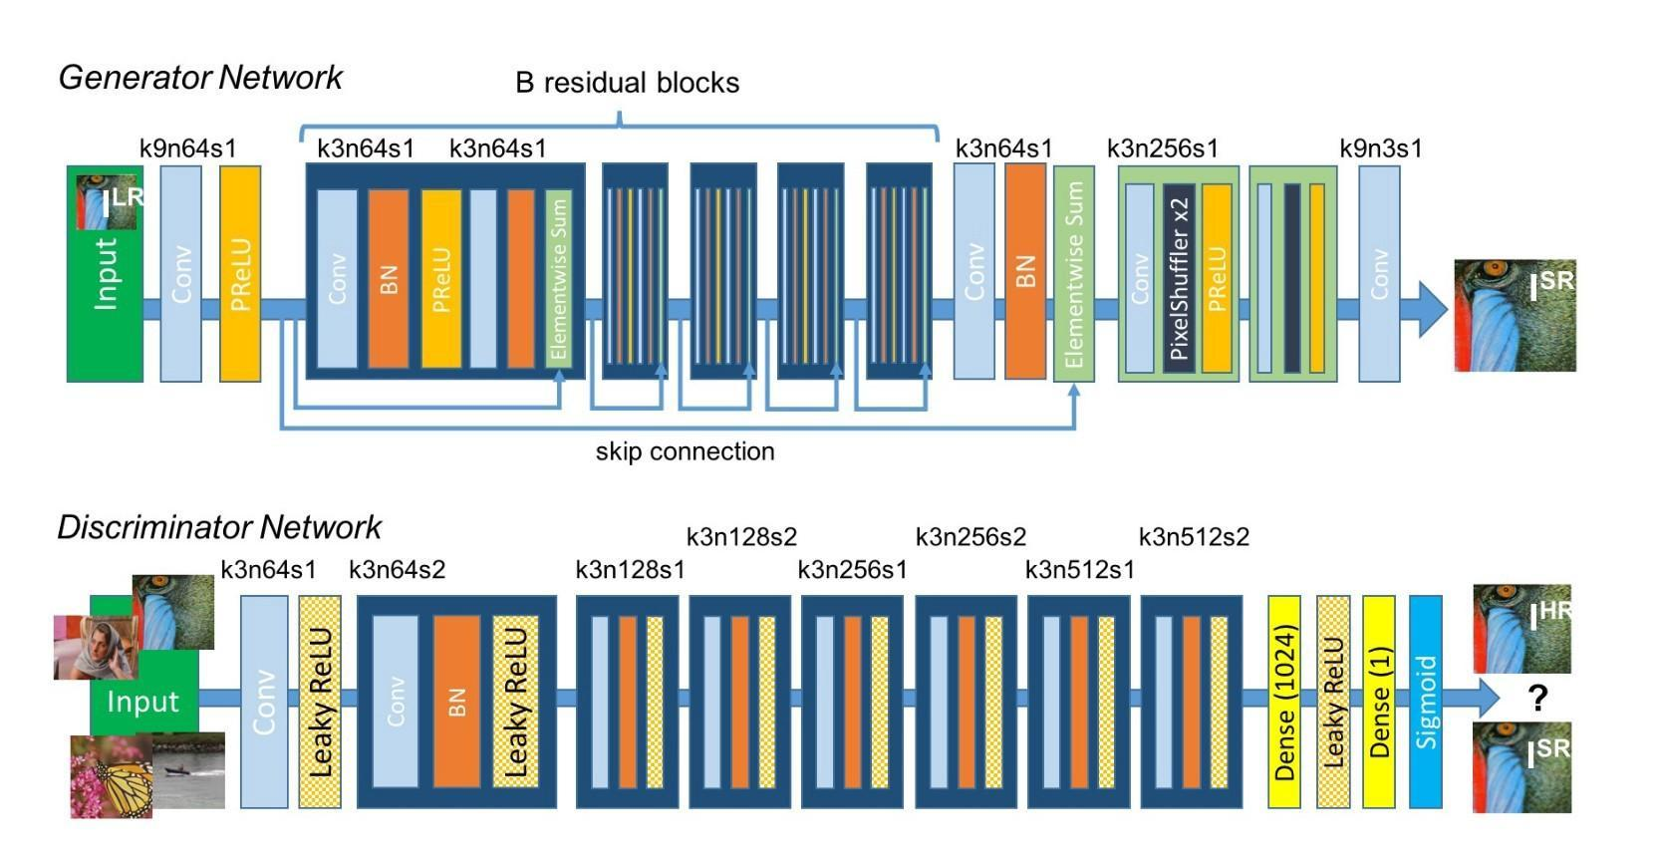

The original Paper proposes a simpler method however we are using a bit advanced method, the link of the original paper will be provided with this article. Few things to note from the architecture here,

* The residual learning framework eases the training of these networks, and enables them to be substantially deeper, leading to improved performance. We are using 16 residual blocks in the Generator block of the neural network with upsampling network twice. The generator also implements skip connections similar to ResNet Architecture.
* k3n64s1 this means kernel 3, channels 64 and strides 1.
* To compare two images and compare them we dont required to use all the pixels as the computation would be heavy. Instead, we compare the important features of two images. For this purpose we use Convolution Neural network Architectures which are pre-trained and we dont required to train them further. In this Architecture we use VGG19 Architecture as a Cconvolution Neural Network model to get the perpetual loss. We future took the Root Mean Square error of the different in features of two images. For learning more about perpetual losses the link to the paper is provided.
* For the discriminator, we are using the standard cross-entropy loss function as we classify the images as real or fake.
* The activation function which are used is PRelu(Parameterized Relu).
* The optimizer for loss minimization is Adam for both Generator and Discriminator as they give stable results as compared to other optimizers

The overall loss function here consist of two parts, One of them in Content loss given by the generator using VGG19 Architecture. The other one consist of the loss by Discriminator given by Cross-entropy function. The desired results are achieved when the discriminator gives similar results when high resolution image and generated super resolution image and the generator losses is low. This means that discriminator is not able to distinguish between real image and generated image because the generated image is close enough to the real image.

Below are the images which consist of the results of SRGANS

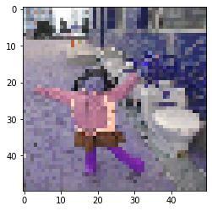

Input low-resolution image

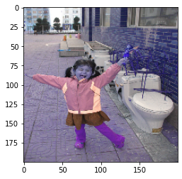

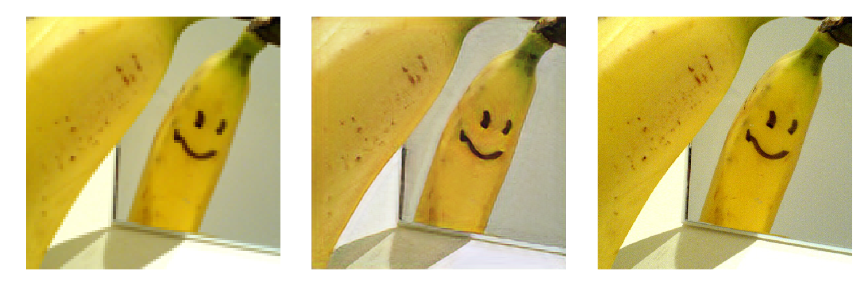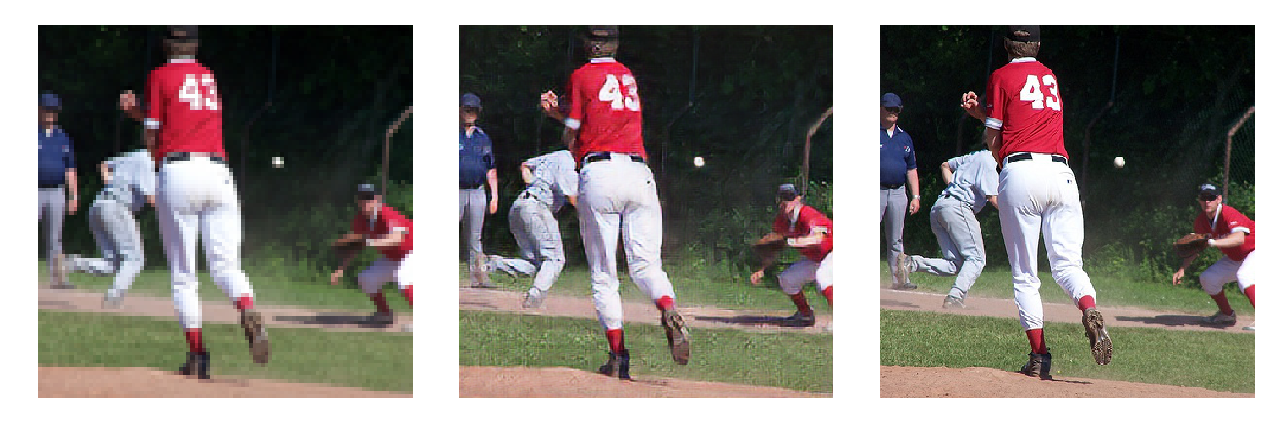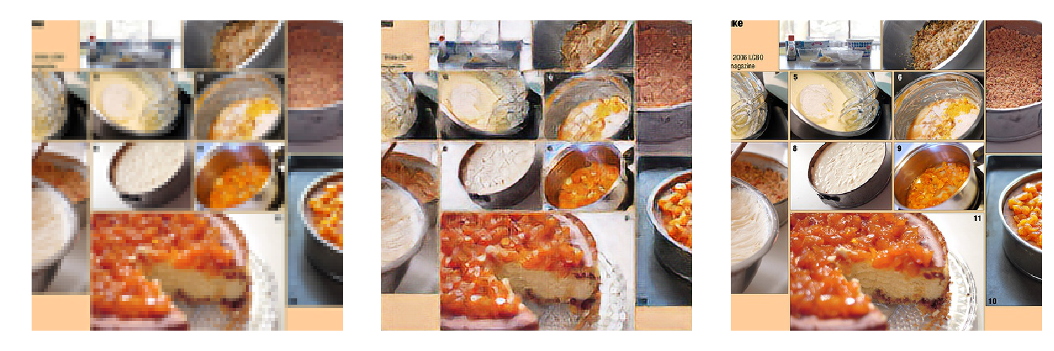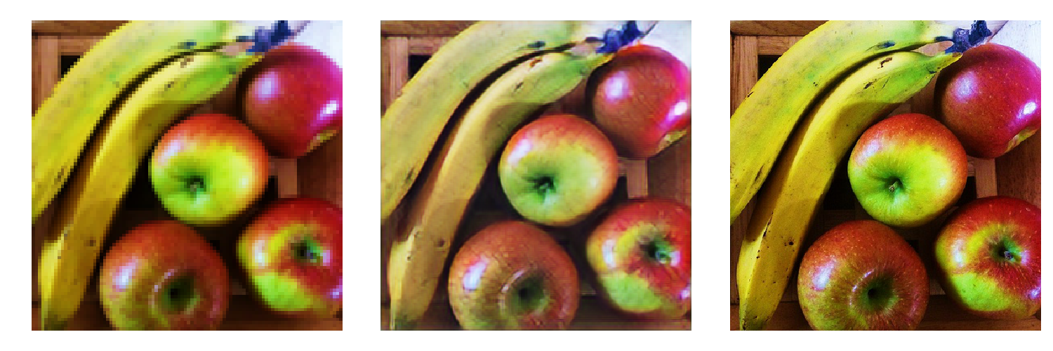

Links for educational purpose

Adversarial Network :[*https://arxiv.org/pdf/1609.04802.pdf*](https://arxiv.org/pdf/1609.04802.pdf)

Perceptual loss: <https://arxiv.org/pdf/1603.08155.pdf>

Deep Residual Learning for Image Recognition : <https://arxiv.org/pdf/1512.03385.pdf>

GANs Original Paper: <https://arxiv.org/abs/1406.2661>

SRGANS Paper: <https://arxiv.org/abs/1609.04802>