ExpenseFlow
Employee Expense & Reimbursement Management System

Part I: Project Context & Executive Overview

1.1. Project Overview
ExpenseFlow is an enterprise-grade low-code business application designed and implemented on the Microsoft Power Platform. It streamlines the complete lifecycle of corporate expense submissions, managerial approvals, finance auditing, bank disbursement reconciliation, and automated employee communication.
By leveraging Microsoft Dataverse as a secure, relational cloud datastore, ExpenseFlow replaces fragmented manual email threads and spreadsheets with an audited, multi-persona operational architecture:
- Frontline Employee Self-Service (Power Apps Canvas App): Empowers employees to draft claims, itemize transactions across categories (Flight, Lodging, Meals, Software, Transport), attach digital receipt proofs, track live submission statuses, and review historic payouts.
- Back-Office Audit & Reconciliation (Power Apps Model-Driven App): Equips the Finance and Accounts department with a centralized administration console (ExpenseFlow Admin & Finance Console) featuring specialized views (Pending Reimbursements), itemized subgrids, and a 4-stage Business Process Flow (BPF) to verify claims before disbursement.
- Automated Process Governance (Power Automate Cloud Flows): Enforces organization expense policies through automated tiered routing. Standard claims (≤ ₹25,000) require only reporting manager approval, while high-value claims (> ₹25,000) automatically escalate to Finance Review. Once settled, an event-driven cloud flow dispatches an HTML confirmation receipt containing the bank UTR transaction reference.
- Role-Based Access Control (Dataverse Security Roles): Enforces strict row-level data isolation between frontline staff (ExpenseFlow - Employee) and back-office auditors (ExpenseFlow - Finance Auditor).

1.2. Business Problem
Prior to the implementation of ExpenseFlow, corporate expense management was hindered by significant administrative overhead, compliance exposure, and operational delays:
- Submission & Reconciliation Friction: Employees manually compiled paper receipts and spreadsheets, resulting in frequent calculation errors, missing receipt attachments, and time-consuming back-and-forth communication with the Finance team.
- Approval Bottlenecks & Lack of Escalation: Expense claims lingered in manager inboxes without automated routing or status tracking, while high-value expenses lacked mandatory secondary financial scrutiny.
- Segregation of Duties & Security Vulnerabilities: Without robust database-level security and role-appropriate forms, employees could view peer submissions, and non-finance personnel could theoretically view or modify internal audit fields such as approval statuses or bank payout references.
- Manual Payout Notifications: Finance personnel spent hours drafting manual emails to inform claimants of bank transaction reference numbers (UTR) after batch disbursements, leading to repeated status inquiries.

1.3. Project Objectives
- Centralized Relational Architecture: Establish a normalized relational schema in Microsoft Dataverse linking Departments, Employees, Expense Reports (Parent Headers), and Expenses (Child Line Items).
- Role-Segregated Front-End Interfaces: Deliver an intuitive, multi-screen Canvas App for frontline staff and a governed Model-Driven App with related subgrids for back-office Finance Auditors.
- Multi-Tier Automated Routing: Build a dynamic Power Automate approval engine with automated Dataverse state transitions, rejection feedback loops, and conditional escalation at ₹25,000.
- 4-Stage Visual Process Governance: Enforce a mandatory Business Process Flow (Expense Reimbursement Process) across Submission, Manager Review, Finance Review, and Disbursement stages.
- Strict Row-Level Security (RBAC): Implement custom Dataverse security roles ensuring employees can only access their own claims (User scope) while granting global auditing clearance to Finance (Organization scope).

Part II: Technical Specification & Implementation Architecture

2.1. Dataverse Schema & Table Format
The operational backend is deployed on Microsoft Dataverse within the Dev_Arindam environment. The data architecture follows a strict 1-to-Many (1:*) relational hierarchy enforcing referential integrity across four core tables and a global choice option set.

2.1.1. Department Table (arii_department)
Master dimension table capturing business unit cost centers, geographic regions, and annual operational expense budgets.
Column Display Name | Logical / Schema Name | Data Type | Constraint / Requirement | Business Description
Department Name | arii_name | Single Line of Text | Primary Column (Required) | Full name of the department (e.g., Engineering, Sales & Marketing).
Department ID | arii_departmentid | Single Line of Text | Unique Alternate Key | Unique business identifier (D001, D002, etc.).
Cost Center | arii_costcenter | Single Line of Text | Business Required | Accounting cost center code (CC-101, CC-102, etc.).
Region | arii_region | Choice / Text | Business Required | Geographical operating zone (North, West, South, East).
Annual Budget | arii_annualbudget | Currency | Business Required | Allocated annual expense threshold in INR (₹).
Status | statecode | Status | System | Active / Inactive operational state of the department.

2.1.2. Employee Table (arii_employee)
Stores employee profiles, corporate email addresses, reporting managers, and department lookup links.
Column Display Name | Logical / Schema Name | Data Type | Constraint / Requirement | Business Description
Employee Name | arii_name | Single Line of Text | Primary Column (Required) | Full name of the employee (e.g., Arindam Sharma, Priya Singh).
Employee ID | arii_employeeid | Single Line of Text | Unique Alternate Key | Unique corporate employee identifier (EMP-101, EMP-102).
Email | arii_email | Email | Business Required | Corporate email address used for automated Outlook notifications.
Designation | arii_designation | Single Line of Text | Optional | Job title / organizational role.
Department | arii_department | Lookup | Business Required (N:1) | Foreign Key lookup linking to Department (arii_department).
Manager Name | arii_managername | Single Line of Text | Business Required | Reporting manager responsible for Tier-1 approvals.
Manager Email | arii_manageremail | Email | Business Required | Manager's corporate email address for approval routing.

2.1.3. Expense Reports Table (arii_expensereport) — Parent Header
Captures the overarching claim container, trip dates, total rolled-up financial values, approval status, and bank payout references.
Column Display Name | Logical / Schema Name | Data Type | Constraint / Requirement | Business Description
Expense Report Name | arii_expensereportname | Single Line of Text | Primary Column (Required) | Report identifier or title (e.g., ER-0001 to ER-0029).
Employee | arii_employee | Lookup | Business Required (N:1) | Lookup linking the report to the submitting employee.
Expense Start Date | arii_expensestartdate | Date Only | Business Required | Beginning date of the business trip or expense period.
Expense End Date | arii_expenseenddate | Date Only | Business Required | Concluding date of the business trip or expense period.
Total Amount | arii_totalamount | Currency | Business Required | Aggregated rupee value (₹) of all child line items.
Status | arii_reportstatus | Choice (Option Set) | Business Required | Current workflow lifecycle state (Draft, Submitted, Paid, etc.).
Reimbursement Date | arii_reimbursementdate | Date Only | Optional | Date Finance disbursed funds to the employee's bank account.
Payment Reference | arii_paymentreference | Single Line of Text | Optional | Bank transaction UTR number recorded by Finance upon payout.
Finance Comments | arii_financecomments | Multiple Lines of Text | Optional | Internal audit and verification remarks by Finance Auditors.

2.1.4. Expenses Table (arii_expense) — Child Line Item
Stores individual transaction receipts, vendor names, expense categories, payment methods, and supporting file attachments.
Column Display Name | Logical / Schema Name | Data Type | Constraint / Requirement | Business Description
Expense ID | arii_name | Single Line of Text | Primary Column (Required) | Unique receipt identifier (EX-1001, EX-1002, etc.).
Expense Report | arii_expensereport | Lookup | Business Required (N:1) | Parent lookup linking the line item to Expense Reports.
Expense Date | arii_expensedate | Date Only | Business Required | Date the individual expenditure occurred.
Category | arii_category | Choice | Business Required | Spend classification (Flight, Lodging, Meals, Software, Transport).
Merchant | arii_merchant | Single Line of Text | Business Required | Vendor or establishment name (IndiGo, Taj Hotels, Uber).
Amount | arii_amount | Currency | Business Required | Line item transaction value in INR (₹).
Payment Method | arii_paymentmethod | Choice | Business Required | Corporate Card, Personal Card, or Personal Cash.
Description | arii_description | Multiple Lines of Text | Business Required | Business justification for the individual receipt (e.g., Cab, Flight to Mumbai).
Is Reimbursable | arii_isreimbursable | Two Options (Yes/No) | Business Required | True if paid personally by employee and eligible for cash payout.
Receipt | arii_receipt | File | Optional | Scanned invoice, photo, or PDF receipt attachment.

2.1.5. Global Option Set Mapping: Expense Report Status (arii_reportstatus)
To eliminate ambiguous string comparisons and ensure deterministic transitions in Power Fx and Power Automate OData filters, the status choice set maps to explicit integer values:
Status Display Name | Option Set Integer Value | Triggered By | Operational Meaning & Governance Rule
Draft | 475530000 | Employee (Canvas App) | Claim initialized locally/saved before formal submission.
Submitted | 475530001 | Employee (Canvas App) | Claim submitted; triggers the Multi-Tier Approval Cloud Flow.
Manager Approved | 475530002 | Power Automate | Reporting manager approved; evaluates ₹25,000 threshold.
Manager Rejected | 475530003 | Power Automate | Manager rejected claim; rejection email sent with comments.
Finance Review | 475530004 | Power Automate | Escalated secondary tier for high-value claims exceeding ₹25,000.
Finance Rejected | 475530005 | Power Automate | Finance Auditor rejected claim during secondary audit.
Reimbursement Processing | 475530008 | Power Automate | All approvals cleared; queued for Finance bank disbursement.
Paid | 475530009 | Finance Auditor (Modal/MDA) | Bank UTR recorded and funds disbursed; triggers Payout Receipt Flow.

2.2. Application & Security Refinements (Issues & Solutions)

2.2.1. UI, Delegation, and Governance Issues Addressed
During the initial prototype build and security review of the Canvas App and Dataverse environment, several design and governance challenges were identified:
- Exposed Back-Office Fields on Employee Creation Forms: Initial default forms in Create Expense Report (1000289470.heic) and Add Expense (1000289471.heic) exposed internal finance columns (Status, Reimbursement Date, Reimbursement Status, Finance Comments, and Payment Reference) to frontline submitters.
- Date Picker Time-Component Clutter: Default Dataverse Date/Time controls rendered redundant hour and minute dropdowns (00 : 00) next to Expense Start Date, Expense End Date, and Expense Date.
- Dataverse Delegation Warning on Dashboard KPIs: Client-side aggregation of Total Reimbursed (₹57,600.00) on Employee Dashboard (1000289469.heic) triggered a delegation warning triangle when summing across unfiltered Dataverse records.
- Unfiltered Cross-User Visibility Prior to RBAC: Before custom security role assignment, standard users could view expense reports submitted by other employees (ER-0001 to ER-0029) in My Expense Reports (1000289472.heic).
- Unfiltered Payout Flow Execution: Modifying any column on an Expense Report row risked re-triggering payout emails unless restricted by column and OData status filters.

2.2.2. Summary of Technical Solutions Implemented
- Segregation of Form Fields & Payout Modal Isolation: Restricted employee entry to business context (Start Date, End Date, line-item receipts) while isolating Payment Reference (UTR) and Reimbursement Date inside a role-restricted Finance Payout Modal on scrReportDetails and the back-office Model-Driven App.
- Delegation-Safe Power Fx Aggregation: Replaced raw summation with a filtered Coalesce(Sum(Filter('Expense Reports', 'Status (arii_reportstatus)' = 'Expense Report Status'.Paid), 'Total Amount'), 0) expression formatted in Indian Rupees (₹).
- Parent-Child Transactional Patching: Implemented an in-memory collection (colExpenses) on scrAddExpense paired with a two-stage Patch() and ForAll() loop that creates the parent Expense Report, rolls up Sum(colExpenses, Amount), and links all child receipts automatically.
- Trigger-Level OData Filtering in Power Automate: Configured Select columns (arii_reportstatus,arii_paymentreference,arii_reimbursementdate) and Filter rows (arii_reportstatus eq 475530009) on the Payout Notification flow so emails fire strictly when a report transitions to Paid.
- Row-Level RBAC Lockdown: Created ExpenseFlow - Employee (User read/write scope) and ExpenseFlow - Finance Auditor (Organization scope) roles, ensuring employees only see their own records and cannot open the Model-Driven App.

2.3. Final Application Screens & User Experience (Canvas App)
The frontline Power Apps Canvas App features a persistent dark left-hand navigation bar (Home Dashboard, Create Report, My Reports), a top application header displaying the logged-in user (Welcome, Arindam Sharma), and five dedicated operational screens:

2.3.1. Screen-by-Screen Specification
Screen Name | Header Title | Core Controls & Layout | Operational Functionality
scrHomeDashboard | Employee Dashboard | 3 KPI Summary Metrics (Total Reports: 26, Pending Approval: 9, Total Reimbursed: ₹57,600.00) + Left Navigation Bar. | Provides the signed-in employee with real-time visibility into their submission volume, pending approvals, and total disbursed reimbursements.
scrCreateReport | Create Expense Report | Date pickers (Expense Start Date, Expense End Date), Total Amount, status metadata, and Save action button. | Initializes the parent expense report container and captures the trip date range before adding itemized receipts.
scrAddExpense | Add Expense | Inputs for Amount, Category, Description, Expense Date, Cost Center, Is Reimbursable, Payment Method, Location, Receipt file upload (Upload file), Add Another, and Submit Report buttons. | Allows users to attach multiple itemized receipts to a single report (Add Another collects items into memory; Submit Report patches parent and child tables).
scrMyReports | My Expense Reports | Multi-column scrollable gallery (galReports) displaying Report ID (ER-0001 to ER-0029), Rupee Amount (₹650.00, ₹22,700.00), Timestamp, and Claimant Name. | Lists the user's submitted expense claims with one-click drill-through navigation (>) to the details screen.
scrReportDetails | Expense Report Details | Back button, child line-item gallery (650 - Cab, 12000 - Flight to Mumbai, 8000 - Hotel accommodation), parent metadata summary, and conditional Finance Payout Modal. | Displays itemized receipt breakdowns alongside parent report status and enables authorized Finance users to log bank UTR references and mark claims Paid.

2.3.2. Core Production Power Fx Formulas
1. Delegation-Safe Total Reimbursed KPI Formula (scrHomeDashboard):
Text(
Coalesce(
Sum(
Filter('Expense Reports', 'Status (arii_reportstatus)' = 'Expense Report Status'.Paid),
'Total Amount'
),
0
),
"[$-en-IN]₹#,##,##0.00"
)

2. Dynamic Status Badge Color Coding (galReports in scrMyReports):
Switch(
Text(ThisItem.'Status (arii_reportstatus)'),
"Draft", RGBA(241, 245, 249, 1),
"Submitted", RGBA(254, 243, 199, 1),
"Manager Approved", RGBA(224, 231, 255, 1),
"Reimbursement Processing", RGBA(219, 234, 254, 1),
"Paid", RGBA(220, 252, 231, 1),
"Manager Rejected", RGBA(254, 226, 226, 1),
RGBA(243, 244, 246, 1)
)

3. Multi-Item Collection (OnSelect of Add Another in scrAddExpense):
Collect(
colExpenses,
{
ExpenseDate: dpExpenseDate.SelectedDate,
Category: drpCategory.Selected.Value,
Merchant: txtMerchant.Text,
Amount: Value(txtAmount.Text),
Description: txtDescription.Text,
PaymentMethod: drpPaymentMethod.Selected.Value,
IsReimbursable: tglReimbursable.Value
}
);
Reset(dpExpenseDate); Reset(drpCategory); Reset(txtMerchant); Reset(txtAmount); Reset(txtDescription);

4. Parent-Child Transactional Patch (OnSelect of Submit Report in scrAddExpense):
// Step 1: Create Parent Expense Report Header
Set(
varNewReport,
Patch(
'Expense Reports',
Defaults('Expense Reports'),
{
'Expense Report Name': "ER-" & Text(Now(), "yyyyMMdd-hhmmss"),
'Expense Start Date': dpStartDate.SelectedDate,
'Expense End Date': dpEndDate.SelectedDate,
'Total Amount': Sum(colExpenses, Amount),
'Status': 'Expense Report Status'.Submitted
}
)
);
// Step 2: Patch All Related Child Line Items
ForAll(
colExpenses,
Patch(
'Expenses',
Defaults('Expenses'),
{
'Expense Report': varNewReport,
'Expense Date': ThisRecord.ExpenseDate,
'Category': ThisRecord.Category,
'Merchant': ThisRecord.Merchant,
'Amount': ThisRecord.Amount,
'Payment Method': ThisRecord.PaymentMethod,
'Is Reimbursable': ThisRecord.IsReimbursable
}
)
);
Clear(colExpenses);
Navigate(scrMyReports, ScreenTransition.Fade);

2.4. Architecture, Automation & Security Pointers and Snapshots

2.4.1. Power Automate Cloud Workflow 1: Multi-Tier Approval & Escalation Engine
- Trigger: Microsoft Dataverse – When a row is added or modified on Expense Reports (Change type: Added or Modified, Scope: Organization, Filter rows: arii_reportstatus eq 475530001).
- Tier 1 – Reporting Manager Review: Initiates a Start and wait for an approval (Approve/Reject - First to respond) action routed to the claimant's manager.
- If Rejected (Outcome = Reject): Updates Expense Report status to Manager Rejected (475530003) and dispatches an automated rejection email containing reviewer comments (responses[0]['comments']).
- If Approved (Outcome = Approve): Evaluates a Condition control checking Total Amount (arii_totalamount) is greater than 25000:
- Branch A – Standard Claim (≤ ₹25,000): Updates Status directly to Reimbursement Processing (475530008) and sends an approval confirmation email to the claimant.
- Branch B – High-Value Claim (> ₹25,000): Updates Status to Finance Review (475530004) and initiates a Tier-2 approval action assigned to the Finance Auditor. Upon Finance approval, updates Status to Reimbursement Processing (475530008).

2.4.2. Power Automate Cloud Workflow 2: ExpenseFlow - Notify Payout Disbursed
- Trigger: Microsoft Dataverse – When a row is modified on Expense Reports.
- Trigger Optimization: Select columns: arii_reportstatus, arii_paymentreference,arii_reimbursementdate. Filter rows (OData): arii_reportstatus eq 475530009.
- Action: Office 365 Outlook – Send an email (V2) delivering an HTML disbursement receipt table containing Report ID, Amount Paid, Payment Date, and Bank UTR / Ref.

2.4.3. Role-Based Access Control (RBAC) Security Matrix
Table / Resource | Privilege Type | ExpenseFlow - Employee Role | ExpenseFlow - Finance Auditor Role | Governance Rationale
Expense Reports | Create, Read, Write, Append, Append To | User Scope (Own records only) | Organization Scope (All records) | Isolates employee claims; grants global audit visibility to Finance.
Expenses (Line Items) | Create, Read, Write, Append, Append To | User Scope (Own records only) | Organization Scope (All records) | Prevents unauthorized modification of receipt line items.
Department & Employee | Read | Organization Scope | Organization Scope | Allows lookup dropdowns (cost centers, managers) to resolve cleanly.
Business Process Flow | Read, Write (Expense Reimbursement Process) | None | Organization Scope | Restricts BPF stage progression strictly to back-office Finance staff.
Model-Driven App | App Access (ExpenseFlow Admin & Finance Console) | Hidden / Denied | Shared / Granted | Blocks standard employees from opening the back-office console.

2.4.4. Architecture & Automation Snapshots
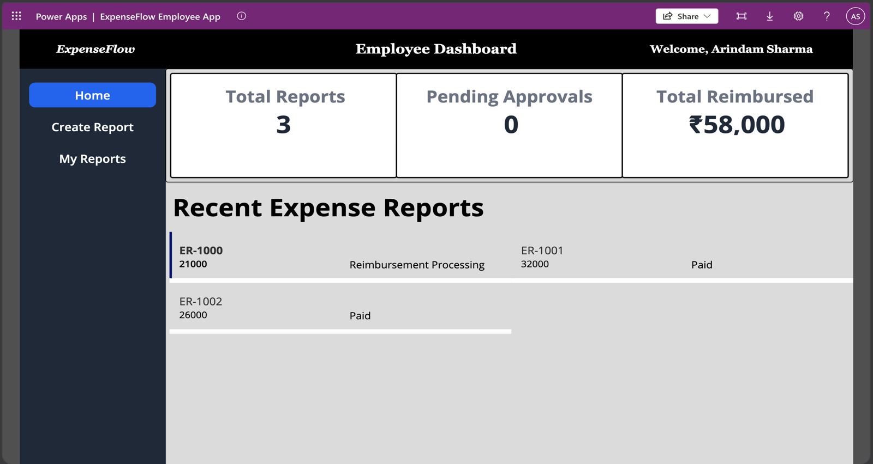Figure 4.1 – Canvas App Screens: Employee Dashboard
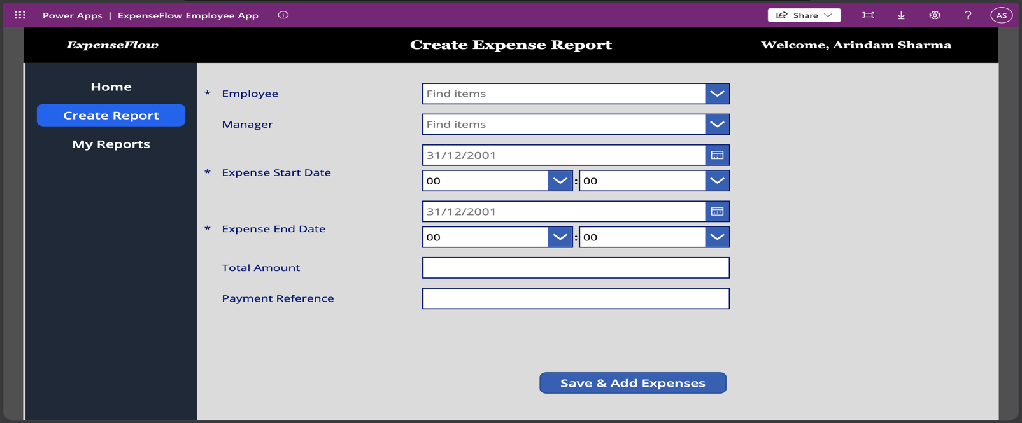Figure 4.2 – Canvas App Screens: Create Expense Report
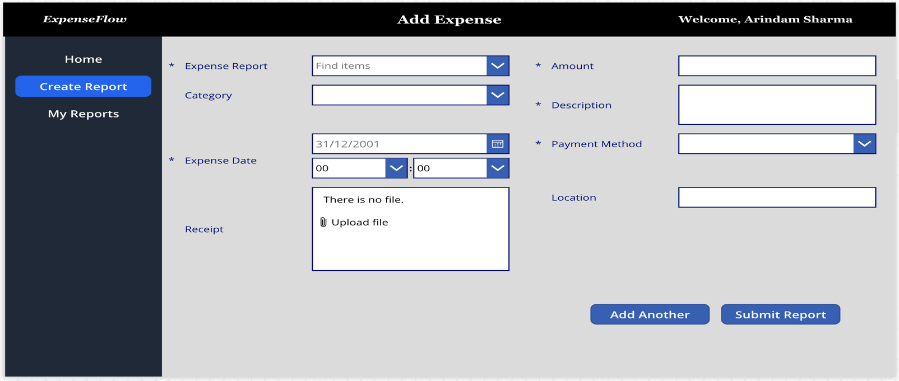Figure 4.3 – Canvas App Screens: Add Expense
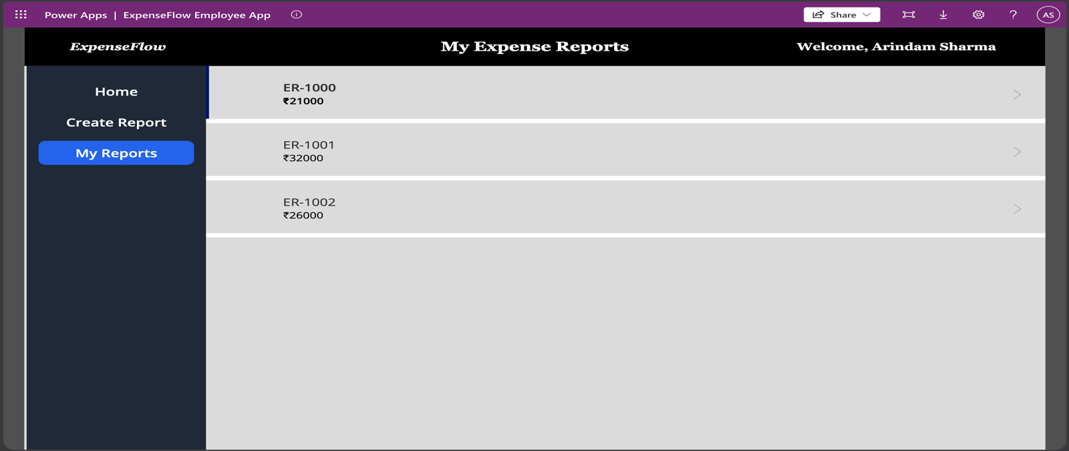 Figure 4.4 – Canvas App Screens: My Expense Reports
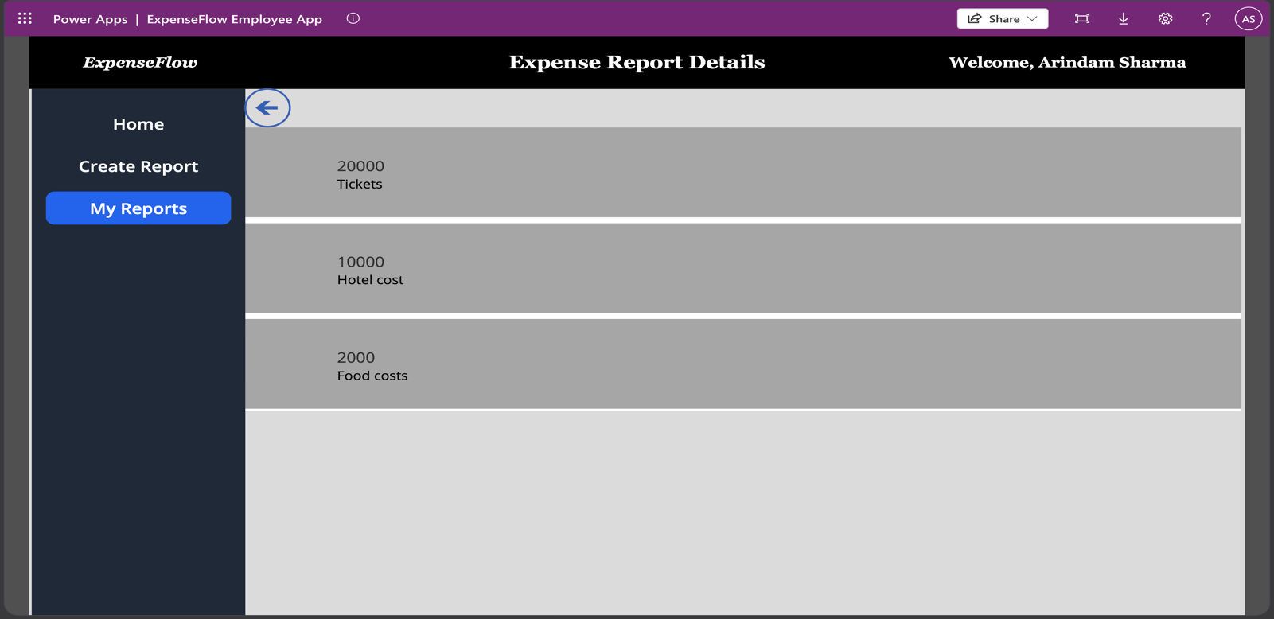 Figure 4.5 – Canvas App Screens: Expense Report Details
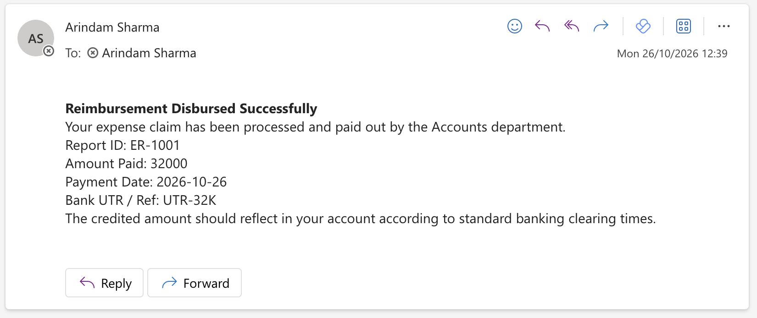Figure 4.6 – Power Automate Email: Received Outlook HTML payout confirmation email.
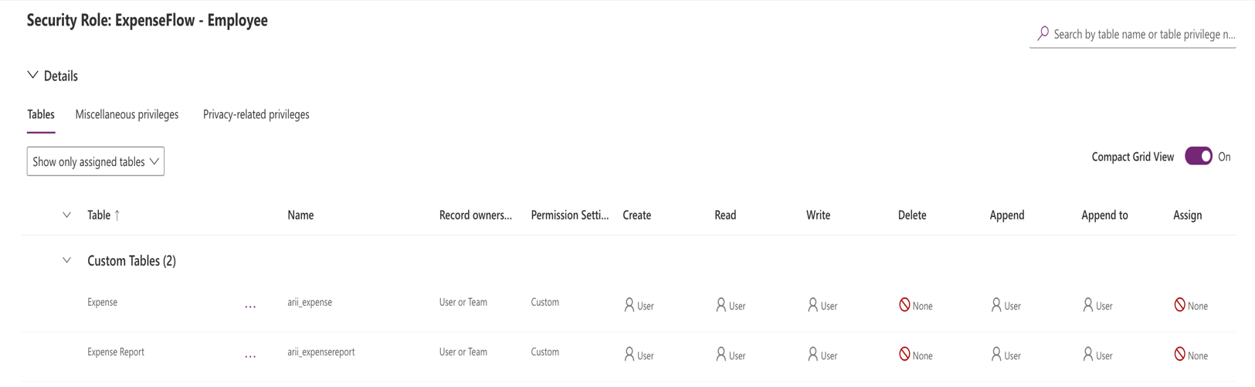Figure 4.7 – Dataverse Security Roles Matrix: ExpenseFlow - Employee

2.5. Back-Office Console Layout (Model-Driven App & BPF)
The back-office administration application (ExpenseFlow Admin & Finance Console) is built as a Power Apps Model-Driven App tailored for Finance Auditors.

2.5.1. Sitemap & Custom Operational Views
- Group 1 – Financial Operations (Expense Reports & Expenses):
- Active Expense Reports View: Displays Expense Report Name, Employee, Total Amount, Status, Submission Date, Reimbursement Date, and Payment Reference.
- Pending Reimbursements View: Filtered operational queue (Status Equals Reimbursement Processing) allowing Finance to process ready-to-pay claims immediately.
- Group 2 – Organization Setup (Employees & Departments): Enables administrators to maintain employee manager assignments, department cost centers, and annual budgets.

2.5.2. Main Form & Itemized Subgrid Architecture
The customized Expense Report Main Form features a two-column executive layout containing:
- Header & General Tab: Displays Expense Report ID, Employee lookup, Expense Start Date, Expense End Date, and Total Amount.
- Embedded Related Subgrid (Itemized Receipts & Expenses): Filtered to Show related records from the Expenses table, allowing auditors to inspect every child receipt (Cab - ₹650, Flight to Mumbai - ₹12,000, Hotel accommodation - ₹8,000) without leaving the parent record.
- Audit & Payout Section: Houses Status, Finance Reviewer, Finance Comments, Reimbursement Date, and Payment Reference (UTR).

2.5.3. 4-Stage Business Process Flow (Expense Reimbursement Process)
Rendered as an interactive chevron stage banner across the top of the Model-Driven App form:
BPF Stage | Stage Category | Mapped Dataverse Fields | Required Gatekeeper Rules | Stage Purpose
Stage 1: Submission | Qualify | Employee, Expense Start Date, Expense End Date, Total Amount | Employee & Total Amount Required | Confirms claimant identity, trip dates, and claim total.
Stage 2: Manager Review | Develop | Manager, Status (arii_reportstatus) | Status Required | Tracks first-tier managerial review and approval state.
Stage 3: Finance Review | Review | Finance Reviewer, Finance Comments, Status | Status Required | Governs secondary financial audit for claims > ₹25,000.
Stage 4: Disbursement | Close | Payment Reference, Reimbursement Date, Status | Payment Reference & Date Required | Captures bank UTR reference and locks the claim as Paid.

2.6. Final End-to-End Operational View & Verification Matrix

2.6.1. End-to-End Functional & Security Testing Matrix
The complete Power Platform solution was verified across five end-to-end operational and security test scenarios:
Test ID | Test Scenario | Execution Steps | Expected Outcome | Verified Result | Status
TC-01 | Tier-1 Standard Approval (≤ ₹25,000) | Submit a ₹21,000 claim in the Canvas App and approve as Manager. | Flow transitions Status directly from Submitted to Reimbursement Processing (475530008). | Status updated to 475530008; approval alert email received. | PASS
TC-02 | Tier-2 High-Value Escalation (> ₹25,000) | Submit a ₹35,000 claim in the Canvas App and approve as Manager. | Flow escalates claim to Finance Review (475530004) and awaits Finance Auditor approval. | Escalated to Finance Review; moved to 475530008 after 2nd approval. | PASS
TC-03 | Finance Payout Closure & UTR Receipt Email | Open a Reimbursement Processing claim, enter UTR-AXIS-99201, and click Mark as Paid. | Status updates to Paid (475530009); Payout Disbursed flow sends HTML receipt email. | Dataverse updated; formatted HTML receipt delivered to inbox. | PASS
TC-04 | Model-Driven App Subgrid & BPF Progression | Open ExpenseFlow Admin & Finance Console and inspect an active report. | 4-stage BPF chevron banner loads at top; related child receipts populate in subgrid. | BPF stages and child subgrid rendered and advanced cleanly. | PASS
TC-05 | Non-Admin RBAC Isolation Validation | Sign into Canvas App via InPrivate browser using a non-admin account assigned ExpenseFlow - Employee. | User submits claims without permission errors, sees only their own reports, and cannot access the Model-Driven App. | Clean submission verified; admin reports (ER-0001–ER-0029) hidden; MDA blocked. | PASS

2.6.2. Final Solution Snapshots Placeholder
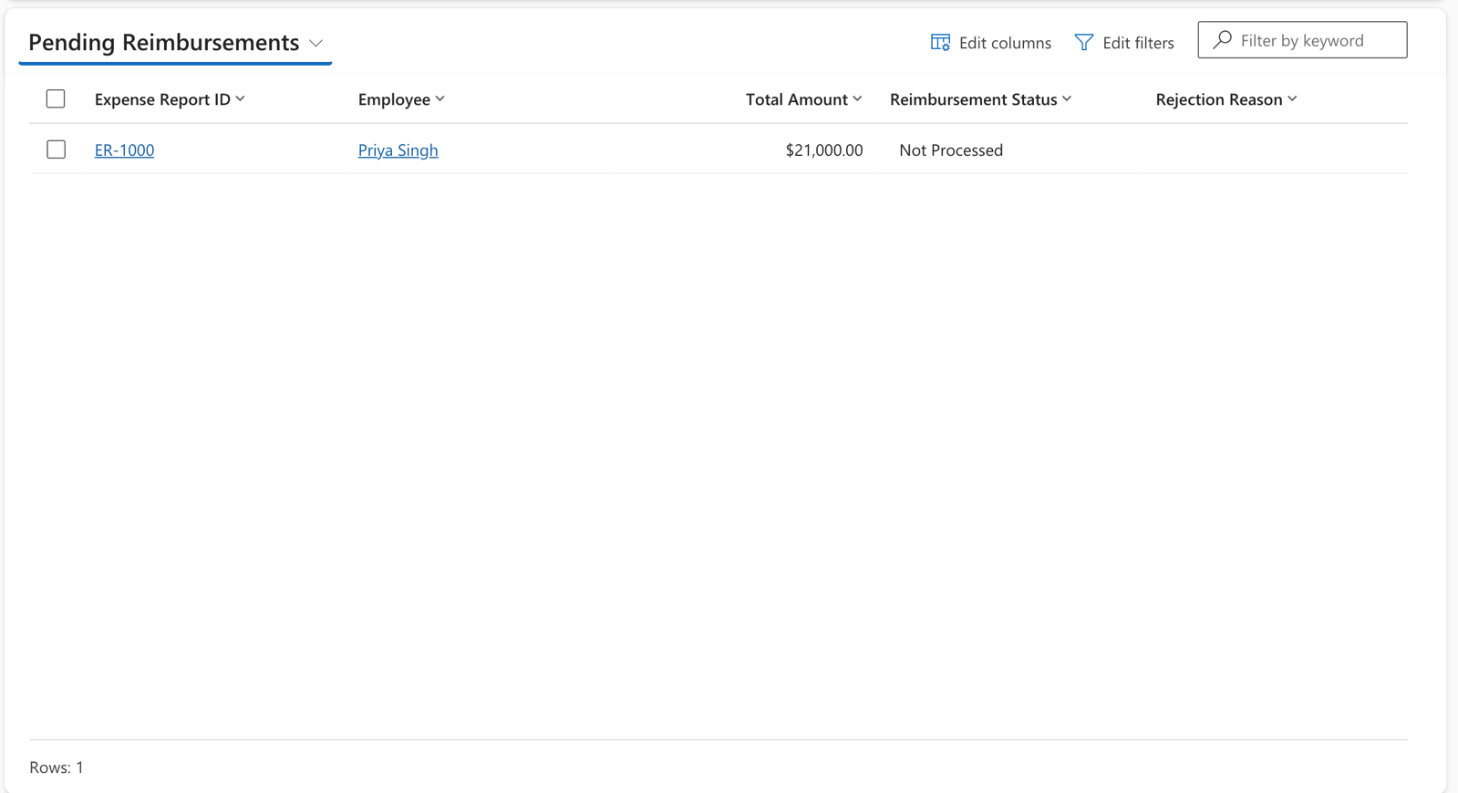Figure 6.1 – Model-Driven App: Pending Reimbursements view
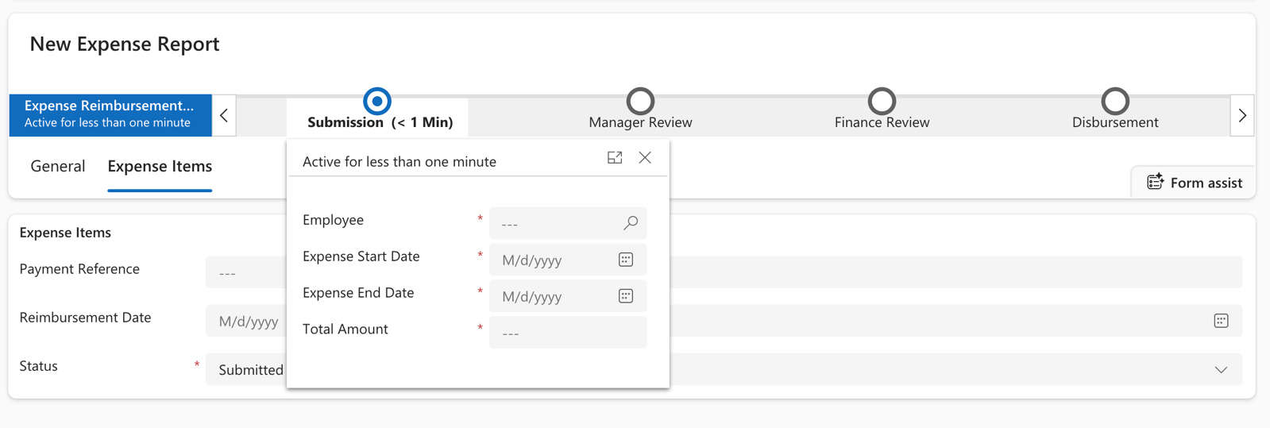Figure 6.2 – BPF Banner: 4-stage BPF chevron bar

