**How to set up unit tests for Jenkins to run**

**1) Create a .cpp in this directory:**

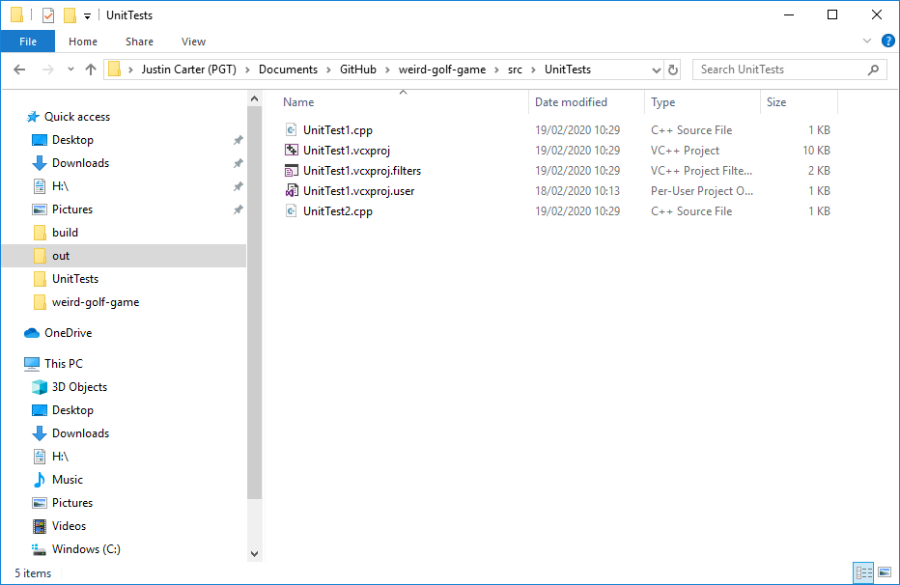

**2) Use ASSERT_WITH_FAILEXIT to define when a test should pass** 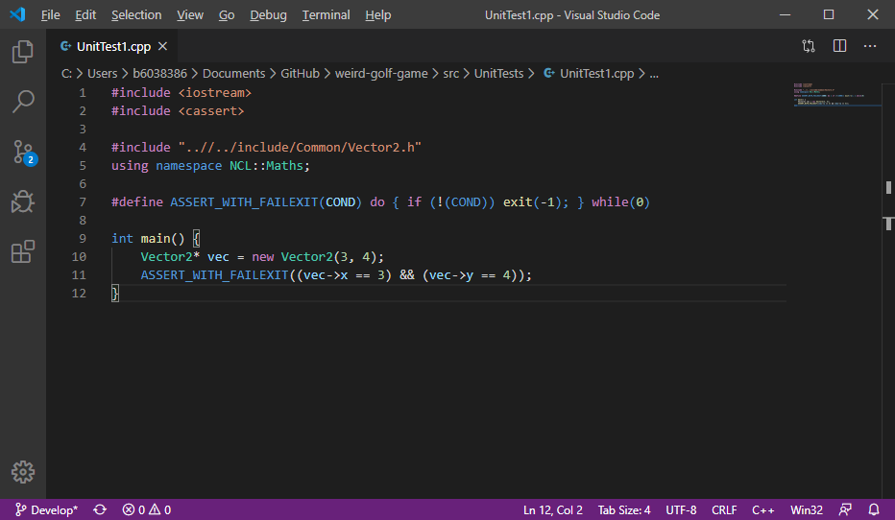

**3) Open the CMakeLists.txt and add the following lines at the bottom:**

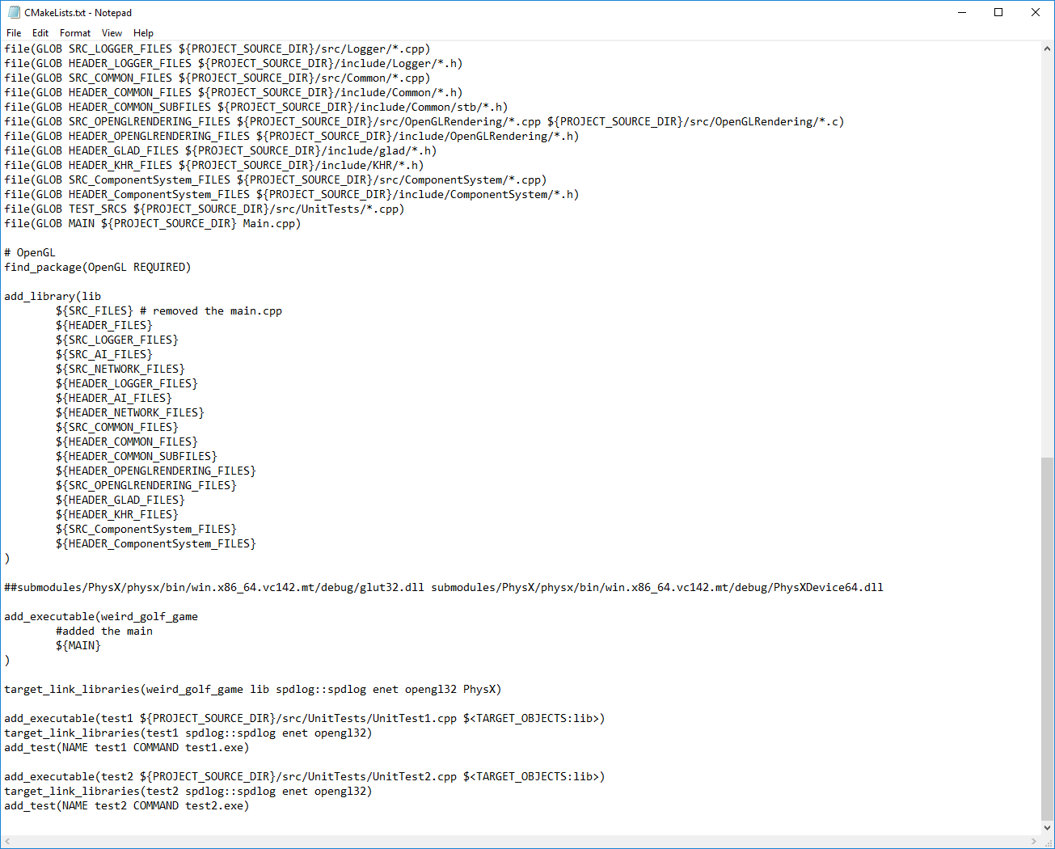

**Replace with the name of your test file**

**Replace “test1” with your own name for your test**