**Algorithms and Data Structures – 2**

**Module-1 Activity 12**

1. Implement the following Graph API.

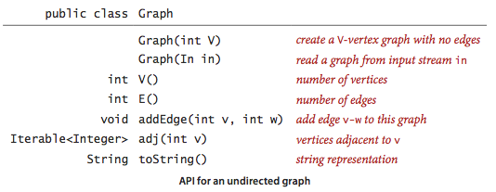

Check for the sample Input and output in the given folder.