**Algorithms and Data Structures – 2**

Module – 7 Bonus Activity 8

1. Implement the following API for DirectedEdge and EdgeWeightedDigraph.

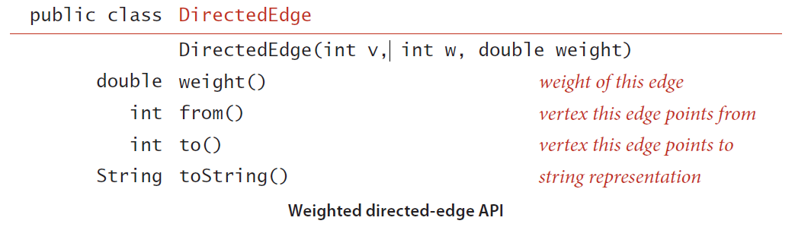

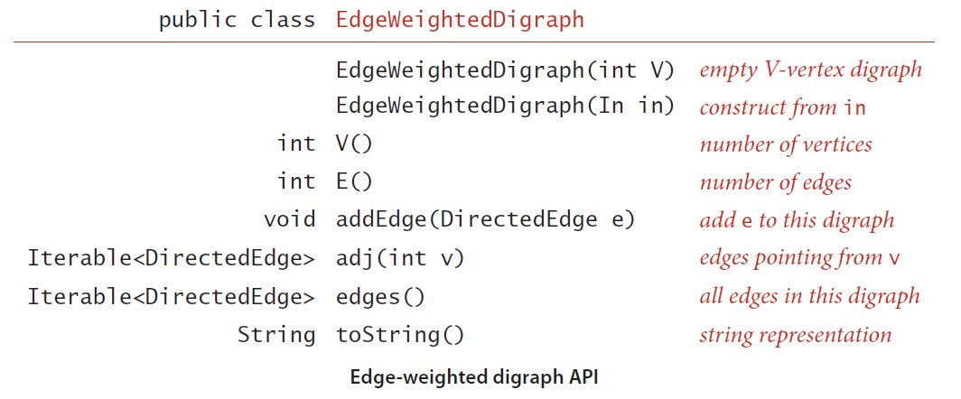

**Input:**

First Line indicates the number of the Vertices (V).

Second Line indicates the number of the Edges (E).

Next E lines contains 2 integers and weight which is double that are separated by spaces.

**Output:**

Print the adjacency list.

**Note:** Check for the test cases.