1. Observations –

time 7542133

duration 385323

client_address 2214

result_code 77

bytes 484519

request_method 220

URL 196762

user 1818

hierarchy_code 36926

type 162

Client address vs amount of data transacted by each client.

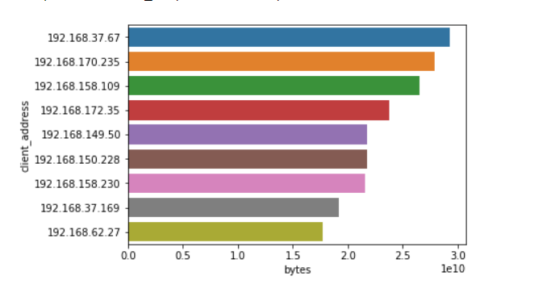

Client address vs duration of connectivity including every transaction.

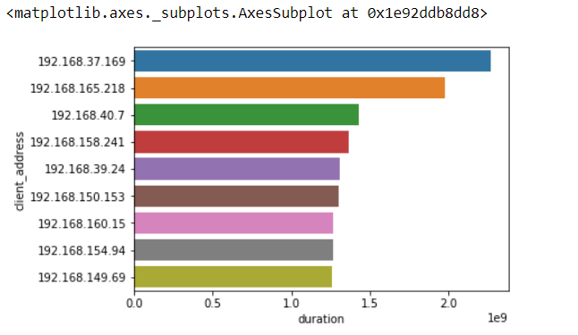

Correlation matrix between duration and bytes

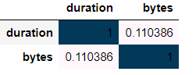

URL analysis –

Top URL hits.

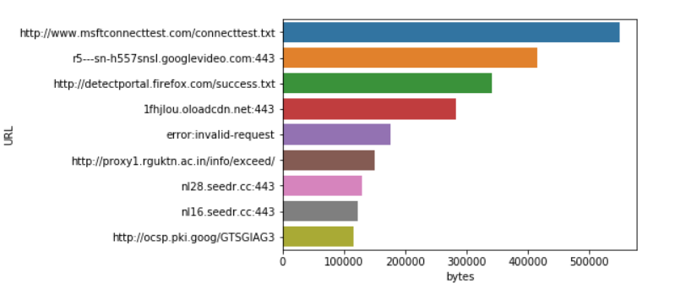

Top URL data

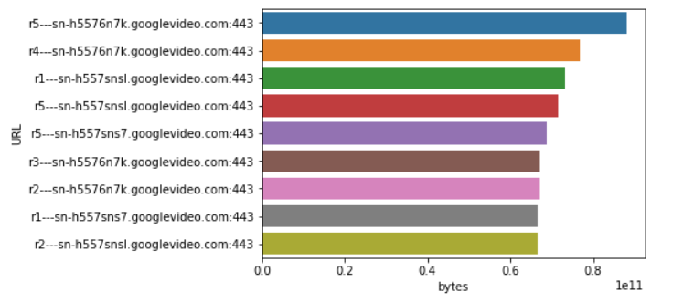

Maximum Usage on the basis of time. Hour in 24 hour format

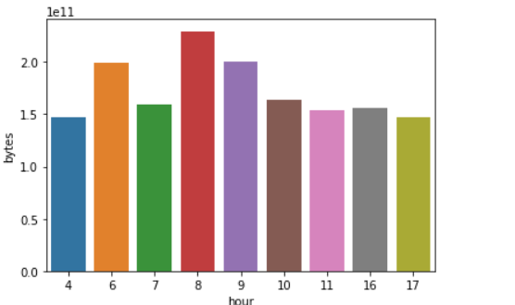

Hour vs Client_address(count)

