**MOTION SENSING SECURITY CAMERA DESIGN DOCUMENTS**

**PROJECT BLOCK DIAGRAM**

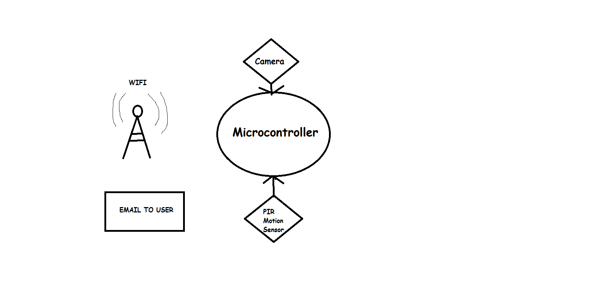

**DESIGN OPTION 1: ARDUINO UNO R3**

**HARDWARE**

The project can be set up with an Arduino Uno. The speed is one of the constraints here and Arduino lacks a lot when it comes to processing power.

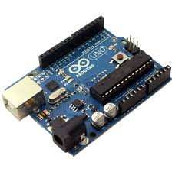

But, since the project requires Wi-Fi, an external Wi-Fi shield is required. Okay, so when we attach the Wi-Fi shield, pin no. 7 gets used up since it acts as a handshake pin. Moreover, for SPI bus communication the pins 11, 12, 13 are taken up. Not just that, since we are doing a picture clicking and sending email version, we need SD card selection, hence pin 4 is also taken. Moreover pin 10 is used up too for Wi-Fi SS. Hence, it leaves us with bare minimum number of pins already and we are not even halfway through the project.

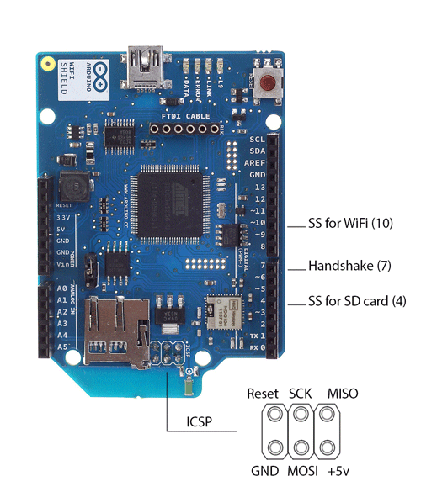

The project requires a camera module or a shield. A shield is preferably since it bring in its in-built libraries. Now, attaching it is very tricky since we are left with so less pins and most of the pins that the shield uses to connect to, hence, we have to avoid it.

Hence, we may try with camera module.

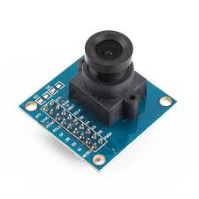

But, it is next to impossible to connect it with the Arduino, since, it needs a lot of connection to function properly.

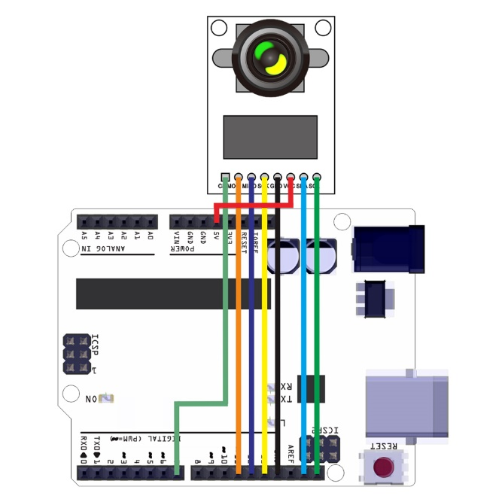

Hence it is quite vague to use this, since it leaves no room for our motion sensor to put in place.

**PIR SENSOR**

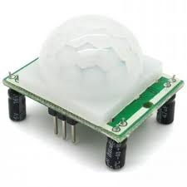

It detects motion and one of its pin need to connect to Arduino digital pin. The rest two to Ground and +5V.

**SOFTWARE:**

C is powerful enough, but since most of it is dependent on hardware based library and Arduino has enough library for such hardware, hence, it won’t be a problem.

**CONCLUSION**

**1. HARDWARE CONSTRAINT:** Very High

**2. COST:** Medium

**3. DIFFICULTY:** Very High

**4.** **SIZE:** Bulky

**DESIGN OPTION 2: NODEMCU ESP8266**

**HARDWARE**

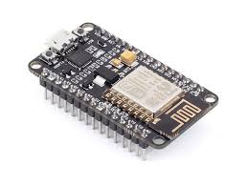

This Wi-Fi based hardware can be one of the prime options for this project. It has built in Wi-Fi, but doesn’t have any SD card reader which is necessary here. But a SD card module can be interfaced with it to swift the running. But, it still lacks the processing power.

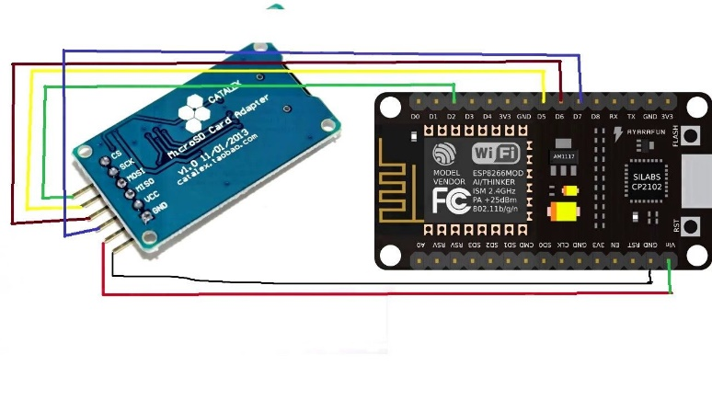

Now, next it has more than enough pins to accommodate the camera module that is needed for the project.



**PIR SENSOR**



It detects motion and one of its pin need to connect to NodeMcu digital pin. The rest two to Ground and +5V

**SOFTWARE:**

It uses the Arduino IDE for initialization. Hence, it’s quite easy and nicely suite.

**CONCLUSION**

**1. HARDWARE CONSTRAINT:** Very High w.r.t. processing power

**2. COST:** Low

**3. DIFFICULTY:** Medium

**4.** **SIZE:** Small

**DESIGN OPTION 3: RASPBERRY PI 4 MODEL B**

**HARDWARE**

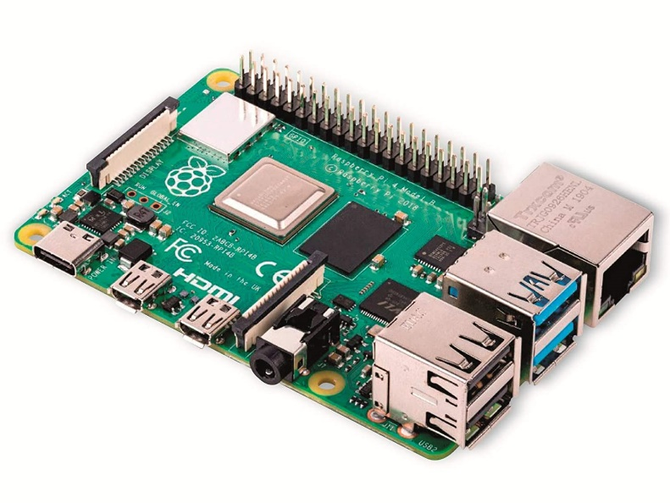

It is powerful. Has inbuilt Wi-Fi, SD card slot and a CSI camera Interface. It ticks every box that is needed for building our project. Our project needed

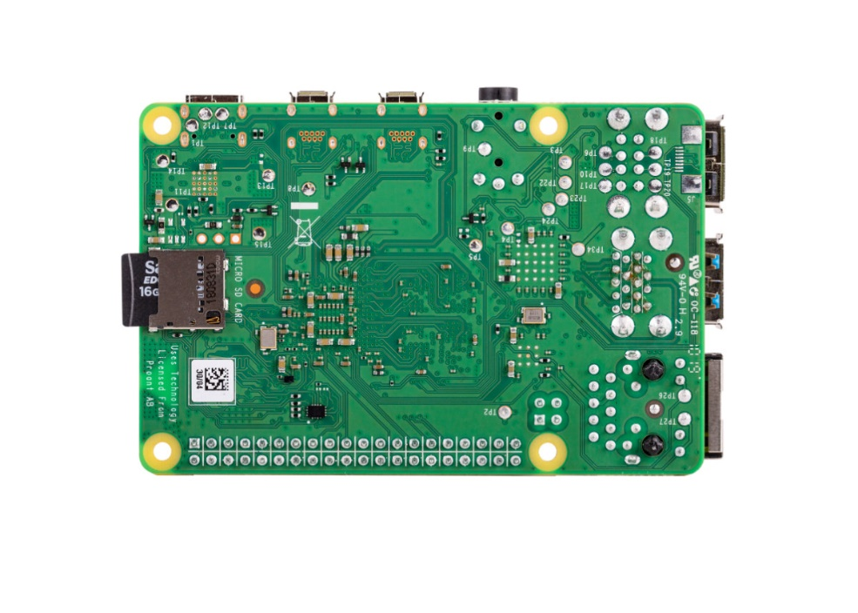

The Raspberry Pi camera module comes in with its own package and can be easily set up using the CSI interface.

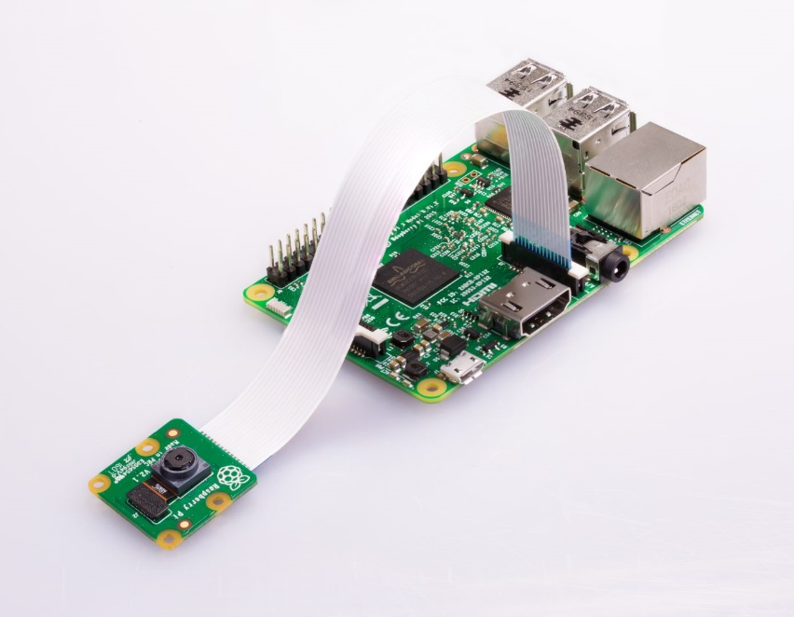

**PIR SENSOR**



It detects motion and one of its pin need to connect to Raspberry Pi GPIO pin. The rest two to Ground and +5V. It is quite easy to interface too.

**SOFTWARE**

Raspberry Pi 4 uses Python. It is slower than C, but it is very versatile. Sending email by taking in data was a breeze. Moreover, the processing power quite well makes up for everything.

**CONCLUSION**

**1. HARDWARE CONSTRAINT:** Minimal. Very Easy to process

**2. COST:** Average

**3. DIFFICULTY:** Easy

**4.** **SIZE:** Medium

**FINAL DESIGN DECISION**

After checking all the things, it was an easy decision. The Raspberry Pi was the one that was perfect for my project. Its powerful and has easier interface with Camera and its built in sd card plays a pivotal role in our project. Moreover, huge package option of Python makes it sweet.

(My partners are: Arijit Ghosh and Anirban Bej. We are doing this project together and have taken in this specialization. So, we might submit similar documents. No plagiarism is intended)