**MOTION SENSING SECURITY CAMERA**

**Backdrop**

When leaving the house, security becomes your prime focal point. There are times where we are scared and worried if we have put everything to place, and deep inside we hope everything remains true.

**A generic look of the device**

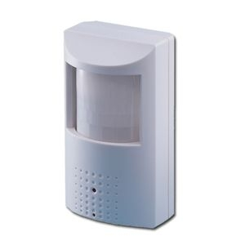

**Usability for User**

-Can be hooked at the front porch to look out for movements

-Will let you know if there is any movement at the front of your door

-Will send direct emails with the picture of the person who has shown movement in front of your porch

-Will need to login with email and connect to wifi

-More security than ever

**Design Perspective**

**-**Connects directly to the wifi and sends emails whenever it senses motion

-Has a small camera that powers up whenever motion is sensed

-Is powered with the help of small AA batteries

**Constraints**

**Cost**

In around $70 for each piece

**Email Speed**

Totally depends on the wifi speed