**TESTING DOCUMENTATION**

**MOTION SENSING SECURITY CAMERA**

1. **CHECKING RASPBERRY PI**

The Board is tested by the Blink Led Program and it worked like a charm.



It worked fine, stating that the Raspberry Pi was okay.

1. **CHECKING THE PIR MOTION SENSOR**

The PIR is tested next. The outputs are printed on screen.

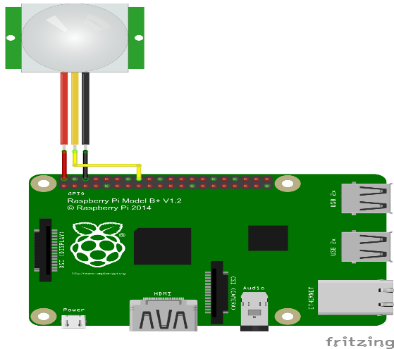

Whenever I came in close to the face of the PIR sensor it showed 1 as output and as I moved away it started showing zero.

I figured the max distance was around 20-25feet and it was exactly what I needed.

The results didn’t come right away, I had to play with it a bit and calibrated it to fetch best result.

1. **CHECKING MY EMAIL CODE**

Next up I checked my email program and saw that really received the mail or not. Later I have updated the program a bit to make it more precise.

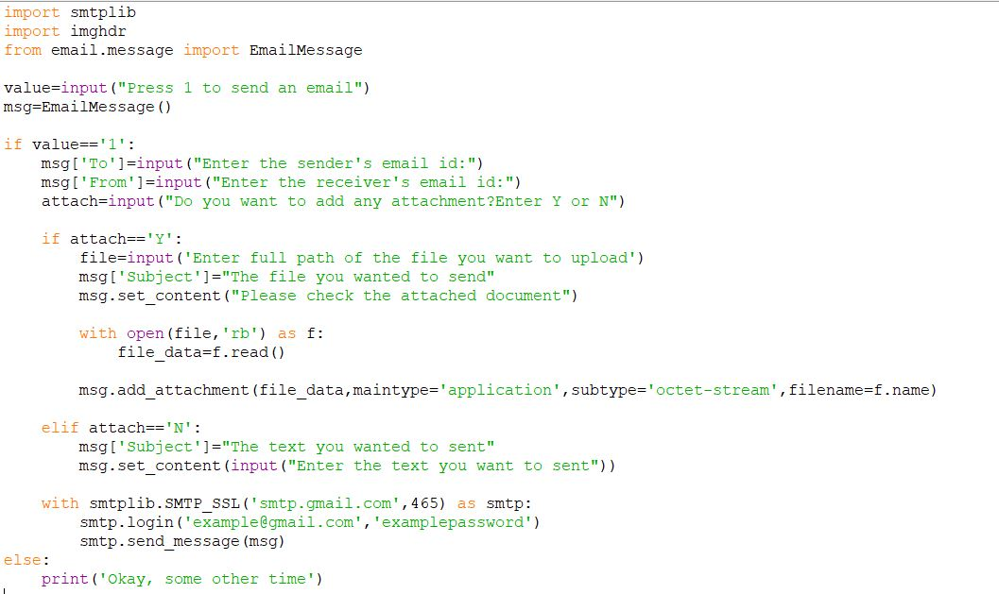

And when I pressed 1, I did receive an email.



1. **CHECKING EVERYTHING TOGETHER**

Finally, I attached all of the thing and rewrote my code and checked. Whenever I came close to my PIR motion sensor it detected me and sent out an email. I have attached the code below.

import RPi.GPIO as GPIO

import smtplib

import time

from picamera import PiCamera

from email.mime.text import MIMEText

from email.mime.multipart import MIMEMultipart

from email.mime.base import MIMEBase

from email import encoders

inputPin=16

i=1

GPIO.setmode(GPIO.BOARD)

GPIO.setup(inputPin,GPIO.IN)

camera=PiCamera()

email_sender='example@gmail.com'

email_receiver='example@gmail.com'

while True:

inputValue=GPIO.input(inputPin)

if inputValue==True:

picture='image '+str(i)+'.jpg'

camera.capture(picture)

server=smtplib.SMTP('smtp.gmail.com',587)

msg=MIMEMultipart()

msg['To']=email_receiver

msg['From']=email_sender

msg['Subject']='Hye,you got an intruder'

attachment=open(picture,'rb')

part=MIMEBase('application','octet-stream')

part.set_payload(attachment.read())

encoders.encode_base64(part)

part.add_header('content-Disposition','attachment;filename= '+picture)

msg.attach(part)

pictureSent=msg.as_string()

i=i+1

server.ehlo()

server.starttls()

server.ehlo()

server.login(email_sender,'examplepassword')

server.sendmail(email_receiver,email_sender,pictureSent)

server.quit()

time.sleep(5)

GPIO.cleanup()

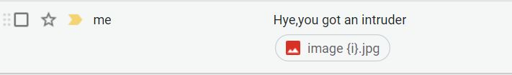

When I was far away from it, it didn’t get bother, and stayed there waiting for prompt.

(My partners are: Arijit Ghosh and Anirban Bej. We are doing this project together and have taken in this specialization. So, we might submit similar documents. No plagiarism is intended)

**---THANK YOU---**