1. INTRODUCTION

1.1 OVERVIEW:

The ability of computers to enhance and augment both mental and physical abilities and potential is no longer the exclusive realm of science fiction writers. It is becoming a reality. Brain Computer Interface technology will help define the potential of the human race. It holds the promise of bringing sight to the blind, hearing to the deaf, and the return of normal functionality to the physically impaired. A miracle? Hardly. But perhaps the next closest thing.
A brain–computer interface (BCI), often called a mind-machine interface (MMI), or sometimes called a direct neural interface (DNI), synthetic telepathy interface (STI) or a brain–machine interface (BMI), is a direct communication pathway between the brain and an external device.
For generations, humans have fantasized about the ability to communicate and interact with machines through thought alone or to create devices that can peer into person’s mind and thoughts. These ideas have captured the imagination of humankind
in the form of ancient myths and modern science fiction stories. However, it is only
recently that advances in cognitive neuroscience and brain imaging technologies
have started to provide us with the ability to interface directly with the human brain.
This ability is made possible through the use of sensors that can monitor some of
the physical processes that occur within the brain that correspond with certain forms
of thought.
Primarily driven by growing societal recognition for the needs of people with
physical disabilities, researchers have used these technologies to build braincomputer
interfaces (BCIs), communication systems that do not depend on the
brain’s normal output pathways of peripheral nerves and muscles. In these systems,
users explicitly manipulate their brain activity instead of using motor movements to
produce signals that can be used to control computers or communication devices.
Recently, the commercial brain-computer interface devices are emerging in
gaming industry. These devices translate the electrical biosignals of a brain directly into computer commands and take advantage of total immersion into game play. In recent years, the application of BCI for interacting with computer games has become increasingly popular among many BCI research studies, with a large upsurge of studies within the last five years BCI games are often used to test paradigms or train users how to use BCI and, in recent years, have become increasingly more advanced; including 3-D environments, multiple user objectives, and hybrid control systems incorporating both conventional input devices and multiple
BCI techniques
This report starts with a brief overview of BCI, moving on to its classification and discussing the various prevalent BCI based devices and games . The report concludes with a discussion of the viability of BCI as a commercial product influencing the gaming industry and not just a field of laboratory research.
1.2 PROBLEM STATEMENT:
Introduce the concept of Brain Computer Interface as a subcategory of Man-machine interaction . Discuss the prevalent technologies in BCI and the viability of BCI from a commercial perspective narrowing the focus to application of BCI in the gaming industry .
Currently efforts in BCI tend to have a steeper inclination towards overcoming the frailty and shortcomings to the physically disabled . Efforts in assimilation of BCI with the commercial field of gaming is at an archaic level. However , not only does BCI form the future of the billion dollar gaming industry but also success of BCI in gaming industry will strengthen it as a means of overcoming physical shortcomings in humans by providing it with the necessary financial viability .

1.3 SCOPE:
The study presented in this report follows a survey agenda and not an implementation paradigm as Brain Computer Interface in itself forms an intricate area of research and the devices and accessories required to aid any such implementation are not only baroque and byzantine but require humongous fiscal funding. Moreover this report looks at the sophisticated and perplexing department of Brain Computer Interface as a commercially viable commodity. The survey of this commercial viability is further restricted to the industry of gaming as it forms not only one of the largest zones in software development but also one which accepts new discoveries and rewards novelty .

1.4 SUMMARY :
Research on brain-computer interface (BCI) began in the 1970s. Most of the studies have concentrated on the BCI for control of prosthesis, rehabilitation and interfaces for users with motor disabilities. The animal experiments and neuroprosthetic devices implanted in humans experiments demonstrated the prominent research successes. A brain-computer interface, sometimes called a direct
neural interface or a brain-machine interface, is a direct communication between a brain and an external device, such as computer.BCIs are often aimed at assisting,
augmenting or repairing human cognitive or sensory-motor functions. Research on BCIs began in the 1970s at the University of California Los Angeles. The idea of “reading” the brain to detect intended actions and to use extrapolated signals to move robots or prosthetic devices has been developed by researchers over 40 years
Recently, the commercial brain-computer interface devices are emerging in gaming industry. These noninvasive BCI devices translate the electrical biosignals of a brain directly into computer commands and take advantage of total immersion into game play. They bring the BCIs from the laboratory to the public. It seems that the application of turning "thought into action" may soon become reality.
Not only does BCI form the future of a billion dollar gaming industry , but gaming can provide the necessary fiscal backing such a novel field of technology needs to undertake newer projects and subsidize further development cost or marginal cost which will in turn lead to cheaper BCI interfaces to physically disabled humans.

2. LITERATURE SURVEY

2.1 Biao Zhang, Jian Wang and Thomas Fuhlbriggie “A Review of the Commercial Brain-Computer Interface Technology from perspective of Industrial Robotics” - International Conference on Automation and Logistics – August 16-20, 2010

Research on brain-computer interface (BCI) began in the 1970s. Great efforts in neuroscience, robotics and computer sciences have spent by many research groups to develop BCI technologies and its applications. Recently, the commercial brain-computer interface devices are emerging in gaming industry. These devices translate the electrical biosignals of a brain directly into computer commands and take advantage of total immersion into game play. This article summarizes the recent progress of brain-computer interface technologies from industrial robotics perspective and presents the evaluation of the new BCI commercial products. Then it
discusses the potential applications of non-invasive commercial brain-computer interfaces to industrial robot system.
With the current state of Invasive BCI essential steps for development of a human motor neural prosthesis are in place. The application of turning "thought
into action" may soon become reality for patients with severe motor disabilities.
However for non-invasive BCIs, the current commercial brain-computer interface products can really only provide the signal with very low signal-to-noise ratio, and can be thought of as measuring the volume of the noise in the
system rather than any specific thought. It is only good to control a single bit of information, such as high/low. They may be good as an augmenting device for the game industry, but are not accurate and reliable enough to control robot fine movement. Most of the commercial BCI products were just released in 2009. Some are still under test phase. The commercial BCI technology is not mature enough to really be useful now. But there are very interesting potential applications of BCI to industrial robot. The safety, reliability and robustness aspects should be considered depending on the industrial applications.
This conference paper provides an excellent overview of the BCI technology. It goes further to discuss how BCI is classified broadly into two sub categories NON-INVASIVE and INVASIVE . It then expands further on explaining Non-Invasive BCI development and the current trends. The information provided in this paper about popular Non-invasive BCI devices and their use in BCI based games was really helpful. Although the primary focus of this paper is Industrial Robotics , the parts where it discusses commercialization of BCI provides a necessary and precise insight into BCI from a fiscal perspective , which helped me understand BCI in the proper light and expand on its commercial viability in another field , viz gaming.

2.2 David Marshall, Damien Coyle, Senior Member , IEEE, Shane Wilson and Michael Callaghan , Member, IEEE “Games, Gameplay, and BCI : The State of the Art” IEEE TRANSACTIONS on COMPUTATIONAL INTELLIGENCE and AI in Games, VOL. 5, NO. 2, JUNE 2013

Brain–computer interfaces (BCIs) and basic computer games have been interconnected since BCI development began, exploiting gameplay elements as a means of enhancing performance in BCI training protocols and entertaining and challenging participants while training to use a BCI. By providing the BCI user with an entertaining environment, researchers hope to assist users in becoming more proficient at controlling a BCI system. BCIs have been used to enrich the experience of abled-bodied and physically impaired users in various computer applications, in particular, computer games. BCI games have been reviewed previously, yet a critical evaluation of “gameplay” within BCI games has not been undertaken. Gameplay is a key aspect of any computer game and encompasses the challenges presented to the player, the actions made available to the player by the game designer to overcome the challenges and the interaction mechanism in the game. Here, the appropriateness of game genres (a category of games characterized by a particular set of gameplay challenges) and the associated gameplay challenges for different BCI paradigms is evaluated. The gameplay mechanics employed across a range of BCI games are reviewed and evaluated in terms of the BCI control strategy’s suitability, considering the genre and gameplay mechanics employed. A number of recommendations for the field relating to genre-specific BCI-games development and assessing user performance are also provided for BCI game developers.
Games within BCI are limited only by the control schemes they use. Most BCI games to date have been used for training purposes, or to test a BCI paradigm, and employ simplified gameplay mechanics. Gameplay must be altered to achieve accurate control of the game and to make the game more enjoyable for the player. Within most BCI games, the alterations have meant simplifying the game’s gameplay significantly. Gameplay within most existing BCI games involves the player controlling only one aspect of the game (character movement, simple choices, or passively altering the gameplay). Within many studies, users have commented that the use of BCI made these small activities significantly more entertaining (as opposed to when using a traditional input device). High accuracy results are largely due to the simplicity of the underlying games; if they are applied to most commercial games, they will not work as replacement control schemes.
Finally, it is recommended that, as traditional and BCI games evolve, many different variables such as the player’s level of BCI control proficiency, the number of sessions a user has undertaken, types of control strategies, BCI setup (including the
number of electrodes used), types of assistance, games distractions and environments, along with other variables, should be reported consistently. It is important that BCI-game developers and testers glean and report as much information about BCIgameplay performance when presenting new gaming concepts and studies. This will enable thorough comparison between approaches, leading to the development of better techniques .
2.3 Athanasios Vourvoloulos, Fotis Lairokapis , Panagiotis Petridis “Brain-Cotrolled Serious games for Cultural Heritage” IEEE Journal 2010

This paper proposes a prototype system for cultural heritage based on brain computer interfaces for navigating and interacting with serious games. By analyzing traditional human-computer interaction methods and paradigms with brain-controlled games it is possible to investigate novel methods for interacting and perceiving virtual heritage worlds. An interactive serious cultural heritage game was developed based on commercial BCI headsets controlling virtual aggents in the ancient city of Rome. Initial results indicate that brain computer technologies can be very useful for the creation of interactive serious games.

2.4 Bram van de Laar, Hayrettin Gürkök, Danny Plass-Oude Bos, Mannes Poel, and Anton Nijholt “Experiencing BCI Control in a popular computer game” - IEEE Transactions on COMPUTATIONAL INTELLIGENCE and AI in Games, VOL. 5, NO. 2, JUNE 2013

Brain–computer interfaces (BCIs) are not only being developed to aid disabled individuals with motor substitution, motor recovery, and novel communication possibilities, but also as a modality for healthy users in entertainment and gaming. This study investigates whether the incorporation of a BCI in the popular game World of Warcraft (WoW) has effects on the user experience. A BCI control channel based on parietal alpha band power is used to control the shape and function of the avatar in the game. In the experiment, participants , a mix of experienced and inexperienced WoW players, played with and without the use of BCI in a within-subjects design. Participants themselves could indicate when they wanted to stop playing. Actual and
estimated duration was recorded and questionnaires on presence and control were administered. Afterwards, oral interviews were taken. No difference in actual duration was found between conditions. Results indicate that the difference between estimated and actual duration was not related to user experience but was person specific. When using a BCI, control and involvement were rated lower. But BCI control did not significantly decrease fun. During interviews, experienced players stated that they saw potential in the application of BCIs in games with complex interfaces such as WoW. This study suggests that BCI as an additional control can be as much fun and natural to use as keyboard/mouse control, even if the amount of control is limited.

2.5 Cuntai Guan, Haihong Zhang, Chuanchu Wang ,Bo Jiang “BCI based 3D Game for Ateention Training and Rehabilitation” - 2011 6th IEEE Conference on Industrial Electronics and Applications

This paper presents a novel approach which uses brain computer interface (BCI) technology to translate the user’s mental conditions, especially the attention state, into game control. Leveraging on BCI engine to measure a user’s attention level to control a virtual hand’s movement and utilizing 3D animation technique, the proposed system is significant for training those who suffering from Attention Deficit Hyperactivity Disorder (ADHD). Comparing to robotic based system, the proposed system is cost-effective, interesting, and ease of use. It also can be extended for rehabilitating the people with neurological disorders, such as those debilitating traumatic events. Potentially, millions people may benefit from the system. The system structure and experimental results will be illustrated in this paper.

3. Brain Computer Interface

3.1 INTRODUCTION :

A brain–computer interface (BCI), often called a mind-machine interface (MMI), or sometimes called a direct neural interface (DNI), synthetic telepathy interface (STI) or a brain–machine interface (BMI), is a direct communication pathway between the brain and an external device.
For generations, humans have fantasized about the ability to communicate and interact with machines through thought alone or to create devices that can peer into person’s mind and thoughts. These ideas have captured the imagination of humankind
in the form of ancient myths and modern science fiction stories. However, it is only
recently that advances in cognitive neuroscience and brain imaging technologies
have started to provide us with the ability to interface directly with the human brain.
This ability is made possible through the use of sensors that can monitor some of
the physical processes that occur within the brain that correspond with certain forms
of thought.
The ability of computers to enhance and augment both mental and physical abilities and potential is no longer the exclusive realm of science fiction writers. It is becoming a reality. Brain Computer Interface technology will help define the potential of the human race. It holds the promise of bringing sight to the blind, hearing to the deaf, and the return of normal functionality to the physically impaired. A miracle? Hardly. But perhaps the next closest thing.

3.2 HISTORY:

The history of brain–computer interfaces (BCIs) starts with Hans Berger's discovery of the electrical activity of the human brain and the development of electroencephalography (EEG). In 1924 Berger was the first to record human brain activity by means of EEG. Berger was able to identify oscillatory activity in the brain by analyzing EEG traces. One wave he identified was the alpha wave (8–13 Hz), also known as Berger's wave.
Berger's first recording device was very rudimentary. He inserted silver wires under the scalps of his patients. These were later replaced by silver foils attached to the patients' head by rubber bandages. Berger connected these sensors to a Lippmann capillary electrometer, with disappointing results. More sophisticated measuring devices, such as the Siemens double-coil recording galvanometer, which displayed electric voltages as small as one ten thousandth of a volt, led to success.
Berger analyzed the interrelation of alternations in his EEG wave diagrams with brain diseases. EEGs permitted completely new possibilities for the research of human brain activities.
Research on BCIs began in the 1970s at the University of California Los Angeles (UCLA) under a grant from the National Science Foundation, followed by a contract from DARPA. The papers published after this research also mark the first appearance of the expression brain–computer interface in scientific literature.

3.3 GENERAL ARCHITECTURE :

A brain-computer interface, sometimes called a direct neural interface or a brain-machine interface, is a direct communication between a brain and an external device, such as computer. BCIs are often aimed at assisting, augmenting or repairing human cognitive or sensory-motor functions. Research on BCIs began in the 1970s at the University of California Los Angeles. The idea of “reading” the brain to detect intended actions and to use extrapolated signals to move robots or prosthetic devices has been developed by researchers over 40 years. The
architecture of general BCI is shown in Figure 1.
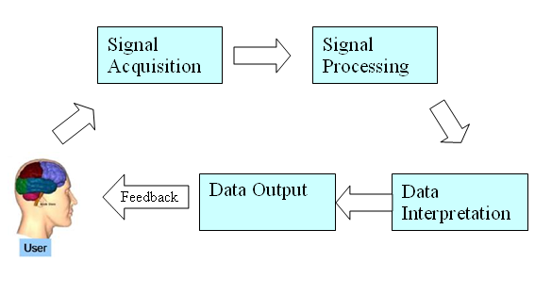
Figure 1
BCI Architecture

It has 5 stages:
- Signal Acquisition
- Signal Processing
- Data Interpretation
- Data Output
- Feedback

3.3 CLASSIFICATION :

There are two types of method to extract signals from the brain, Invasive BCIs, Non-invasive BCIs :

1) Invasive BCIs: Invasive BCIs are implanted directly into the brain during neurosurgery. Using chips implanted against the brain that have hundreds of electrodes as shown in Figure 2, the scientists are able to read the firing of
hundreds of neurons in the brain. The invasive devices produce the highest quality signals of BCI devices. Real world testing of this technology has been conducted using rats and monkeys in laboratories

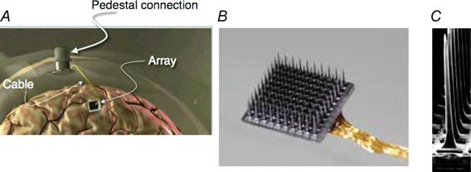

Figure 2.
BCI Chip Array

2) Non-invasive BCIs: The non-invasive BCIs are the means of reading brain activity other than direct neural contact via pins. Electroencephalography (EEG) is the first and most studied potential non-invasive interface, where electrodes are placed against the scalp are used to pick up brain signals. The EEG-based brain-machine interface as shown in Figure 3 has fine temporal resolution. It is easy to use, portable and low cost. However, EEG signals suffer from a reduced spatial resolution and noise because this approach does not pick up brain signals by direct contact to
each neuron. The EEG signals reflect the electrical activities of millions of neurons under the scalp. The other newer and more accurate non-invasive
technology is magneto encephalography (MEG) and functional magnetic resonance imaging (fMRI) as shown in Figure 3. Although this technology provides the speed and accuracy needed for a successful non-invasive BMI, the large size and powerful magnetic field generated by the fMRI scanner limited the locations and conditions where it can be used.

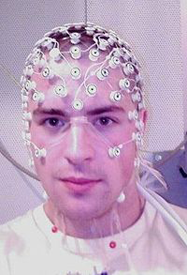
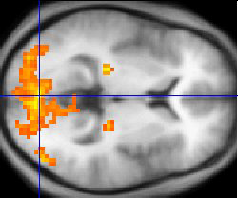


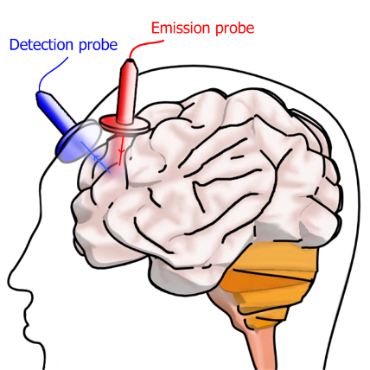

Figure 3:
FMRI

More recently Near Infrared Spectroscopy (NIRS) technology is used in BMI. NIRS is a relatively affordable and portable neuroimaging method that can detect cerebral blood flow as a surrogate for cortical activity. Unlike functional magnetic resonance, it allows the subject to have freedom of movement to perform a wide variety of tasks. The emission probe of NIRS sensor, as shown in Figure 3, emits the near-infrared light into the blood vessels in brain and the detection probe receives the reflection of the light from the cerebral blood. Its reflection relates to the concentration of both oxhemoglobin and deoxyhemoglobin. It measures changes in haemodynamics due to the neural activation.

4. BCI IN GAMING :

4.1 INTRODUCTION :

A computer game is an electronic game that involves human interaction with a user interface that generates visual and/or auditory feedback. Typically played against a computer opponent or another human, computer games possess all of the core attributes of traditional games. The players are presented with an overall goal or victory condition and a set of rules, which together define the gameplay. Computer games present the players with the gameplay challenges and act as an arbitrator, using the rules (gameplay mechanics) to defi ne the valid set of actions the player is permitted to take in order to complete the objectives. While generic gameplay challenges such as hand-to-eye coordination, pattern recognition, and logical thinking may be applied across a variety of game genres, many gameplay challenges are genre specific. As such, the design and application of appropriate gameplay challenges represents one of the attributes of excellent game design. Good gameplay is often regarded as more essential than the periphery elements of a computer game (e.g., graphical qualities, story, or narrative) as it represents the fundamental core of any game. In recent years, the application of BCI for interacting with computer games has become increasingly popular among many BCI research studies, with a large upsurge of studies within the last fi ve years (Fig. 4). BCI games are often used to test paradigms or train users how to use BCI and, in recent years, have become increasingly more advanced; including 3-D environments, multiple user objectives, and hybrid control systems incorporating both conventional input devices and multiple BCI techniques. Computer games can be classifi ed by genre based on the abstract gameplay challenges employed within the game. Several BCI surveys have analyzed and reviewed BCI games in terms of human–computer interaction (HCI) multiplayer gaming, and virtual reality (VR) applications. Each of these papers focuses on a separate aspect of BCI gaming in detail and provides useful information about specific BCI control strategies for game interaction. However, BCI games have not yet been categorized by genre or reviewed in terms of their application of gameplay challenges. Gameplay is a fundamental aspect to consider when developing a computer game.


Figure 4
No of papers on BCI Gaming per year

4.2 MISC STATS ABOUT THE GAMING INDUSTRY :

- The average gamer is 34 years old and has been playing computer and video games for 12 years.
- The average gamer spends about 8 hours a week playing video games.
- The average video game purchaser is 39 years old.
- 40% of all gamers are female.
- The computer and video game industry generated :

- $10.5 billion in revenue in 2009
- $25.1 billion in 2010
- $63 bilion in 2012
- and predicted to cross
- $82 billion by 2017

4.3 GENRES IN BCI GAMES (with market share analysis)

A. Action Games
Action games typically involve gameplay challenges that test the player’s physical skills, such as the player’s reaction times, hand-to-eye coordination, and spatial awareness inside the game environment. Action gaming is the most popular and diverse of all computer game genres encompassing arcade, platform, and first person shooter (FPS) games.

B. Strategy Games
Strategy games challenge the player to complete objectives through specifically planning a series of actions taken against one or more opponents. Strategy games originate from board games such as Chess and Risk and can be divided into two broad categories depending upon their gameplay type: real-time and
turn-based strategy games

C. Role-Playing Games
Role-playing games (RPGs) primarily focus on exploration gameplay challenges, incorporating secondary logistical, conflict, or tactical challenges. RPGs often allow the player a great deal of freedom in navigating through the game world and,
therefore, each player’s experience of the game can vary significantly. The development of a suitable BCI control system that addresses RPG gameplay challenges would, therefore, represent a significant challenge (most RPGs feature several different gameplay elements)

D. Adventure Games
Adventure games provide exploration and puzzle-solving challenges. Adventure games typically revolve around an engaging central story that acts as a vehicle to structure the gameplay and experiences. Adventure games typically incorporate
decision-based gameplay developed around a central story, often presenting many different routes for a player to follow throughout the game. Developing an adventure game is, therefore, a more challenging undertaking than developing
a pure action game

E. Sports Games
Sports games are similar to action games in that they test the player’s reaction times, hand-to-eye coordination, and spatial awareness. Sports games typically simulate a real-life sport and are based upon the same rules and objectives that govern that
sport.

F. Simulations
Simulation games attempt to accurately recreate the feeling of participating in an action that is real or imaginary. Simulations often involve players participating in activities that would be either dangerous (driving an F1 racing car) or unfeasible (assuming the role of mayor of New York) in real life. Flight simulators (one of the most popular types of simulators) require a player to take control of an aircraft and fly it from point to point, going through complex procedures for landing, takeoff,
and continuous flight.

G. Puzzle Games
In the puzzle game genre, puzzle solving requires logical thinking, deductive reasoning, pattern recognition, and intrinsic or extrinsic knowledge. The player’s objective in puzzle games is to complete the puzzle within the game’s set rules (time,
amount of moves allowed, or the type of moves allowed).

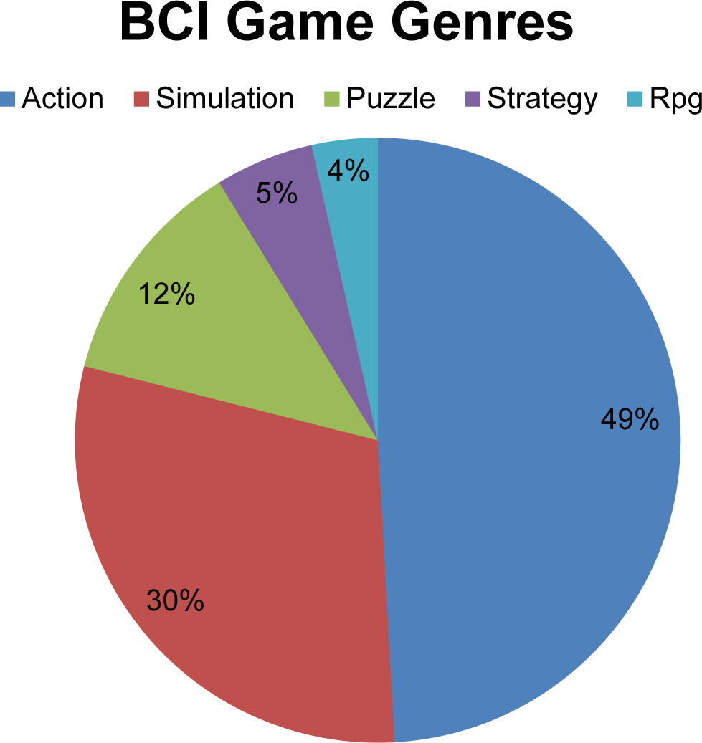

Fig 5. Genre-wise market share
4.4 POPULAR CONSUMER BCI INTERFACES :

1) OCZ Neural Impulse Actuator: The Neural Impulse Actuator (NIA) has three electrodes on headband as shown in Figure 6. It is powered and communicated directly by PC via a USB port. The NIA extracts the EEG signal of muscles, brain and eyes, respectively. It is designed for playing computer game to allow assignment of different commands. The NIA features a GUI to allow the user to
calibrate signals as shown in Figure 6
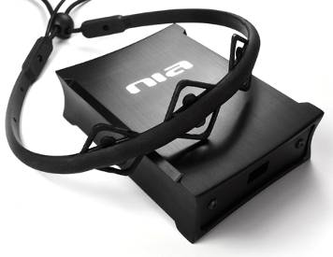
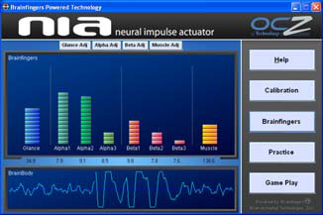
Fig 6 Neural Impulse Actuator

2) NeuroSky MindSet: Neurosky’s mindset has four electrodes on its headset shown in Figure 7. It includes the sensor that touches the forehead, the contact and reference points located on the ear pad, and the on-board chip that processes all of the data. The on-board chip processes both the raw brainwaves and amplifies the raw brainwave signal and removes the ambient noise and muscle movement. The
Mindset has a rechargeable lithium-ion battery and communicates to the PC via built-in Bluetooth. The MindSet provides software to characterize the mental states into Attention (similar to concentration) or Meditation (similar to relaxation). Generally, Attention can be controlled through a visual focus. For Meditation, it typically helps to try to relax. The MindSet also has a brainwave visualizer
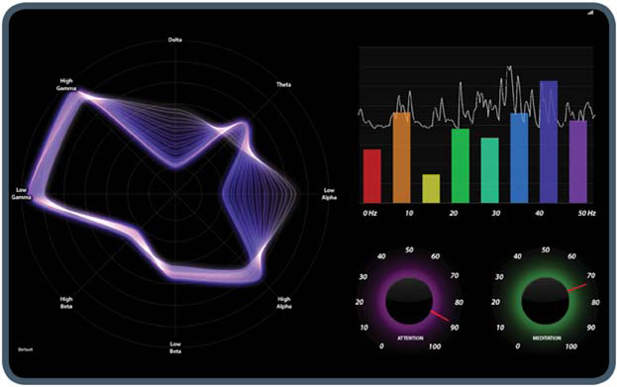


Fig 7. NeuroSky Mindset

3) Star Wars Force Trainer: The Force Trainer, shown in Figure 8, is a new Star War-themed toy, which allows its user to create the illusion of performing Jedi Mind Tricks. The toy is produced by Uncle Milton Industries, which is the NeuroSky partner. The Force Trainer has a Training tower and a wireless headset. It uses the same technology as NeuroSky Mindset to senses EEG signals from brain by three electrodes on forehead and ears. Then it relays the signals to training tower. The training tower uses a fan to blow a ball in a tube into the air. The harder the user concentrates, the stronger the fan blows, and the higher the ball is suspended.

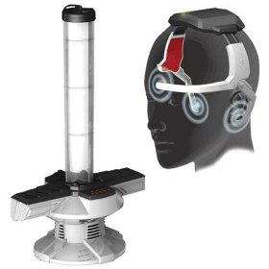
Fig 8
Star Wars Force Trainer

4) MindFlex: MindFlex, shown in Figure 9, is another new toy using the powers of concentration in a game. It has a game console and a headset. On the game console, a fan nozzle, which floats the ball into air, can be moved by turning the control knob. The headset measures the brain waves by three electrodes. One is on the forehead and two are on ear clips to each ear lobe. The game begins when you strap on the headset so you can use your powers of concentration to move the ball around the game console and through a mind-bending obstacle course in Figure 9. A dial-in console lets you to keep the ball lifted on a cushion of air, but rising and lowering the ball must be accomplished by alternating concentrating and relaxing your mind.

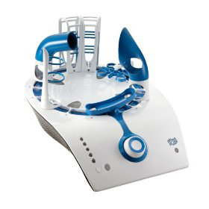


Fig 9
MindFlex

4) Emotive Systems: Emotiv Systems was founded in 2003 by four scientists and executives: neuroscientist Professor Allan Snyder, chip-designer Neil Weste, and technology entrepreneurs Tan Le and Nam Do. The EPOC, shown in Figure 10, has 14 electrodes (compared to the 19 electrodes of a standard medical EEG, and the 3 of OCZ's NIA and NeuroSky’s). It also has a two-axis gyro for measuring head rotation. It connects wirelessly with the PC. Emotiv Systems claims the headset will make it possible for games to be controlled and influenced by the player's mind, and facial expressions. The headset must first be trained to recognize what kind of thought pattern equates to a certain action. Figure 10 shows the Emotiv control panel. The Emotiv Control Panel allows users to train the various thoughts (currently 4), such as "push", "left", “right”, etc., and test them on a floating, bobbing, cube. It also allows users to view their emotional state, such as "excitement", on a graph. It has a 2D blue avatar that allows the user to view their own facial expressions, and adjust the sensitivity of those detections. Emotiv EPOC headset provides the research license to get EEG data (the raw electricity measurements) to PC
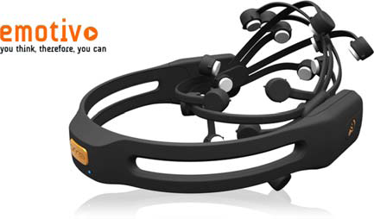
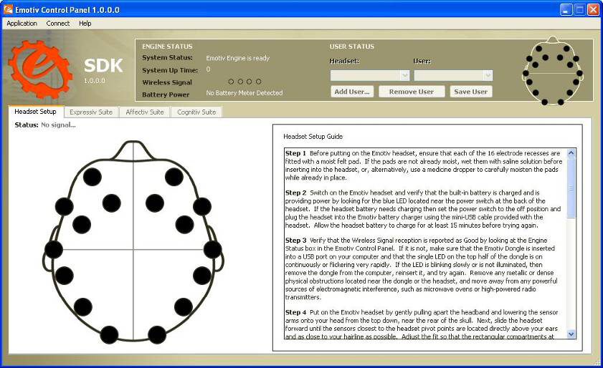

Fig 10.
Emotivo Systems

5) ENOBIO from Starlab: A Spanish company, Starlab, has entered this market in 2009 with a wireless 4-channel system called ENOBIO shown in Figure 11. Designed for research purposes the system provides a platform for application development. Enobio is a wearable, modular and wireless electro-physiology sensor system for the recording of EEG (brain activity) ECG (heart activity) and EOG (eye movement). ENOBIO software manages wireless communication between the ENOBIO and the Host computer, data recording and data display. The ENOBIO software provides a TPC/IP socket in order to stream data to any TCP/IP capable application in real-time.

Fig 11. ENOBIO

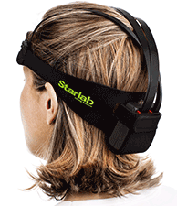

            - CURRENT SCENARIO:
(Proving viability of BCI games)

5.1 SOME MAJOR PLAYERS IN THE BCI GAMING INDUSTRY:
Device | Cost | Electrodes | Sensors Interpret: | Peripheral | SDK | Released | Producer | Interface | Notes
MindWave | $99.95 | 1 | 2 mental states (based on 4 brainwaves), eyeblinks | Yes | Yes | 21 March 2011; 2 years ago | NeuroSky
Mindflex (UsesNeuroSky chips) | $50 | 1 | 1 mental state | No | No | 21 December 2009; 4 years ago | Mattel  (Neurosky  partner)
Emotiv EPOC | $299 | 14 | 4 mental states (based on brainwaves), 13 conscious thoughts, facial expressions, head movements (sensed by 2 gyros) | Yes | Yes | 21 December 2009; 4 years ago | Emotiv Systems
Emotiv Insight | No price yet | 5 |  | Yes | Expected | Expected Summer 2014 | Emotiv  Lifescience | Bluetooth 4.0 LE.[14]
Star Wars Force Trainer  (based onNeuroSky chips) | $45 | 1 | 1 mental state | No | No | 21 June 2009; 4 years ago | Uncle Milton  (Neurosky)
MindSet | $199 |  | 2 mental states (based on 4 brainwaves), eyeblinks | Yes | Yes | March 2007; 6 years ago | NeuroSky
Neural Impulse Actuator | $90 | 3 | 2 brainwaves (Alpha & Beta), facial muscle and eye movements | Yes | Yes | May 2008; 5 years ago; No longer being manufactured (EOL).[1] | OCZ Technology
Mindball | $20,000 | 1 | 1 mental state | No | No | 21 March 2003; 10 years ago | Interactive  Productline
XWave headset(uses NeuroSky chips) | $90 | 1 | 8 EEG bands | Yes | Yes | 5 January 2011; 3 years ago (Windows and iOS apps available now, Android app available soon[25]) | PLX Devices | Bluetooth | Designed to look like a normal sports headband, no longer available
XWave Sonic(uses NeuroSky chips) | $100 | 1 | ? | ? | ? | iOS apps available now | PLX Devices | Bluetooth | Discontinued
MyndPlay BrainBand (Uses NeuroSky chips ) | $158 | 1 | 8 EEG bands | Yes | Yes | 1 December 2011; 2 years ago | MyndPlay | Bluetooth | Soft headband, uses conductive gel for ear-clip
Muse | $269 | 4 | 6 sensors; one ground, one reference | ? | Yes | 2014 | InteraXon | Bluetooth | Designed to be worn all day
OpenBCI | US$324 | 8 per board |  | Yes | Yes | Expected April 2014 | OpenBCI project | Bluetooth4.0 | Open hardware project. Boards can be daisy chained together to increase electrode count.

5.2 TRANSFORMING A POPULAR WELL KNOWN GAME INTO A COMPLETE BCI CONTROLLED GAME

World of Warcraft (WoW) is a massive multiplayer online role-playing game (MMORPG), meaning that thousands of users log on to servers with their virtual characters to battle monsters or each other and evolve their character through an interactive narrative set in a fictional medieval virtual world. The game is immensely popular with currently more than ten million subscribers. The objective of the game is essentially to level up, and get better abilities and better gear. This is done by achieving experience points, gained by completing quests, slaying enemies, and exploring the world.
In the experiment, participants played a character which is part of the Night Elf race and is a druid. The druid has the unique ability to transform itself into bear shape, more or less providing a completely different character.
1) Bear Shape: The bear shape simulates the armor and health similar to a warrior, therefore providing a so-called Tank ability. In this shape, the player is able to soak up damage, especially useful when fighting more than one enemy. At the same time, the bear has slow speed but high impact attacks at close range (melee).
2) Druid Shape: The druid shape is able to cast magic spells on enemies, that is, attacking from a distance. The druid is also able to heal itself and others through spells. More suitable for healing after a fight or when fighting only one enemy from a distance, the druid requires a different playing strategy than when in bear form.
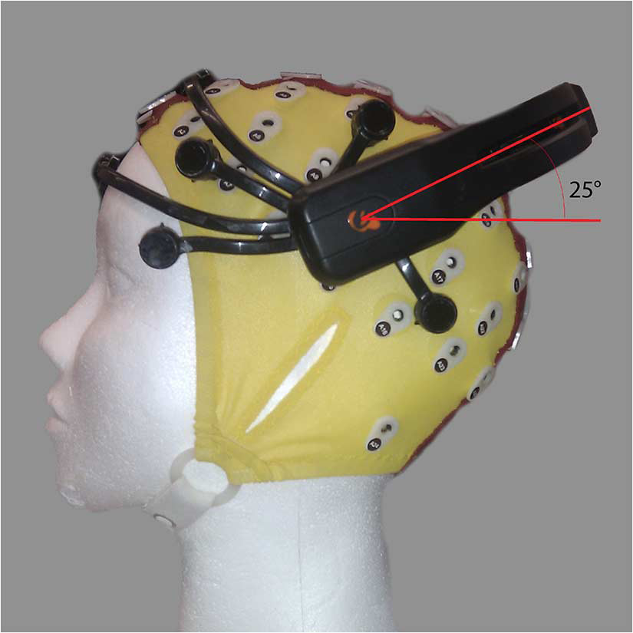


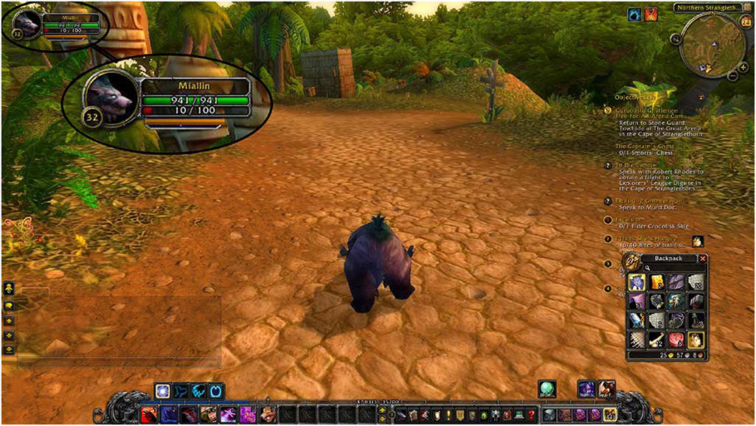
Fig 12. World of Warcraft
5.4 LOW COST BCI INTERFACES (CHRONOLOGICAL) :

Recently a number of companies have scaled back medical grade EEG technology (and in one case, NeuroSky, rebuilt the technology from the ground up) to create inexpensive BCIs. This technology has been built into toys and gaming devices; some of these toys have been extremely commercially successful like the NeuroSky and Mattel MindFlex.
- In 2006 Sony patented a neural interface system allowing radio waves to affect signals in the neural cortex.
- In 2007 NeuroSky released the first affordable consumer based EEG along with the game NeuroBoy. This was also the first large scale EEG device to use dry sensor technology.
- In 2008 OCZ Technology developed a device for use in video games relying primarily on electromyography.
- In 2008 the Final Fantasy developer Square Enix announced that it was partnering with NeuroSky to create a game, Judecca.
- In 2009 Mattel partnered with NeuroSky to release the Mindflex, a game that used an EEG to steer a ball through an obstacle course. By far the best selling consumer based EEG to date.
- In 2009 Uncle Milton Industries partnered with NeuroSky to release the Star Wars Force Trainer, a game designed to create the illusion of possessing the force.
- In 2009 Emotiv Systems released the EPOC, a 14 channel EEG device that can read 4 mental states, 13 conscious states, facial expressions, and head movements. The EPOC is the first commercial BCI to use dry sensor technology, which can be dampened with a saline solution for a better connection.
- In November 2011 Time Magazine selected "necomimi" produced by Neurowear as one of the best inventions of the year. The company announced that it expected to launch a consumer version of the garment, consisting of cat-like ears controlled by a brain-wave reader produced by NeuroSky, in spring 2012.
- In March 2012 g.tec introduced the intendiX-SPELLER, first commercially available BCI system for home use which can be used to control computer games and apps. It can detect different brain signals with an accuracy of 99%.[100] g.tec has hosted several workshop tours to demonstrate the intendiX system and other hardware and software to the public, such as ag.tec workshop tour of the US West Coast during September 2012.
- In January 2013 Hasaca National University (HNU) announced first Masters program in Virtual Reality Brain Computer interface application design.

6.ETHICAL ISSUES, CONCLUSION AND FUTURE SCOPE

6.1 ETHICAL CONSIDERATIONS:

Important ethical, legal and societal issues related to brain-computer interfacing are:
- conceptual issues (researchers disagree over what is and what is not a brain-computer interface),
- obtaining informed consent from people who have difficulty communicating,
- risk/benefit analysis,
- shared responsibility of BCI teams (e.g. how to ensure that responsible group decisions can be made),
- the consequences of BCI technology for the quality of life of patients and their families,
- side-effects (e.g. neurofeedback of sensorimotor rhythm training is reported to affect sleep quality),
- personal responsibility and its possible constraints (e.g. who is responsible for erroneous actions with a neuroprosthesis),
- issues concerning personality and personhood and its possible alteration,
- therapeutic applications and their possible exceedance,
- questions of research ethics that arise when progressing from animal experimentation to application in human subjects,
- mind-reading and privacy,
- mind-control,
- use of the technology in advanced interrogation techniques by governmental authorities,
- selective enhancement and social stratification, and
- communication to the media.

Clausen stated in 2009 that “BCIs pose ethical challenges, but these are conceptually similar to those that bioethicists have addressed for other realms of therapy”. Moreover, he suggests that bioethics is well-prepared to deal with the issues that arise with BCI technologies. Haselager and colleagues[89] pointed out that expectations of BCI efficacy and value play a great role in ethical analysis and the way BCI scientists should approach media. Furthermore, standard protocols can be implemented to ensure ethically sound informed-consent procedures with locked-in patients.
Researchers are well aware that sound ethical guidelines, appropriately moderated enthusiasm in media coverage and education about BCI systems will be of utmost importance for the societal acceptance of this technology. Thus, recently more effort is made inside the BCI community to create consensus on ethical guidelines for BCI research, development and dissemination.

6.2 CONCLUSION

Games within BCI are limited only by the control schemes they use. Most BCI games to date have been used for training purposes, or to test a BCI paradigm, and employ simplified gameplay mechanics. Gameplay must be altered to achieve accurate control of the game and to make the game more enjoyable for the player. Within most BCI games, the alterations have meant simplifying the game’s gameplay significantly. Gameplay within most existing BCI games involves the player controlling only one aspect of the game (character movement, simple choices, or passively altering the gameplay). Within many studies, users have commented that the use of BCI made these small activities signifi cantly more entertaining (as opposed to when using a traditional input device). High accuracy results are largely due to the simplicity of the underlying games; if they are applied to most commercial
games, they will not work as replacement control schemes.

In order to create entertaining BCI games, we need to examine the gameplay challenges associated with the genre and match the gameplay with appropriate BCI control strategies and vice versa . For example, action, RPG, and vehicle simulations
genres may not be suitable when the BCI reaction times are very slow, whereas turn-based strategy games, CMS, and puzzle games are perfect for BCI as there are normally no time constraints.

Not only does BCI form the future of a billion dollar gaming industry , but gaming can provide the necessary fiscal backing such a novel field of technology needs to undertake newer projects and subsidize further development cost or marginal cost which will in turn lead to cheaper BCI interfaces to physically disabled humans.

6.3 FUTURE SCOPE

As already mentioned in the report BCI is definitely the future of gaming industry. The same industry which is currently valued as a $60 billion industry and expected to grow at a steady rate of $10 billion per year. By 2017 it is expected to cross $82 billion which in INR translates to above 500 thousand crores . Development in BCI games though prevalent are at a primitive stage. Considering these aspects of market share and scope combined with an untapped potential BCI gaming forms a very viable field of higher education and research.

