Objective:-
Sometimes due to changes of any module we have to do a regression test. And sometimes it’s become too much difficult to identify the changes in the before (Avant) and after (Après) file.
Via ISPF option 3.13 it will only give us the result of the record (inserted or deleted) changes. From which it is very difficult to find out the copybook field wise changes.
Overview:-
To overcome the above problem this tool will compare the Before (Avant) and After (Apres) file on the basis of keys and give the result in excel format with highlighting the non key field changes in copybook format. It will give the result for only those records which are present in both files having changes in non-key fields.
Steps to Compare:-
Step:-1
Create a folder CompareTool in the below path of your own system
C:\Data\CompareTool
Step:-2
Open the comparison tool and click on the Compare button. It will take you to the form where you have to provide the files name and other inputs also.


Step:-3
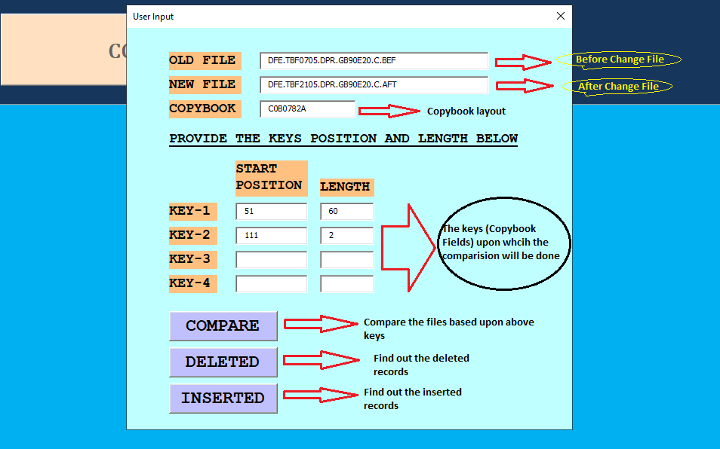
OLD FILE:- The AVANT file(Before changes)
NEW FILE:-The APRES file (After changes)
COPYBOOK:-Provide the copybook name of the files.
For an Example:-
OLD FILE:- DFE.TT61704.DPR.GB90E20.A.BEF
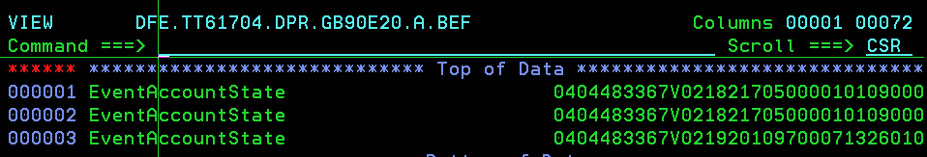
NEW FILE:- DFE.TT61704.DPR.GB90E20.A.AFT
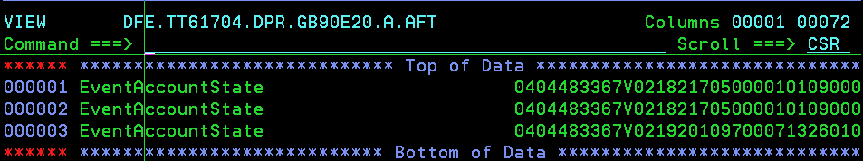
COPY BOOK:-Both the files are in C0B0780A layout.
Keys:- I want to compare above two files on the besis of below fields—
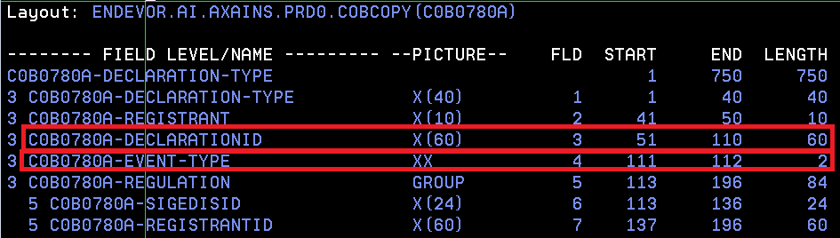
The comparision keys are –
C0B0780A-DECLARATIONID (Total length 60, starting position 51)
C0B0780A-EVENT-TYPE (Total length 2, starting position 111)
Step:-4
After that click on Submit button. Once you clicked a popup will be shown like below
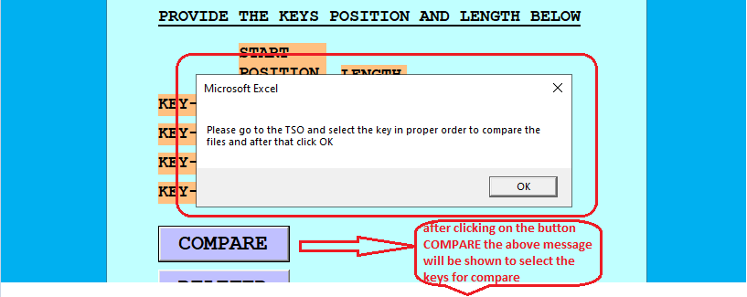
Now please go to TSO to provide the keys and once done please return back to the tool and click on OK button for further processing.
Step:-5
To provide the keys in TSO please go through the below example
I want to compare the file on basis of the below keys:-
C0B0780A-DECLARATIONID (Total length 60, starting position 51)
C0B0780A-EVENT-TYPE (Total length 2, starting position 111)
In TSO
Select the keys first
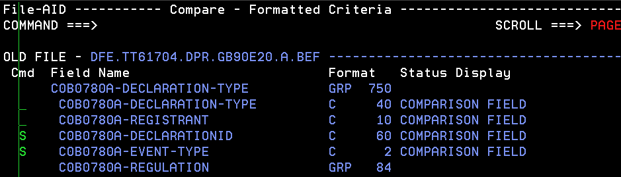
Now press F3 and the below screen will come
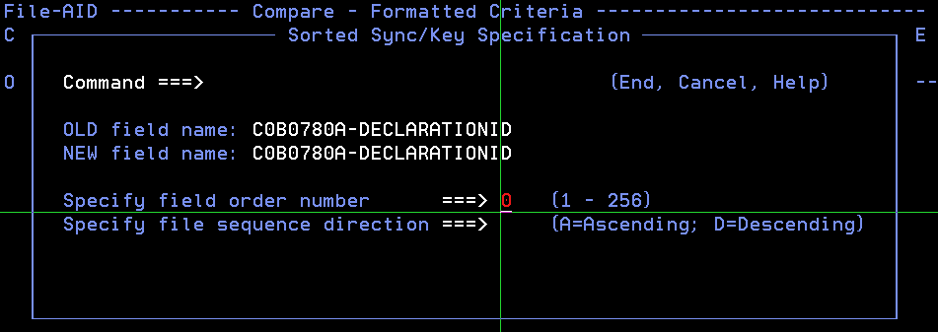
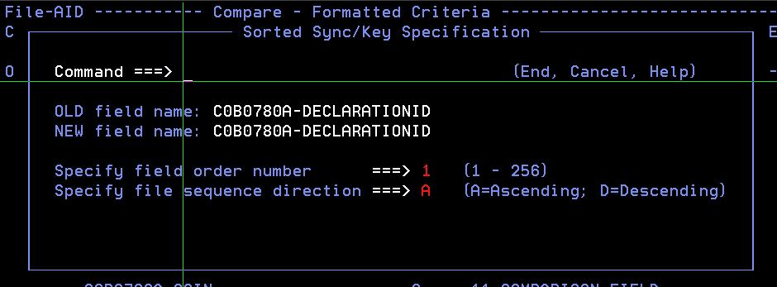
Again press F3
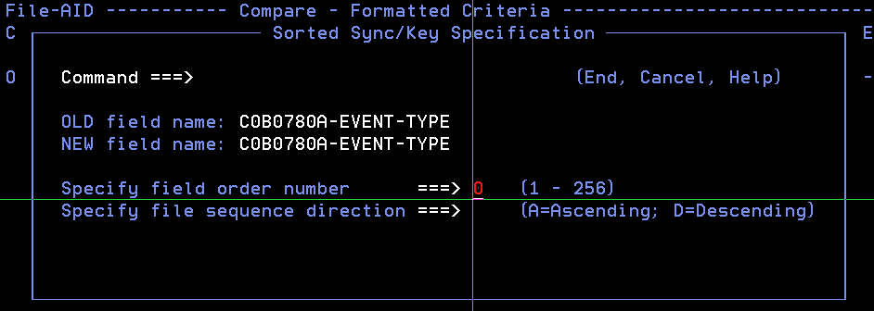
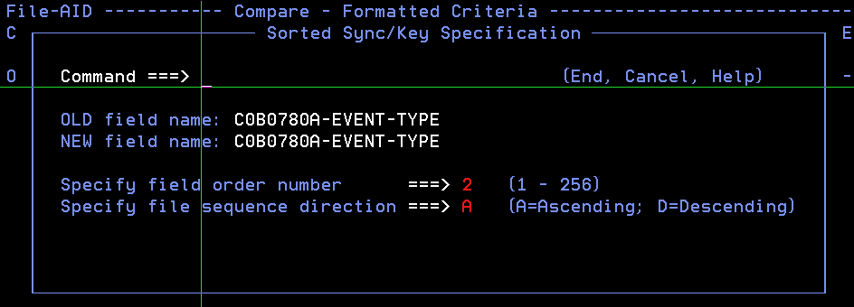
User have to press F3 for each key.Like in the above example I have taken only two keys that’s why I have pressed two time F3 after providing the proper order and sequence direction.
Sequence direction will be always A(Ascending)
Once everything is done you have to prees F3 in the last.
Step:-6
Return back to the tool and click on OK button.
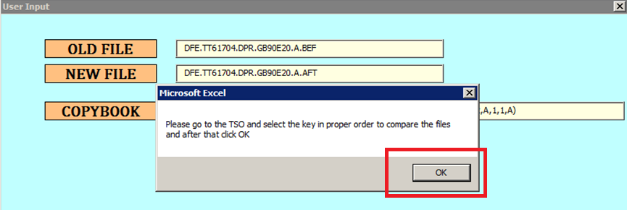
The final result will be populate in a EXCEL sheet like below.

