Objective: -
Sometimes for the sake of testing and to map a mainframe file with the respective copybook to create a report or to create a excel file mapping with the respective copybook is a manual and time taking and lengthy process.
Via FAMVS we can do that, but the process is bit lengthy and time taking.
Overview: -
To overcome the above problem this tool will create the excel file from a mainframe file mapped with the copybook format without any manual intervention and save the time as well as effort.
Steps to Generate: -
Step: -1
Create a folder Excel in the below path of your own system
C:\Data\Excel
Step: -2
Open the tool and click on the Compare button. It will take you to the form where you have to provide the input details for report creation in excel.
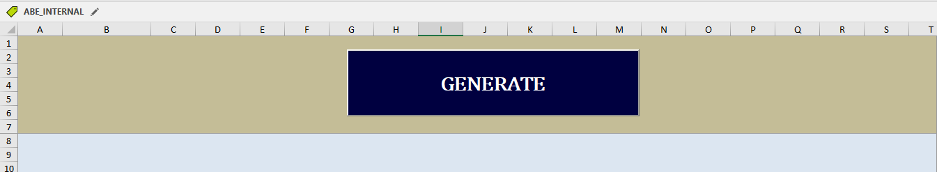
Step:-3
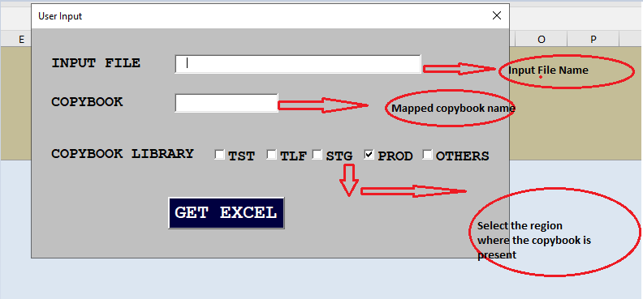
Example:-
Input File:- DFE.TBF0705.DPR.GB90E20.C.BEF
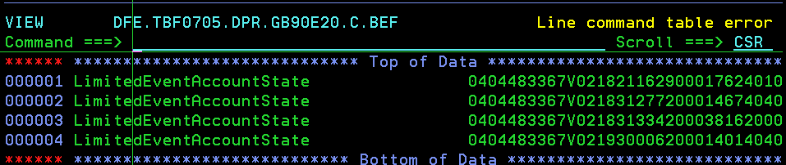
COPYBOOK: -Above file is in C0B0782A layout.
And the copybook present in PROD
Step:-4
After that click on GET EXCEL button. Once you clicked the data present in the input file will be populated in a excel mapped with the above copybook.
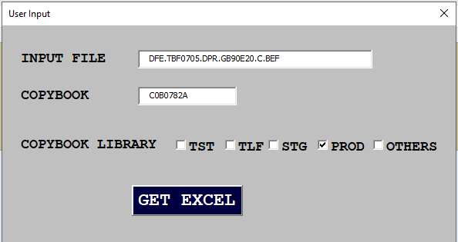
Step:-5
The final result will be populated in a EXCEL sheet like below.
