Objective: -
Objective: -1 Sometimes for the sake of testing and to map a mainframe file with the respective copybook to create a report or to create a excel file mapping with the respective copybook is a manual and time taking and lengthy process.
Via FAMVS we can do that, but the process is bit lengthy and time taking.
Objective: -2 Some time for the testing purposes we need to execute several batches. To generate the anomaly report we have to execute the GB49A0 application manually and then we extracted the file in a excel format. The whole process is done manually and take some effort. To overcome this, we have added a feature in this tool which will generate the anomaly report automatically with minimum user intervention.

Overview: -
To overcome the above problem this tool will create the excel file from a mainframe file mapped with the copybook format without any manual intervention and save the time as well as effort.
Steps to Generate: -
Step: -1
Create a folder Excel in the below path of your own system
C:\Data\Excel
Step: -2
Open the tool and click on the Generate button. It will take you to the form where you have to provide the input details for report creation in excel.
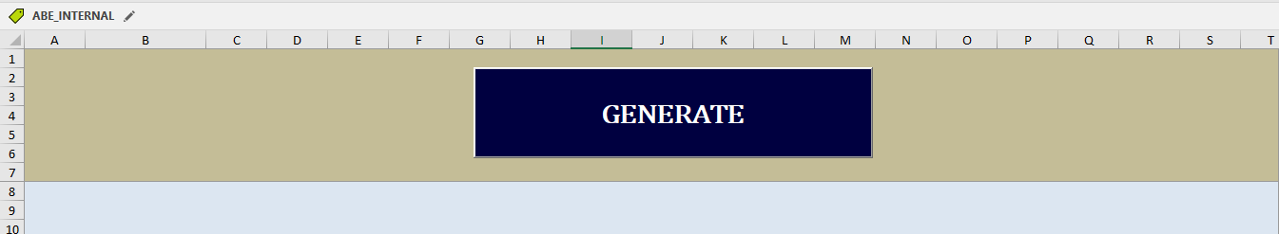
Step:-3
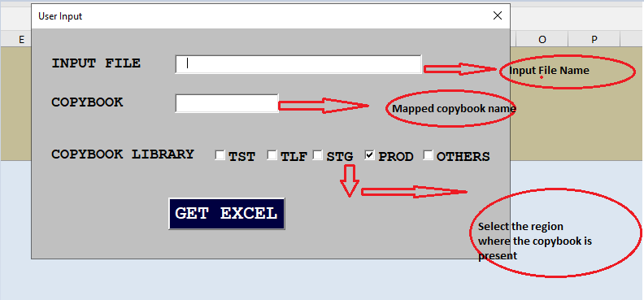
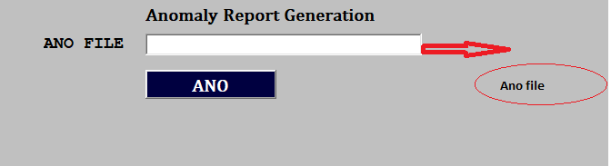
Example:-
Input File:- DFE.TBF0705.DPR.GB90E20.C.BEF
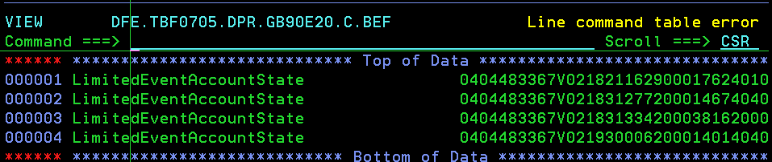
COPYBOOK: -Above file is in C0B0782A layout.
And the copybook present in PROD
Step:-4
After that click on GET EXCEL button. Once you clicked the data present in the input file will be populated in a excel mapped with the above copybook.
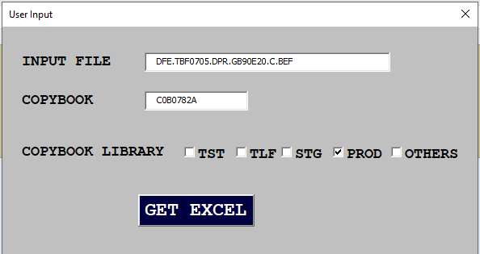
Step:-5
The final result will be populated in an EXCEL sheet like below.
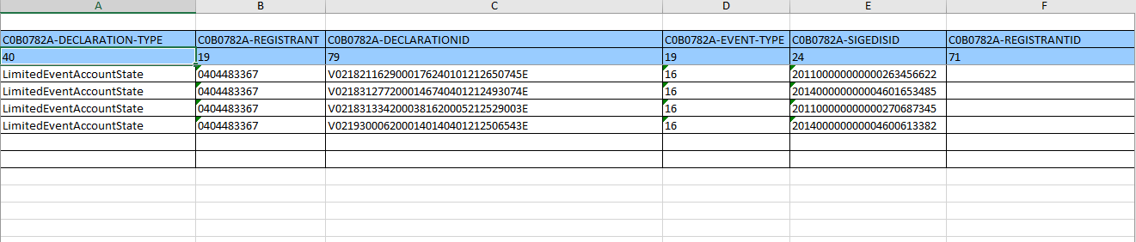
Anomaly Report creation:-
Step:-1
To generate the Anomaly Report,provide the anoamly file In the below
Step:-2
Click on the Ano button.Upon clicking the button the anomaly file will be populated in a excel standard anomaly format.
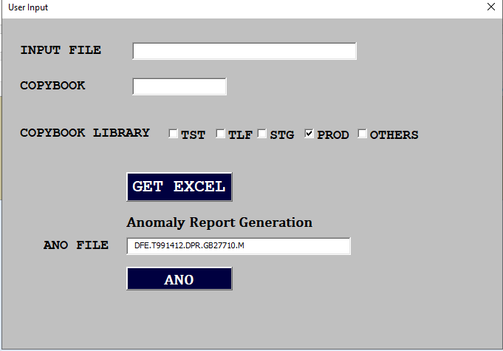
Final Result:-
