PROOF OF CONCEPT
AI Insurance Portal
AI-Assisted Claims Intake & Policy Management Platform

Prepared for: | Engineering Manager
Prepared by: | Arijit — Software Engineer
Document type: | Proof of Concept (POC) Summary
Date: | 6 July 2026
Repository: | github.com/arijit477/ai-insurance-portal
Live preview: | ai-insurance-portal.vercel.app

1. Executive Summary
The AI Insurance Portal is a full-stack proof of concept that demonstrates how an insurer's claims and policy workflows can be modernized with a web-based self-service portal augmented by generative AI. The POC pairs a modern Angular 17+ frontend with a FastAPI backend integrated with OpenAI (GPT-4o-mini), giving policyholders and claims staff an AI-assisted interface for submitting, tracking, and reviewing insurance claims.
This document summarizes what has been built, the technical approach, current status, and the recommended next steps to take the POC from a working prototype to a pilot-ready application.

Purpose of this POC
- Validate that an AI-assisted layer (document understanding, claim triage, conversational assistance) can be integrated into a real insurance claims workflow with acceptable speed and accuracy.
- Prove out a modern, cloud-deployable architecture (Angular + FastAPI) that can scale from prototype to production without a rewrite.
- Provide a tangible, clickable artifact that stakeholders can review to inform a go/no-go decision on further investment.

Current Status
WORKING PROTOTYPE Core flows (authentication, claim submission, document upload, AI-assisted review) are implemented and deployed to a public preview environment. A short list of known issues is tracked in Section 7.

2. Business Problem & Opportunity
Traditional insurance claims intake is slow and manually intensive: customers fill paper or PDF forms, adjusters manually read supporting documents, and status updates require phone calls or email. This creates friction for customers and operational overhead for staff.

Pain Points Addressed
- Manual, unstructured claim submissions that are slow to review and easy to misfile.
- Limited self-service visibility into claim or policy status for customers.
- High manual effort to read, summarize, and triage supporting documents (medical reports, repair estimates, police reports, etc.).
- No consistent, structured record of communication between the insurer and the claimant.

Opportunity
By combining a self-service portal with an LLM-based assistant, the insurer can accelerate first-pass review, reduce manual data entry, and give customers a faster, more transparent experience — while keeping a human adjuster in the loop for final decisions.

3. Proposed Solution Overview
The portal is built as a decoupled web application: an Angular single-page application for the user experience, and a FastAPI service that exposes REST endpoints, manages persistence, and orchestrates calls to OpenAI's GPT-4o-mini model for AI-assisted tasks.

Core User Flows Demonstrated
- Account registration & secure login (JWT-based authentication).
- Policyholder dashboard for viewing policies and claims.
- New claim submission with supporting document upload.
- AI-assisted review of submitted claim details and documents.
- Individual claim detail view with status tracking (e.g., route pattern /claims/{id}).

Why This Approach
- Angular Signals + zoneless change detection: a modern, high-performance rendering model with less boilerplate than legacy Angular.
- FastAPI: async-first Python framework, fast to iterate on and well suited to wrapping AI API calls.
- GPT-4o-mini: a low-cost, low-latency model appropriate for a POC — validates the interaction pattern before committing to a more expensive model.
- Cloud-native deployment (Vercel + Render) to prove the app can run entirely on managed infrastructure with no custom ops overhead.

4. Technical Architecture
The system follows a standard three-tier pattern: a client SPA, a stateless API layer, and a persistence + AI services layer.
Layer | Technology | Role in the POC
Frontend | Angular 17+ (Signals, zoneless change detection), TypeScript, HTML/SCSS | Renders the portal UI, manages client-side state reactively, calls backend REST API
Backend / API | FastAPI (Python), Uvicorn | Exposes REST endpoints for auth, claims, policies; coordinates AI calls
AI Layer | OpenAI API — GPT-4o-mini | Assists with claim review / document understanding tasks
Data | SQL database (SQLite for local dev; PostgreSQL-compatible for production) | Stores users, policies, claims, and related metadata
Auth | JWT-based authentication (SECRET_KEY signed tokens) | Secures API endpoints and gates client routes via an authGuard
Hosting — Frontend | Vercel | Static/SSR hosting for the Angular app
Hosting — Backend | Render (Web Service / Blueprint via render.yaml) | Hosts the FastAPI service and database

High-Level Request Flow
- 1. User authenticates from the Angular app → FastAPI issues a JWT.
- 2. User submits a claim and uploads supporting documents through the portal.
- 3. FastAPI persists the claim record and forwards relevant content to the OpenAI API for AI-assisted review.
- 4. The AI response (e.g., a summary, extracted fields, or triage suggestion) is stored and surfaced back to the user/adjuster in the claim detail view.
- 5. Client routes such as /upload/{id} and /claims/{id} render the corresponding step of the journey.

4b. End-to-End Process Flow
The diagram below traces a single claim from submission through AI-assisted review to the policyholder seeing a result. It maps directly onto the layers introduced in Section 4.
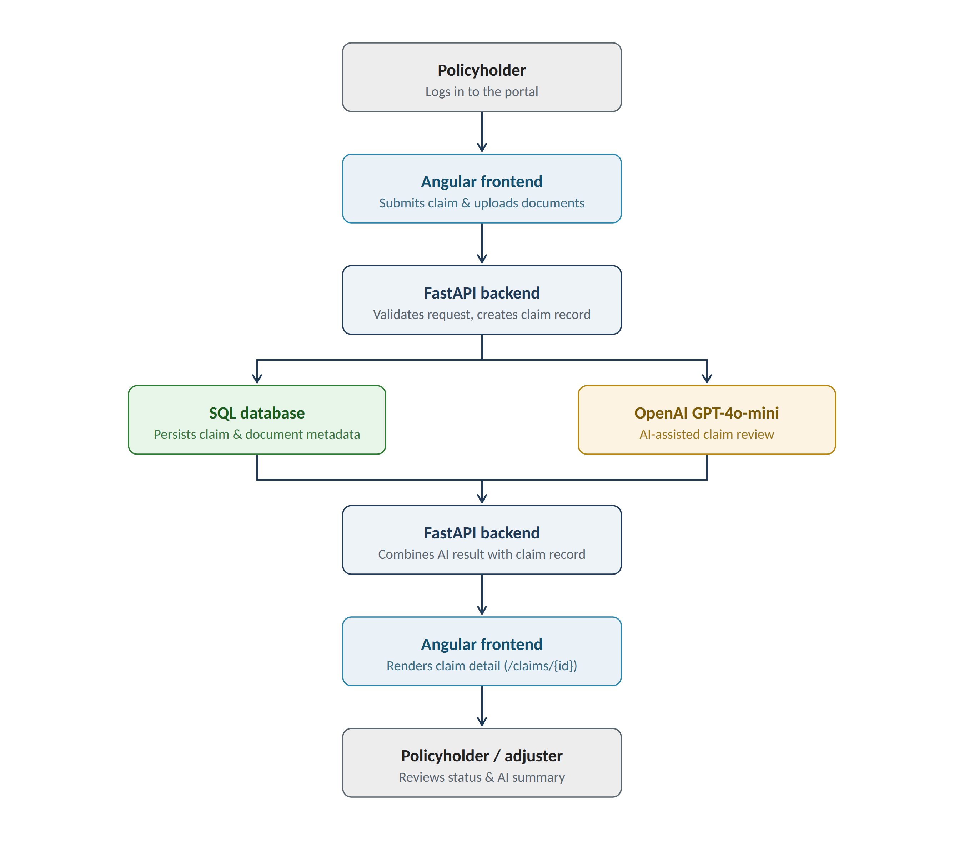

Steps in the Flow
- 1. The policyholder logs in to the Angular portal (JWT-authenticated session).
- 2. They submit a new claim and upload supporting documents through the client UI.
- 3. The FastAPI backend validates the request and creates a claim record.
- 4. The backend fans out in parallel: it persists the claim and document metadata to the SQL database, and sends the relevant content to OpenAI's GPT-4o-mini for AI-assisted review.
- 5. The backend merges the AI-generated result (e.g. a summary or triage suggestion) with the stored claim record.
- 6. The Angular frontend renders the updated claim detail view (route pattern /claims/{id}).
- 7. The policyholder or an adjuster reviews the claim status and the AI-generated summary.

5. Scope of the POC
This POC is intentionally scoped as a technical validation, not a production-ready system. The table below draws the line between what is demonstrated today and what would be required for a pilot.

In Scope — Demonstrated Today
- Angular frontend with signal-based state management and zoneless rendering
- FastAPI backend with REST endpoints for auth, policies, and claims
- JWT authentication with route guarding on the client
- Document upload flow tied to a specific claim
- OpenAI GPT-4o-mini integration for AI-assisted claim review
- SQL-backed persistence (SQLite locally, PostgreSQL-ready)
- Cloud deployment pipeline (Vercel + Render, including render.yaml blueprint)

Out of Scope — Deferred to Future Phases
- Production-grade security hardening (secrets management, rate limiting, audit logging)
- Real underwriting or claims-adjudication business logic (fraud scoring, payout automation)
- Integration with a live policy administration or core insurance system
- Multi-tenant support, role-based access beyond a basic auth guard
- Formal accessibility (WCAG) and load/performance testing
- Mobile app equivalents (web-responsive only)

6. Deployment Model
The POC is designed to run entirely on managed, low-cost infrastructure, which keeps validation cost near zero while still being reachable over the public internet for stakeholder review.

Backend — Render
- Deployed as a Python web service (or via the included render.yaml Blueprint).
- Environment variables: PYTHON_VERSION, SECRET_KEY (JWT signing), DATABASE_URL, OPENAI_API_KEY.
- Start command: uvicorn app.main:app --host 0.0.0.0 --port $PORT

Frontend — Vercel
- Deployed from the /frontend directory using Angular's default build (npm run build).
- Publicly reachable at ai-insurance-portal.vercel.app for demo purposes.

Local Development
- Backend: cd backend && uv run uvicorn app.main:app --reload
- Frontend: cd frontend && npm run start

7. Current Limitations & Open Items
As a POC, a few items are tracked as open work rather than production blockers. These are pulled directly from the project's TODO.md:
- Angular SSR routing needs adjustment so parameterized client routes (e.g., /upload/123, /claims/5) render correctly on the client instead of being forced through server rendering.
- The authGuard needs to be made SSR-safe — it should not evaluate login state during server rendering, which can currently cause incorrect redirects or blank screens.
- Verification is still needed to confirm /upload/123 and /claims/5 reliably load their components with no blank-screen regressions.
KNOWN ISSUE None of the above are architectural blockers — they are routing/SSR configuration fixes expected before broader user testing begins.

8. Success Criteria
The following criteria were used to judge whether the POC proves out the intended concept.
Criterion | Target for POC | Status
End-to-end claim submission | User can log in, submit a claim, and upload a document without errors | Demonstrated
AI-assisted review | AI layer returns a usable response for a submitted claim/document | Demonstrated
Client-side routing stability | All core routes render without blank screens, including under SSR | In progress
Cloud deployment | Full stack reachable via public URLs with no local setup | Demonstrated
Cost per AI call | Stay within a low, predictable per-request cost using GPT-4o-mini | To be measured

9. Recommended Next Steps

Short Term (1–2 weeks)
- Resolve the three SSR/routing items in Section 7 to stabilize the demo experience.
- Move secrets (OPENAI_API_KEY, SECRET_KEY) to a proper secrets manager and confirm they are not exposed in any client bundle.
- Add basic automated tests around auth, claim submission, and the AI integration endpoint.

Medium Term (1–2 months)
- Pilot with a small internal group or a single line of business to gather real usage data and AI-response quality feedback.
- Introduce structured evaluation of AI outputs (accuracy, latency, cost per claim) to decide if GPT-4o-mini is sufficient or a larger model is warranted for specific tasks.
- Migrate from SQLite to a managed PostgreSQL instance and add data backup/retention policies.

Longer Term
- Define integration points with core policy administration / claims systems if the POC is approved for productization.
- Add role-based access control for adjusters vs. policyholders, and audit logging for compliance.
- Evaluate accessibility, security review, and load testing ahead of a production rollout.

10. Risks & Considerations
Risk | Impact | Mitigation
AI output accuracy/hallucination on claim data | Medium–High | Keep a human adjuster in the loop for all decisions; log and review AI outputs
Data privacy of sensitive claim/medical documents sent to a third-party AI API | High | Review OpenAI data-handling terms; consider redaction or a private/enterprise AI endpoint before production
SSR/routing issues affecting user experience | Low | Tracked in Section 7; fix is scoped and well understood
Single-model dependency (OpenAI) | Medium | Abstract the AI call behind an internal interface to allow provider swap later

11. Conclusion & Ask
This POC demonstrates a technically sound, end-to-end path for combining a modern web portal with an AI-assisted layer for insurance claims handling. The core architecture — Angular + FastAPI + OpenAI, deployed on managed cloud infrastructure — is sound and reusable for a production build.
Recommendation: Approve a short stabilization pass (Section 9, Short Term) followed by a limited internal pilot to gather real usage data before committing further engineering investment.
Ask of the Manager: Time-box approval to fix the remaining SSR/routing issues, and sign-off to run a small internal pilot with real (or de-identified) claim scenarios.

