**Sample Input / Output**

**All the tasks are performed in small dataset given in Canvas.**

**Color Moments:**

**Task1 :**

**Input**:

Provide the model you want to work with lbp/cm: cm

Tell us which task you want to perform: task1

Enter the folder: C:\\Users\\Lenovo\\Desktop\\Downloads\\CSE 515 Fall19 - Smaller Dataset\\CM

Provide the image name: Hand_0011684.jpg

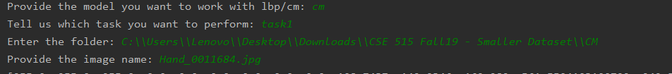

**output:**

**[255.0, 255.0, 255.0, 0.0, 0.0, 0.0, 0.0, 0.0, 0.0, 108.7437, 142.9346, 169.282, 561.5504103100792, 242.54652284000124, 58.669076000000686, 2.7879738509277012, 2.8832904783573015, 1.757897758099997, 255.0, 255.0, 255.0, 0.0, 0.0, 0.0, 0.0, 0.0, 0.0, 255.0, 255.0, 255.0, 0.0, 0.0, 0.0, 0.0, 0.0, 0.0, 255.0, 255.0, 255.0, 0.0, 0.0, 0.0, 0.0, 0.0, 0.0, 142.0997, 168.8684, 195.646, 5276.513159909848, 3500.097681439863, 1769.7682839999889, 0.5169033031980457, 0.18071952983052808, -0.1309981917970265, 84.296, 124.7143, 161.5853, 626.3865840000038, 814.2710755099974, 663.8757239100017, -1.5259058468806113, -2.0046153458423377, -1.8765663824683247, 90.7842, 125.7958, 166.648, 662.822630359997, 1004.588102359991, 899.0300959999876, -1.9677012018821092, -2.5596613188636637, -2.593493047032178, 82.5503, 120.8709, 161.12, 782.4938699099994, 552.5732331899995, 302.54659999999876, 3.0596054035136606, 1.8761039742645291, 0.8029275883662184, 207.937, 215.8582, 222.3489, 3019.1024310002545, 2389.3500927603204, 1376.4553687901455, -1.346062700107573, -1.6197894019193884, -1.1800384388493421, 241.3003, 241.9129, 243.2855, 2709.754719908952, 2617.444513589742, 2116.092989751115, -3.993281668834579, -4.066933100071259, -4.128037599939252, 255.0, 255.0, 255.0, 0.0, 0.0, 0.0, 0.0, 0.0, 0.0, 217.8014, 221.7842, 212.1489, 357.60075803999837, 277.03643035999926, 175.3069287899979, -2.5035040757152984, -1.7019856026161764, -0.6986425374304784, 254.9771, 254.9771, 254.9771, 0.12057559000001934, 0.12057559000001934, 0.12057559000001934, -22.145547045827136, -22.145547045827136, -22.145547045827136, 255.0, 255.0, 255.0, 0.0, 0.0, 0.0, 0.0, 0.0, 0.0, 255.0, 255.0, 255.0, 0.0, 0.0, 0.0, 0.0, 0.0, 0.0, 255.0, 255.0, 255.0, 0.0, 0.0, 0.0, 0.0, 0.0, 0.0, 255.0, 255.0, 255.0, 0.0, 0.0, 0.0, 0.0, 0.0, 0.0, 255.0, 255.0, 255.0, 0.0, 0.0, 0.0, 0.0, 0.0, 0.0, 255.0, 255.0, 255.0, 0.0, 0.0, 0.0, 0.0, 0.0, 0.0, 255.0, 255.0, 255.0, 0.0, 0.0, 0.0, 0.0, 0.0, 0.0, 255.0, 255.0, 255.0, 0.0, 0.0, 0.0, 0.0, 0.0, 0.0, 162.2157, 173.8706, 191.4636, 9404.467773508934, 8201.209255639, 5744.631875039797, -0.3625090950000179, -0.601379940796661, -1.0062907309347728, 254.349, 254.6983, 251.9717, 2.939999000000657, 1.320877109999452, 32.299299110003766, -4.075757715233724, -5.634309755192537, -1.9720658051883924, 87.582, 125.1924, 159.5691, 1067.4354759999999, 1330.7551822400396, 992.6454251899949, -0.7848938922996974, -1.6254754165845804, -1.7309978057951467, 75.8733, 114.4462, 151.079, 729.2866471099923, 1079.8895055600028, 855.1983589999967, -0.734884293469025, -1.5228534488737115, -1.9180941306156358, 110.658, 142.9, 172.1127, 3834.6320359999895, 2451.596800000082, 1166.5175987099992, 1.0356143160849856, 0.89071360255132, 0.8536532371344016, 252.7346, 253.5308, 253.6232, 53.80936283998918, 26.770651360007253, 22.43622175998968, -3.5895859939637216, -3.895784380164325, -3.7562229838774517, 255.0, 255.0, 255.0, 0.0, 0.0, 0.0, 0.0, 0.0, 0.0, 255.0, 255.0, 255.0, 0.0, 0.0, 0.0, 0.0, 0.0, 0.0, 255.0, 255.0, 255.0, 0.0, 0.0, 0.0, 0.0, 0.0, 0.0, 255.0, 255.0, 255.0, 0.0, 0.0, 0.0, 0.0, 0.0, 0.0, 254.8438, 254.9355, 254.1746, 0.20200155999997607, 0.07513975000000732, 1.2651148399999574, -3.2595558333839123, -5.3838887393869035, -1.6593423013425566, 255.0, 255.0, 255.0, 0.0, 0.0, 0.0, 0.0, 0.0, 0.0, 255.0, 255.0, 255.0, 0.0, 0.0, 0.0, 0.0, 0.0, 0.0, 255.0, 255.0, 255.0, 0.0, 0.0, 0.0, 0.0, 0.0, 0.0, 255.0, 255.0, 255.0, 0.0, 0.0, 0.0, 0.0, 0.0, 0.0, 255.0, 255.0, 255.0, 0.0, 0.0, 0.0, 0.0, 0.0, 0.0, 255.0, 255.0, 255.0, 0.0, 0.0, 0.0, 0.0, 0.0, 0.0, 255.0, 255.0, 255.0, 0.0, 0.0, 0.0, 0.0, 0.0, 0.0, 251.5329, 252.9191, 252.4261, 81.27891759002429, 37.400155190012335, 49.23173879000573, -3.1052489909196437, -4.077825920153435, -3.4050850101177796, 67.6858, 93.7881, 132.3352, 2521.0620783599975, 3151.6383983899877, 2715.184440960006, 1.4043515132583766, 0.23715061500176263, -0.6066796226139504, 60.9048, 91.824, 132.5542, 1064.7103369599772, 1860.349624, 2022.530062359993, 0.020253038532380634, -0.6199277531441231, -1.2196501279952612, 134.3438, 150.1245, 176.157, 8446.129401560254, 7212.618199750134, 4060.706350999986, 0.08918052810193643, -0.09586785244664299, -0.4787740057048637, 255.0, 255.0, 255.0, 0.0, 0.0, 0.0, 0.0, 0.0, 0.0, 255.0, 255.0, 255.0, 0.0, 0.0, 0.0, 0.0, 0.0, 0.0, 255.0, 255.0, 255.0, 0.0, 0.0, 0.0, 0.0, 0.0, 0.0, 255.0, 255.0, 255.0, 0.0, 0.0, 0.0, 0.0, 0.0, 0.0, 255.0, 255.0, 255.0, 0.0, 0.0, 0.0, 0.0, 0.0, 0.0, 254.9508, 254.9779, 254.831, 0.07157936000000108, 0.02921159000000061, 0.4218390000000081, -6.522823479499374, -8.603109023434863, -6.005168812211458, 254.4399, 254.738, 251.7197, 0.5915879900000276, 0.34695599999997584, 5.264131909999424, -1.6217904480290044, -2.7426481776130895, -0.4993489495507114, 255.0, 255.0, 255.0, 0.0, 0.0, 0.0, 0.0, 0.0, 0.0, 255.0, 255.0, 255.0, 0.0, 0.0, 0.0, 0.0, 0.0, 0.0, 255.0, 255.0, 255.0, 0.0, 0.0, 0.0, 0.0, 0.0, 0.0, 255.0, 255.0, 255.0, 0.0, 0.0, 0.0, 0.0, 0.0, 0.0, 255.0, 255.0, 255.0, 0.0, 0.0, 0.0, 0.0, 0.0, 0.0, 255.0, 255.0, 255.0, 0.0, 0.0, 0.0, 0.0, 0.0, 0.0, 255.0, 255.0, 255.0, 0.0, 0.0, 0.0, 0.0, 0.0, 0.0, 254.8469, 254.96, 254.9344, 1.4844603900004034, 0.16860000000005188, 0.3834966399999964, -9.550417635070307, -12.054301986112797, -11.035679650818093, 190.5283, 195.9567, 202.7841, 8135.128399109833, 7560.711625108881, 5440.574087190284, -1.0852064958211471, -1.192900863525857, -1.3027859877825472, 114.7227, 125.2445, 146.0623, 8474.935804709892, 8120.932319749618, 5775.633818709938, 0.3534622924712016, 0.17774758532681284, -0.22379247224610754, 238.5352, 240.262, 241.1247, 2865.3267609611057, 2667.847955999209, 1978.3209499093439, -3.738395564160704, -3.9659529546420234, -4.021466146978009, 255.0, 255.0, 255.0, 0.0, 0.0, 0.0, 0.0, 0.0, 0.0, 255.0, 255.0, 255.0, 0.0, 0.0, 0.0, 0.0, 0.0, 0.0, 254.9944, 254.9976, 254.9864, 0.005568640000000069, 0.0023942400000000344, 0.019815040000000124, -13.250549426647817, -20.338856222524548, -11.468553728960753, 254.9476, 254.988, 254.7732, 0.06405424000000075, 0.01185600000000068, 0.2849617600000019, -5.267067594337746, -8.96356397212101, -2.5851410536069137, 254.5682, 254.7292, 252.5198, 0.42254876000007013, 0.38266735999998824, 3.8154079600002233, -1.6977331874435255, -2.8847034248763364, -0.7809279913049252, 255.0, 255.0, 255.0, 0.0, 0.0, 0.0, 0.0, 0.0, 0.0, 254.1311, 254.413, 249.1266, 0.9069127899999959, 0.6384309999999175, 3.31257243999988, -1.0585537119349913, -1.6471883411281392, -0.5359302247845599, 255.0, 255.0, 255.0, 0.0, 0.0, 0.0, 0.0, 0.0, 0.0, 255.0, 255.0, 255.0, 0.0, 0.0, 0.0, 0.0, 0.0, 0.0, 255.0, 255.0, 255.0, 0.0, 0.0, 0.0, 0.0, 0.0, 0.0, 255.0, 255.0, 255.0, 0.0, 0.0, 0.0, 0.0, 0.0, 0.0, 255.0, 255.0, 255.0, 0.0, 0.0, 0.0, 0.0, 0.0, 0.0, 255.0, 255.0, 255.0, 0.0, 0.0, 0.0, 0.0, 0.0, 0.0, 255.0, 255.0, 255.0, 0.0, 0.0, 0.0, 0.0, 0.0, 0.0, 254.9474, 254.9871, 254.8772, 0.06463323999998698, 0.021933589999992203, 0.27032015999999714, -5.8578865414590515, -14.05293084410311, -5.023007470467758, 254.7791, 254.8955, 254.2428, 0.4891031899997429, 0.19097975000002276, 3.5768481600009814, -3.7730126348829622, -5.503042562261187, -2.4577002530045755, 255.0, 255.0, 255.0, 0.0, 0.0, 0.0, 0.0, 0.0, 0.0, 255.0, 255.0, 255.0, 0.0, 0.0, 0.0, 0.0, 0.0, 0.0, 254.9598, 254.9738, 254.8558, 0.06178396000000005, 0.0391135599999985, 0.18420635999999946, -8.301215620488577, -11.519248937573717, -3.768198869913221, 254.7056, 254.8892, 253.8479, 0.2677286399999874, 0.135923359999995, 2.2695655899999463, -1.6677027406572111, -3.7008914554085073, -1.3387014683291993, 254.6122, 254.7818, 252.1231, 0.3570111599999216, 0.2815887600000261, 4.773146389999807, -1.484806420014117, -2.698902431261913, -0.4337576474370443, 254.6744, 254.5693, 250.9783, 0.3627846399999713, 0.443597509999986, 4.904029109999925, -2.132219101008556, -1.5117010981219037, -0.8021586393624125, 254.6172, 254.454, 249.5704, 0.5326641600000368, 0.6766839999999764, 2.6180438399999475, -2.1421884054134455, -1.6754288502438748, -0.8820346376647461, 252.7193, 254.2881, 245.4201, 2.6787075099999003, 0.947298390000052, 9.513615989999776, -0.8231064776277707, -1.7325004542943234, -0.3638928909849707, 255.0, 255.0, 255.0, 0.0, 0.0, 0.0, 0.0, 0.0, 0.0, 255.0, 255.0, 255.0, 0.0, 0.0, 0.0, 0.0, 0.0, 0.0, 255.0, 255.0, 255.0, 0.0, 0.0, 0.0, 0.0, 0.0, 0.0, 255.0, 255.0, 255.0, 0.0, 0.0, 0.0, 0.0, 0.0, 0.0, 255.0, 255.0, 255.0, 0.0, 0.0, 0.0, 0.0, 0.0, 0.0, 255.0, 255.0, 255.0, 0.0, 0.0, 0.0, 0.0, 0.0, 0.0, 255.0, 255.0, 255.0, 0.0, 0.0, 0.0, 0.0, 0.0, 0.0, 255.0, 255.0, 255.0, 0.0, 0.0, 0.0, 0.0, 0.0, 0.0, 255.0, 255.0, 255.0, 0.0, 0.0, 0.0, 0.0, 0.0, 0.0, 255.0, 255.0, 255.0, 0.0, 0.0, 0.0, 0.0, 0.0, 0.0, 254.9896, 255.0, 254.8152, 0.010291839999999976, 0.0, 0.17144896000000667, -9.652168432561446, 0.0, -2.054315673275795, 254.6561, 254.9319, 253.6449, 0.3608327899999746, 0.09046239000000834, 1.1938039899999993, -1.9402852370088726, -5.075748820192193, -0.9943249895863931, 254.8156, 254.6462, 250.3575, 0.23099664000001835, 0.372625560000007, 2.4660937500001108, -3.0367212623327045, -1.7031786249334946, -1.5016575880371439, 254.4359, 254.6474, 246.5415, 0.5552911900000904, 0.4408732399999382, 6.325477750000269, -1.3293642425728864, -2.0913535087873307, -0.20009048878162158, 255.0, 255.0, 255.0, 0.0, 0.0, 0.0, 0.0, 0.0, 0.0, 254.4831, 254.6867, 245.3405, 0.6009143899999164, 0.4091431100000804, 7.207959750000367, -1.4996190950222463, -2.411847737753261, -0.10190894003173141, 254.1096, 254.5626, 246.4343, 0.9313878399999755, 0.5986812400000117, 5.145483509999981, -1.2001284272026103, -2.2643943361697656, -0.366837362018849, 252.7461, 254.343, 240.2315, 2.6774347900002384, 0.8823510000000268, 11.388507749999935, -0.5677929676896254, -1.6894944835812262, -0.6146812824269915, 255.0, 255.0, 255.0, 0.0, 0.0, 0.0, 0.0, 0.0, 0.0, 255.0, 255.0, 255.0, 0.0, 0.0, 0.0, 0.0, 0.0, 0.0, 255.0, 255.0, 255.0, 0.0, 0.0, 0.0, 0.0, 0.0, 0.0, 252.7877, 253.6477, 248.7313, 17.515428709994502, 8.96458471000104, 72.99930030999373, -2.0530359536128704, -2.4515265502390475, -1.1274552451057458, 179.3163, 196.5505, 198.404, 3894.307254310011, 2281.426849749911, 930.4249840000023, -0.2251884576122541, -0.19923441694540223, -0.1620043485633031, 91.712, 134.0851, 158.0246, 33.701056000001785, 11.904657990000212, 17.182194840000165, 0.21161048263809892, -0.10139979206493052, -0.300742379257738, 84.5619, 130.7551, 159.2042, 30.62596838999962, 18.347723989999654, 17.65950236000012, -0.1995199206922338, -0.6361629639407846, -0.5405853647004799, 82.3121, 127.4031, 159.0474, 36.47329358999908, 21.111810390000045, 19.927753239999728, 0.03091861345904199, -0.38245880419126455, -0.38057778408298, 161.558, 181.621, 192.3, 4517.663636000039, 2583.8679590000206, 1110.3923999999756, 0.07528604492570054, 0.12426905328130688, 0.18744112669476673, 254.7532, 254.8351, 253.7245, 1.0446897600000256, 0.7697079900000315, 9.5691997500002, -6.659884761630401, -8.709827566592185, -2.5953312124345485, 255.0, 255.0, 255.0, 0.0, 0.0, 0.0, 0.0, 0.0, 0.0, 255.0, 255.0, 255.0, 0.0, 0.0, 0.0, 0.0, 0.0, 0.0, 255.0, 255.0, 255.0, 0.0, 0.0, 0.0, 0.0, 0.0, 0.0, 255.0, 255.0, 255.0, 0.0, 0.0, 0.0, 0.0, 0.0, 0.0, 255.0, 255.0, 255.0, 0.0, 0.0, 0.0, 0.0, 0.0, 0.0, 255.0, 255.0, 255.0, 0.0, 0.0, 0.0, 0.0, 0.0, 0.0, 255.0, 255.0, 255.0, 0.0, 0.0, 0.0, 0.0, 0.0, 0.0, 255.0, 255.0, 255.0, 0.0, 0.0, 0.0, 0.0, 0.0, 0.0, 255.0, 255.0, 255.0, 0.0, 0.0, 0.0, 0.0, 0.0, 0.0, 255.0, 255.0, 255.0, 0.0, 0.0, 0.0, 0.0, 0.0, 0.0, 254.0595, 254.7495, 252.6809, 5.2191597500005384, 0.9125497499999056, 21.866675190001935, -3.07401123426682, -7.691092634449472, -1.964573471801121, 145.2366, 173.8529, 186.8969, 3901.873820440043, 2288.8012615899725, 942.4312703899802, 0.7920872784893497, 0.8114460987395041, 0.8508171519231834, 255.0, 255.0, 255.0, 0.0, 0.0, 0.0, 0.0, 0.0, 0.0, 83.4009, 131.013, 158.313, 41.09457919, 25.96523099999982, 19.94443100000016, 0.054228584078283786, -0.36204466550720593, 0.10259676043852013, 73.5493, 123.2017, 155.805, 33.37356950999982, 27.405217110000308, 28.708374999999283, -0.14848623524150614, -0.3871711065815486, -0.04200613790036718, 85.361, 131.393, 164.1214, 46.0538789999999, 31.30855099999836, 18.929462039998917, 0.11864254089298479, -0.30102908010578977, -0.5467705831133097, 91.7393, 132.3523, 164.2195, 491.13193551001393, 331.5637847099977, 198.65511975000504, 2.7893235120211384, 0.8885635512761929, -0.4918065244420166, 220.2434, 227.4303, 232.5185, 3929.9333564400054, 2451.807741909901, 1374.9580577500735, -1.439240729832568, -1.4020273919882524, -1.3286422132585962, 255.0, 255.0, 255.0, 0.0, 0.0, 0.0, 0.0, 0.0, 0.0, 255.0, 255.0, 255.0, 0.0, 0.0, 0.0, 0.0, 0.0, 0.0, 255.0, 255.0, 255.0, 0.0, 0.0, 0.0, 0.0, 0.0, 0.0, 255.0, 255.0, 255.0, 0.0, 0.0, 0.0, 0.0, 0.0, 0.0, 255.0, 255.0, 255.0, 0.0, 0.0, 0.0, 0.0, 0.0, 0.0, 254.984, 254.9943, 254.9201, 0.020544000000004645, 0.008267509999997685, 0.18171598999993224, -9.987675953870689, -17.77025514174733, -6.937999843599365, 255.0, 255.0, 255.0, 0.0, 0.0, 0.0, 0.0, 0.0, 0.0, 255.0, 255.0, 255.0, 0.0, 0.0, 0.0, 0.0, 0.0, 0.0, 255.0, 255.0, 255.0, 0.0, 0.0, 0.0, 0.0, 0.0, 0.0, 255.0, 255.0, 255.0, 0.0, 0.0, 0.0, 0.0, 0.0, 0.0, 254.3142, 254.8291, 254.1736, 2.602678360000226, 0.22609318999998745, 4.159463040001076, -2.5316678083605106, -3.2332312899723585, -2.736052822226056, 122.5275, 158.2062, 181.2238, 2908.3650437500123, 1708.7674815599744, 780.5939135600044, 1.565127790743976, 1.5954242245329107, 1.5455681002833013, 80.9018, 130.1552, 162.262, 73.31275676000062, 40.039712960000955, 39.53235600000075, 0.1918351391759913, -0.13004480326953496, -0.18245512402054143, 73.2101, 122.4342, 158.9018, 43.33715799000028, 52.299070360000016, 32.78015675999968, -0.1787469047006869, -0.37483735151964015, -0.26920496692906853, 78.2116, 126.1083, 162.4468, 43.68342544000122, 42.769971109999204, 33.884169759999786, 0.05537598697093745, -0.45565623005366773, -0.5034236059519915, 75.389, 116.4704, 153.6457, 619.1554790000039, 1009.4715238400031, 796.9749715100031, -1.4087841615545307, -1.750732522906557, -2.005159993453985, 248.2513, 249.7403, 239.8039, 53.35954831000337, 36.97405590999849, 123.27924479000254, -0.5877962887441951, -0.71741715640384, -0.005763786483267709, 179.5811, 196.7872, 210.9502, 6118.771022789815, 3592.6735161601573, 1823.1719199599795, -0.28161256582227745, -0.26713971886328974, -0.24372477123411584, 255.0, 255.0, 255.0, 0.0, 0.0, 0.0, 0.0, 0.0, 0.0, 255.0, 255.0, 255.0, 0.0, 0.0, 0.0, 0.0, 0.0, 0.0, 255.0, 255.0, 255.0, 0.0, 0.0, 0.0, 0.0, 0.0, 0.0, 255.0, 255.0, 255.0, 0.0, 0.0, 0.0, 0.0, 0.0, 0.0, 255.0, 255.0, 255.0, 0.0, 0.0, 0.0, 0.0, 0.0, 0.0, 255.0, 255.0, 255.0, 0.0, 0.0, 0.0, 0.0, 0.0, 0.0, 255.0, 255.0, 255.0, 0.0, 0.0, 0.0, 0.0, 0.0, 0.0, 255.0, 255.0, 255.0, 0.0, 0.0, 0.0, 0.0, 0.0, 0.0, 255.0, 255.0, 255.0, 0.0, 0.0, 0.0, 0.0, 0.0, 0.0, 198.0378, 208.4097, 201.3266, 1999.3689711599704, 1108.0026459099884, 418.88853244001325, -0.948360769425935, -0.8807290303263196, -0.6649495696736072, 254.3537, 254.8936, 254.7943, 2.560396310000016, 0.16467903999994768, 0.5939875099998784, -2.7490651468938347, -5.088146628733202, -5.725438810654461, 112.6714, 151.611, 179.8352, 3004.940822039972, 1730.0936789999712, 856.4652409599857, 1.6452244605238986, 1.6143009100071406, 1.517288521194736, 80.215, 129.3541, 168.1329, 110.34457499999986, 89.6563131899988, 68.71663759000022, 0.11826714817486556, -0.2629904615785967, -0.12488908797759163, 72.4573, 115.4527, 160.5251, 97.10437671000058, 161.8563627099986, 84.08316999000105, -0.1542155530700695, -0.5908015867438831, 0.04342047273047142, 75.2313, 118.2725, 163.931, 64.53760031000083, 119.86004375000073, 49.46663900000022, -0.5217819042540691, -0.7500909905347016, -0.6015333314302943, 61.3673, 97.1389, 140.6688, 723.2501907100007, 1589.6352067900107, 1439.6519065599925, -1.0165287477617075, -1.1606795869575606, -1.5660311021390119, 188.2672, 203.4092, 216.2107, 6058.378204160122, 3686.788955359821, 1887.817305510007, -0.6528143429937592, -0.6966124597401145, -0.6900790829916066, 255.0, 255.0, 255.0, 0.0, 0.0, 0.0, 0.0, 0.0, 0.0, 255.0, 255.0, 255.0, 0.0, 0.0, 0.0, 0.0, 0.0, 0.0, 255.0, 255.0, 255.0, 0.0, 0.0, 0.0, 0.0, 0.0, 0.0, 111.0907, 146.5332, 166.1268, 111.67247350999915, 49.449897759999494, 72.55752175999868, -0.3208949947477639, -0.047787131590859615, -0.1965554662410796, 255.0, 255.0, 255.0, 0.0, 0.0, 0.0, 0.0, 0.0, 0.0, 255.0, 255.0, 255.0, 0.0, 0.0, 0.0, 0.0, 0.0, 0.0, 255.0, 255.0, 255.0, 0.0, 0.0, 0.0, 0.0, 0.0, 0.0, 255.0, 255.0, 255.0, 0.0, 0.0, 0.0, 0.0, 0.0, 0.0, 255.0, 255.0, 255.0, 0.0, 0.0, 0.0, 0.0, 0.0, 0.0, 255.0, 255.0, 255.0, 0.0, 0.0, 0.0, 0.0, 0.0, 0.0, 254.9616, 255.0, 255.0, 0.07532544000001157, 0.0, 0.0, -7.007346801019228, 0.0, 0.0, 132.6915, 165.4726, 191.8388, 4166.066727750018, 2525.306049239891, 1290.775014560006, 0.9376667788153559, 0.7073407386682301, 0.5195859588566306, 83.3091, 126.1054, 164.6439, 556.4401571900072, 683.6654908399686, 503.0820927899992, -1.4887724672667537, -2.2712323979154916, -2.2244651666820463, 77.8284, 118.5909, 165.0359, 263.41675343999964, 339.257737189996, 268.68261119000084, -0.9492853066063685, -2.443232417212554, -3.0486656543119253, 101.5519, 142.1377, 165.1272, 39.06470639000046, 16.271538709999955, 21.116620160000146, -0.15680223681704783, -0.17980774386408746, -0.46904416730883725, 67.8649, 107.7759, 155.2149, 180.0096479899988, 313.4608791900205, 246.55391798999807, -1.4183258827270275, -1.934005698382526, -2.606014566573734, 58.1851, 80.9577, 126.708, 780.2630379899975, 1311.26811070999, 1471.272936000003, -0.1717796915560787, -0.7385263743870156, -1.1098176685374823, 201.4508, 206.7604, 214.8639, 7046.145379359766, 6214.968991839619, 4475.085376790218, -1.3448044836001924, -1.510290950215623, -1.7575404998972182, 255.0, 255.0, 255.0, 0.0, 0.0, 0.0, 0.0, 0.0, 0.0, 255.0, 255.0, 255.0, 0.0, 0.0, 0.0, 0.0, 0.0, 0.0, 255.0, 255.0, 255.0, 0.0, 0.0, 0.0, 0.0, 0.0, 0.0, 255.0, 255.0, 255.0, 0.0, 0.0, 0.0, 0.0, 0.0, 0.0, 255.0, 255.0, 255.0, 0.0, 0.0, 0.0, 0.0, 0.0, 0.0, 255.0, 255.0, 255.0, 0.0, 0.0, 0.0, 0.0, 0.0, 0.0, 255.0, 255.0, 255.0, 0.0, 0.0, 0.0, 0.0, 0.0, 0.0]**

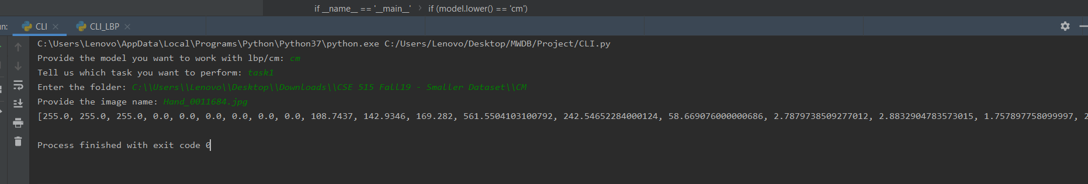

**Task2 :**

**input:**

Provide the model you want to work with lbp/cm: cm

Tell us which task you want to perform: task2

Enter the folder: C:\\Users\\Lenovo\\Desktop\\Downloads\\CSE 515 Fall19 - Smaller Dataset\\CM

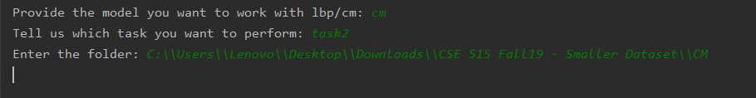

**Output:**

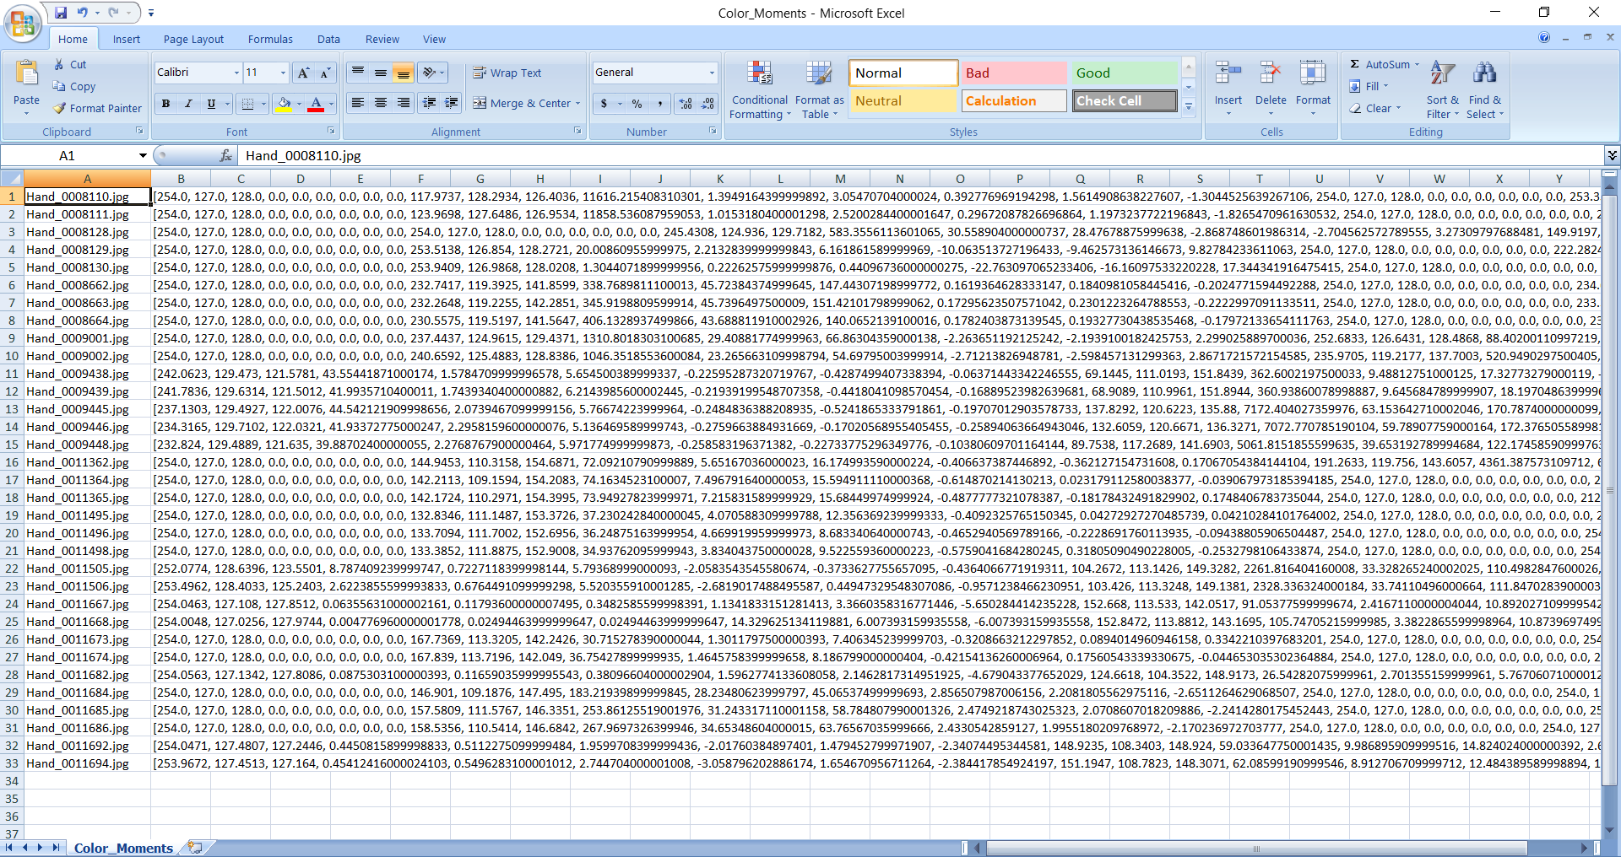



**Task3:**

**Input:**

Provide the model you want to work with lbp/cm: cm

Tell us which task you want to perform: task3

Enter the folder: C:\\Users\\Lenovo\\Desktop\\Downloads\\CSE 515 Fall19 - Smaller Dataset\\LBP

Provide the image name: Hand_0011684.jpg

number of similar images you want to show: 3



**Output:**

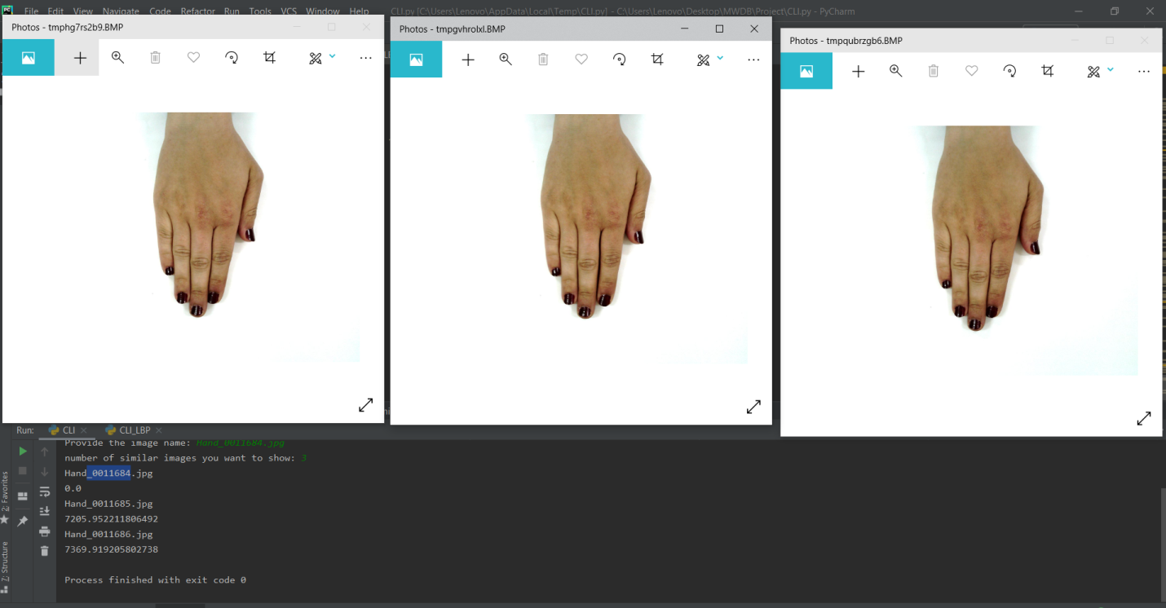

**Local Binary Patterns:**

**Task1 :**

**Input**:

Provide the model you want to work with lbp/cm: lbp

Tell us which task you want to perform: task1

Enter the folder: C:\\Users\\Lenovo\\Desktop\\Downloads\\CSE 515 Fall19 - Smaller Dataset\\LBP

Provide the image name: Hand_0011684.jpg

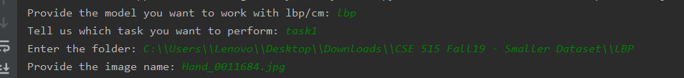

**Output:**

**[0, 0, 0, 4, 0, 392, 0, 0, 9604, 0, 169, 604, 314, 1210, 1592, 2187, 1082, 778, 1159, 905, 0, 0, 0, 4, 0, 392, 0, 0, 9604, 0, 0, 0, 0, 4, 0, 392, 0, 0, 9604, 0, 0, 0, 0, 4, 0, 392, 0, 0, 9604, 0, 104, 429, 286, 1060, 2075, 2107, 744, 541, 2080, 574, 200, 527, 402, 1370, 2878, 2097, 798, 603, 494, 631, 165, 577, 353, 1230, 2512, 2214, 903, 645, 680, 721, 269, 718, 516, 1260, 2166, 1808, 954, 677, 689, 943, 80, 269, 194, 910, 1735, 2077, 685, 454, 3262, 334, 37, 69, 59, 150, 319, 666, 95, 112, 8386, 107, 0, 0, 0, 4, 0, 392, 0, 0, 9604, 0, 151, 565, 281, 1164, 1340, 2262, 1043, 905, 1416, 873, 0, 2, 0, 24, 12, 448, 16, 27, 9468, 3, 0, 0, 0, 4, 0, 392, 0, 0, 9604, 0, 0, 0, 0, 4, 0, 392, 0, 0, 9604, 0, 0, 0, 0, 4, 0, 392, 0, 0, 9604, 0, 0, 0, 0, 4, 0, 392, 0, 0, 9604, 0, 0, 0, 0, 4, 0, 392, 0, 0, 9604, 0, 0, 0, 0, 4, 0, 392, 0, 0, 9604, 0, 0, 0, 0, 4, 0, 392, 0, 0, 9604, 0, 0, 0, 0, 4, 0, 392, 0, 0, 9604, 0, 206, 415, 261, 811, 1399, 1517, 530, 467, 3803, 591, 12, 34, 11, 233, 111, 1152, 169, 161, 8058, 59, 147, 474, 368, 1321, 2781, 2277, 824, 526, 635, 647, 224, 507, 475, 1338, 2974, 1948, 748, 575, 518, 693, 247, 630, 426, 1222, 2285, 1987, 947, 750, 662, 844, 5, 31, 29, 144, 228, 828, 126, 75, 8482, 52, 0, 0, 0, 4, 0, 392, 0, 0, 9604, 0, 0, 0, 0, 4, 0, 392, 0, 0, 9604, 0, 0, 0, 0, 4, 0, 392, 0, 0, 9604, 0, 0, 0, 0, 4, 0, 392, 0, 0, 9604, 0, 0, 6, 0, 75, 0, 856, 20, 62, 8970, 11, 0, 0, 0, 4, 0, 392, 0, 0, 9604, 0, 0, 0, 0, 4, 0, 392, 0, 0, 9604, 0, 0, 0, 0, 4, 0, 392, 0, 0, 9604, 0, 0, 0, 0, 4, 0, 392, 0, 0, 9604, 0, 0, 0, 0, 4, 0, 392, 0, 0, 9604, 0, 0, 0, 0, 4, 0, 392, 0, 0, 9604, 0, 0, 0, 0, 4, 0, 392, 0, 0, 9604, 0, 11, 48, 37, 243, 368, 1069, 156, 135, 7841, 92, 278, 680, 484, 1290, 2531, 1808, 746, 672, 648, 863, 237, 519, 484, 1362, 2595, 1912, 829, 567, 724, 771, 237, 481, 375, 1088, 1874, 2120, 802, 606, 1725, 692, 0, 0, 0, 4, 0, 392, 0, 0, 9604, 0, 0, 0, 0, 4, 0, 392, 0, 0, 9604, 0, 0, 0, 0, 4, 0, 392, 0, 0, 9604, 0, 0, 0, 0, 4, 0, 392, 0, 0, 9604, 0, 0, 0, 0, 4, 0, 392, 0, 0, 9604, 0, 0, 4, 0, 43, 6, 544, 30, 31, 9321, 21, 4, 56, 5, 287, 43, 1877, 159, 232, 7212, 125, 0, 0, 0, 4, 0, 392, 0, 0, 9604, 0, 0, 0, 0, 4, 0, 392, 0, 0, 9604, 0, 0, 0, 0, 4, 0, 392, 0, 0, 9604, 0, 0, 0, 0, 4, 0, 392, 0, 0, 9604, 0, 0, 0, 0, 4, 0, 392, 0, 0, 9604, 0, 0, 0, 0, 4, 0, 392, 0, 0, 9604, 0, 0, 0, 0, 4, 0, 392, 0, 0, 9604, 0, 2, 3, 2, 39, 22, 415, 22, 20, 9465, 10, 172, 292, 212, 778, 1399, 1590, 480, 429, 4173, 475, 352, 681, 458, 1208, 1924, 1748, 797, 688, 1218, 926, 66, 118, 57, 359, 463, 1208, 192, 243, 7107, 187, 0, 0, 0, 4, 0, 392, 0, 0, 9604, 0, 0, 0, 0, 4, 0, 392, 0, 0, 9604, 0, 0, 0, 0, 8, 0, 425, 0, 3, 9564, 0, 0, 0, 0, 20, 0, 604, 4, 16, 9356, 0, 11, 60, 2, 294, 57, 1733, 178, 282, 7187, 196, 0, 0, 0, 4, 0, 392, 0, 0, 9604, 0, 20, 84, 19, 487, 122, 2228, 313, 388, 6148, 191, 0, 0, 0, 4, 0, 392, 0, 0, 9604, 0, 0, 0, 0, 4, 0, 392, 0, 0, 9604, 0, 0, 0, 0, 4, 0, 392, 0, 0, 9604, 0, 0, 0, 0, 4, 0, 392, 0, 0, 9604, 0, 0, 0, 0, 4, 0, 392, 0, 0, 9604, 0, 0, 0, 0, 4, 0, 392, 0, 0, 9604, 0, 0, 0, 0, 4, 0, 392, 0, 0, 9604, 0, 0, 1, 0, 21, 1, 544, 6, 22, 9404, 1, 3, 35, 4, 136, 67, 803, 100, 124, 8667, 61, 0, 0, 0, 4, 0, 392, 0, 0, 9604, 0, 0, 0, 0, 4, 0, 392, 0, 0, 9604, 0, 0, 2, 0, 26, 4, 594, 17, 26, 9331, 0, 1, 19, 3, 81, 18, 998, 52, 58, 8704, 66, 6, 63, 4, 257, 49, 1864, 184, 230, 7097, 246, 13, 103, 7, 416, 93, 2134, 280, 400, 6391, 163, 21, 170, 26, 655, 197, 2247, 462, 662, 5304, 256, 33, 268, 56, 700, 366, 2272, 592, 659, 4610, 444, 0, 0, 0, 4, 0, 392, 0, 0, 9604, 0, 0, 0, 0, 4, 0, 392, 0, 0, 9604, 0, 0, 0, 0, 4, 0, 392, 0, 0, 9604, 0, 0, 0, 0, 4, 0, 392, 0, 0, 9604, 0, 0, 0, 0, 4, 0, 392, 0, 0, 9604, 0, 0, 0, 0, 4, 0, 392, 0, 0, 9604, 0, 0, 0, 0, 4, 0, 392, 0, 0, 9604, 0, 0, 0, 0, 4, 0, 392, 0, 0, 9604, 0, 0, 0, 0, 4, 0, 392, 0, 0, 9604, 0, 0, 0, 0, 4, 0, 392, 0, 0, 9604, 0, 0, 0, 0, 13, 0, 524, 0, 8, 9455, 0, 2, 23, 2, 153, 27, 1053, 80, 135, 8503, 22, 2, 28, 0, 303, 19, 1950, 123, 216, 7298, 61, 5, 52, 4, 342, 41, 1957, 188, 308, 6977, 126, 0, 0, 0, 4, 0, 392, 0, 0, 9604, 0, 3, 67, 9, 388, 61, 2017, 192, 304, 6835, 124, 8, 49, 4, 380, 74, 2098, 218, 335, 6697, 137, 14, 223, 40, 795, 296, 2331, 516, 625, 4775, 385, 0, 0, 0, 4, 0, 392, 0, 0, 9604, 0, 0, 0, 0, 4, 0, 392, 0, 0, 9604, 0, 0, 0, 0, 4, 0, 392, 0, 0, 9604, 0, 19, 95, 23, 437, 225, 1625, 293, 293, 6842, 148, 161, 551, 284, 1173, 1638, 2276, 1045, 808, 1284, 780, 105, 505, 276, 1243, 1577, 2425, 1189, 757, 1142, 781, 162, 560, 321, 1274, 1550, 2387, 1140, 723, 1070, 813, 170, 567, 341, 1302, 1653, 2219, 1127, 785, 984, 852, 183, 510, 329, 1351, 1718, 2222, 1079, 756, 1035, 817, 2, 29, 12, 101, 74, 880, 58, 86, 8708, 50, 0, 0, 0, 4, 0, 392, 0, 0, 9604, 0, 0, 0, 0, 4, 0, 392, 0, 0, 9604, 0, 0, 0, 0, 4, 0, 392, 0, 0, 9604, 0, 0, 0, 0, 4, 0, 392, 0, 0, 9604, 0, 0, 0, 0, 4, 0, 392, 0, 0, 9604, 0, 0, 0, 0, 4, 0, 392, 0, 0, 9604, 0, 0, 0, 0, 4, 0, 392, 0, 0, 9604, 0, 0, 0, 0, 4, 0, 392, 0, 0, 9604, 0, 0, 0, 0, 4, 0, 392, 0, 0, 9604, 0, 0, 0, 0, 4, 0, 392, 0, 0, 9604, 0, 11, 42, 10, 215, 134, 1124, 187, 173, 8023, 81, 132, 502, 227, 1205, 1543, 2485, 1071, 844, 1149, 842, 0, 0, 0, 4, 0, 392, 0, 0, 9604, 0, 210, 567, 385, 1345, 1638, 2202, 1126, 760, 922, 845, 239, 679, 454, 1327, 1660, 1980, 1150, 725, 797, 989, 138, 556, 326, 1332, 1668, 2279, 1200, 706, 957, 838, 158, 583, 370, 1327, 1841, 2213, 1069, 747, 847, 845, 91, 244, 166, 552, 737, 1323, 430, 304, 5819, 334, 0, 0, 0, 4, 0, 392, 0, 0, 9604, 0, 0, 0, 0, 4, 0, 392, 0, 0, 9604, 0, 0, 0, 0, 4, 0, 392, 0, 0, 9604, 0, 0, 0, 0, 4, 0, 392, 0, 0, 9604, 0, 0, 0, 0, 4, 0, 392, 0, 0, 9604, 0, 0, 0, 0, 18, 0, 482, 5, 6, 9489, 0, 0, 0, 0, 4, 0, 392, 0, 0, 9604, 0, 0, 0, 0, 4, 0, 392, 0, 0, 9604, 0, 0, 0, 0, 4, 0, 392, 0, 0, 9604, 0, 0, 0, 0, 4, 0, 392, 0, 0, 9604, 0, 2, 9, 3, 119, 14, 809, 36, 75, 8906, 27, 156, 548, 324, 1223, 1890, 2323, 1027, 773, 928, 808, 171, 559, 369, 1349, 1822, 2214, 1121, 717, 804, 874, 269, 708, 503, 1325, 1726, 1982, 1074, 701, 762, 950, 223, 581, 380, 1433, 1666, 2106, 1122, 750, 833, 906, 221, 566, 472, 1362, 2148, 2072, 955, 653, 723, 828, 61, 330, 90, 793, 583, 2257, 710, 566, 4138, 472, 157, 387, 233, 919, 1362, 2079, 781, 564, 2957, 561, 0, 0, 0, 4, 0, 392, 0, 0, 9604, 0, 0, 0, 0, 4, 0, 392, 0, 0, 9604, 0, 0, 0, 0, 4, 0, 392, 0, 0, 9604, 0, 0, 0, 0, 4, 0, 392, 0, 0, 9604, 0, 0, 0, 0, 4, 0, 392, 0, 0, 9604, 0, 0, 0, 0, 4, 0, 392, 0, 0, 9604, 0, 0, 0, 0, 4, 0, 392, 0, 0, 9604, 0, 0, 0, 0, 4, 0, 392, 0, 0, 9604, 0, 0, 0, 0, 4, 0, 392, 0, 0, 9604, 0, 157, 572, 283, 1221, 1458, 2237, 1170, 876, 1155, 871, 2, 11, 10, 77, 13, 835, 46, 40, 8942, 24, 180, 553, 346, 1306, 2060, 2139, 1013, 696, 876, 831, 219, 587, 470, 1441, 1963, 2057, 1056, 655, 695, 857, 309, 710, 541, 1446, 1988, 1894, 930, 694, 629, 859, 263, 683, 526, 1348, 1917, 1930, 1101, 671, 638, 923, 219, 549, 437, 1375, 2579, 2030, 892, 602, 573, 744, 179, 446, 270, 927, 1185, 1879, 790, 555, 3138, 631, 0, 0, 0, 4, 0, 392, 0, 0, 9604, 0, 0, 0, 0, 4, 0, 392, 0, 0, 9604, 0, 0, 0, 0, 4, 0, 392, 0, 0, 9604, 0, 148, 572, 270, 1264, 1575, 2278, 1162, 761, 1091, 879, 0, 0, 0, 4, 0, 392, 0, 0, 9604, 0, 0, 0, 0, 4, 0, 392, 0, 0, 9604, 0, 0, 0, 0, 4, 0, 392, 0, 0, 9604, 0, 0, 0, 0, 4, 0, 392, 0, 0, 9604, 0, 0, 0, 0, 4, 0, 392, 0, 0, 9604, 0, 0, 0, 0, 4, 0, 392, 0, 0, 9604, 0, 0, 0, 0, 9, 0, 432, 0, 4, 9555, 0, 152, 450, 329, 1157, 2382, 2253, 712, 502, 1450, 613, 210, 614, 416, 1268, 2268, 2034, 968, 600, 716, 906, 272, 706, 522, 1376, 1994, 1853, 1041, 672, 663, 901, 130, 516, 298, 1276, 1295, 2314, 1105, 843, 1416, 807, 259, 654, 538, 1477, 2035, 1831, 993, 677, 663, 873, 266, 596, 502, 1259, 2544, 2007, 955, 532, 534, 805, 150, 378, 213, 560, 1108, 1332, 500, 461, 4860, 438, 0, 0, 0, 4, 0, 392, 0, 0, 9604, 0, 0, 0, 0, 4, 0, 392, 0, 0, 9604, 0, 0, 0, 0, 4, 0, 392, 0, 0, 9604, 0, 0, 0, 0, 4, 0, 392, 0, 0, 9604, 0, 0, 0, 0, 4, 0, 392, 0, 0, 9604, 0, 0, 0, 0, 4, 0, 392, 0, 0, 9604, 0, 0, 0, 0, 4, 0, 392, 0, 0, 9604, 0]**

**Task2 :**

**input:**

Provide the model you want to work with lbp/cm: lbp

Tell us which task you want to perform: task2

Enter the folder: C:\\Users\\Lenovo\\Desktop\\Downloads\\CSE 515 Fall19 - Smaller Dataset\\LBP

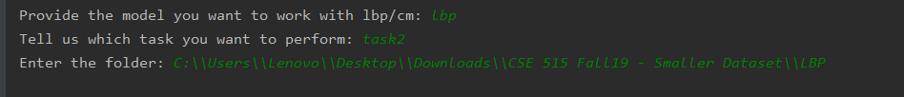

**Output:**

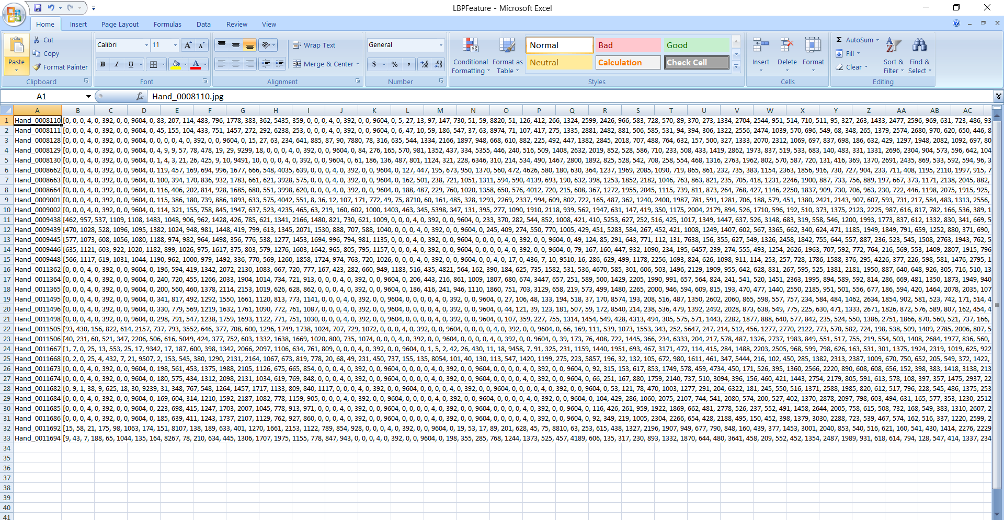



**Task3:**

**Input:**

Provide the model you want to work with lbp/cm: lbp

Tell us which task you want to perform: task3

Enter the folder: C:\\Users\\Lenovo\\Desktop\\Downloads\\CSE 515 Fall19 - Smaller Dataset\\LBP

Provide the image name: Hand_0011684.jpg

number of similar images you want to show: 4

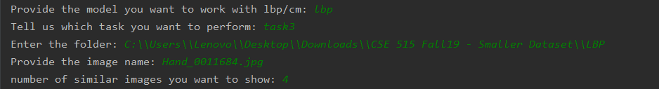

**Output:**

