Netra AI: An offline-first smartphone system for cataract screening and referral—architecture, on-device deep learning and pre-clinical technical verification
Short title: Offline-first smartphone cataract screening and referral
Arijit Das Gupta^{1*}
¹ Kurukshetra University (Independent Researcher, Chittagong, Bangladesh)
* Corresponding author. E-mail: arijitdasgupta543@gmail.com · ORCID: 0009-0003-2144-5068

Abstract
Smartphone tools for cataract screening are usually evaluated by the accuracy of their image classifier, while the system around the classifier is rarely specified or tested: what happens to negative results, whether reference labels are independent of the artificial intelligence, whether records survive poor networks, and whether the model running on the phone still behaves like the evaluated one. We present Netra AI, an offline-first web application in which health workers photograph the eye with a low-cost phone, obtain an on-device score from a pupil crop and a calibrated visual acuity test, and refer patients through rules enforced in the database. Four convolutional neural networks were compared by five-fold cross-validation on 212 public eye images whose labels had been reviewed by a clinician. MobileNetV2, the smallest network, reached an out-of-fold area under the receiver operating characteristic curve of 0.976 (95% confidence interval 0.958–0.994), comparable to DenseNet121, ResNet50 and VGG16 (0.972–0.984), against 0.939 with the original public labels. Converted TensorFlow Lite and TensorFlow.js models reproduced every reference decision on a locked test split, and median browser inference took 247 ms under sixfold processor throttling. The data layer was verified with 29 database behavior checks, injection of 35,702 network faults with no screening lost or duplicated, a load test with 200,401 synthetic patients, and a Monte Carlo study of a stratified estimator of field sensitivity from a random audit of negative results. Verification exposed and fixed seven design faults, including an audit flaw that would have overstated field sensitivity by 3 to 11 percentage points and a review queue that revealed the model’s result to graders. Growth analysis indicates that photograph storage and ophthalmologist time, not database load, limit national scale. All results concern public web images; accuracy on patients will be measured in a prospective field study.

Author summary
Cataract is the most common cause of blindness, yet the operation that cures it is cheap and effective. The hard part is finding the people who need it and making sure they reach a hospital. Smartphone apps that use artificial intelligence to recognize cataract in eye photographs could help, and many studies report how accurate such apps are. We asked a different question: can the whole system around the app be trusted? We built Netra AI, an open-source app that works without internet, scores the eye photograph on the phone itself, and sends suspected cases to a doctor. We then tested it the way engineers test safety-critical software. We simulated tens of thousands of network failures, filled the database with two hundred thousand artificial patients, and checked every rule with automated tests. These tests revealed seven design faults that accuracy figures alone would never have shown, for example a flaw that would have made the app look better at catching cataract than it really was. All faults were fixed. Because this study used public web images rather than patients, it does not yet show how well the app works in the field; that is the next step.

Introduction
Cataract remains the leading cause of blindness worldwide: the World Health Organization (WHO) estimates that at least 2.2 billion people live with near or distance vision impairment, of whom about one billion have a condition that could have been prevented or has not been addressed, including 94 million with unoperated cataract [1], and cataract was the leading cause of blindness among adults aged 50 years and older in 2020, with an estimated 15.2 million cases [2]. Cataract surgery is inexpensive and effective; the bottleneck is case finding and completed referral to a surgeon, and ophthalmologists are fewest where the need is greatest [3].
Case finding for cataract also serves Sustainable Development Goal (SDG) 3, which aims to ensure healthy lives and promote well-being for all at all ages, through target 3.8 on universal health coverage [4], and the Lancet Global Health Commission on Global Eye Health argues that eye care must be an integral part of universal health coverage [5]. In 2021 the World Health Assembly endorsed a global target of a 30-percentage-point increase in effective cataract surgical coverage by 2030 [6]. Meeting it requires case finding that is cheap enough to scale and referral pathways whose misses can be measured, which are engineering problems as much as clinical ones.
Smartphones are now widely available, which makes screening by community health workers attractive. Field studies of e-Paarvai, an artificial-intelligence (AI) smartphone cataract application used in Tamil Nadu, show both the promise and the difficulty: in a hospital study sensitivity was 96% but specificity only 25% [7], and in a multi-center primary-care study subject-level sensitivity and specificity were 83% and 53% [8]. A review of smartphone visual-acuity applications found that few had evidence of clinical validation [9], and ophthalmology reviews identify sampling bias, instrument bias and poor image-quality control as the main threats to AI in eye care [10].

Related work
Smartphone cataract detection. Deep learning has reached expert-level detection of diabetic retinopathy from fundus photographs [11], and reviews describe its rapid spread across ophthalmology [12]; for cataract, a collaborative AI platform triaged slit-lamp images for referral [13]. Early smartphone proposals described low-cost smartphone detection with an external lens or simple color thresholding, without tests of accuracy [14,15]. Hu et al. combined YOLOv3 localization with ShuffleNet and support-vector classification on smartphone slit-lamp images (93.5% accuracy) using a dataset that is not public [16]. Askarian et al. used support-vector machines on iPhone photographs of an eye model rather than of human eyes [17], and Neogi et al. reported a lightweight sequential network with 93.4% accuracy on Kaggle and private data, without releasing data or software [18]. Ignatowicz et al. released an open Android application that crops the pupil and grades nuclear cataract on slit-lamp images; six architectures reached 91–95% accuracy, but accuracy fell to 63–85% after conversion to TensorFlow Lite, and live-camera photographs produced false positives from overexposure, which the authors proposed to address with real-time image-quality assessment [19]. A recent preprint fused smartphone anterior-segment images with acuity and pinhole data and validated the deployed model prospectively on 118 patients in India (macro-averaged area under the receiver operating characteristic curve, AUC, 0.96) [20].
Datasets. Public anterior-segment datasets are scarce. Recent releases include CatScreen, 18,640 portable slit-lamp images of 2,251 subjects with multi-tier expert labels, available under a non-commercial license agreement [21], and SLID, 2,617 slit-lamp images with ophthalmologist-verified lesion annotations [22]. Neither contains ordinary phone photographs taken by health workers. Public web image sets, often used in smartphone studies, carry duplicates and non-clinical shortcuts [23].
Systems around the model. When a diabetic-retinopathy system was deployed in clinics in Thailand, image quality, internet connectivity and clinic workflow, not model accuracy alone, determined whether it helped [24]. Regulated diabetic-retinopathy systems usually include automatic image-quality assessment, while evidence on workflow and post-market monitoring is limited [25]. National screening programs manage the false-negative problem with quality assurance: the English diabetic eye screening program sends a minimum of 10% of normal grades to second-level grading [26].
Gap. Most smartphone cataract studies report a model’s accuracy on a held-out set. Few describe or verify the system that decides whether a missed case is ever noticed, whether reference labels are blinded to the AI, whether a screening survives a dropped connection, whether personal data leak into research data, and whether the deployed model is numerically the model that was evaluated.

Contributions
- C1. The architecture of an offline-first screening and referral system for low-cost phones, in which triage, audit sampling, blinding and access rules are enforced in the database rather than in the user interface.
- C2. A comparison of four convolutional architectures on pupil crops with repeated cross-validation, an ablation of cropping and of initialization, and verification that converted on-device models (TensorFlow.js, TF.js, and TensorFlow Lite) reproduce the reference decisions.
- C3. A stratified (Horvitz–Thompson) estimator of field sensitivity from a random audit of AI-negative patients, with a Monte-Carlo study of its bias and precision.
- C4. A pre-clinical verification of the system—database behavior tests, fault injection of the offline path, a 200,401-patient load test—and the seven design faults it revealed.
- C5. Open source code, migrations, tests and analysis scripts.

Materials and methods

Ethics statement
This study involved no human participants, patient records or animals. Model development used publicly available, de-identified eye photographs from a web image collection, and the database, load and fault-injection experiments used synthetic records only. The clinician who reviewed image labels contributed expertise and was not a research participant. Ethics committee approval was therefore not required. Collection of field data will begin only after approval by an ethics committee and with written informed consent.

Requirements
Four roles use the system: health workers (consent, photographs, vision test, referral slip, follow-up; low- or mid-range Android, often offline), ophthalmologists (labels and referral decisions), administrators (users, sites, hospitals, model versions, audit rate) and the research pipeline. Non-functional requirements were ranked so that the higher one wins in a conflict (Table 1).
Table 1. Requirements in priority order and acceptance criteria.
# | Requirement | Acceptance criterion used in this study
R1 | Offline first | 0 screenings lost and 0 duplicated under injected network faults (see “Verification methods”)
R2 | Privacy | names/phones only in a separate table; never in exports, audit log or short message service (SMS) texts; reviewers see only the pupil region
R3 | Low-cost phones | model ≤ 15 MB; inference < 1 s under 6× central processing unit (CPU) throttling (see “On-device deployment and conversion fidelity”)
R4 | Trustworthy data | every score linked to model version and threshold; reference labels blinded; audit draw recorded
R5 | Scale | 1,000 workers × 20 patients/day without redesign; key queries < 100 ms at 200,000 patients
R6 | Speed for the worker | capture to submission < 2 min per patient (to be measured in the field)
At 1,000 workers × 20 patients/day × 2 eyes, the system receives 40,000 photographs per day. Full photographs (≈400 KB) would need ≈16 GB/day; pupil crops and thumbnails need ≈2.2 GB/day. The average write load is below one screening per second, so the true bottleneck is ophthalmologist time: reviewing every eye at 30 s would need ≈333 doctor-hours per day, so the system must triage.

System architecture
Fig 1 shows the four parts. The client is an installable React web application (one code base for phones and laptops, updates without an app store). It runs camera guidance, MediaPipe iris landmarks [27], the TF.js model, the vision test and an IndexedDB offline queue. The backend is PostgreSQL with row-level security (RLS), private object storage and server functions that hold secrets (SMS gateway, language-model key). Doctor and administrator views run in the same application under role gates; access control is enforced by RLS, never by the interface. The machine learning (ML) pipeline exports labeled pupil crops, de-duplicates, trains with cross-validation, chooses thresholds on inner validation data and releases versioned TF.js/TensorFlow Lite files that are registered in a model_runs table.
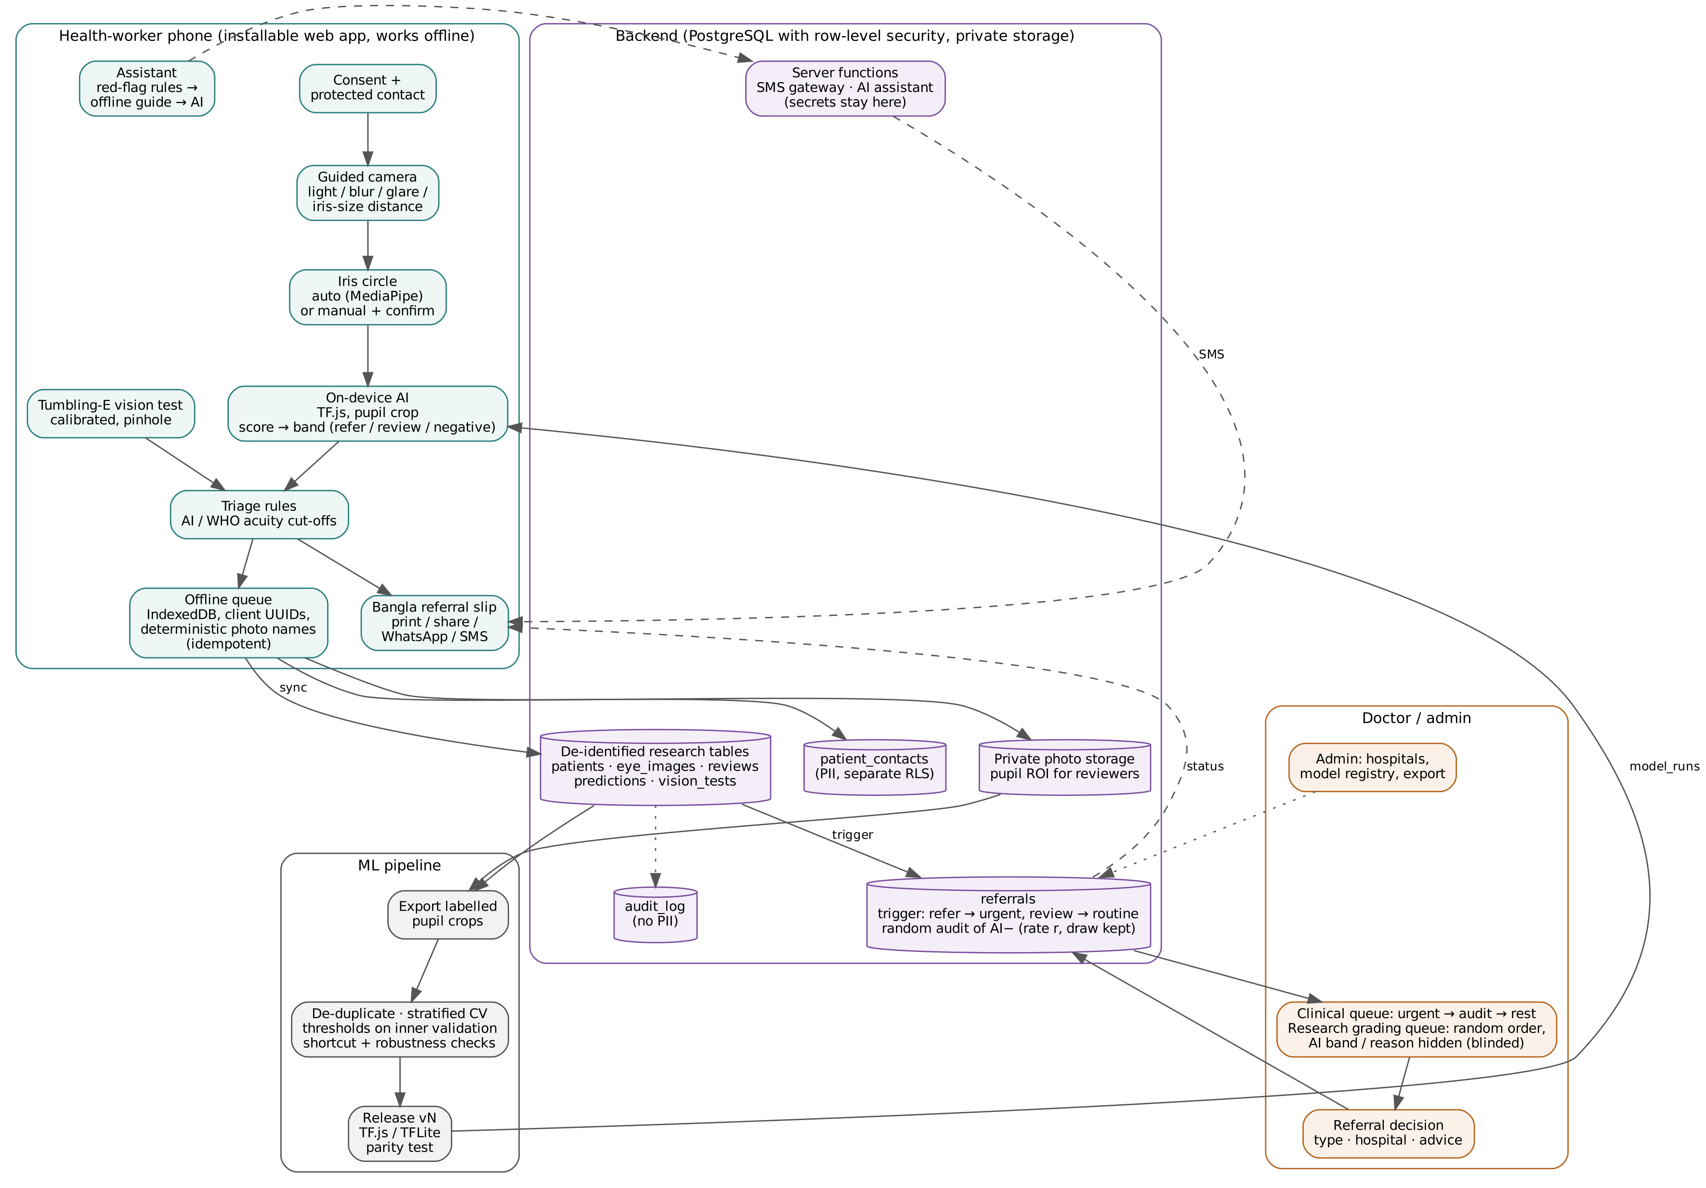
Fig 1. Netra AI architecture. Solid arrows show data flow, dashed arrows notifications and status, dotted arrows audit and administration.
Research tables carry only a study identifier, age, sex, district and area; names, mobile numbers and addresses live only in patient_contacts (Table 2).
Table 2. Data model and access rules (migrations 0000–0008).
Table | Purpose | Key access rule
patients | de-identified screening record | staff read; workers insert their own
eye_images | photo paths, pupil circle, capture checks, phone model | pupil crop visible to staff; full photo admin-only
predictions | score, band, threshold, model version per eye | band computed by trigger; doctors see a score only after labeling that eye
reviews | doctor label, confidence, blinded flag | doctors write their own
referrals | reason, type, priority, status, audit draw | workers may change only outcome fields; audit draw immutable
vision_tests | acuity, distance, calibration, pinhole, contrast | workers insert
patient_contacts | name, mobile, address (optional, consented) | admin, doctors, creating worker
model_runs, screening_config | model registry and thresholds; audit rate | admin writes
sms_log, audit_log | message status (last 4 digits); change history without personal data | admin/doctor read

Image acquisition, quality gate and region of interest
The camera view shows a 3×3 grid with a target circle. Three times per second the application measures brightness, contrast, sharpness (variance of the Laplacian) and saturated-pixel glare inside the target, and runs iris landmarks on a 240×320 frame; messages such as “too dark”, “glare on pupil” or “move closer” are shown until the photograph is acceptable. Because the visible iris diameter is nearly constant in adults (≈11.7 mm), its radius in the image gives an approximate camera distance by the pinhole model. After capture the worker confirms or corrects the iris circle; the method (automatic, manual, automatic then edited) is stored.
The model sees only a square pupil crop of side 2.5× the iris radius, resized to 224×224 px with black padding outside the image (Fig 2). One function computes the crop in the application, and the training pipeline reproduces the same geometry, so training and deployment inputs are identical. Unlike slit-lamp images, ordinary photographs include eyelids, skin, make-up and background; cropping removes most of these.
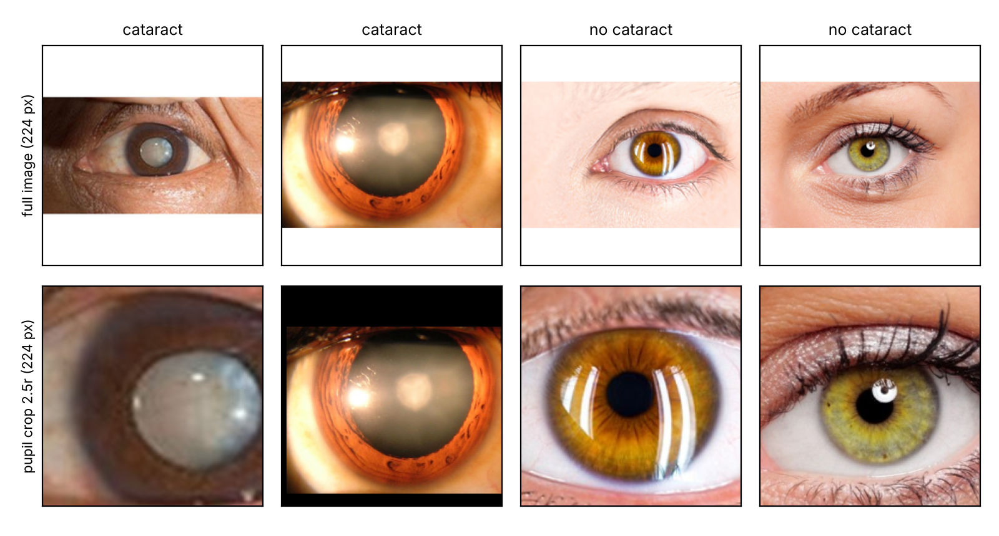
Fig 2. Full images and pupil crops. Top: full web images; bottom: the square pupil crops (side 2.5 times the iris radius, 224 × 224 px) that the model receives.

Dataset
No public dataset of ordinary phone photographs with clinical labels exists for our setting, so the model pipeline was exercised on a public web image set of cataract and normal eyes, collected by web image search and shared on Kaggle [28]. The local copy used here contained 557 of the 612 published images (55 normal training images were missing from the download). An earlier audit of the 557-image set by the author (scripts in the repository) found 218 duplicates, 54 duplicate groups crossing the original train/test split, and a shortcut in the sense of [23]: image size and color alone predicted the label with AUC 0.73. After de-duplication and removal of two multi-person composites, 226 images remained; iris circles were obtained for 224. Circles were proposed automatically (MediaPipe found only three eyes in these close-ups; Hough circles [29] otherwise) and checked visually on gridded contact sheets with AI assistance (36 automatic circles accepted, 188 re-marked). A second quality-control pass on contact sheets of the final crops found 8 crops that missed the iris (6 normal, 2 cataract); these circles were corrected before any experiment reported here. Because failures concentrated in one class, uncorrected crops would have created a label-correlated artifact. Clinician label review. A registered medical doctor (acknowledged below) reviewed all 224 crops with a purpose-built web page in two parts. Part A showed 56 crops one at a time with the public label hidden: 26 suspicious crops (24 on which an initial out-of-fold model disagreed with the label, plus 2 flagged on contact sheets) and 30 crops drawn at random from the rest; the reviewer chose cataract, no cataract or cannot tell. Part B showed the other 168 crops twelve per page with their public label, and the reviewer marked any label he considered wrong or unjudgeable. The reviewer completed a first pass, judged it hurried, and repeated the review; the second pass is used as the reference. On the random sample, agreement with the public label was 18/24 gradable crops (Cohen’s κ [30] = 0.50) in the first pass and 27/28 (κ = 0.93) in the second; 36 of 56 Part-A answers were unchanged between passes. Following the second pass, 10 labels were changed (9 crops labeled cataract judged normal, 1 the reverse) and 12 crops were excluded (6 judged ungradable in Part A, 6 disputed in Part B), leaving 212 images (100 cataract, 112 normal) for all experiments below. This is a single-reviewer check of web images, not a clinical reference standard; the set is used to verify the pipeline, not to estimate clinical accuracy.

Neural network architectures and training
Four ImageNet-pretrained [31] architectures spanning size and design were compared: MobileNetV2 [32], DenseNet121 [33], ResNet50 [34] and VGG16 [35]. Each received the same head (global average pooling, dropout 0.3, sigmoid output), the same augmentation (horizontal flip, rotation ±0.06 turns, zoom 0.1, contrast and brightness ±0.15) and the same two-stage schedule: 15 epochs training the head (Adam, learning rate 10⁻³), then 15 epochs fine-tuning the last 30 backbone layers (4 for VGG16) with batch normalization frozen (10⁻⁵), with early stopping on validation AUC (patience 5) and class weights.
Performance was estimated with stratified five-fold cross-validation, repeated with different fold seeds for the MobileNetV2 arms. Inside each training fold, 20% was held out as inner validation for early stopping and for choosing two thresholds: Youden’s J [36] and the highest threshold with validation sensitivity ≥ 0.95. The held-out fold was never used for any decision; its scores were pooled across folds (out-of-fold, OOF). We report OOF AUC with DeLong 95% confidence intervals (CIs) [37], and sensitivity and specificity at each fold’s own thresholds with Wilson intervals [38]. Paired differences in AUC (crop vs. full image; ImageNet vs. earlier initialization) use DeLong’s test on the same images. Two ablations isolate one factor each: (i) input — pupil crop vs. full image, MobileNetV2, everything else equal; (ii) initialization — ImageNet vs. the earlier in-house model (“V1”), which had been trained on the original Kaggle split that overlaps these images, to measure optimism caused by initialization leakage. A deployable model (v3.1) was then trained on the original locked split (147/33/32 train/validation/test images after label review), and its test split was evaluated once. Because the review was partly directed at images on which an earlier model disagreed with the public label, correcting those labels can favor the model; we therefore also report performance against the original public labels.

On-device deployment and conversion fidelity
The deployed graph omits the augmentation layers and takes red–green–blue (RGB) input in the range 0–255. It was exported to a TF.js graph model [39] (used by the web application) and to TensorFlow Lite with float16 weights (for a future native client). A release is accepted only if each converted file reproduces the reference model’s decisions on the locked test split. Browser inference was timed in headless Chromium with TF.js on the pure-JavaScript CPU back end and on the WebAssembly (WASM) back end with single-instruction multiple-data (SIMD) instructions, at 1×, 4× and 6× CPU throttling to emulate low-cost phones (model load, first inference, median of 20 runs).

Screening-to-referral logic in the data layer
Two-tier band. A database trigger computes each eye’s band from the registered model run, so a stale or modified client cannot change it: score ≥ refer threshold → refer (urgent cataract referral, visible to the worker); score ≥ review threshold → review (routine doctor review); otherwise negative (Fig 3). For the deployed model the refer threshold is the conventional 0.5 and the review threshold is the sensitivity-first value chosen on validation data.
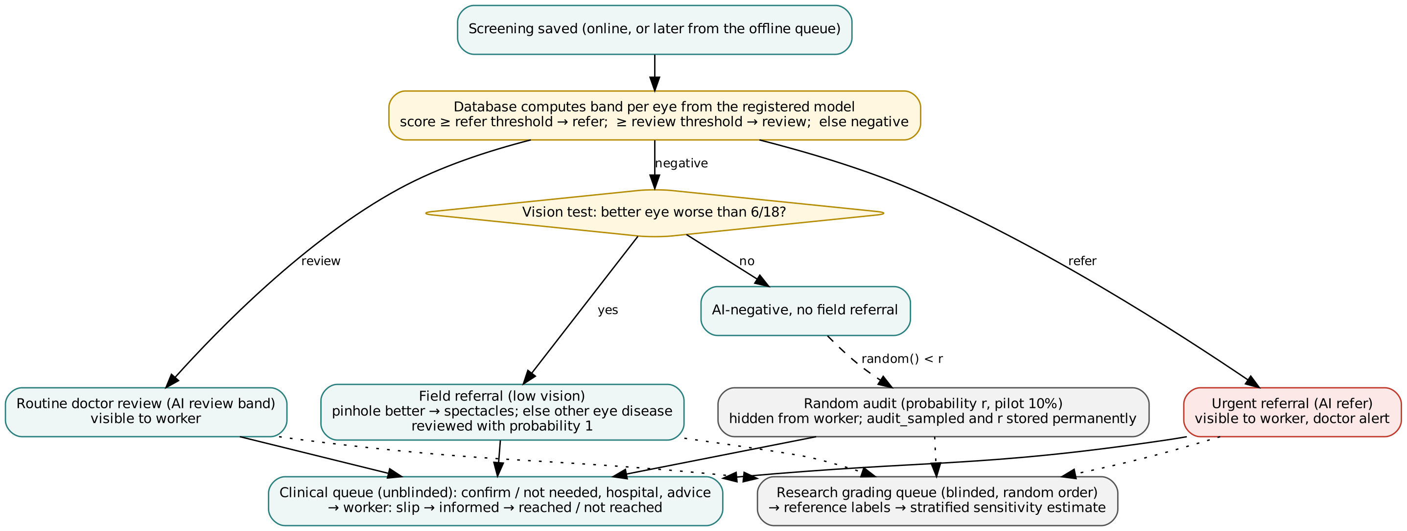
Fig 3. Triage, audit and grading flow. Bands are computed by a database trigger from the registered model run; a random sample of AI-negative patients is referred to a hidden audit, and reference labels are collected in a blinded research grading queue.
Random audit and stratified estimator. When the first prediction of a patient is negative, the trigger draws a random number and, with probability r (configurable; 10% during a pilot), creates a hidden audit referral that only doctors see. The draw (audit_sampled, audit_p) is stored permanently and cannot be changed by any later upgrade. AI-negative patients who receive a field referral for low vision are all reviewed. Field sensitivity at patient level is then estimated as
S=TPTP+FNfield+i∈audit∩cataract​1/pi,
where TP counts screen-positive patients with cataract, FN_field counts AI-negative patients with a field referral and cataract, and the sum runs over audit-sampled AI-negative patients without a field referral whose reference label is cataract (a stratified Horvitz–Thompson estimator [40]). The database function audit_sensitivity() returns the estimate and its counts.
Blinding. If doctors know the AI result while labeling, their labels are biased towards the AI and cannot be used to measure it. Scores are hidden by RLS until the doctor has saved a label for that eye. In addition, reference labels are collected in a separate research grading queue that presents the research sample in a pseudo-random order without band, referral reason or priority; labels record whether they were made blinded. The clinical queue, which orders urgent referrals first, is used for patient care.
Low vision. A field referral is created from the phone through an idempotent function: better-eye acuity worse than 6/18 (WHO moderate visual impairment) is referred as spectacles if a pinhole improves it and otherwise as “other eye disease” (urgent); 6/18 is referred routinely for spectacles.
Guard. A trigger lets health workers change only outcome fields of a referral (informed, reached, not reached). It relies on the executing database role, which an application programming interface (API) client cannot change.
Privacy by separation. Contact details are optional, require a separate consent flag, are validated, and are readable only by administrators, doctors and the worker who entered them. They never appear in exports, training data or the audit log; SMS messages contain the study identifier and hospital but no name or score; the SMS log keeps the last four digits only. Non-admin reviewers can read only the pupil crop, and only after the circle has been confirmed.

Offline-first synchronization
The design follows local-first principles, in which the device keeps a complete working copy and synchronizes when it can [41]. Patient and eye identifiers are generated on the phone. If submission fails for network reasons, the complete screening (photographs, crops, contact, scores, vision results, field referral) is kept in IndexedDB and retried at start-up and when the browser reports that the network is back. Every step is safe to repeat: existing rows are detected and skipped, inserts ignore duplicates, the field referral is idempotent, and photographs use deterministic object names so that a retry reuses an object already stored. Because many phones may regain network at the same moment after a camp day (a sync storm), uploads start after a random delay of 0–30 s and each device retries on its own 45–75 s period.

Calibrated tumbling-E vision test
Optotype height for logMAR $L$ at distance $d$ is $h=d⋅tan\left(5′\right)⋅{10}^{L}$ (2.9 mm for 6/6 at 2 m). As in validated smartphone acuity tests such as Peek Acuity [42], optotypes are tumbling Es. Each phone is calibrated once by matching an on-screen bar to an ISO ID-1 card (85.6 mm). Lines from 6/60 to 6/6 present five randomly oriented optotypes; a line passes with three correct answers, the test stops when a line fails, and a pinhole repeat follows if acuity is worse than 6/12.

Use of generative AI tools
Claude (Anthropic), a large language model, was used as a programming and writing assistant. It drafted parts of the application code, database migrations, tests and analysis scripts, assisted the visual quality control of iris-circle annotations, and helped draft and edit the manuscript. The author designed the study, reviewed all code and text, and is responsible for the content. Outputs were verified as follows: code was accepted only when the unit tests and database checks passed; every number reported here is regenerated by the analysis scripts in the code repository; circle annotations were checked on contact sheets as described under “Dataset”; and references were checked against PubMed and publisher records.

Verification methods
- Database behavior tests. All migrations were applied to PostgreSQL 16 with a shim of the authentication schema; 29 scripted checks exercise every access rule and trigger (see “Data-layer safeguards”).
- Unit and component tests. 57 tests (district list, phone normalization, optotype size, scoring and stopping rules, WHO cut-offs, triage bands, hospital ranking, message content, red-flag detection, distance estimate, full vision-test interaction, fault injection).
- Fault injection. In the spirit of chaos engineering [43], an in-memory backend failed each request, at random, either before it reached the server (lost request) or after it was applied (lost response), with probability p ∈ {0.05, 0.10, 0.20} per phase. One thousand screenings were retried until saved; afterwards the stored rows and photo objects were compared with what one clean save produces.
- Load test. 200,401 synthetic patients, 400,802 eye photographs and ≈50,000 referrals (about ten field days at 1,000 workers) on a container with two virtual CPUs (vCPUs), pgbench as authenticated users with RLS on. Network and API-gateway latency are not included.
- Audit simulation. Monte-Carlo study (20,000 replicates per setting) of the bias and precision of the sensitivity estimate for audit rates 5–20% and 300–20,000 screened patients, comparing the stratified estimator with the earlier design in which the audit flag could be overwritten.
- Growth model. Load at four growth stages (10 to 10,000 workers, 20 patients per worker per day) was derived from the measured costs: ≈55 KB per eye for the crop and thumbnail, full photographs kept for a 10% sample, 300 working days per year, and a worst-case sync storm in which a whole day’s screenings arrive within one hour, compared with the measured save capacity.
- Hazard analysis. An ISO 14971-style [44] table linking each hazard to its mechanism and verification test (S1 Table).

Results

Dataset after review
After clinician review, 212 images (100 cataract, 112 normal) remained. A logistic model using only color statistics and image size predicted the label with AUC 0.67 ± 0.01 from full images and 0.60 ± 0.02 from pupil crops (five repetitions of five-fold cross-validation), so cropping removed part, but not all, of the non-clinical signal in the web images.

Comparison of network architectures
Table 3 and Fig 4 summarize out-of-fold performance on pupil crops (one repetition of five-fold cross-validation per architecture; 212 images each). All architectures reached out-of-fold AUCs between 0.972 and 0.984. MobileNetV2, the smallest network (2.3 M parameters), reached 0.976 (0.958–0.994), with 92.0% accuracy at a threshold of 0.5 and sensitivity 93% and specificity 92% at the Youden thresholds. Differences from MobileNetV2 were not significant (DenseNet121 -0.003 (p = 0.74); ResNet50 +0.008 (p = 0.33); VGG16 +0.005 (p = 0.64)). Because it is the smallest and fastest model and no larger network was clearly better, MobileNetV2 was retained for deployment.
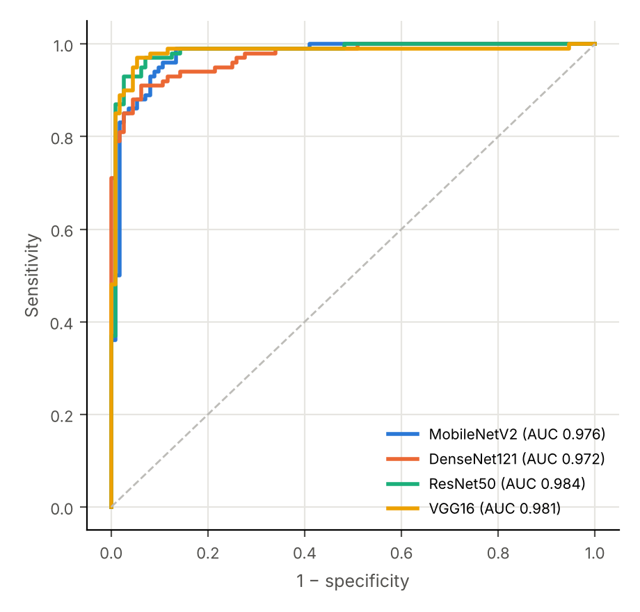
Fig 4. Out-of-fold receiver operating characteristic curves of the four architectures. Pupil crops, 212 images, five-fold cross-validation.
Table 3. Out-of-fold performance of four ImageNet-initialised architectures on pupil crops. Thresholds were chosen in each fold on inner validation data only. Sens/Spec = sensitivity/specificity (95% Wilson CI); AUC with DeLong 95% CI.
Architecture | Parameters | AUC (95% CI) | Sens (Youden) | Spec (Youden) | Sens (≥0.95 rule) | Spec (≥0.95 rule) | Accuracy at 0.5 | Train time/fold
MobileNetV2 | 2.3 M | 0.976 (0.958–0.994) | 93% (86–97) | 92% (85–96) | 93% (86–97) | 89% (82–94) | 92.0% | 69 s
DenseNet121 | 7.0 M | 0.972 (0.955–0.990) | 86% (78–91) | 83% (75–89) | 95% (89–98) | 69% (60–77) | 91.5% | 284 s
ResNet50 | 23.6 M | 0.984 (0.968–0.999) | 89% (81–94) | 96% (91–99) | 95% (89–98) | 74% (65–81) | 93.9% | 226 s
VGG16 | 14.7 M | 0.981 (0.960–1.002) | 92% (85–96) | 96% (90–98) | 97% (92–99) | 61% (51–69) | 94.3% | 586 s

Effect of pupil cropping and of initialization
Cropping did not change discrimination significantly: crop minus full-image AUC was +0.008 (95% CI -0.019 to +0.034; p = 0.58), and +0.007 in a second repetition with different folds. Its value lies in privacy, smaller uploads and a weaker non-clinical shortcut (see “Dataset after review”), not in a higher AUC. Initializing from the in-house model trained on overlapping data changed AUC by +0.003 (p = 0.63), so no optimism from initialization leakage was detected after de-duplication. Clinician review raised the AUC from 0.939 (original labels, 224 images) to 0.976; because the review targeted images on which a model disagreed with the label, part of this gain is expected by construction, and the true performance on correctly labeled web images is likely to lie between the two values (Table 4).
Table 4. Single-factor ablations (MobileNetV2, out-of-fold, paired DeLong test on the same images).
Comparison | AUC A (95% CI) | AUC B (95% CI) | Difference A − B (95% CI) | p (DeLong)
Input: pupil crop (A) vs full image (B), repeat 1 | 0.976 (0.958–0.994) | 0.968 (0.945–0.992) | +0.008 (-0.019 to +0.034) | 0.58
Input: pupil crop (A) vs full image (B), repeat 2 | 0.976 (0.958–0.994) | 0.969 (0.947–0.991) | +0.007 (-0.011 to +0.025) | 0.45
Initialization: V1 in-house (A) vs ImageNet (B), crop | 0.979 (0.961–0.997) | 0.976 (0.958–0.994) | +0.003 (-0.009 to +0.015) | 0.63
Labels: clinician-reviewed (A, 212 images) vs original public (B, 224 images), crop | 0.976 (0.958–0.994) | 0.939 (0.908–0.971) | not paired (different image sets) | not applicable

Locked test split, robustness and conversion fidelity
On the locked test split (32 images, 14 cataract), the deployable model reached AUC 0.996 (full-image model trained identically: 0.937; paired bootstrap difference +0.060, 95% CI +0.000 to +0.150). At the validation-chosen threshold (0.327) it classified 14/14 cataract and 17/18 normal eyes correctly, and 13/14 and 17/18 at 0.5. Under simulated capture problems its AUC stayed at or above 0.97 for blur, darkening and JPEG compression, 0.97 for over-exposure and 0.91 for glare, and fell to 0.85 for strong noise (Fig 5), which supports rejecting noisy and glare-affected photographs at capture. The TensorFlow Lite file (4.5 MB) reproduced 32/32 decisions (maximum score difference 0.014) and the TF.js graph model used by the application reproduced 32/32 on the WASM back end and 32/32 on the CPU back end (maximum difference 2.9e-06) (Table 5). In the browser, the WASM back end ran a median inference in 247 ms under 6× throttling, against 7,567 ms for the pure-JavaScript CPU back end.
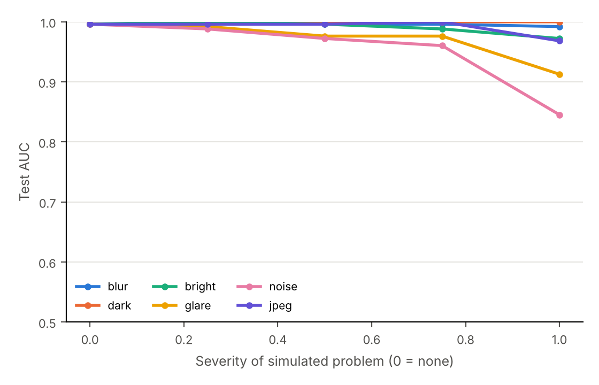
Fig 5. Robustness of the deployable model to simulated capture problems. Test-split area under the curve by severity of each perturbation (severity 0 = none).
Table 5. Conversion fidelity and browser inference of the deployable model (v3.1, MobileNetV2, pupil crop). Decisions are compared with the reference Keras model on the 32 locked test images. Times are medians of 20 runs in headless Chromium; 4× and 6× CPU throttling emulate low-cost phones. With the WASM back end, loading the model took 96–408 ms and the first inference 90–549 ms.
Deployed model and back end | Size | Same decisions as reference (validation threshold · 0.5) | Max. score difference | Median inference, ms (1× / 4× / 6× CPU throttling)
TF.js graph model, WebAssembly (WASM SIMD) back end, used by the application | 8.9 MB | 32/32 · 32/32 | 2.1e-06 | 44 / 165 / 247
TF.js graph model, pure-JavaScript CPU back end | 8.9 MB | 32/32 · 32/32 | 2.9e-06 | 1,178 / 4,844 / 7,567
TensorFlow Lite, float16 weights, for a future native client | 4.5 MB | 32/32 · 32/32 | 0.014 | not run in the browser

Verification findings
Verification found seven faults; all were fixed before field use (Table 6).
Table 6. Faults found during verification.
# | Found by | Fault | Consequence if not fixed | Fix
F1 | Load test | Study-identifier default lpad(n,4) truncates numbers above 9,999 | 10,000th patient collides with NETRA-1000; every later save fails | sequence-based next_study_id()
F2 | Load test | RLS role checks evaluated per row | referral queue 4,424 ms; review query 5,298 ms at 200k patients | scalar sub-selects (one evaluation per query): 17 ms / 369 ms; server-side review queue 21 ms
F3 | Design review + simulation | A field referral overwrote the reason of an audit row, so the audit draw was lost | field sensitivity overstated by +0.03 to +0.11 (see “Field-sensitivity estimator”) | permanent audit_sampled/audit_p; stratified estimator
F4 | Design review | Clinical review queue revealed AI result through priority and order | reference labels not blinded, biasing the measured sensitivity | separate blinded research grading queue; reviews.blinded
F5 | Design review + workload model | Registered threshold of the earlier model (sensitivity-first, specificity 19%) would flag about 85% of eyes, contradicting the triage assumption | doctor workload close to reviewing every eye | two-tier band (refer ≥ 0.5, review ≥ validation threshold) computed in the database
F6 | Fault injection | Random photo names on retry | 2,619–17,185 orphan photo objects per 7,000 needed (p = 0.05–0.20) | deterministic object names; “already exists” treated as success
F7 | Browser benchmark | Without a graphics processor, TF.js fell back to its pure-JavaScript CPU back end | median 7.6 s per eye under 6× throttling, violating R3 | WASM back end loaded before the CPU fallback: median 247 ms (31× faster)
— | Behavior test | Referral guard trusted a session setting that a direct SQL session could set | worker could bypass the guard outside the API | guard keyed to the executing database role

Data-layer safeguards
All 29 database checks passed (Table 7).
Table 7. Database behavior checks (PostgreSQL 16, migrations 0000–0008).
Property | Check | Result
Triage | refer score → urgent referral visible to worker; review score → routine; client-sent “positive” overridden by registry threshold | pass
Upgrade | review → refer upgrades the referral; field referral upgrades an audit row and keeps the draw | pass
Audit rate | 87 of 1,000 AI-negative patients sampled at r = 10% (expected 100; 95% range 81–119); invisible to workers | pass
Immutability | administrator update of the audit draw silently reverted | pass
Guard | worker cannot change type, priority, reason or visibility, also after setting the old bypass flag | pass
Blinding | doctor sees no score before labeling and sees it after; grading queue exposes no band, reason or priority | pass
Estimator | audit_sensitivity() equals an independent computation (0.2051 in a constructed scenario); workers cannot call it | pass
Privacy | worker 2 cannot read worker 1’s contacts; invalid phone rejected; no names or numbers in the audit log | pass
Configuration | audit rate changeable by administrator only | pass

Field-sensitivity estimator
With the stratified estimator, bias was below 0.013 in every setting and below 0.001 from 5,000 patients. Precision depended mainly on the number of screened patients and the audit rate (Fig 6): with a 5% audit, the 95% half-width of the sensitivity estimate was ±0.17 at 300 patients, ±0.08 at 2,000 and ±0.03 at 20,000; a 10–20% audit reduced these to ±0.14–0.12, ±0.06–0.05 and ±0.020–0.015. With the earlier design (F3), sensitivity was overstated by +0.03, +0.07 and +0.11 when 25%, 50% and 75% of missed cataracts had low vision, independent of prevalence (Table 8).
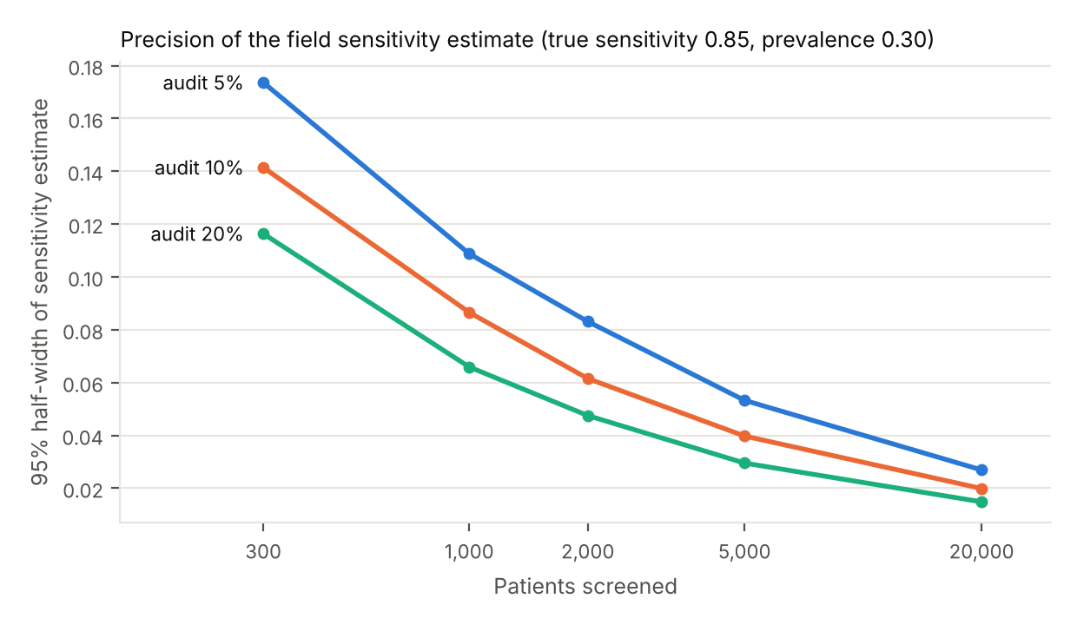
Fig 6. Precision of the field-sensitivity estimate. 95% half-width of the stratified estimate by audit rate and number of screened patients (true sensitivity 0.85, prevalence 0.30; 20,000 Monte Carlo replicates).
Table 8. Bias of the sensitivity estimate (true 0.85; prevalence 0.15 and 0.30 gave identical results to three decimals; 20,000 patients; 5% audit).
Share of missed cataracts with low vision | Earlier design (flag lost) | Stratified estimator
25% | +0.034 | +0.001
50% | +0.070 | +0.001
75% | +0.108 | +0.000

Scalability and doctor workload
Table 9. Average latency before and after rewriting RLS policies (200,401 patients). A complete screening was saved at 668 transactions/s with eight clients, about 190 times the expected peak at 1,000 workers.
Operation | Before | After
Save one screening (patient, contact, 2 eyes, 2 scores + trigger, vision test) | 14.9 ms | 12.0 ms
Records page (20 patients) | 1.7 ms | 1.2 ms
Open-referral queue (50) + urgent count | 4,424 ms | 17.3 ms
Original review query (all confirmed photos) | 5,298 ms | 369 ms
Server-side review_queue(20) | did not exist | 21.3 ms
Dashboard and referral statistics | 422 ms | 434 ms
Table 10 converts out-of-fold band rates into doctor workload at 1,000 workers (40,000 eyes/day, 20% cataract prevalence among eyes, 10% audit of negatives, 30 s per review). Referring only at 0.5 flagged 28% of eyes (116 doctor-hours/day) and missed about 400 cataract eyes per day; adding the review band raised sensitivity to 98% for 13 more doctor-hours/day. Thresholds should therefore be chosen from ophthalmologist capacity as well as from validation sensitivity.
Table 10. Expected doctor reviews per day at 1,000 workers (40,000 eyes), from out-of-fold band rates of the deployable configuration, by prevalence of cataract among screened eyes.
Operating point | Sensitivity | Specificity | Eyes flagged | Doctor reviews/day (incl. 10% audit) | Doctor-hours/day (30 s) | Cataract eyes missed/day
Refer only (score ≥ 0.5) | 95% | 89% | 28% | 13,926 | 116 | 400
Two-tier: refer ≥ 0.5, review ≥ Youden threshold | 98% | 88% | 30% | 14,656 | 122 | 160
Two-tier: refer ≥ 0.5, review ≥ sensitivity-0.95 threshold | 98% | 85% | 32% | 15,427 | 129 | 160

Offline synchronization under faults
Across 3 × 1,000 screenings with 2,594, 6,992 and 35,702 injected faults (p = 0.05, 0.10, 0.20), every screening was eventually saved exactly once: 1,000 patients, 2,000 eye records, 1,000 contacts, 2,000 scores, 2,000 vision tests and 334 field referrals in every run, with no non-network errors. Mean attempts per screening were 3.5, 7.4 and 33.3 (maximum 13, 22 and 109). With random photo names, retries left 2,619, 5,428 and 17,185 orphan photo objects; with deterministic names, 0.

Quality attributes, growth stages and trade-offs
We evaluated the design against four quality attributes used in system design—scalability, availability, performance, and maintainability with cost (Table 11)—and planned growth in stages, adding components only when a stage needs them (Fig 7, Table 12). Database writes are not the limiting resource at any stage: even if all 200,000 screenings of a national day arrived within one hour (56 saves/s), the measured capacity of a 2-vCPU instance (668 saves/s) leaves a 12-fold margin. The limits are elsewhere: photograph storage at national scale (≈38 GB/day, ≈11 TB/year), and ophthalmologist time at every stage (Table 10).
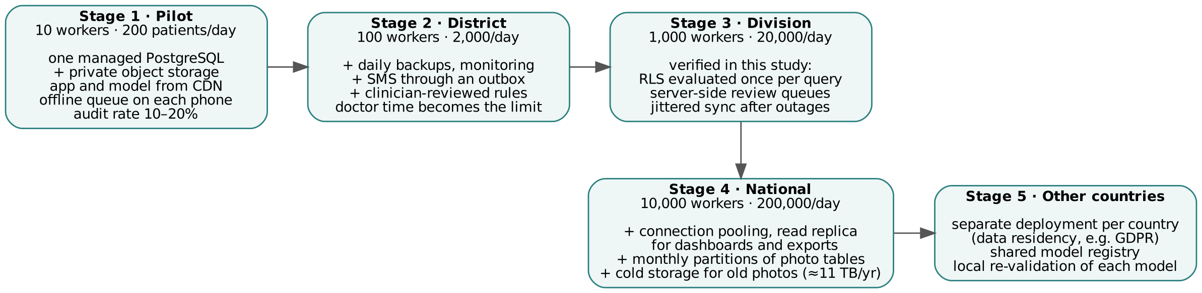
Fig 7. Growth stages. Components are added only when a stage needs them.
Table 11. Quality attributes, design responses and evidence.
Attribute | Meaning for Netra AI | Design response | Evidence in this study
Scalability | more workers and patients without redesign | RLS evaluated once per query; server-side queues; indexes; sequence identifiers | 200,401-patient load test (Table 9); 12× margin at national sync storm
Availability | screening continues when network or server is down | on-device model; offline queue; idempotent writes and uploads; jittered retry | 0 lost / 0 duplicated under 35,702 injected faults (see “Offline synchronization under faults”)
Performance | fast for worker and doctor | on-device inference; crops instead of full photos; review queue in the database | median inference 247 ms at 6× CPU throttling (WASM); key queries 1–21 ms
Maintainability and cost | small team, low budget | one web code base (no app store); managed PostgreSQL; rules as versioned migrations with tests | 29 database checks, 57 unit tests; storage ≈3.8 GB/day at 1,000 workers

Table 12. Load by growth stage (20 patients per worker per day; 300 working days; measured capacity 668 saves/s on 2 vCPU).
Stage | Workers | Patients/day | Storage/day | Storage/year | Average saves/s | Sync-storm saves/s (1 h) | Margin vs measured
Pilot | 10 | 200 | 0.04 GB | 0.01 TB | 0.007 | 0.06 | 12,024×
District | 100 | 2,000 | 0.38 GB | 0.11 TB | 0.069 | 0.56 | 1,202×
Division | 1,000 | 20,000 | 3.8 GB | 1.14 TB | 0.694 | 5.56 | 120×
National | 10,000 | 200,000 | 38.0 GB | 11.4 TB | 6.944 | 55.56 | 12×
Every design choice gave something up (Table 13); the guiding rule, as in general system design, was to meet today’s need while keeping tomorrow’s step possible.
Table 13. Main trade-offs.
Choice | Gain | Cost | Decision
Pupil crops instead of full photographs | privacy, ≈7× less storage, no background shortcut | less context for a reviewing doctor | crops for every eye; full photographs for a 10% sample
Higher audit rate | more precise field sensitivity | more doctor reviews of negatives | 10–20% in pilot, lower at scale
Lower review threshold | fewer missed cataracts | more doctor reviews | two-tier band; urgent only above 0.5
Blinded grading queue | unbiased reference labels | second workflow for doctors | separate research queue
On-device inference | works offline, no image leaves the phone | model size limited; updates need download | MobileNetV2 (≈9 MB), cached once
Web application instead of native | one code base, instant updates | less camera control, no native accelerator | web now; TensorFlow Lite file ready for native
Rules in the database | cannot be bypassed by a client | changes need migrations and tests | all safety rules in migrations with behavior tests

Discussion
What improves results. Three choices mattered most for trustworthy numbers. First, what the model sees: cropping to the pupil removed most of the non-clinical shortcut in web images (shortcut AUC 0.67 → 0.60) without changing discrimination significantly, but only after the crops themselves were checked—eight wrong circles, mostly in normal eyes, would have taught the model “skin means normal”. Second, where the model starts: initializing from a model trained on overlapping data can inflate estimates; after de-duplication we found no measurable effect, and ImageNet initialization with out-of-fold evaluation gives an honest baseline. Third, what the labels say: a short clinician review corrected ten web labels, and the largest single change in measured performance came from labels rather than from architecture. Fourth, what is deployed: unlike reports in which accuracy fell from 91–95% to 63–85% after conversion [19], the deployed TF.js and TensorFlow Lite files reproduced every reference decision, because conversion was verified as a release gate rather than assumed.
What the system adds beyond the model. Accuracy measured once on a test set does not tell a program whether it is missing cataracts in the field. The random audit makes misses measurable; the stratified estimator keeps the measurement unbiased when field referrals and audit samples overlap; the blinded grading queue keeps reference labels independent of the AI; and enforcing these rules in the database means a buggy screen or an offline replay cannot bypass them. Several faults (F1, F2, F6) appeared only at volume or under faults, which supports load testing and fault injection as routine steps for health systems intended to scale.
Comparison with existing tools. e-Paarvai’s field studies show that high sensitivity with low specificity overloads referral pathways [7,8]. The two-tier band addresses this by separating urgent referral from routine doctor review, and the workload model (Table 10) makes the trade-off explicit for program planners. The multimodal preprint [20] supports combining image scores with acuity and pinhole data, which Netra AI already collects; fusion will be trained once clinically labeled field data exist.
Design guidelines. (G1) Put safety rules in the data layer. (G2) Never let the AI’s negatives disappear: audit a random sample and record the draw permanently. (G3) Blind the reference standard, including indirect cues such as queue order. (G4) Separate identity from research data. (G5) Use one preprocessing function in training and deployment, and audit its output visually. (G6) Record the model version and band with every score. (G7) Generate identifiers on the device and make every write—including file uploads—idempotent. (G8) Load-test the access rules, not only the queries. (G9) Design for referral completion: slip in the local language, nearest suitable hospital, multiple channels and explicit outcome status. (G10) Constrain conversational assistants: rules first, vetted offline content second, a language model last.
Relevance to the Sustainable Development Goals. Netra AI relates to SDG 3 in three ways. It lowers the cost of case finding, a precondition for target 3.8 on access to quality essential health services [4]; its audit estimator makes misses measurable, which programs need in order to report progress towards the 2030 target for effective cataract surgical coverage [6]; and its open, offline-first design suits places where connectivity and eye specialists are scarce [3,5], in line with the aim of SDG 10 to reduce inequalities in access to services [4]. These are design properties, not demonstrated health outcomes; the field study will measure whether they translate into more cataract operations.
Limitations. This is a design and pre-clinical verification study. It contains no patient data, and results on public web images say nothing about accuracy on patients photographed with phones in the field. The web set is small, labels were reviewed by a single doctor in two passes rather than adjudicated by a panel, circle annotation was AI-assisted with visual quality control rather than performed by two independent human annotators, and many normal images are young stock photographs. Triage rules, red-flag rules and the assistant’s knowledge base have not yet been reviewed by an independent clinician. The browser benchmark emulates low-cost phones by CPU throttling rather than measuring them, the load test excludes network and API layers, and the vision test has not been validated against a standard chart. The next steps are clinician review of all rules, independent human re-annotation with agreement statistics, pre-training on licensed clinical datasets [21,22], and a prospective field study with masked slit-lamp reference, blinded grading and the audit estimator, reported according to STARD 2015, TRIPOD+AI and DECIDE-AI [45,46,47].

Conclusion
Safety properties of a community screening system—no silent misses, blinded reference labels, privacy, survival of poor networks and fidelity of the deployed model—can be specified as testable requirements and enforced in the data layer. Verifying them before field use revealed faults that model accuracy alone would never have shown. By making case finding inexpensive and its misses measurable, systems of this kind can support SDG target 3.8 and the 2030 cataract coverage target [4,6]. The open system is ready for a prospective field evaluation.

Acknowledgments
The author thanks Dr. Nafis Ahmed Shahriar (Chittagong Eye Hospital, Chattogram, Bangladesh) for reviewing the image labels.

References
- World Health Organization. Blindness and vision impairment [fact sheet]. Geneva: World Health Organization; 2026 [cited 2026 Oct 30]. Available from: https://www.who.int/news-room/fact-sheets/detail/blindness-and-visual-impairment
- GBD 2019 Blindness and Vision Impairment Collaborators; Vision Loss Expert Group of the Global Burden of Disease Study. Causes of blindness and vision impairment in 2020 and trends over 30 years, and prevalence of avoidable blindness in relation to VISION 2020: the Right to Sight: an analysis for the Global Burden of Disease Study. Lancet Glob Health. 2021;9(2): e144–e160. doi:10.1016/S2214-109X(20)30489-7
- Resnikoff S, Lansingh VC, Washburn L, Felch W, Gauthier TM, Taylor HR, et al. Estimated number of ophthalmologists worldwide (International Council of Ophthalmology update): will we meet the needs? Br J Ophthalmol. 2020;104(4): 588–592. doi:10.1136/bjophthalmol-2019-314336
- United Nations General Assembly. Transforming our world: the 2030 Agenda for Sustainable Development. Resolution A/RES/70/1. New York: United Nations; 2015.
- Burton MJ, Ramke J, Marques AP, Bourne RRA, Congdon N, Jones I, et al. The Lancet Global Health Commission on Global Eye Health: vision beyond 2020. Lancet Glob Health. 2021;9(4): e489–e551. doi:10.1016/S2214-109X(20)30488-5
- World Health Assembly. Integrated people-centred eye care, including preventable vision impairment and blindness. Decision WHA74(12). Geneva: World Health Organization; 2021 [cited 2026 Oct 30]. Available from: https://apps.who.int/gb/ebwha/pdf_files/WHA74/A74(12)-en.pdf
- Vasan CS, Gupta S, Shekhar M, Nagu K, Balakrishnan L, Ravindran RD, et al. Accuracy of an artificial intelligence-based mobile application for detecting cataracts: results from a field study. Indian J Ophthalmol. 2023;71(8): 2984–2989. doi:10.4103/IJO.IJO_3372_22
- Shruthee SG, Vellingiri D, Rajagopal K, Shanmugaiah P. Diagnostic accuracy of an artificial intelligence based mHealth intervention for cataract detection: a multi-center prospective study in Tamil Nadu, India. Natl J Community Med. 2025;16(9): 887–894. doi:10.55489/njcm.160920255469
- Kawamoto K, Stanojcic N, Li JO, Thomas PBM. Visual acuity apps for rapid integration in teleconsultation services in all resource settings: a review. Asia Pac J Ophthalmol (Phila). 2021;10(4): 350–354. doi:10.1097/APO.0000000000000384
- Kaur R, Morya AK, Gupta PC, Aggarwal S, Menia NK, Kaur A, et al. Artificial intelligence-based apps for screening and diagnosing diabetic retinopathy and common ocular disorders. World J Methodol. 2025;15(4): 107166. doi:10.5662/wjm.v15.i4.107166
- Gulshan V, Peng L, Coram M, Stumpe MC, Wu D, Narayanaswamy A, et al. Development and validation of a deep learning algorithm for detection of diabetic retinopathy in retinal fundus photographs. JAMA. 2016;316(22): 2402–2410. doi:10.1001/jama.2016.17216
- Ting DSW, Pasquale LR, Peng L, Campbell JP, Lee AY, Raman R, et al. Artificial intelligence and deep learning in ophthalmology. Br J Ophthalmol. 2019;103(2): 167–175. doi:10.1136/bjophthalmol-2018-313173
- Wu X, Huang Y, Liu Z, Lai W, Long E, Zhang K, et al. Universal artificial intelligence platform for collaborative management of cataracts. Br J Ophthalmol. 2019;103(11): 1553–1560. doi:10.1136/bjophthalmol-2019-314729
- Kaur M, Kaur J, Kaur R. Low cost cataract detection system using smart phone. In: Proceedings of the 2015 International Conference on Green Computing and Internet of Things (ICGCIoT); 2015 Oct 8–10; Greater Noida, India. IEEE; 2015. pp. 1607–1609. doi:10.1109/ICGCIoT.2015.7380724
- Rana J, Galib SM. Cataract detection using smartphone. In: Proceedings of the 3rd International Conference on Electrical Information and Communication Technology (EICT); 2017 Dec 7–9; Khulna, Bangladesh. IEEE; 2017. pp. 1–4. doi:10.1109/EICT.2017.8275136
- Hu S, Wang X, Wu H, Luan X, Qi P, Lin Y, et al. Unified diagnosis framework for automated nuclear cataract grading based on smartphone slit-lamp images. IEEE Access. 2020;8: 174169–174178. doi:10.1109/ACCESS.2020.3025346
- Askarian B, Ho P, Chong JW. Detecting cataract using smartphones. IEEE J Transl Eng Health Med. 2021;9: 3800110. doi:10.1109/JTEHM.2021.3074597
- Neogi D, Chowdhury MA, Akter MM, Hossain MIA. Mobile detection of cataracts with an optimised lightweight deep edge intelligent technique. IET Cyber-Phys Syst Theory Appl. 2024;9(3): 269–281. doi:10.1049/cps2.12083
- Ignatowicz AA, Marciniak T, Marciniak E. AI-powered mobile app for nuclear cataract detection. Sensors (Basel). 2025;25(13): 3954. doi:10.3390/s25133954
- Kannan VP, Shuff J, Acharya A, Venkatesh R, Shekhawat NS, Parikh KS. Development and clinical validation of lightweight, multimodal machine learning models for smartphone-based cataract detection and classification [preprint]. medRxiv. 2025. doi:10.1101/2025.11.14.25340278
- Khurshid M, Kumar S, Bhattacharyya A, Kiyawat D, Chauhan A, Buragohain S, et al. CatScreen: a large multimodal benchmark dataset for cataract screening. Transactions on Machine Learning Research. 2026 [cited 2026 Oct 30]. Available from: https://openreview.net/forum?id=cF7tSNAVQ6
- Xu M, Sun Y, Cheng H, Zhou Y, Maimaiti N, Chen P, et al. SLID: a slit-lamp image dataset for deep learning-based anterior eye anatomical segmentation and multi-lesion detection. Front Digit Health. 2025;7: 1716501. doi:10.3389/fdgth.2025.1716501
- Geirhos R, Jacobsen JH, Michaelis C, Zemel R, Brendel W, Bethge M, et al. Shortcut learning in deep neural networks. Nat Mach Intell. 2020;2: 665–673. doi:10.1038/s42256-020-00257-z
- Beede E, Baylor E, Hersch F, Iurchenko A, Wilcox L, Ruamviboonsuk P, et al. A human-centered evaluation of a deep learning system deployed in clinics for the detection of diabetic retinopathy. In: Proceedings of the 2020 CHI Conference on Human Factors in Computing Systems; 2020 Apr 25–30; Honolulu, HI, USA. New York: ACM; 2020. pp. 1–12. doi:10.1145/3313831.3376718
- Grzybowski A, Jin K. Artificial intelligence-based medical devices for diabetic retinopathy screening in the European Union. Ophthalmol Ther. 2026;15(2): 569–589. doi:10.1007/s40123-026-01322-3
- Public Health England. NHS Diabetic Eye Screening Programme: the management of grading. London: Public Health England; 2016.
- Ablavatski A, Vakunov A, Grishchenko I, Raveendran K, Zhdanovich M. Real-time pupil tracking from monocular video for digital puppetry [preprint]. arXiv:2006.11341. 2020. doi:10.48550/arXiv.2006.11341
- nandanp6. Cataract dataset: cataract eye images from camera images (scraped from Bing) dataset. Kaggle; [cited 2026 Oct 30]. Available from: https://www.kaggle.com/datasets/nandanp6/cataract-image-dataset
- Duda RO, Hart PE. Use of the Hough transformation to detect lines and curves in pictures. Commun ACM. 1972;15(1): 11–15. doi:10.1145/361237.361242
- Cohen J. A coefficient of agreement for nominal scales. Educ Psychol Meas. 1960;20(1): 37–46. doi:10.1177/001316446002000104
- Deng J, Dong W, Socher R, Li LJ, Li K, Fei-Fei L. ImageNet: a large-scale hierarchical image database. In: Proceedings of the IEEE Conference on Computer Vision and Pattern Recognition (CVPR); 2009 Jun 20–25; Miami, FL, USA. IEEE; 2009. pp. 248–255. doi:10.1109/CVPR.2009.5206848
- Sandler M, Howard A, Zhu M, Zhmoginov A, Chen LC. MobileNetV2: inverted residuals and linear bottlenecks. In: Proceedings of the IEEE/CVF Conference on Computer Vision and Pattern Recognition (CVPR); 2018 Jun 18–23; Salt Lake City, UT, USA. IEEE; 2018. pp. 4510–4520. doi:10.1109/CVPR.2018.00474
- Huang G, Liu Z, van der Maaten L, Weinberger KQ. Densely connected convolutional networks. In: Proceedings of the IEEE Conference on Computer Vision and Pattern Recognition (CVPR); 2017 Jul 21–26; Honolulu, HI, USA. IEEE; 2017. pp. 4700–4708. doi:10.1109/CVPR.2017.243
- He K, Zhang X, Ren S, Sun J. Deep residual learning for image recognition. In: Proceedings of the IEEE Conference on Computer Vision and Pattern Recognition (CVPR); 2016 Jun 27–30; Las Vegas, NV, USA. IEEE; 2016. pp. 770–778. doi:10.1109/CVPR.2016.90
- Simonyan K, Zisserman A. Very deep convolutional networks for large-scale image recognition. In: Proceedings of the 3rd International Conference on Learning Representations (ICLR); 2015 May 7–9; San Diego, CA, USA. arXiv:1409.1556. doi:10.48550/arXiv.1409.1556
- Youden WJ. Index for rating diagnostic tests. Cancer. 1950;3(1): 32–35. doi:10.1002/1097-0142(1950)3:1<32::AID-CNCR2820030106>3.0.CO;2-3
- DeLong ER, DeLong DM, Clarke-Pearson DL. Comparing the areas under two or more correlated receiver operating characteristic curves: a nonparametric approach. Biometrics. 1988;44(3): 837–845. doi:10.2307/2531595
- Wilson EB. Probable inference, the law of succession, and statistical inference. J Am Stat Assoc. 1927;22(158): 209–212. doi:10.1080/01621459.1927.10502953
- Smilkov D, Thorat N, Assogba Y, Yuan A, Kreeger N, Yu P, et al. TensorFlow.js: machine learning for the web and beyond. In: Proceedings of Machine Learning and Systems (MLSys); 2019; Stanford, CA, USA. arXiv:1901.05350. doi:10.48550/arXiv.1901.05350
- Horvitz DG, Thompson DJ. A generalization of sampling without replacement from a finite universe. J Am Stat Assoc. 1952;47(260): 663–685. doi:10.1080/01621459.1952.10483446
- Kleppmann M, Wiggins A, van Hardenberg P, McGranaghan M. Local-first software: you own your data, in spite of the cloud. In: Proceedings of the 2019 ACM SIGPLAN International Symposium on New Ideas, New Paradigms, and Reflections on Programming and Software (Onward!); 2019 Oct 23–24; Athens, Greece. New York: ACM; 2019. pp. 154–178. doi:10.1145/3359591.3359737
- Bastawrous A, Rono HK, Livingstone IAT, Weiss HA, Jordan S, Kuper H, et al. Development and validation of a smartphone-based visual acuity test (Peek Acuity) for clinical practice and community-based fieldwork. JAMA Ophthalmol. 2015;133(8): 930–937. doi:10.1001/jamaophthalmol.2015.1468
- Basiri A, Behnam N, de Rooij R, Hochstein L, Kosewski L, Reynolds J, et al. Chaos engineering. IEEE Softw. 2016;33(3): 35–41. doi:10.1109/MS.2016.60
- International Organization for Standardization. ISO 14971:2019. Medical devices—Application of risk management to medical devices. Geneva: ISO; 2019.
- Bossuyt PM, Reitsma JB, Bruns DE, Gatsonis CA, Glasziou PP, Irwig L, et al. STARD 2015: an updated list of essential items for reporting diagnostic accuracy studies. BMJ. 2015;351: h5527. doi:10.1136/bmj.h5527
- Collins GS, Moons KGM, Dhiman P, Riley RD, Beam AL, Van Calster B, et al. TRIPOD+AI statement: updated guidance for reporting clinical prediction models that use regression or machine learning methods. BMJ. 2024;385: e078378. doi:10.1136/bmj-2023-078378
- Vasey B, Nagendran M, Campbell B, Clifton DA, Collins GS, Denaxas S, et al. Reporting guideline for the early-stage clinical evaluation of decision support systems driven by artificial intelligence: DECIDE-AI. Nat Med. 2022;28(5): 924–933. doi:10.1038/s41591-022-01772-9

Supporting information
S1 Table. Hazard analysis (ISO 14971-style). Hazards, their causes, the mechanisms that control them and the tests that verify each mechanism.
S1 Checklist. TRIPOD+AI checklist. Location in the manuscript of each TRIPOD+AI reporting item.

