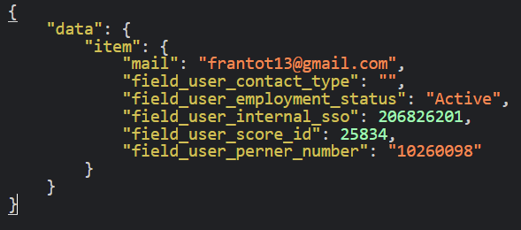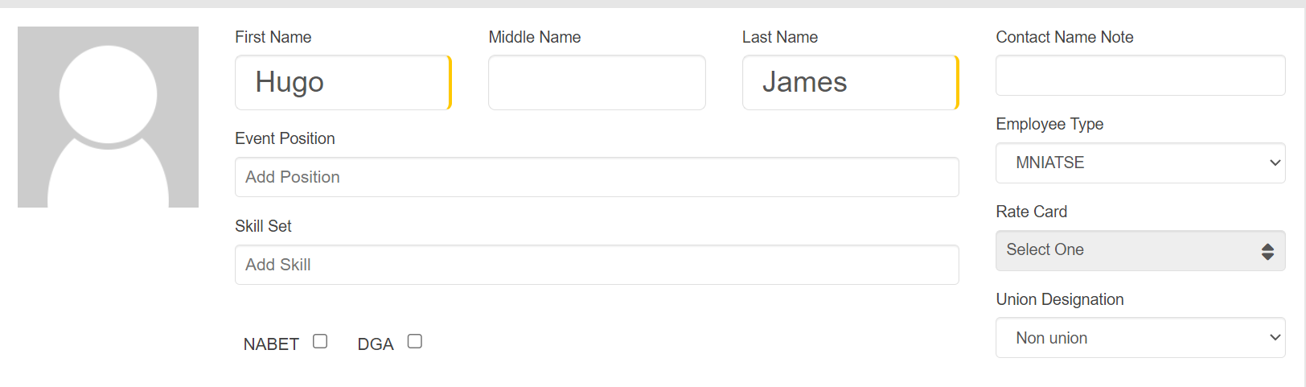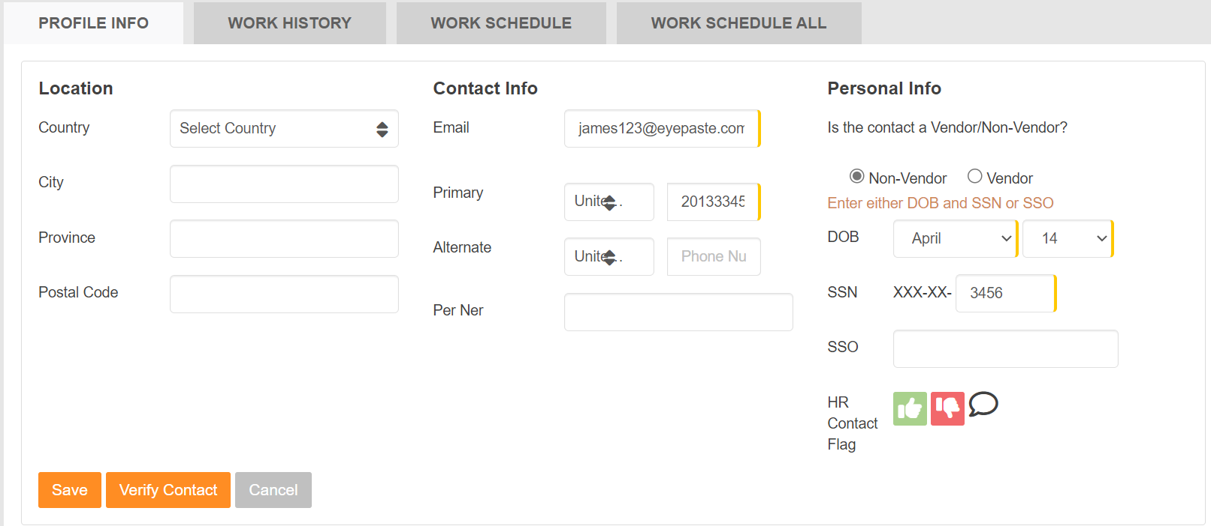

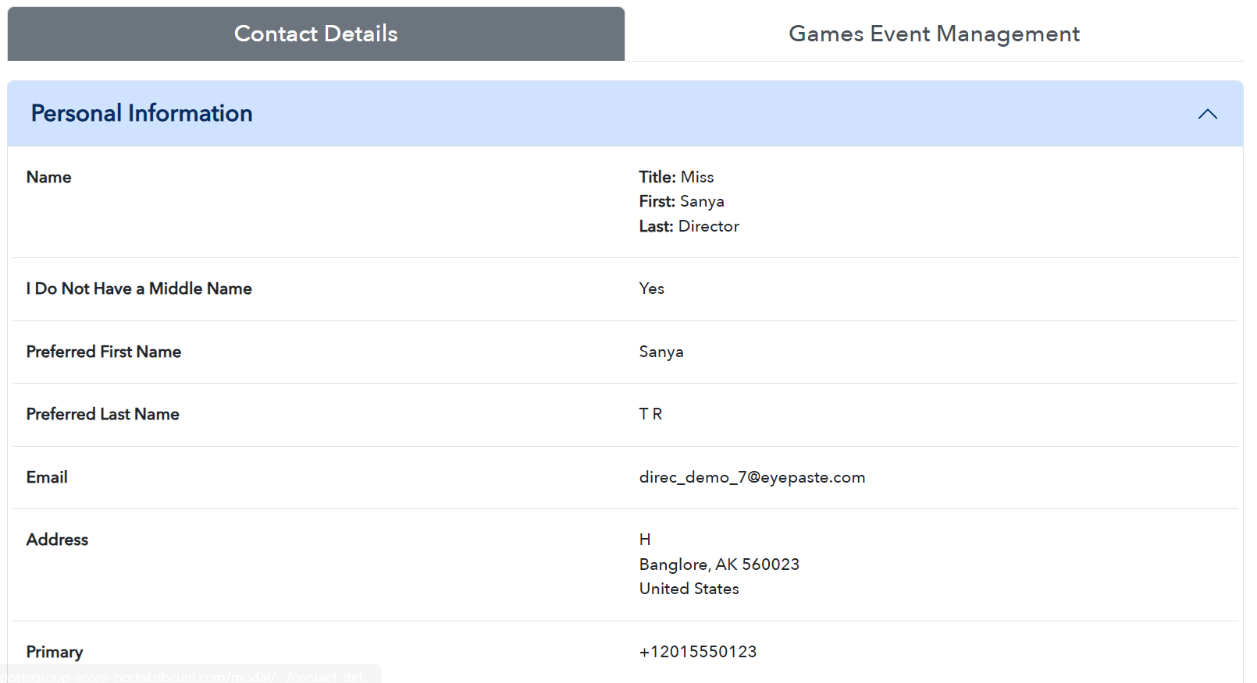 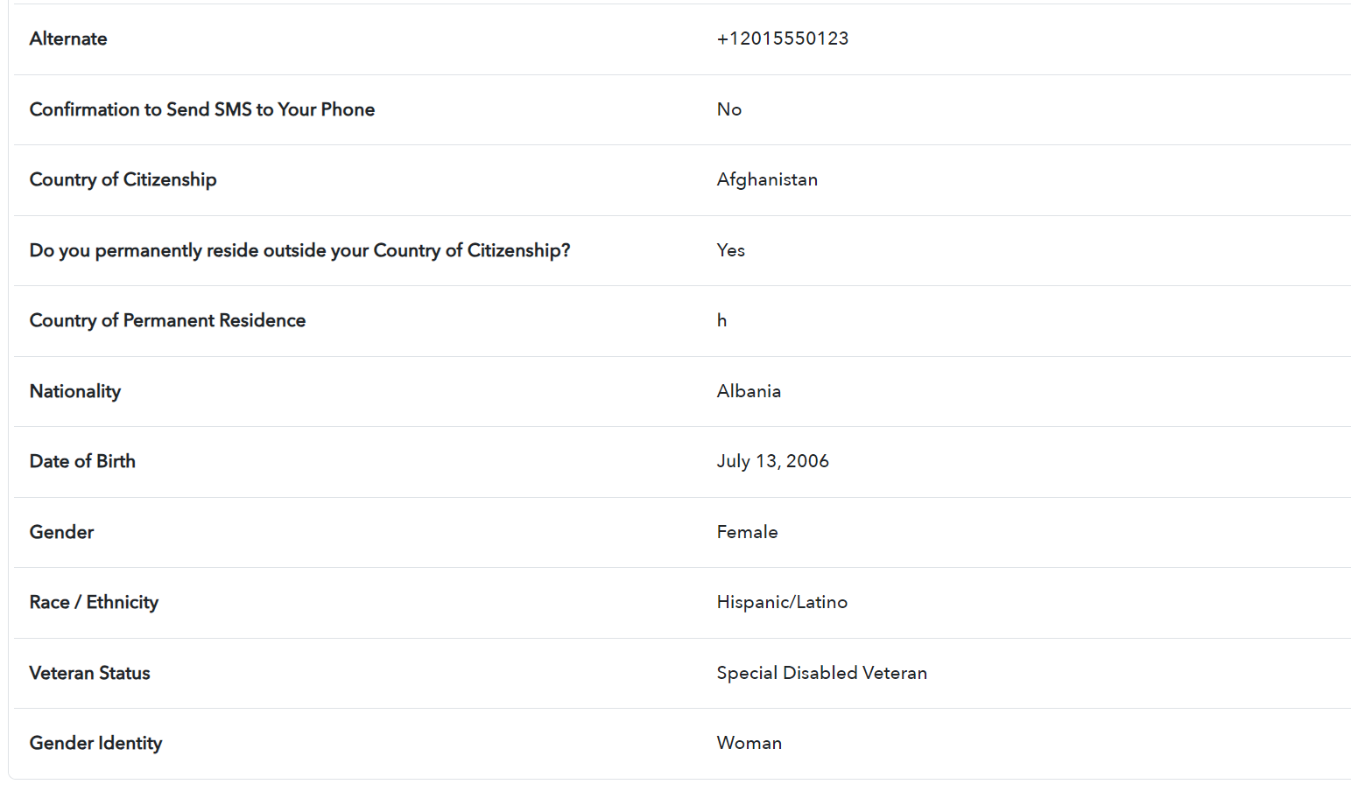

|  |  |
| --- | --- |
| **OLD APPICATION** | **JSON FILE** |
| Score id | field_user_score_id |
| First Name |  |
| Middle Name |  |
| Last Name |  |
| Contact Name Note |  |
| Event Position |  |
| Skill Set |  |
| Employee Type (pklist) |  |
| Rate Card |  |
| Union Designation (pklist) |  |
| NABET (checkbox) |  |
| DGA (checkbox) |  |
| Email | mail |
| Primary ( number ) |  |
| Alternate (number) |  |
| Per Ner | field_user_perner_number |
| Contact Type | field_user_contact_type |
| DOB |  |
| SSN |  |
| HR Contact Flag |  |
| SSO |  |
| Country (pklist) |  |
| City |  |
| Province |  |
| Postal Code |  |
| Is the contact a Vendor/Non-Vendor? (radio) |  |
|  | field_user_internal_sso |
|  | field_user_employment_status (Active) |
| **Title** |  |
| **I Do Not Have a Middle Name** |  |
| **Preferred First Name** |  |
| **Preferred Last Name** |  |
| **Address** |  |
| **Confirmation to Send SMS to Your Phone** |  |
| **Country of Citizenship** |  |
| **Do you permanently reside outside your Country of Citizenship?** |  |
| **Country of Permanent Residence** |  |
| **Nationality** |  |
| **Gender** |  |
| **Date of Birth** |  |
| **Race / Ethnicity** |  |
| **Veteran Status** |  |
| **Gender Identity** |  |