Responsible AI Report
AI Bias Audit & Fairness Report

1. Overview
This report documents a fairness audit of a binary loan-approval classification model, carried out to detect and mitigate bias against a protected attribute — gender. The audit follows the standard pipeline: build/train a model on a biased dataset, measure fairness with demographic-fairness metrics, visualize the disparities, apply a bias-mitigation strategy, and compare metrics before and after mitigation.

2. Dataset & Model
A synthetic loan-approval dataset (6,000 records) was used, deliberately constructed with the same failure pattern found in well-known biased public datasets (e.g. UCI Adult Income, COMPAS, German Credit):
- Proxy-feature bias — income and credit_score are, on average, historically lower for Female applicants (mirroring the real gender pay gap and historical under-scoring), independent of the applicant's actual merit.
- Label bias — historical approval decisions additionally penalized Female applicants beyond what their (already-lowered) qualifications warranted.
- gender itself was never used as a model input feature — the model was trained only on age, income, credit_score, years_employed, and debt_ratio.
A Logistic Regression classifier was trained on a 75/25 train-test split to predict loan approval.

3. Fairness Metrics Used
- Demographic Parity difference — the gap in approval rate between groups, regardless of actual qualification: DP = |P(approved | Male) - P(approved | Female)|.
- Equalized Odds difference — the largest gap between groups in True Positive Rate or False Positive Rate, conditional on the true label.
By convention, a difference greater than ~0.10 (10 percentage points) on either metric is treated as a meaningful fairness concern.

4. Findings — Before Mitigation
The baseline model reproduced the bias present in the training data even though gender was not a model feature: the bias entered through correlated “neutral-looking” features (income, credit_score) and through the historically biased labels.
- Demographic Parity difference: 0.189 (Male approval rate 49.5% vs Female 30.6%)
- Equalized Odds difference: 0.137
- Overall accuracy: 67.3%
Both figures exceed the 0.10 concern threshold, indicating a real fairness problem despite gender being excluded from the feature set — a clear demonstration that “fairness through unawareness” is not sufficient.

Bias Visualization Dashboard — Before Mitigation
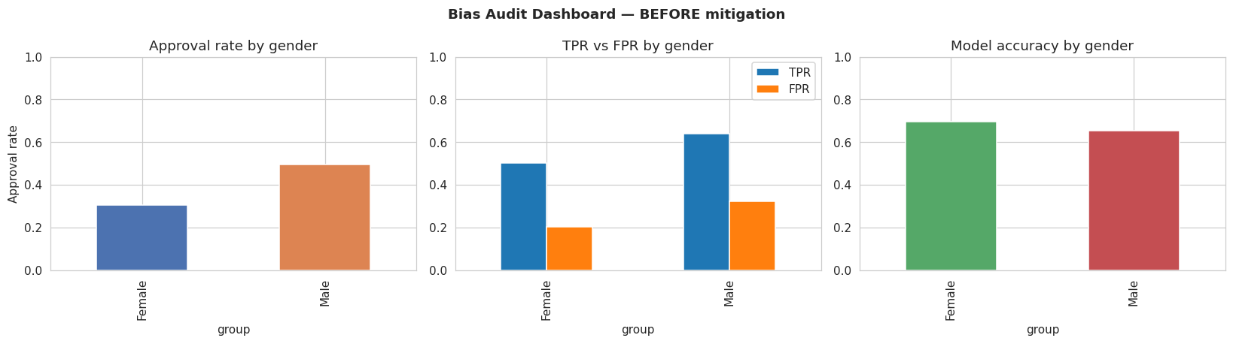

5. Mitigation Strategy Applied
Reweighing (Kamiran & Calders, 2012) was applied as a pre-processing mitigation technique. Each training example is re-weighted so that every (group, label) combination is represented as if group and label were statistically independent — down-weighting over-represented combinations and up-weighting under-represented ones, without altering or removing any data and without adding gender as a feature.

6. Findings — After Mitigation
- Demographic Parity difference: 0.161 (down from 0.189)
- Equalized Odds difference: 0.115 (down from 0.137)
- Overall accuracy: 67.5% (unchanged, +0.1 pt)
Reweighing reduced both fairness gaps at essentially no accuracy cost. The residual gap is expected: reweighing corrects for label-distribution bias, but cannot fully undo bias that has already been encoded into correlated input features (income, credit_score). This is an important, realistic limitation to report to stakeholders rather than a mitigation failure.

Bias Visualization Dashboard — After Mitigation
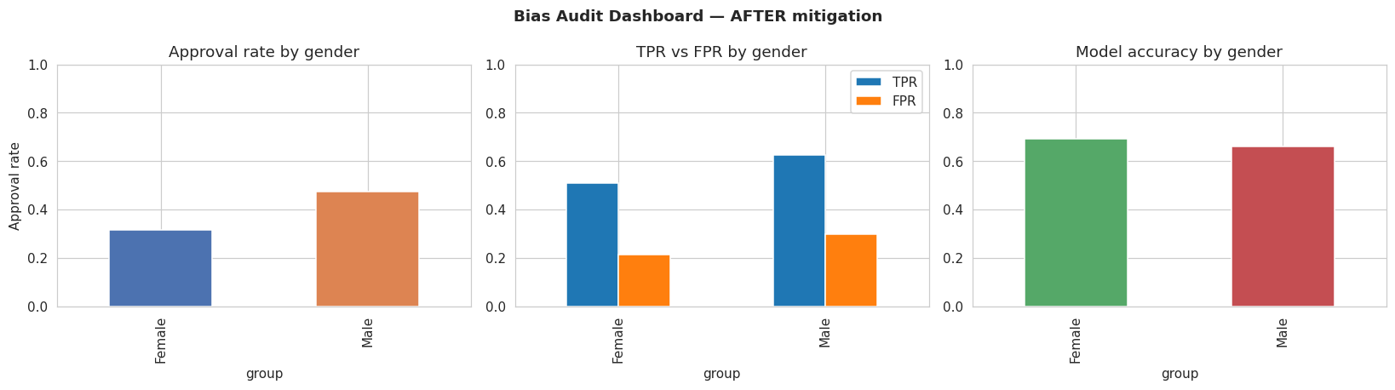

7. Before vs. After Comparison
Metric | Before mitigation | After mitigation | Change
Overall accuracy | 0.673 | 0.675 | +0.001
Demographic Parity difference | 0.189 | 0.161 | -0.028
Equalized Odds difference | 0.137 | 0.115 | -0.022
Approval rate - Male | 0.495 | 0.476 | -0.019
Approval rate - Female | 0.306 | 0.315 | +0.009

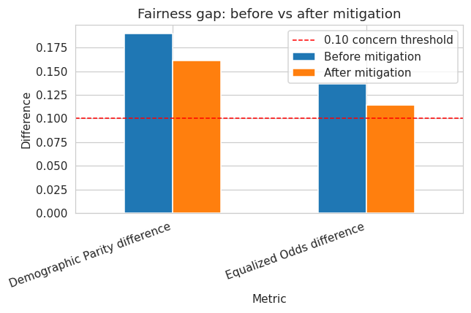

8. Ethical Recommendations
1. Don't rely on “fairness through unawareness.” Removing the protected attribute from the feature set is not sufficient — bias can still enter through correlated features and biased historical labels, as demonstrated here.
2. Audit regularly with group-wise metrics, not just overall accuracy. A model can show high overall accuracy while still being systematically unfair to a subgroup.
3. Apply mitigation at the appropriate stage — pre-processing (reweighing, resampling), in-processing (fairness constraints during training), or post-processing (per-group threshold adjustment) — and document which was used and why.
4. Report the fairness-accuracy trade-off explicitly to stakeholders rather than optimizing for accuracy alone; a small accuracy cost is often acceptable for a meaningful fairness gain.
5. Monitor in production. Data drift can reintroduce disparities even in a model that was fair at deployment time — fairness auditing should be a recurring process, not a one-off check.
6. Keep a human in the loop for high-stakes decisions (loans, hiring, healthcare, criminal justice), and provide a clear appeals / override mechanism.

9. Conclusion
This audit confirms that a model trained on historically biased data can produce discriminatory outcomes even without using the protected attribute directly. Fairness-aware auditing (demographic parity, equalized odds) combined with a mitigation strategy (reweighing) meaningfully reduced — though did not fully eliminate — the disparity, underscoring the need for ongoing, multi-stage responsible-AI practices rather than a single fix.
Deliverables: Fairness Audit Notebook (.ipynb) · Bias Visualization Dashboard (included above, and inline in the notebook) · this Responsible AI Report.

