**Capstone Project -2**

**Table of Content –**

1. **Abstract pg2**
2. **Business Problem pg2**
3. **Data Wrangling pg2**
4. **Data Visualization pg4**
5. **Inference Statistics pg8**
6. **Model Implementation pg9**
7. **Conclusion pg10**
8. **Next Steps pg11**
9. **Code pg11**
10. **Presentation pg11**
11. **Reference pg11**

**Abstracts –** Recently there has been a topic of fake news detection on social media, where lots of posts are getting published by many companies and daily basis and in order to identify if there is a fake news or not its not very easy, so with help of Machine learning, we will develop a solution which can identify if this is a fake news or not.

**Business Problem Description** – In this era, where social media has so much dominance on knowledge and information across the globe, it is very important to identify if it is a fake or a genuine article, so that the knowledge and information is valuable and can a real education for the society.

1. With help of NLP (Natural Language processing), we will create a corpus of words from real and fake news articles. This corpus will be used to create a classifier model, which can predict the news/ article to be fake or real. With this model we can focus on the source of these articles and classify them with high confidence that the news or article coming from the source is real or fake.

**Dataset Details –**

There are 20800 and 5 attributes. Key features from the dataset are as below from the training dataset

|  |  |
| --- | --- |
| **Columns** | **Description** |
| id | Identified/ Unique Id for a news articles |
| title | Title of a news articles |
| author | Author/ Source of the news articles |
| text | It is the text of the article; could be incomplete |
| label | Label that marks the article as potentially unreliable |

Reference data source –

* <https://www.kaggle.com/c/fake-news/data>

**Data Wrangling –**

We have downloaded the dataset provided on the Kaggle; and with our analysis of the data, there are 20800 records in the training dataset and 5200 records in the test dataset. This dataset set has the Author, Title, text and label as the attributes in the dataset.

Due to Indexing already available, it looks like ID column is duplicate column, hence it been dropped from the dataset, as shown in The sample with positive values are the of same positive sentiments. The sample with positive values are the of same positive sentiments.1,2.

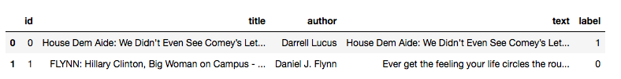

figure1

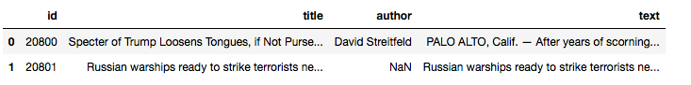

figure2

There are 10413 records, which are labeled as real / valid news and 10387 records are labeled as fake news. There are records, with null for Author, Title and Text columns.

In Training Dataset

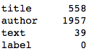

In Test Dataset



Data Preprocessing, Below in figure4, steps will be performing for the text – attribute, Remove Line Breaks element, remove new Line element, remove Hyperlink element, remove ampersand, remove greater than sign, remove less than sign, remove non-breaking space, remove Emails, remove new line characters, remove distracting single quotes.

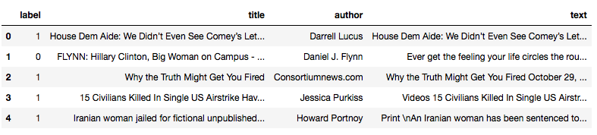

figure4

In figure4.1, using these preprocessed text, we created the length attribute of the words in the text.

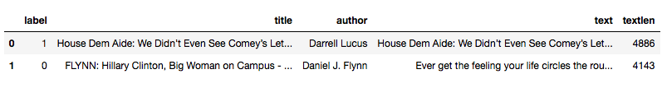

figure4.1

Below in figure5, plotting the bar graph to see if check the null records in Author, Title and Text -

* Around 1957 records are null for Author
* Around 558 records are null for Title

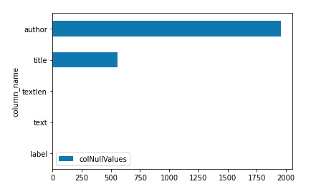

figure5

To handle the Null values, replaced Author and Title column as NA and dropped all the NA records. Also removed any text, which has less than 45 characters. Finally we are having 20563 records and 5 attributes.

As the dataset is ready, we have split the data between training and test data with 70:30 ratio. Created the Count Vector Training and Test dataset. Created the TFIDF train and test dataset for later in modeling section.

**Data Visualization -**

A new additional attribute is created to capture the sentiments from the text, used the sentiment polarity API to calculate the values. The values are calculated to -1 to 1, being 1 as positive sentiments and -1 as negative sentiments, as shown in figure6.

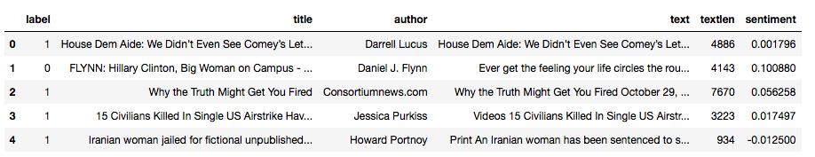

figure6

In figure7, Plotted the distribution of the sentiments score, it has close to normal distribution, as it seems, it has both positive and negative sentiments almost equally.

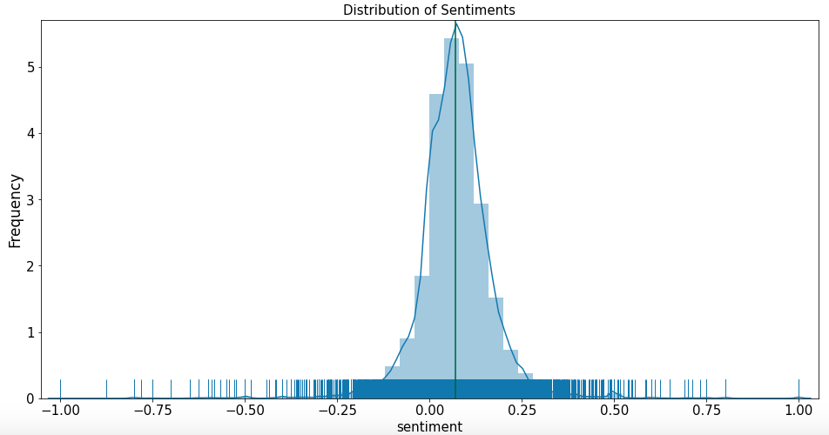

figure7

In figure8, Below is the PIE chart for fake and real news; it is almost same number records classified as fake and real news.

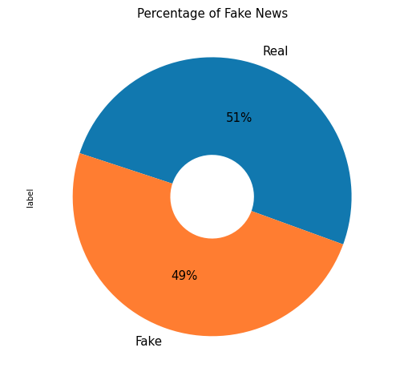

figure8

Next in figure9, is the correlation matrix, describing the relation between the attributes, the values of the correlation are between -1 and 1, showing positive and negative correlation. There is not strong correlation between any attributes, but there is a negative correlation of -0.12 between length and label.

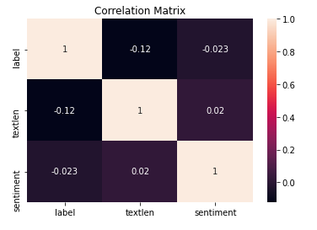

figure9

In fi10, WordCloud from Train Dataset, creating the word cloud of 50 most common words are “Obama”, followed by “Clinton” and “American”.

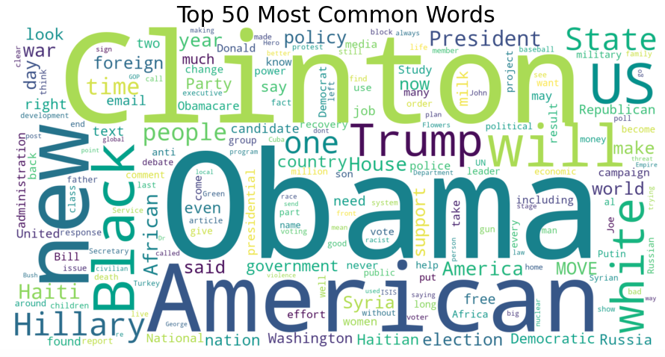

figure10

Creating the n-Gram plots for Unigram, Bigram and Trigram, in the unigram, the most common words after stopword are “said”, “mr” and “trump”. In the Bigram, we can see “mr trump”, “united states” and “donald trump”. In the trigram, we can see the common words are “new york times”, “president Donald trump ” and “mr trump said” as shown in figure11.

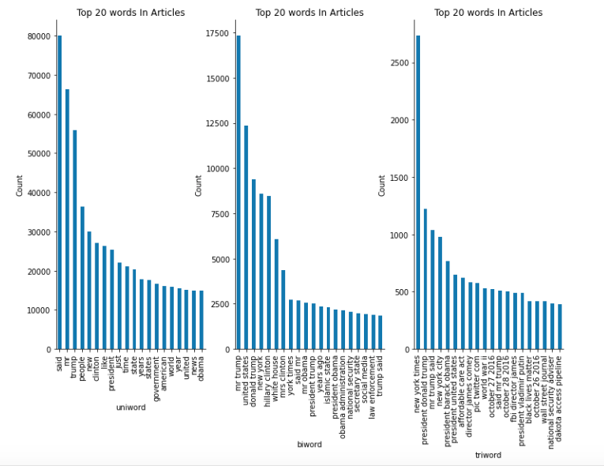

figure11

Creating the n-Gram plots for Unigram, Bigram and Trigram, in the unigram, the most common words after stopword and updating stopword, are “trump”, “will” and “one”. In the Bigram, we can see “united states” and “donald trump” and “new york”. In the trigram, we can see the common words are “new york times”, “president Donald trump ” and “new york city”, as shown in figure12.

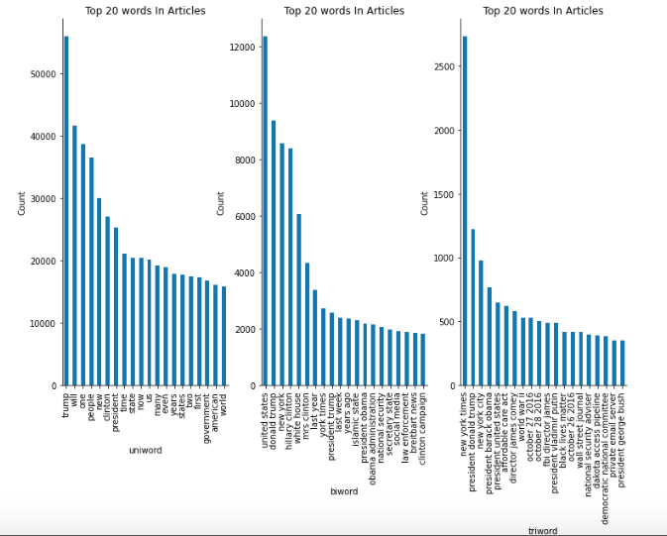

figure12

**Inferential statistics techniques –**

The dataset has 10385 fake news articles and legit/ valid news articles are 10178, out of total articles of 20563 records.

Calculate the T-Statistics of two independent **sentiments** sample from the population of fake news articles and real news articles. We have the below hypothesis –

**Null Hypothesis** – Both of the sample are same and equal, there is no difference in their sentiments analysis.

**Alternate Hypothesis** – Both of the samples are different and not equal and have difference in their sentiments analysis.

T-Statistics helps explain if the means from two samples are different from each other, by calculating the stand error in difference between two means. The critical value is calculated using degree of freedom and significance level with percent point function (PPF), if the critical value is greater than t-statistics, we reject the null hypothesis, else we accept the null hypothesis.

Another method is to calculate the p-value from the cumulative distribution function (CDF) from t-distribution, this p-values is compared to the alpha (significance level). If it is more than alpha, we accept the null hypothesis and if it is less, then reject the null hypothesis.

Values calculated from the t-distribution as –

The t-distribution left quartile range is: -1.9600793684470008. The t-distribution right quartile range is: 1.9600793684470004, as shown in figure14

* T-stats =3.249, degree of freedom=20561, cv=1.645, p=0.001, alpha = 0.05.
* Comparing the critical values to the t-stat, reject the null hypothesis that the means are equal.
* Comparing the p-value to alpha, reject the null hypothesis that the means are equal.

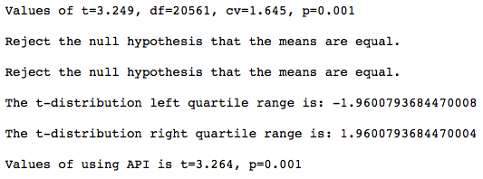

figure14

Based, on the above details, the sentiments of fake and real news are different from each other. The p-value is less than 5% chance that both sentiments sample are same, so reject the null hypothesis.

**Correlation between 'textlen' and ‘sentiment’:**

Calculating for high correlation data from dataset, for 'textlen', 'sentiment', we find that the coeff values is 0.01971846321212139 and p-value is 0.004688487215723314. There is very less correlation (0.0197) between the text length and sentiments calculated. As seen in figure 14.a

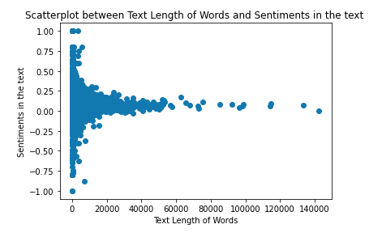

figure14.a

#### Chi-Squared Test Statistics: Assumed Hypothesis as below.

* Null Hypothesis (H0): The samples with positive values are of same positive sentiments.
* Alternate Hypothesis (H1): The samples with positive values sentiments are different from each other.

We find that dof=7806 0.10947413801013585 probability=0.950, critical=8012.652, stat=0.000 Independent (fail to reject H0) significance=0.050, p=1.000 Independent (fail to reject H0)

We can conclude that sample with positive values are of same positive sentiments.

**Model Implementation –**

In the data wrangling section, training dataset is split into train and validation/test datasets. The training dataset is created for COUNT vectors, TF-IDF vectors. In this section, we need to develop a model to predict fake or legit news based on the historical data collected in the training set with labels.

Two methods – CountVectorizer and TF-IDF Vectorizer, are used as Count Vectorizer provides the document term matrix, which is transposed tokens, or words in features with count of occurrence of each word.

TF-IDF (Term Frequency-Inverse Document Frequency), helps downgrade the weights of highly frequent words.

Model created for Logistics Regression with Count Vectors, Logistics Regression with TF-IDF Vectors, Multinomial Naïve Bayes classifier with Count Vectors with hyper parameter and Multinomial Naïve Bayes classifier with TF-IDF Vectors with hyper parameter. The hyper parameter tuning is done using “GridSearchCV”. The Best parameters resulted as alpha = 0.1.

LSTM (long short term memory) neural networks are also used for predicting the fake and legit news classification. This a recurrent neural network, compared to standard and convolutional neural network. Specification used for this model is – maximum number of words is 50000, maximum number of words in each text is 250. The spatialDropout1D value of 0.2, dropout value of 0.1 and recurrent dropout value of 0.1 and activation “softmax”.

As shown in figure 15, Accuracy scores of each of the algorithms -

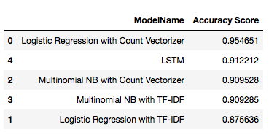

figure15

Best results from the above accuracy score is of – Logistic Regression with Count Vectors. Below we can see the ROC Accuracy is 0.95.

In the confusion matrix, as shown in figure16

1. True positive is 2944 and True Negative is 2945.
2. Type I – False negative is 120 and Type II – False positive is 160.

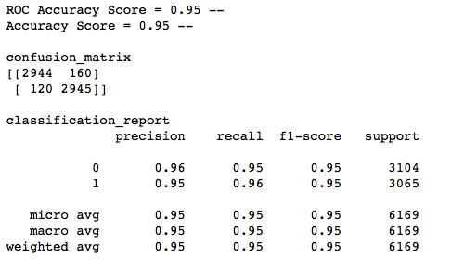

figure16

ROC (Receiver Operating Characteristics) curve with area under curve (AUC) is a measure of how well model is performing in predicting probability of classes. The False positive rate (FPR on x-axis) and True Positive Rate (TPR on y-axis) is plotted. Higher the True positive rate and the curve is more towards 1 on y-axis is considered to be best model.

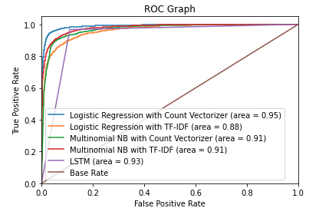

figure17

In Figure17, we can see that Logistic Regression with Count vector has highest AUC-ROC score of 95%.

**Conclusion -**

There are 20800 records in the training dataset and 5200 records in the test dataset. There are 10413 records, which are labeled as real / valid news and 10387 records are labeled as fake news.

Data Preprocessing, was performed on text – attribute with, remove Line Breaks element, remove new Line element, remove Hyperlink element, remove ampersand, remove greater than sign, remove less than sign, remove non-breaking space, remove Emails, remove new line characters, remove distracting single quotes.

Created the Count Vector Training and Test dataset with split of 70:30 ration for training and test dataset. Created the TFIDF train and test dataset for later in modeling section.

“n-Gram” plots for Unigram, Bigram and Trigram, in the unigram, the most common words after stopword and updating stopword, are “trump”, “will” and “one”. In the Bigram, we can see “united states” and “donald trump” and “new york”. In the trigram, we can see the common words are “new york times”, “president Donald trump ” and “new york city”.

T-Statistics of two independent **sentiments** sample from the population of fake news articles and real news articles. T-stats =3.249, degree of freedom=20561, cv=1.645, p=0.001, alpha = 0.05. Comparing the critical values to the t-stat, reject the null hypothesis that the means are equal. Comparing the p-value to alpha, reject the null hypothesis that the means are equal.

Models created for Logistics Regression with Count Vectors, Logistics Regression with TF-IDF Vectors, Multinomial Naïve Bayes classifier with Count Vectors with hyper parameter and Multinomial Naïve Bayes classifier with TF-IDF Vectors with hyper parameter. The hyper parameter tuning is done using “GridSearchCV”. The Best parameters resulted as alpha = 0.1. LSTM (long short term memory) neural networks is also used for predicting the fake and legit news classification.

Best results from the above accuracy score are of – Logistic Regression with Count Vectors with ROC Accuracy is 0.95 or AUC-ROC score of 95%.

**Next Work –**

We can create the weights and feature importance and use that to predict the fake and legit news. We can improve the AUC-ROC score using any ensemble algorithms.

**Code –**

<https://github.com/arijitsinha80/Springboard/blob/master/Project2/CapstoneProject2-FakeNewsPrediction.ipynb>

**PPT –**

<https://github.com/arijitsinha80/Springboard/blob/master/Project2/Capstone%20Project%202_Final.pptx>

**Reference –**

<https://towardsdatascience.com/nlp-part-3-exploratory-data-analysis-of-text-data-1caa8ab3f79d>

<https://www.kaggle.com/aaroha33/fake-news-classifier-with-naive-bayes>

<https://machinelearningmastery.com/how-to-code-the-students-t-test-from-scratch-in-python/>