INDIGO compute-optimal scaling
48-run IsoFLOP sweep, 40M corpus, Porian-corrected

1. Headline
- N* ∝ C^{0.94} on ΔE₀₀, C^{0.83} on CE. Chinchilla is 0.50. D* is pinned at 4 to 8 Mex across 250× in C.
- Both metrics bottom at C = 2.75e15 and worsen after. Best pooled ΔE there: 10.04.
- CE is not the well-behaved control. It breaks at the same budget, so this is not a ΔE artefact.
- Not data repetition. 47 of 48 runs stayed under one epoch.
- Low chroma is the only clean law (α = 0.65, β = 0.40, α + β ≈ 1).
Working claim: the ceiling is problem-side. Section 7 is the one confound I cannot rule out, and what I would run to close it. That is the section I want your read on.

2. Method
- Chinchilla Approach 2. Six budgets × eight runs. Parabola in log N per budget gives N*, then a power law in C. Final checkpoint, aspect ratio held in a 28 to 72 band, D counted in examples.
- The compute axis is not 6ND. src/scaling/flops.py computes forward FLOPs per example analytically and sets C = 3 · F(N) · D. The pointer head runs per (position, slot), 352 times per example, and the slot encoder runs over 32 pool slots rather than the 11-position sequence. Over this ladder C/(N·D) runs from 306 down to 218, so 6ND would understate compute by 36× to 51× and the error itself drifts 1.4× across the grid. This is Porian correction #1, far larger here than in the paper.
- Porian #2: warmup as a fraction of the budget. Porian #3: LR re-tuned per scale, which is section 7.

3. The sweep
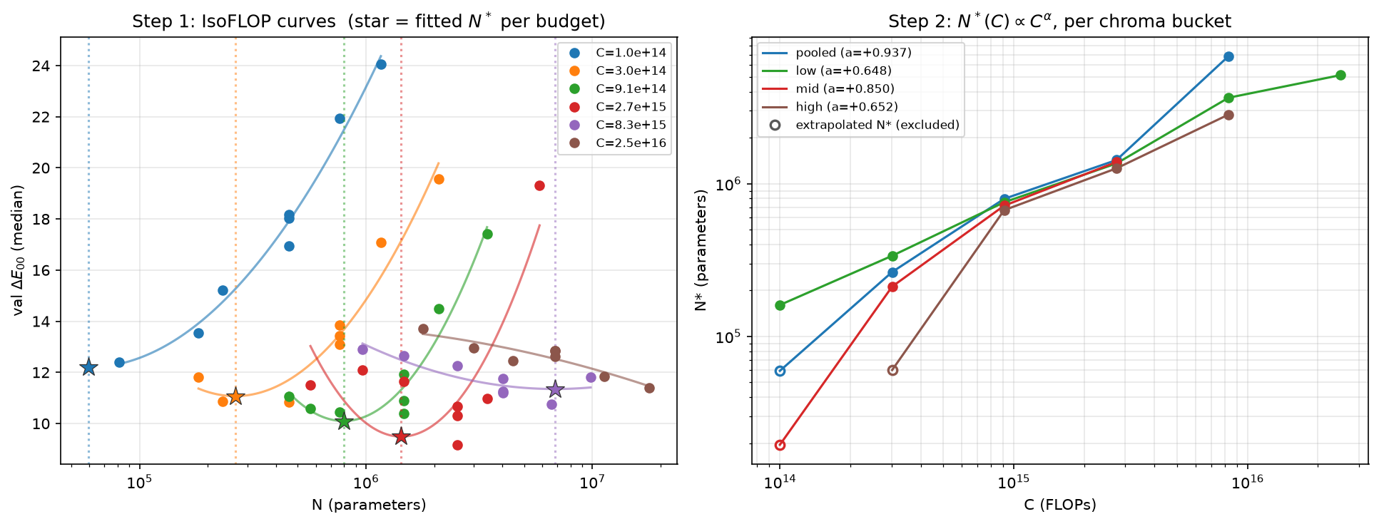
Figure 1. Left: one colour per FLOP budget, dots are the eight model sizes, star is the fitted N*. Right: N*(C) per chroma bucket.
- The parabolas flatten as C rises. At C = 8.3e15 the star sits at the edge of the window; at 2.5e16 there is no interior minimum and the fit is refused.
- The quantity being fitted, curvature in log N, is going to zero. ΔE stops caring how big the model is.
Table 1. Per-budget summary.
C (FLOPs) | N sampled | N* (ΔE) | D* (Mex) | best ΔE₀₀ | best CE | max epochs
1.00e14 | 0.08 - 1.16M | refused | – | 12.39 | 6.144 | 0.11
3.02e14 | 0.18 - 2.09M | 0.26M | 4.05 | 10.84 | 6.075 | 0.14
9.10e14 | 0.46 - 3.42M | 0.80M | 4.25 | 10.46 | 6.042 | 0.18
2.75e15 | 0.57 - 5.84M | 1.43M | 7.66 | 10.04 | 6.024 | 0.46
8.29e15 | 0.97 - 9.82M | 6.85M | 5.31 | 10.75 | 6.030 | 0.84
2.50e16 | 1.78 - 17.84M | refused | – | 11.40 | 6.035 | 1.45
Seed-averaged, not min-over-runs. N* moves 26×; D* does not move.

4. Cross-entropy, same procedure
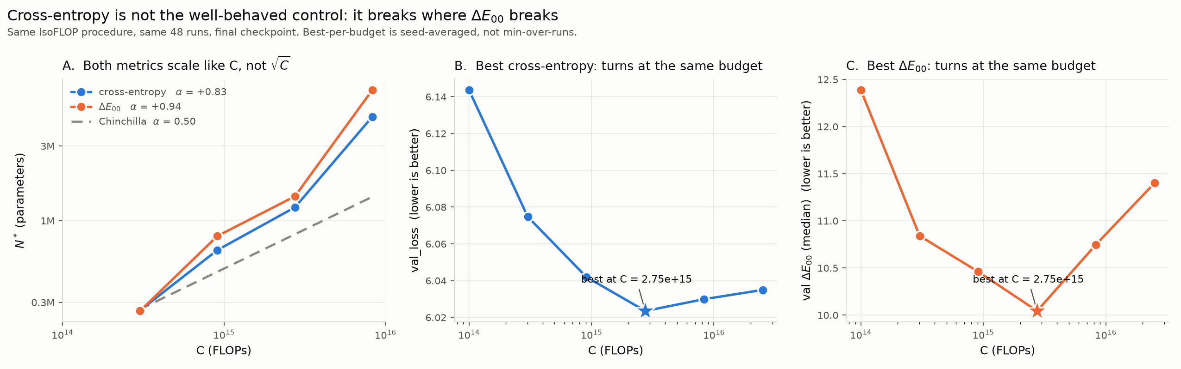
Figure 2. The identical IsoFLOP procedure run on val_loss. Panel A carries a Chinchilla α = 0.5 slope for reference.
- Both exponents near 0.9. Both metrics turn at 2.75e15.
- This kills anything that blames the ΔE evaluator, CIEDE2000, or the greedy decode: token-level CE turns in lockstep.

5. Epoch-ceiling theory, refuted
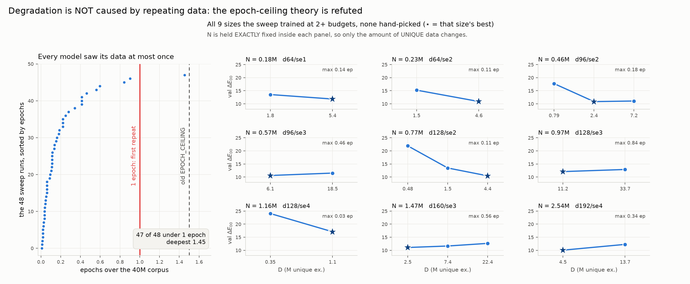
Figure 3. Left: epochs over the 40M corpus, all 48 runs. Right: every model size trained at two or more budgets, N held exactly fixed inside each panel.
- Degradation happens inside the first pass, so it is not memorisation from repeats.
- In four of the nine panels, more unique data makes ΔE worse. That is the opposite of a repetition effect.

6. Where the ceiling comes from
Table 2. Fitted exponents by chroma bucket.
Bucket | α (N*) | 95% CI | β (D*) | α + β | rungs fit | survives noise?
low | +0.648 | 0.595 to 0.713 | +0.403 | 1.05 | 6 of 6 | yes (0.652)
mid | +0.850 | 0.595 to 1.105 | +0.206 | 1.06 | 3 of 6 | no
high | +0.652 | 0.570 to 0.735 | +0.403 | 1.06 | 3 of 6 | no
pooled | +0.937 | 0.529 to 1.420 | +0.129 | 1.07 | 4 of 6 | no
"Survives noise" is the Monte-Carlo re-fit propagating measured seed noise. Low: 43% of draws refused, median α = 0.652. Mid and pooled: 4000/4000 refused. High: 3998/4000.
Table 3. Best ΔE₀₀ by bucket, across the full 250× span.
Bucket | 1.0e14 | 3.0e14 | 9.1e14 | 2.8e15 | 8.3e15 | 2.5e16 | best / worst
low | 6.86 | 6.14 | 5.62 | 5.05 | 5.52 | 6.02 | 1.36×
mid | 15.27 | 12.43 | 12.16 | 12.04 | 12.89 | 12.39 | 1.27×
high | 21.51 | 18.83 | 18.12 | 18.79 | 20.21 | 21.55 | 1.19×
High chroma never gets below 18 ΔE, which is not a usable design, and moves 1.19× across 250× in compute.

The M factor
- pool_size is drawn per example from [4, 32], stacks are at most 10 layers, thicknesses live on a 2 nm grid. The reachable colour set is finite and fixed by the pool, not by the model.
- A floor flattens the parabola: once the model finds the near-pool-optimal stack, extra N buys nothing and N* stops being identified. That is Figure 1.
- A floor should be chroma-dependent, and is. Low chroma is the only bucket with a clean, noise-robust law; high chroma is pinned at 18 to 21.
- So the pooled curve is a mixture of a still-improving component and a pinned one, and mixtures do not have clean power laws.

The alternative
Not the pool but the degeneracy: the map from (target Lab, pool) to stack is massively one-to-many, and a point-estimate decoder on a token-level objective cannot rank that set well enough for its argmax to be good. The two differ on one testable thing: whether enlarging the pool moves the floor.
Test: for ~2000 val examples compute the best ΔE achievable given that example's own pool, using optical_sim.py and thickness_optimizer.py, then plot model ΔE against it by pool_size and chroma. M factor says the gap has already closed at large C; degeneracy says the gap is everything and never closes. A few CPU hours.

7. Learning rate: what we fit, and what I propose fitting instead

7.1 What the sweep does now
Porian correction #3 is to re-tune LR at every scale rather than inherit one global value. We apply it through a fitted law rather than a sweep per config: fit_lr_law() in src/scaling/configs.py fits log lr = a + b·log N to three measured optima, giving lr(N) = 1.573 · N^{−0.567}. Across the ladder's 220× range in N that runs from 2.58e-3 to 1.21e-4. It is a real improvement on the alternative: the production value of 6e-5 left every probe model untrained.

7.2 What the law rests on
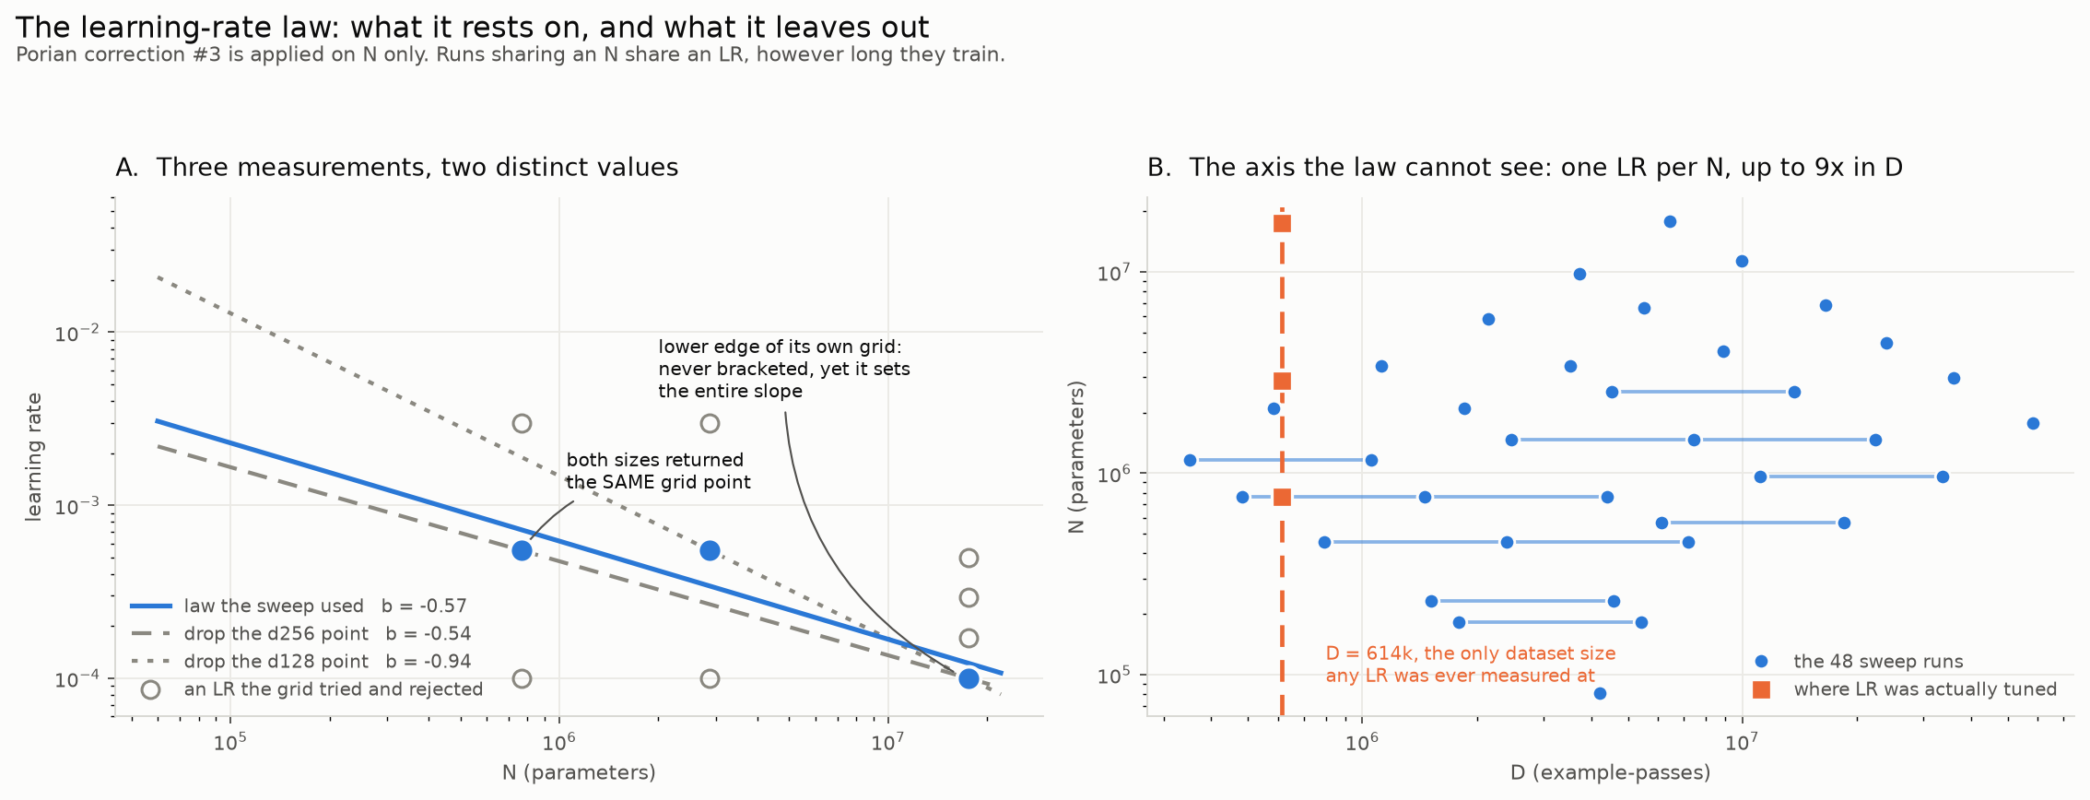
Figure 4. A: the three measured optima, with every LR each grid tried shown hollow. B: the 48 sweep runs in (D, N); a horizontal line joins runs that share an N and therefore share an LR.
- Two of the three points come from a 3-point grid, 1e-4 to 3e-3, whose only candidates were {1e-4, 5.48e-4, 3e-3}. Both sizes returned the middle one, so that measurement carries no size dependence at all.
- The d512 point comes from a different 4-point grid, 1e-4 to 5e-4, and returned 1.00e-4, which is that grid's lower bound. The optimum was never bracketed; the true one may sit below it.
- So the slope rests entirely on one unbracketed boundary value. Leave-one-out shows the cost: dropping d256 gives b = −0.54, dropping d128 gives b = −0.94, which is 8.4× in the LR handed to the smallest model in the sweep.

7.3 The larger gap: there is no D term
All three measurements were taken at one dataset size, D = 614,400 examples. lr_for() takes only N, so LR is constant along lines of constant N (Figure 4B). Runs at a fixed N span up to 9× in D (N = 1.47M trains on 2.5M, 7.4M and 22.4M examples, all at lr = 4.98e-4), and the largest D in the sweep is 95× the tuned one.
The repo already asserts the opposite premise. scripts/fit_lr_scaling.py opens with: "optimal LR depends primarily on the total number of optimization steps", which is D / batch_size, and fits against train_examples. configs.py fits against parameter count. Two different laws; we deployed the N one.
Why this is live rather than pedantic. Within a rung C is fixed, so N and D are anti-correlated and a missing D term is largely absorbed by the N term. Across rungs it is not: the same N appears at three different D. If the optimum falls with D, as the cosine-schedule argument says, then at fixed N the large-budget runs train at too high an LR and the error grows with the budget. That would produce exactly what we see: degradation switching on at high C, on both metrics, unrelated to repetition.
Probably not the whole story, since section 6's clean low-chroma law is hard to get out of it. But it is the only remaining explanation I cannot rule out, and it is cheap to rule out.

7.4 Proposed experiment
Replace the 1-D law with lr_opt(N, D) = A · N^{b} · D^{c}, fitted where both axes move independently.
- Minimal, 3 sweeps, ~37 GPU-hours. Hold N at d128/se2 (0.77M, already measured) and run lr_tuning.py --epochs 1 at D ∈ {0.6M, 4M, 24M}, bracketing the sweep's real D range. Measures c directly. If |c| is inside noise of zero, the current law is fine and we say so.
- Full, 3×3 grid, 9 sweeps, ~110 GPU-hours. Only if c is clearly nonzero. Gives b and c jointly and replaces MEASURED_LR.
- Either way, widen the grid and require bracketing. --n-lrs 6 --lr-min 1e-5 --lr-max 5e-3, and reject any result landing on an endpoint.
The question: is ~1.5 GPU-days worth spending to close this before we commit to "the ceiling is problem-side"? My read is yes for the 3-sweep version, since it is the last mechanism that could produce budget-dependent degradation, and a measured c ≈ 0 lets us state the conclusion cleanly. The 9-sweep version only if the cheap one comes back nonzero.

8. Caveats
- Pooled α is a point estimate. Bootstrap CI 0.53 to 1.42; the noise-propagated fit refuses all 4000 draws. Only the low bucket is robustly identified.
- Two of six rungs contribute nothing, so the pooled law rests on four points.
- Largest model here is 17.8M. The turn could be an artefact of the size window; the counter is that the same window gave a clean low-chroma law.
- Quote 10.04, not 9.17, at 2.75e15. The min over eight runs is biased low; 9.17 is one seed of a three-seed cluster averaging 10.04.
- LR has no D term. Unablated.

9. Takeaway
- 48 runs, Porian-corrected, aspect-controlled, 40M corpus, analytic FLOP axis.
- INDIGO's frontier is not Chinchilla's. Extra compute goes into parameters, not data.
- Past C ≈ 2.75e15 more compute makes the model worse, on both metrics.
- Not repetition, not the metric. One confound left: no D term in the LR law.
- Low chroma is the only clean, noise-robust law. The method works where the problem is solvable.
- If that holds, the payoff is inference-time search and RL against the simulator, not a bigger pretrain. Two cheap experiments decide it: the oracle-floor eval (section 6) and the D-term LR sweep (section 7).

