**PROJECT REPORT TEMPLEATE**

**CRM APPLICATION THAT HELPS TO BOOK A VISA SLOT**

**TERM ID : NM2023TMID19546**

**1.INRODUCTION**

**1.1 Overview :**

In this project, we use custom object, relationships, pages layouts to give the visa slot access to data they need on an existing recruitment app.

To make the existing app more efficient for the visa book team we create custom objects and relationships to store and access the data more efficiently.

**1.2 Purpose :**

$∗$ Marketing campaign management

$∗$ Training & Development

$∗$ Maintaining Healthy work culture

$∗$ Job positing

$∗$ Payroll Management

$∗$ Organizing various activities

$∗$ Resolving conflicts.

**2. Problem Definition & Design Thinking**

**2.1 Empathy map :**

An empathy map is a collaborative visualization used to articulate what we know about a particular type of user. It externalizes knowledge about users in order to

1. Create a shared understanding of user needs, and
2. Aid in decision making

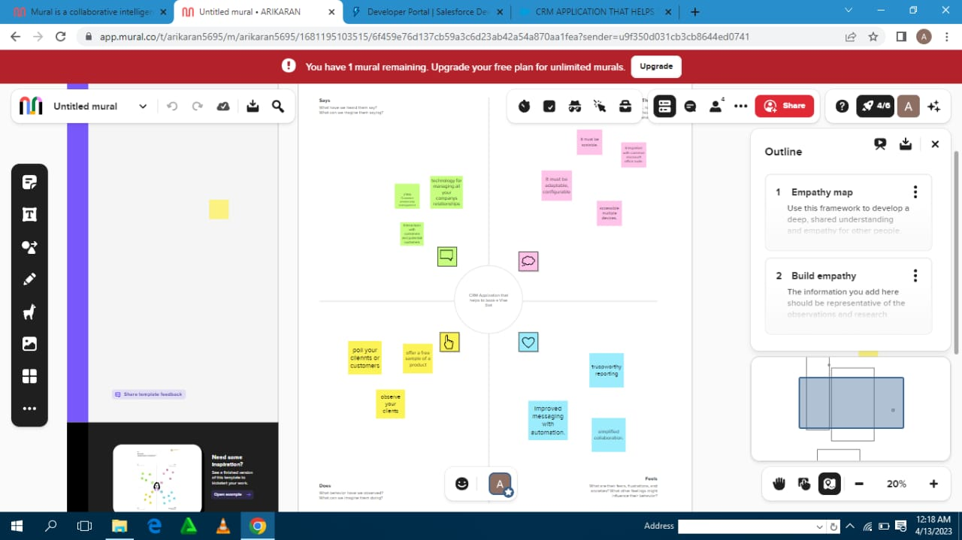

**2.2 Brainstorming :**

Brainstorming is a group problem solving method that involves The spontaneous contribution of creative ideas and solutions. Thistechnique requires intensive, freewheeling discussion in which every member of the group is encouraged to think aloud and suggest as many ideas as possible based knowledge.

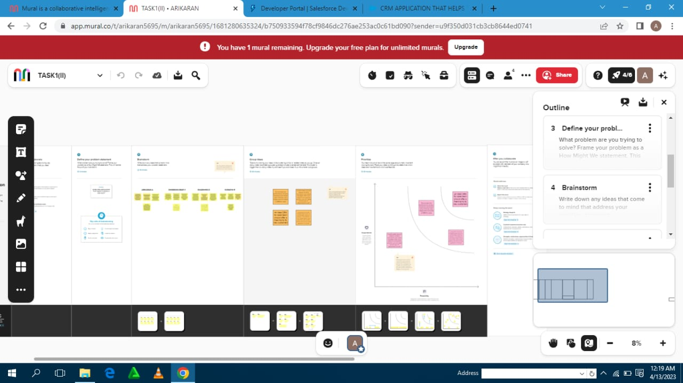

**3.RESULT**

**3.1 Data Model :**

|  |  |  |
| --- | --- | --- |
| Object name | Field label | Data type |
| Visa book | Visa book | text |
| Internal Results | Internal Results | text |
| Review | Review | Auto-number |
| Account | Account | Auto- number |

**3.2 Activity & Screenshort :**

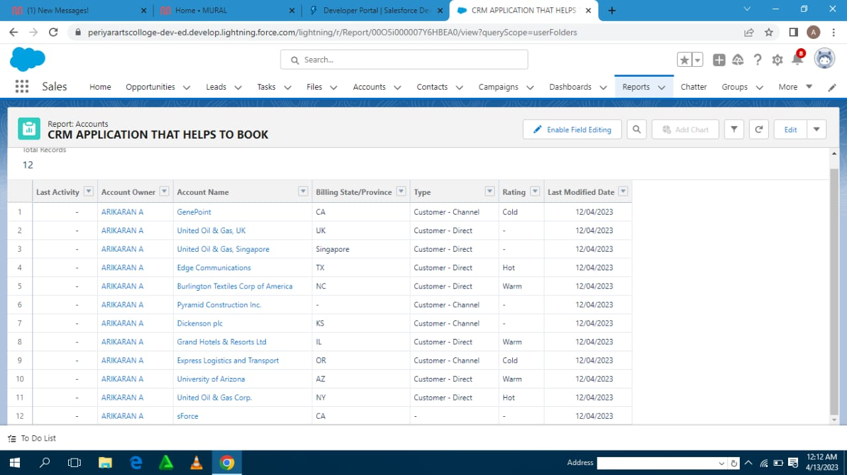

**4. TRAILHEAD PROFILE PUBLIC URL**

Team leader - <https://trailblazer.me/id/arika21>

Team member 1 - <https://trailblazer.me/id/ddharshini36>

Team member 2 - <https://trailblazer.me/id/gomar19>

Team member 3 - <https://trailblazer.me/id/arika21>

**5. ADVANTAGES & DISADVANTAGES**

**Advantages:**

The advantages of a visa slot of using a CRM system greatly outweigh the disadvantages. However , there are pitfalls. For a CRM system to work ,book there needs to be buy –in across the organizationand the processes in place to support it. Otherwise, your CRM visa book may end up being an expensive waste of time.

**Disadvantages:**

We looked at the book the advantages of initating a CRM system, so now its time to examine some of the visa the disadvantage of a CRM system. The short term pain of a cultural and technological shift can be a lot to bear and may not generate a return.

**6. APPLICATIONS**

$∗$ Trustworthy reporting $∗$ Dashboards that visually showcase data $∗$ Improved messaging with automation $∗$ Proactive service $∗$ efficiency enhanced by automation

**7. CONCLUSION**

CRM implementation is a project that requires preparation commitment and co operation across the entire organization . But most importantly you need to get ready for a shift in the mindset as a CRM system may transform the way you do visa slot.

**8. FUTURE SCOPE**

The project has a very vast scope in future .the project can be implemented on internet in future.