Task 1-
import React, { useState, useEffect } from "react";
import "./App.css";
/* ---------------- LOCAL STORAGE KEYS ---------------- */
const STUDENTS_KEY = "students";
const SESSION_KEY = "student_session";
/* ---------------- LOCAL STORAGE FUNCTIONS ---------------- */
function getStudents() {
return JSON.parse(localStorage.getItem(STUDENTS_KEY)) || [];
}
function saveStudents(students) {
localStorage.setItem(STUDENTS_KEY, JSON.stringify(students));
}
function saveSession(student) {
localStorage.setItem(SESSION_KEY, JSON.stringify(student));
}
function getSession() {
return JSON.parse(localStorage.getItem(SESSION_KEY));
}
function clearSession() {
localStorage.removeItem(SESSION_KEY);
}
/* ================= SIGNUP PAGE ================= */
function Signup({ setPage }) {
const [form, setForm] = useState({
name: "",
roll: "",
course: "",
email: "",
password: "",
confirmPassword: "",
});
const [showPassword, setShowPassword] = useState(false);
function handleChange(e) {
const { name, value } = e.target;
setForm({
...form,
[name]: value,
});
}
function handleSubmit(e) {
e.preventDefault();
/* -------- VALIDATIONS -------- */
if (
!form.name.trim() ||
!form.roll.trim() ||
!form.course.trim() ||
!form.email.trim() ||
!form.password.trim() ||
!form.confirmPassword.trim()
) {
alert("All fields are required");
return;
}
const emailPattern = /^[^\s@]+@[^\s@]+\.[^\s@]+$/;
if (!emailPattern.test(form.email)) {
alert("Enter valid email");
return;
}
if (form.password.length < 6) {
alert("Password must be at least 6 characters");
return;
}
if (form.password !== form.confirmPassword) {
alert("Passwords do not match");
return;
}
const students = getStudents();
const emailExists = students.find(
(student) => student.email === form.email
);
if (emailExists) {
alert("Email already registered");
return;
}
const rollExists = students.find(
(student) => student.roll === form.roll
);
if (rollExists) {
alert("Roll number already exists");
return;
}
/* -------- SAVE STUDENT -------- */
const newStudent = {
id: Date.now(),
name: form.name,
roll: form.roll,
course: form.course,
email: form.email,
password: form.password,
};
saveStudents([...students, newStudent]);
alert("Signup Successful");
setForm({
name: "",
roll: "",
course: "",
email: "",
password: "",
confirmPassword: "",
});
setPage("login");
}
return (
<div className="container">
<div className="box">
<h1>Student Signup</h1>
<form onSubmit={handleSubmit}>
<input
type="text"
name="name"
placeholder="Enter Name"
value={form.name}
onChange={handleChange}
required
/>
<input
type="text"
name="roll"
placeholder="Enter Roll Number"
value={form.roll}
onChange={handleChange}
required
/>
<input
type="text"
name="course"
placeholder="Enter Course"
value={form.course}
onChange={handleChange}
required
/>
<input
type="email"
name="email"
placeholder="Enter Email"
value={form.email}
onChange={handleChange}
required
/>
<div className="password-box">
<input
type={showPassword ? "text" : "password"}
name="password"
placeholder="Enter Password"
value={form.password}
onChange={handleChange}
required
/>
<span onClick={() => setShowPassword(!showPassword)}>
{showPassword ? "Hide" : "Show"}
</span>
</div>
<input
type={showPassword ? "text" : "password"}
name="confirmPassword"
placeholder="Confirm Password"
value={form.confirmPassword}
onChange={handleChange}
required
/>
<button type="submit">Signup</button>
</form>
<p>
Already have account?
<span className="link" onClick={() => setPage("login")}>
Login
</span>
</p>
</div>
</div>
);
}
/* ================= LOGIN PAGE ================= */
function Login({ setPage, setStudent }) {
const [form, setForm] = useState({
email: "",
password: "",
});
const [showPassword, setShowPassword] = useState(false);
function handleChange(e) {
const { name, value } = e.target;
setForm({
...form,
[name]: value,
});
}
function handleSubmit(e) {
e.preventDefault();
const students = getStudents();
const foundStudent = students.find(
(student) =>
student.email === form.email &&
student.password === form.password
);
if (!foundStudent) {
alert("Invalid Email or Password");
return;
}
saveSession(foundStudent);
setStudent(foundStudent);
alert("Login Successful");
setForm({
email: "",
password: "",
});
setPage("dashboard");
}
return (
<div className="container">
<div className="box">
<h1>Student Login</h1>
<form onSubmit={handleSubmit}>
<input
type="email"
name="email"
placeholder="Enter Email"
value={form.email}
onChange={handleChange}
required
/>
<div className="password-box">
<input
type={showPassword ? "text" : "password"}
name="password"
placeholder="Enter Password"
value={form.password}
onChange={handleChange}
required
/>
<span onClick={() => setShowPassword(!showPassword)}>
{showPassword ? "Hide" : "Show"}
</span>
</div>
<button type="submit">Login</button>
</form>
<p>
Don't have account?
<span className="link" onClick={() => setPage("signup")}>
Signup
</span>
</p>
</div>
</div>
);
}
/* ================= DASHBOARD ================= */
function Dashboard({ student, logout }) {
if (!student) return null;
return (
<div className="container">
<div className="box">
<h1>Student Dashboard</h1>
<h2>Welcome {student.name}</h2>
<p>
<strong>Roll No:</strong> {student.roll}
</p>
<p>
<strong>Course:</strong> {student.course}
</p>
<p>
<strong>Email:</strong> {student.email}
</p>
<button onClick={logout}>Logout</button>
</div>
</div>
);
}
/* ================= MAIN APP ================= */
export default function App() {
const [page, setPage] = useState("signup");
const [student, setStudent] = useState(null);
useEffect(() => {
const session = getSession();
if (session) {
setStudent(session);
setPage("dashboard");
}
}, []);
function logout() {
clearSession();
setStudent(null);
setPage("login");
}
if (page === "signup") {
return <Signup setPage={setPage} />;
}
if (page === "login") {
return (
<Login
setPage={setPage}
setStudent={setStudent}
/>
);
}
return (
<Dashboard
student={student}
logout={logout}
/>
);
}
Output-
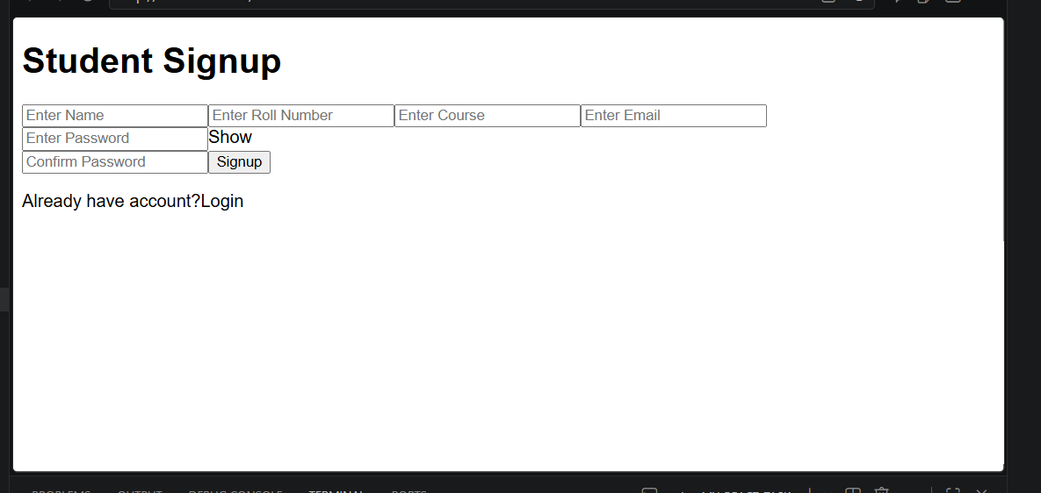

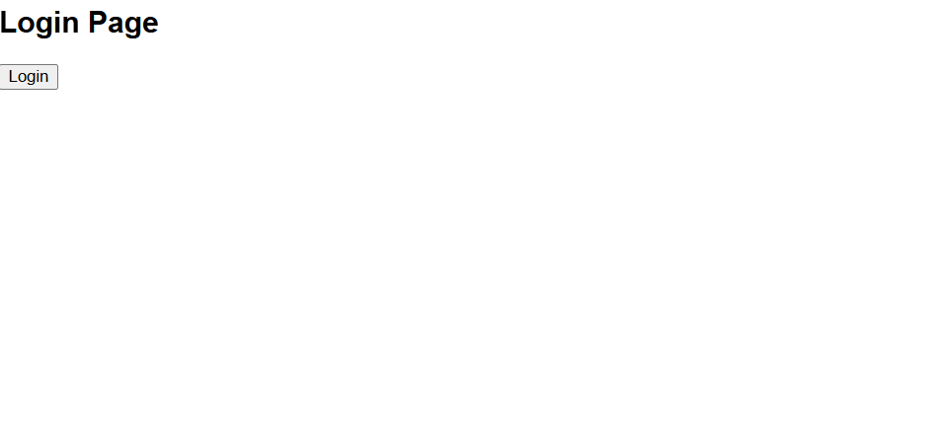

Task 2-
App.jsx
import React, { useState } from 'react';
import Signup from './Signup';
import Login from './Login';
import Dashboard from './Dashboard';

export default function App() {
const [page, setPage] = useState("signup");
const [student, setStudent] = useState(null);

const logout = () => { setStudent(null); setPage("login"); };

return (
<div>
{page === "signup" && <Signup setPage={setPage} />}
{page === "login" && <Login setPage={setPage} setStudent={setStudent} />}
{page === "dashboard" && <Dashboard student={student} logout={logout} />}
</div>
);
}
Signup.jsx
import { useState } from 'react';

export default function Signup({ setPage }) {
const [name, setName] = useState("");
const [email, setEmail] = useState("");

const handleSignup = (e) => {
e.preventDefault();
const newStudent = { name, email };
const existingData = JSON.parse(localStorage.getItem("studentsList")) || [];
existingData.push(newStudent);
localStorage.setItem("studentsList", JSON.stringify(existingData));
alert("Signup Successful!");
setPage("login");
};

return (
<form onSubmit={handleSignup}>
<h2>Signup Page</h2>
<input type="text" placeholder="Name" onChange={(e) => setName(e.target.value)} required />
<input type="email" placeholder="Email" onChange={(e) => setEmail(e.target.value)} required />
<button type="submit">Sign Up</button>
</form>
);
}
Login.jsx
import { useState } from 'react';

export default function Login({ setPage, setStudent }) {
const [email, setEmail] = useState("");

const handleLogin = (e) => {
e.preventDefault();
const storedData = JSON.parse(localStorage.getItem("studentsList")) || [];
const user = storedData.find((s) => s.email === email);
if (user) { setStudent(user); setPage("dashboard"); }
else { alert("Invalid login details!"); }
};

return (
<form onSubmit={handleLogin}>
<h2>Login Page</h2>
<input type="email" placeholder="Enter Email" onChange={(e) => setEmail(e.target.value)} required />
<button type="submit">Login</button>
</form>
);
}

Dashboard.jsx
export default function Dashboard({ student, logout }) {
const allStudents = JSON.parse(localStorage.getItem("studentsList")) || [];

return (
<div>
<h1>Student Dashboard</h1>
<div style={{ background: '#f0f0f0', padding: '10px' }}>
<h3>Total Students Count: {allStudents.length}</h3>
</div>
{student ? (
<div>
<h3>Welcome, {student.name}!</h3>
<button onClick={logout}>Logout</button>
</div>
) : <p>No student data found.</p>}
</div>
);
}

Output-
