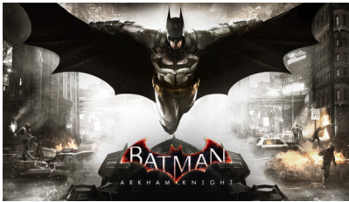 | Batman: Arkham Knight (Steam)  IBEXD-BZL7H-JACWW
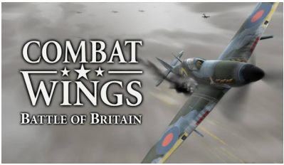 | Combat Wings: Battle of Britain (Steam)  RWR24-NW4DA-ZDIMB
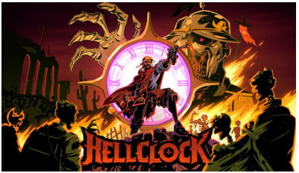 | Hell Clock (Steam)  NM9Y9-9EAYC-KVY4Y
 | Human: Fall Flat (Steam)  I7M8Z-8VL3V-X5YZ5
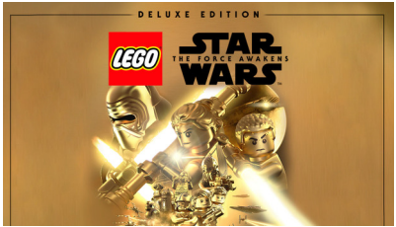 | LEGO Star Wars: The Force Awakens Deluxe Edition (Steam)  PRZQZ-ERZP4-4TDL9
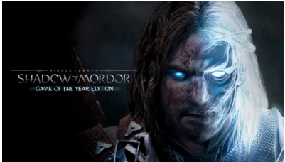 | Middle-earth: Shadow of Mordor - Game of the Year Edition (Steam)  Y853L-XAR8A-AZD6X
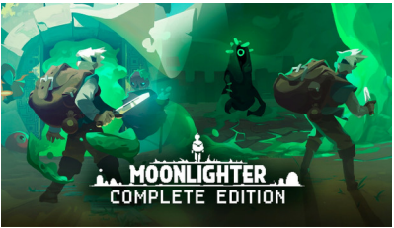 | Moonlighter Complete Edition (Steam)  AVN0F-BAQ64-4RLF0
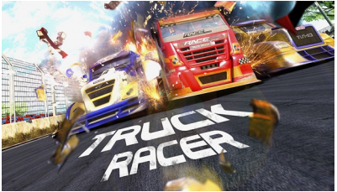 | Truck Racer (Steam)  5VYFJ-JA6AF-EJVYI
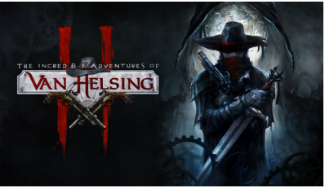 | The Incredible Adventures of Van Helsing II (Steam)  WY4WM-CFCPX-RRCGA
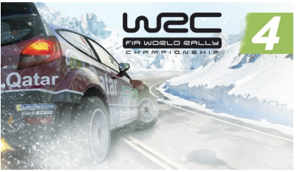 | WRC 4: FIA World Rally Championship (Steam)  XMV85-YLLKY-04NJF

