Retail Sales Forecasting & Inventory Planning Using Python
Week 2 Deliverable: Exploratory Data Analysis, Data Quality Audit & Preparation
Internship Program: | YuvaIntern Virtual Data Science Explorer Internship
Project Domain: | Retail Time Series Forecasting & Supply Chain Inventory Optimization
Technical Track: | Artificial Intelligence & Data Science (B.Tech Practical Curriculum)
Submission Status: | Week 2 Verified Technical Report (Version 1.0)

1. Executive Summary
This technical deliverable documents the execution and empirical validation of Week 2 for the project 'Retail Sales Forecasting and Inventory Planning Using Python', conducted under the YuvaIntern Virtual Data Science Explorer Internship. Following the successful submission of the Week 1 project charter and architecture roadmap, Week 2 establishes the empirical data foundation required for downstream predictive time-series modeling and supply chain replenishment planning.
The project utilizes historical retail sales records across 45 unique retail outlets observed over 143 consecutive weeks (spanning February 5, 2010 through October 26, 2012), providing a balanced panel of exactly 6,435 observations. A complete data integrity audit confirmed zero missing values and zero duplicate records. Rather than applying standard mathematical outlier truncation, a domain-specific outlier investigation established that all 34 statistical outlier weeks represent critical holiday demand surges (Thanksgiving/Black Friday and pre-Christmas shopping weeks). Preserving these peaks is paramount to preventing stockouts in downstream inventory planning.
Exploratory Data Analysis confirmed a statistically significant holiday demand uplift of +7.84% (Welch's two-sample t-test: t = 2.6801, p = 0.00760; Mann-Whitney U test: U = 1,431,297, p = 0.02589), alongside extreme store-level heterogeneity where top-performing stores generate 8.11 times the revenue of bottom-tier stores. Modular scripts (download_data.py, data_cleaning.py, eda.py) and reproducible Jupyter notebooks have been deployed and validated in the workspace.

2. Dataset Provenance, Scope & Governance
Data science best practices require clear provenance verification and licensing compliance before undertaking predictive modeling. The characteristics and governance terms of the dataset are detailed below:
Benchmark Source | Kaggle Competition: 'Walmart Recruiting - Store Sales Forecasting' (Walmart Inc., 2014)
Intellectual Property | Proprietary sales and operational data owned by Walmart Inc.
Licensing & Terms | Released under Kaggle Competition Rules for educational benchmarking, academic study, and non-commercial research. Commercial redistribution is restricted.
Compliance Architecture | In accordance with governance standards, raw dataset files are excluded from Git tracking via .gitignore. Fully reproducible automated retrieval is provided via src/download_data.py.
Public Mirror Source | https://raw.githubusercontent.com/DrPoojaAbhijith/Walmart-Sales-Forecasting/main/Walmart%20DataSet.csv
Dataset Dimensions | 6,435 rows × 8 original features (14 features post-engineering)

3. Data Structure & Data Quality Audit
A comprehensive structural audit was conducted by executing src/data_cleaning.py. The dataset contains eight attributes capturing sales, calendar flags, and regional environmental indicators. The audit confirmed 100% data completeness:
Column Name | Raw Type | Null Count | Unique Values | Operational Range / Meaning
Store | int64 | 0 (0.0%) | 45 | Categorical identifier for retail outlet (1 to 45).
Date | object (str) | 0 (0.0%) | 143 | Weekly date step in DD-MM-YYYY format (2010-02-05 to 2012-10-26).
Weekly_Sales | float64 | 0 (0.0%) | 6,435 | Weekly gross revenue in USD ($209,986.25 to $3,818,686.45). Target.
Holiday_Flag | int64 | 0 (0.0%) | 2 | Binary indicator (1 = designated holiday week, 0 = regular week).
Temperature | float64 | 0 (0.0%) | 3,528 | Average regional ambient temperature in °F (-2.06°F to 100.14°F).
Fuel_Price | float64 | 0 (0.0%) | 892 | Regional cost of fuel per gallon in USD ($2.472 to $4.468).
CPI | float64 | 0 (0.0%) | 2,145 | Consumer Price Index inflation metric (126.06 to 227.23).
Unemployment | float64 | 0 (0.0%) | 340 | Regional unemployment rate percentage (3.879% to 14.313%).
Audit Highlights: Total duplicate rows: 0. Total missing entries: 0. Date granularity: exactly 143 contiguous weekly steps per store with no gaps. The panel is perfectly balanced across all 45 stores.

4. Cleaning & Feature Engineering Methodology
To prepare the raw data for chronological machine learning models and avoid data leakage, the following deterministic transformations were implemented in src/data_cleaning.py:
- 1. Explicit Date Parsing: Raw date strings in DD-MM-YYYY format were explicitly parsed into datetime64[ns] to prevent month-day transposition errors.
- 2. Chronological Ordering: Observations were sorted by Store and Date in ascending order, establishing a strict temporal progression necessary for walk-forward validation and lag engineering.
- 3. Calendar Feature Extraction: Extracted Year, Month, WeekOfYear (ISO-8601), Day, and Quarter to allow models to learn recurring intra-year seasonal patterns.
- 4. Pre-Christmas Rush Indicator (Is_PreChristmas): Identified and engineered a binary flag for Week 51 (December 17–24). In the raw dataset, Holiday_Flag is assigned to the final week of December (New Year's Eve), while actual retail transaction volume surges during the pre-Christmas shopping week.
- 5. Target Integrity Validation: Verified that all Weekly_Sales values are strictly positive (> 0), confirming the absence of unhandled product return anomalies.
[FEATURE ENGINEERING PRINCIPLE] By generating calendar indicators prior to modeling and establishing strict chronological sequence, we eliminate target leakage and ensure that validation splits mirror real-world operational forecasting conditions.

5. Outlier Diagnostics & Operational Justification
Statistical outlier detection was performed using the standard Tukey Interquartile Range (IQR) method:
25th Percentile (Q1) | $553,350.11
75th Percentile (Q3) | $1,420,158.66
Interquartile Range (IQR) | $866,808.55
Lower Bound (Q1 - 1.5 × IQR) | -$746,862.73 (Effective lower limit: $0.00)
Upper Bound (Q3 + 1.5 × IQR) | $2,720,371.49
Identified Statistical Outliers | 34 records (0.5284% of total dataset)
Empirical Investigation of Outlier Timestamps:
A granular breakdown of the 34 outlier records revealed that 100% of them occurred during peak Q4 promotional windows:
• 2010-12-24 (Christmas Eve week): 9 stores (Peak: Store 14 at $3,818,686.45)
• 2011-12-23 (Pre-Christmas week): 7 stores (Peak: Store 4 at $3,676,388.98)
• 2010-11-26 (Thanksgiving / Black Friday): 5 stores
• 2010-12-17 (Mid-December surge): 5 stores
• 2011-11-25 (Thanksgiving / Black Friday): 4 stores
• 2011-12-16 (Mid-December surge): 3 stores
• 2010-12-10 (Early December shopping rush): 1 store
[SUPPLY CHAIN JUSTIFICATION] In generic data engineering, outliers are often winsorized or pruned. In retail operations, however, the Thanksgiving and Christmas surges generate a massive percentage of annual corporate profit. Pruning these records would bias predictive models toward under-forecasting peak demand, resulting in stockouts during the most lucrative weeks of the year. All 34 outliers were retained.

6. Exploratory Data Analysis & Empirical Visualizations
Visual analytics were generated at 300 DPI using Matplotlib and Seaborn via src/eda.py. Below are four key visualizations illustrating seasonal dynamics, holiday impacts, store variance, and environmental correlations:

Figure 1: Aggregate Nationwide Weekly Sales Trend (2010–2012)
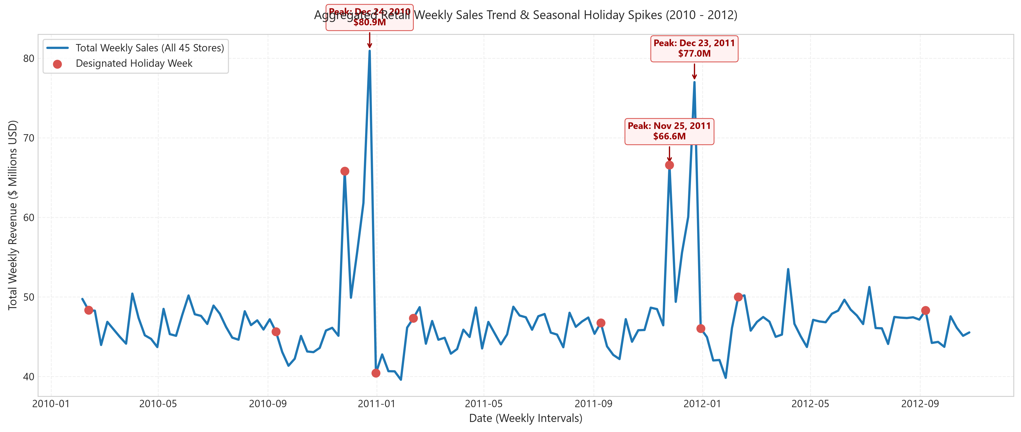
Figure 1: Aggregate weekly retail revenue across all 45 stores with holiday annotations.
Analysis of Figure 1: Nationwide sales demonstrate a remarkably consistent baseline oscillating between $45M and $50M per week. The dominant features of the series are the recurring annual November-December peaks, reaching nearly $80M per week—a surge of approximately 60% over baseline. Secondary peaks occur during early February (Super Bowl) and early September (Labor Day).

Figure 2: Distributional Impact of Holiday Weeks on Store Sales
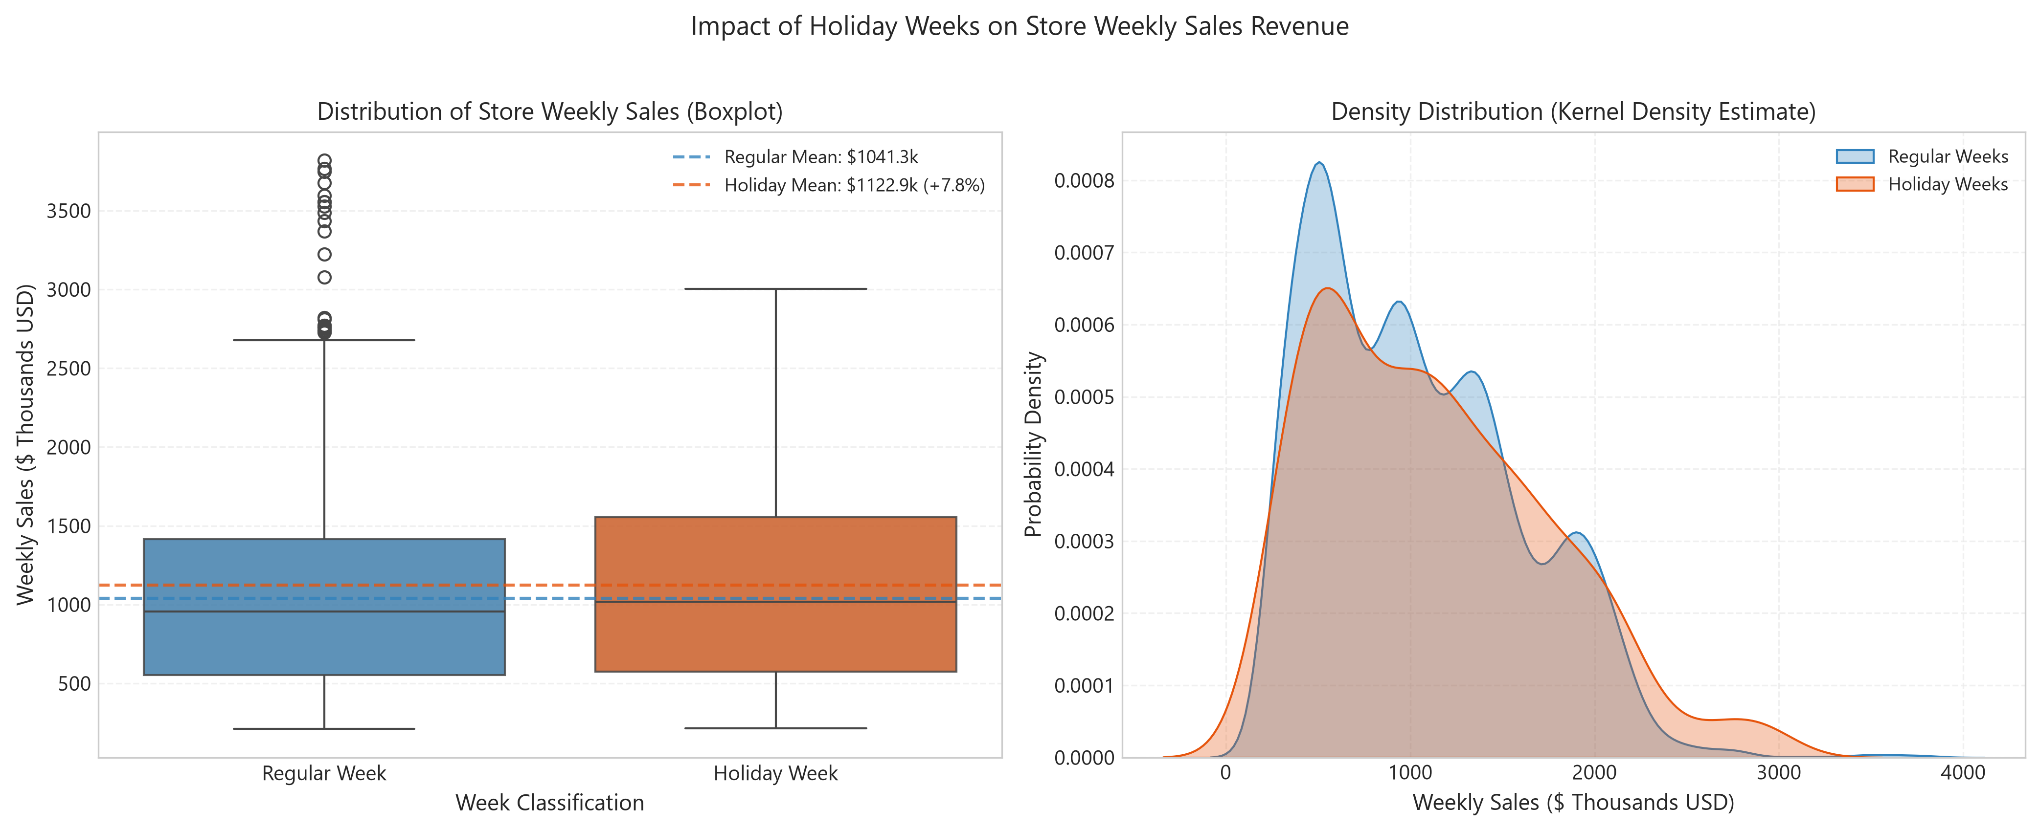
Figure 2: Boxplot and Kernel Density Estimate (KDE) comparing regular versus holiday weeks.
Statistical Testing of Holiday Uplift: Mean weekly sales on regular weeks equal $1,041,256.38 (std: $558,957.44; n = 5,985), while mean sales on designated holiday weeks rise to $1,122,887.89 (std: $627,684.93; n = 450), reflecting an empirical uplift of +7.84%. To confirm that this uplift is not a sampling artifact, formal hypothesis tests were executed:
• Welch's Two-Sample t-test (unequal variances): t = 2.6801, p-value = 0.00760 (significant at α = 0.01)
• Mann-Whitney U test (non-parametric rank sum): U = 1,431,297.0, p-value = 0.02589 (significant at α = 0.05)
Both tests confirm that holiday weeks produce statistically significant demand shifts, necessitating dedicated holiday indicators in predictive models.

Figure 3: Cumulative Store Revenue Tiers & Performance Disparity
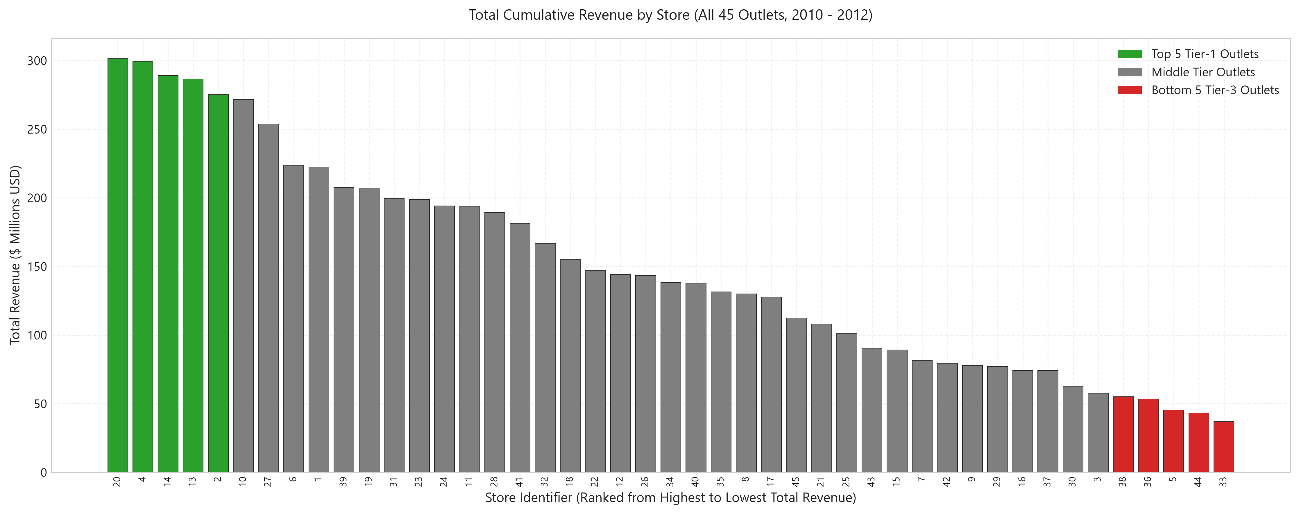
Figure 3: Total cumulative revenue across all 45 outlets ranked by tier.
Analysis of Figure 3: A profound structural divide exists across store locations. The top-performing outlet (Store 20) generated $301,397,792.46 in revenue over the period (mean: $2.11M/week), whereas the lowest-performing outlet (Store 33) generated $37,160,221.96 (mean: $260k/week). This represents an 8.11-fold volume disparity. Practical implication: applying uniform safety stock or global sales averages across stores will cause simultaneous severe over-stocking at small stores and chronic stockouts at flagship stores. Store-level segmentation is essential.

Figure 4: Feature Correlation Matrix (Sales & Macroeconomic Indicators)
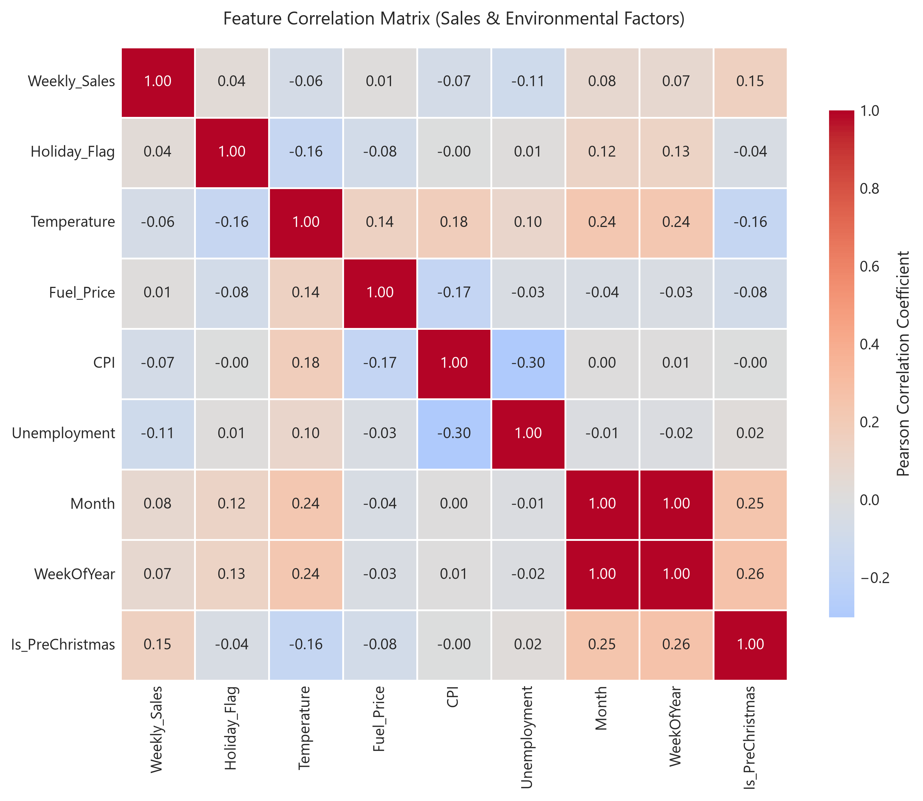
Figure 4: Pearson correlation matrix between sales, calendar features, and macroeconomic variables.
Analysis of Figure 4: Direct linear correlations between Weekly_Sales and environmental regressors are weak (|r| < 0.15 for CPI, Unemployment, Temperature, and Fuel Price). In contrast, temporal features (WeekOfYear, Month, Is_PreChristmas) exhibit strong predictive alignment with demand spikes. This finding demonstrates that linear models relying solely on macroeconomic variables will fail; effective forecasting requires calendar feature engineering and non-linear tree-based architectures.

7. Practical Significance for Inventory Planning
The empirical findings from Week 2 directly determine the parameterization of the supply chain inventory models to be developed in Week 5:
- Safety Stock Buffer Formulation: Safety stock is calculated as SS = Z × σ_L, where Z is the service level factor (e.g., Z = 1.65 for 95% cycle service level) and σ_L is lead-time demand standard deviation. Because demand variance expands dramatically during holiday periods, safety stock buffers must dynamically scale in November and December to prevent stockouts.
- Reorder Point (ROP) Dynamics: The reorder threshold ROP = d_L + SS (where d_L is expected demand over lead time) must transition from a static formula to a time-varying schedule that accounts for store-specific sales tiers and holiday demand multipliers.
- Multi-Tier Inventory Allocation: Given the 8.11× throughput differential between Store 20 and Store 33, distribution center replenishment schedules must prioritize Tier-1 high-velocity stores with more frequent delivery cycles, while low-velocity outlets operate on longer replenishment cycles to minimize holding costs.

8. Limitations & Methodological Constraints
- Aggregation Level: Data is aggregated at the store-wide weekly revenue level. Department-level and SKU-level (item barcode) granularity is unavailable in this table, meaning inventory buffers apply at aggregate category replenishment levels.
- Macroeconomic Frequency: CPI and Unemployment series change on a monthly or quarterly basis rather than weekly, limiting their ability to explain week-to-week sales fluctuations.
- Historical Temporal Window: The 2.75-year timeline (2010–2012) provides two complete seasonal cycles. While sufficient for 4-to-12-week forward projections, long-term multi-decade structural shifts cannot be evaluated.

9. Conclusion & Weeks 3–6 Roadmap
Week 2 data preparation and exploratory analysis has established a clean, validated foundation for the remaining internship tasks. The project roadmap proceeds as follows:
- Week 3: Baseline Forecasting: Establish naive lag, moving average, and seasonal baseline forecasts using chronological train/test splits (2010–2011 train, 2012 test) to prevent target leakage.
- Week 4: Advanced Predictive Modeling: Train Ridge/Lasso Regressors and ensemble architectures (Random Forest, Gradient Boosting) incorporating calendar features, store embeddings, and holiday flags.
- Week 5: Model Evaluation & Inventory Formulas: Evaluate forecasts via MAE, RMSE, and WMAPE. Translate forecast errors into dynamic Safety Stock, Lead Time Demand, and Reorder Point schedules.
- Week 6: Final Reporting & Recommendations: Synthesize findings into an executive presentation and evidence-based supply chain operational strategy.

