Amanda Riley  
1/30/24  
CSD310-O316  
Assignment 4.2

**Initial Database Connection**

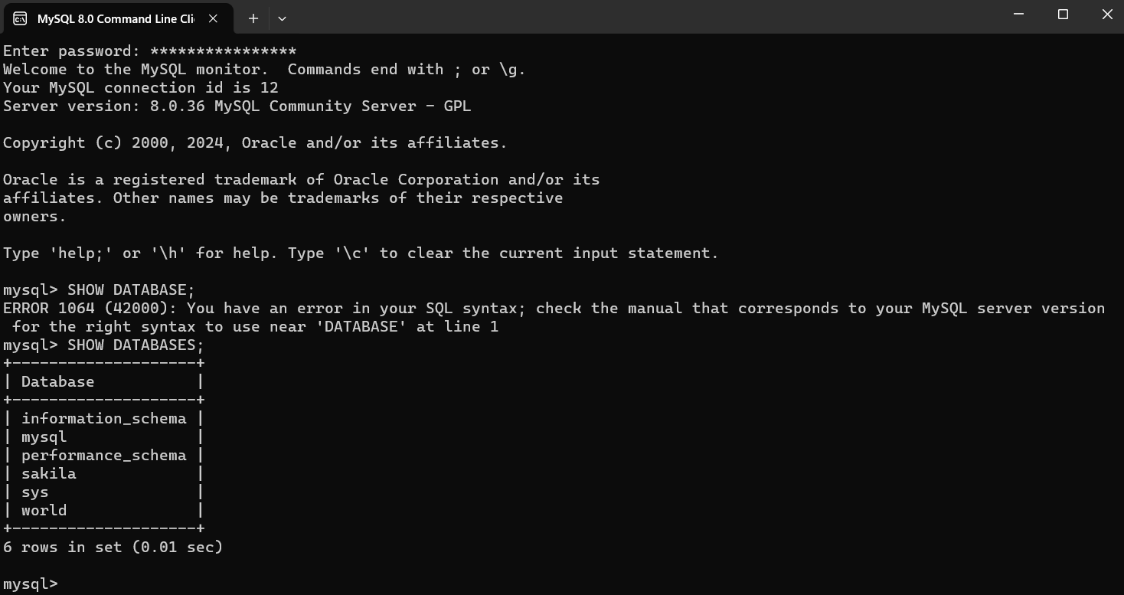

**Create and show movies database**

