Amanda Riley  
2/3/24  
CSD310-O316  
Assignment 5.2

I tried out quite a few SQL functions to learn how they work and what use I could get out of them.

**USER()** function is useful when you want to know what username and host name you are currently logged into SQL with.

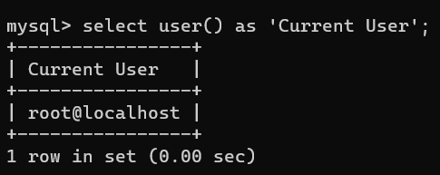

**SYSDATE()** function is useful when you want to get the computer’s current date and time.

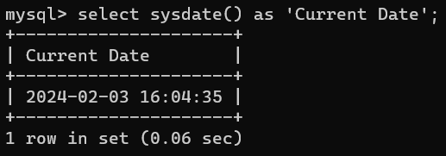

**DATEDIFF(“YYYY-MM-DD”, “YYYY-MM-DD”)** function provides the number of days’ difference between two given dates, which can be very useful to provide a countdown function. Here I show a countdown to my vacation on June 12.

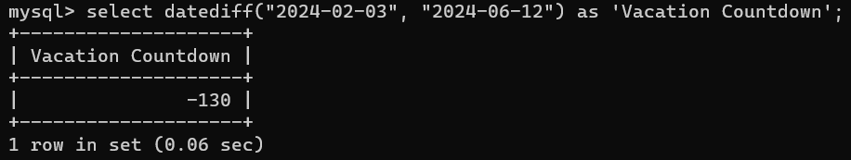

**MONTHNAME(“YYYY-MM-DD”)** is useful when you either have a date already written in numerical format, or if you are fetching one from the system, but you need the actual *name* of the month (e.g. February), say for generating a report that’s more readable for stakeholders. You might also use this for grouping by month.

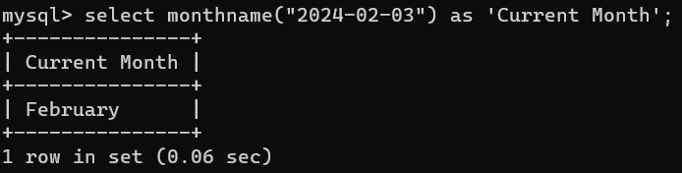

**MAKEDATE(YYYY, *int*)** is useful when you need to know which day is the *nth* day of a particular year. For example, if an event needs to happen on the 100th day of this year, you can put in 2024 and 100 and see that April 9th is the 100th day.

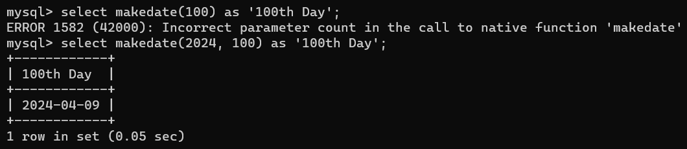

**LAST_DAY(“YYYY-MM-DD”)** is useful when you need to know the last day of the month of a particular date.

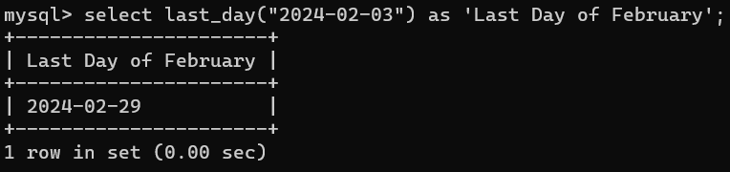

**DAYNAME(“YYYY-MM-DD”)** is useful when you need to know the weekday name of a particular date. For example, you might need to know if a billing date falls on a weekend when the bank is closed, so that you can move it to the preceding Friday.

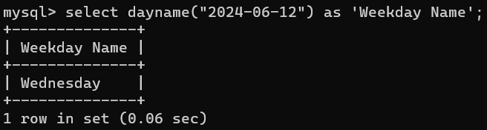

**DATE_SUB(“YYYY-MM-DD”, interval *int* day)** is useful when you need to subtract a certain number of days from a given date. For example, you are planning an event and you need to know which date is exactly 100 days before it, so that you can carry out a particular preparation or planning activity.

