Amanda Riley  
9/15/24  
CSD380-O316  
Module 5.2 Assignment

Analyzing Lean Metrics

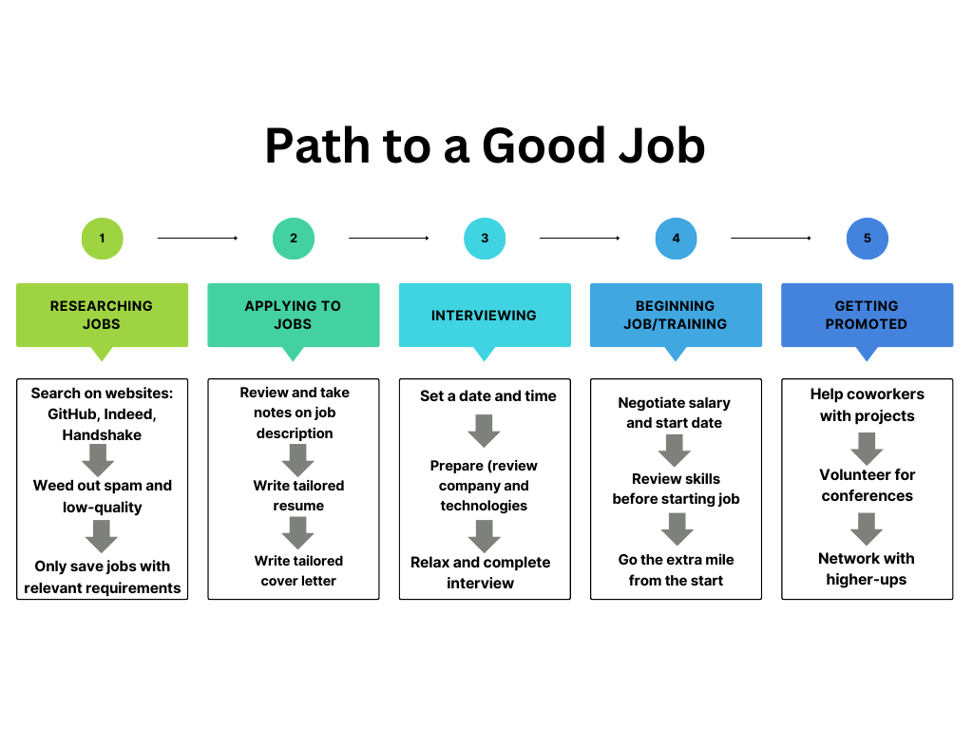

Estimated Average Flow Time

|  |  |
| --- | --- |
| Researching Jobs (1000 jobs) | 1 month |
| Applying to Jobs (100 jobs) | 1 month |
| Interviewing (10 interviews) | 2 weeks |
| Beginning Job/Training | 2 weeks |
| Getting Promoted | 2 years |

**ESTIMATED CYCLE TIME: 2 years, 3 months**

Optimizing Job Process

**Eliminating Waste:**

* I can all but eliminate the step of weeding out spam if I stick to one high-quality website, Handshake. This will also prevent me from seeing duplicate jobs on different websites.
* I can greatly reduce time spent per job application if I create five different tailored resumes and cover letters based on common job descriptions, rather than a new one for each job. I can even automate the process of updating the company name using a simple program.
* I can cut the interview stage from 2 weeks to 1 week if I collect a few interview requests and then make all of the appointments for the same week. I can take 1 week of vacation from work and not have to worry about it again.

**Workflow Orchestration:**

* The first two steps should be done at the same time over the course of 1 month rather than separately over the course of 2 months.
* I might be able to cut down my promotion time from 2 years to 1 year if I start out by networking with the higher-ups, find out which projects are most important to them, and only volunteer for those. This will also save me time at work and help to prevent overwhelm.

**Governance Models:**

* Before giving personal information into a job application, I need to check the company website to ensure that it’s legit. This way I can lower the risk of future spam or even identity theft.