**Event Tracking App Launch Plan**

Andrew Riley

Southern New Hampshire University

CS 360: Mobile Architecture & Programming

Professor Jerome DiMarzio

December 10th, 2023

In the app’s description, all the functionality of the app will be included. Users will know the app will allow them to track the scheduled events, ensuring they remain on task and aware of upcoming deadlines. They will have the ability to add, edit, and delete events. Their information will also be protected as the app requires login to access. The icon the best represents the app would be something simple, such as the checklist shown below.

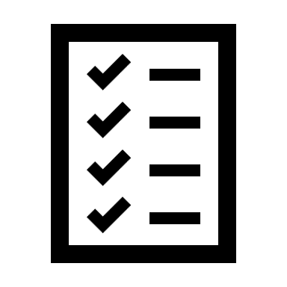

The app was developed on API 33, or Android 13. This makes it compatible with all current devices as well as most older devices. Due to the maintainability of the app, it will be easy to keep the app up to date as newer versions of Android are released. The only permission that the app asks for, in its current state, is to send SMS notifications. The app has a button the user could click if they chose to enable SMS notifications and notify them that notifications have been enabled.

Upon initial launch, the app will be free to download. To monetize the app, it may be necessary to sell ad space. This could be in the form of banners along the top or bottom of the screen. As the app grows, additional features may be able to be unlocked for a one-time payment.