Rails application is broken down into 3 parts

* Controllers
  + Has ownership over pages

CLI commands

rails generate controller *xxxxx*

ie. Rails generate controller Pages

* Views
* Models

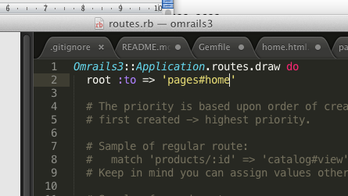

pages controller and a home action ‘pages#home’

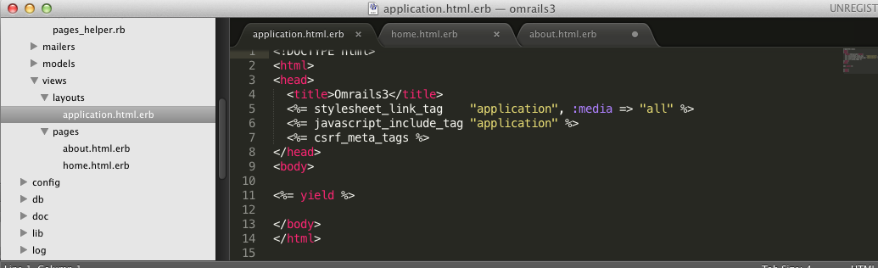

‘layouts’ is the theme  
  
<%= yield %> is the view page content

Partials

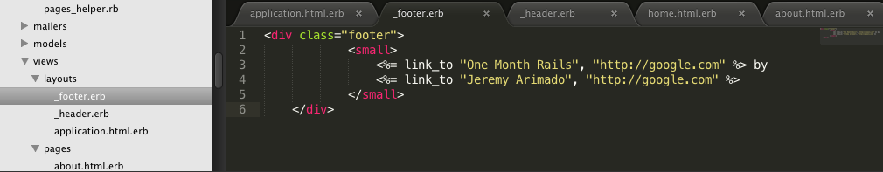

partials are just stuff files that can be linked into by ruby.

**Adding bootstrap**

1. bia bundle install, make sure you restart the server its running on when you install.

2. reference bootstrap in the style.css.scss

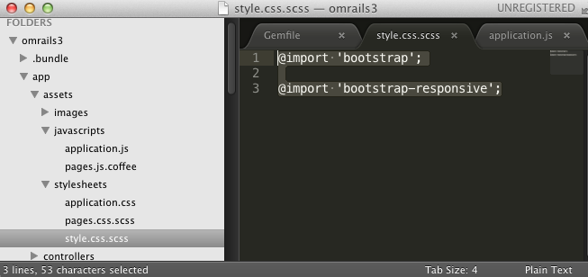

3. require bootstrap in the application.js

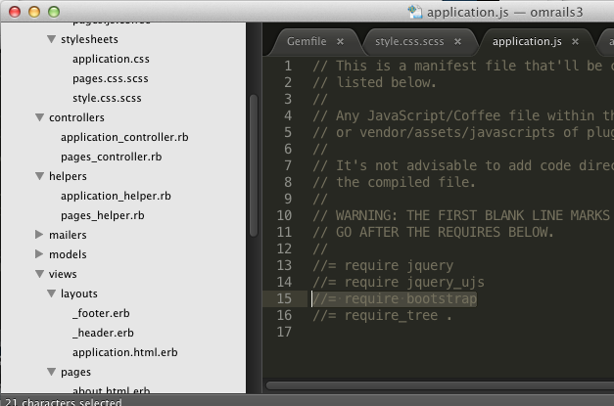

**Using bootstrap**

Bootstrap just gives you a bunch of classes you can use.

**Devise**

About: Login, reset password, add user functionality etc.

Notes:

You get some commands

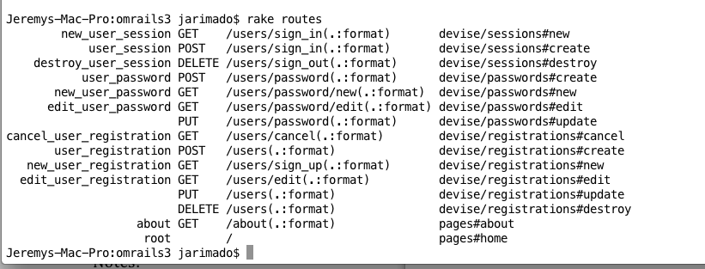

you add path here, i guess for links? … yeah bro

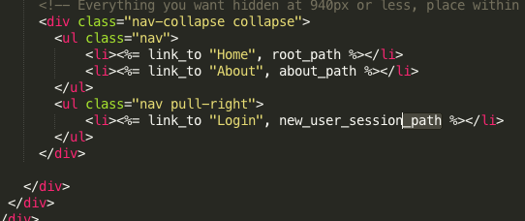

**Dynamic login/logout link**

**Simple Form**

When installing gems;

1. Add to the gemfile
2. Bundle install in the command line
3. Then ‘generate it’ ie ‘rails generate simple_form: install’

**Uploading to heroku/live site**

Use heroku rake db:migrate in CLI to migrate the databse of users/content to heroku/livesite