6/25/2020

**Austin Residential Property Analysis**

Team Members: Angie Bater, Ariana Monteiro, Gatlin Rash, Hadis Hashemi, Nicholas Durhman

1. Where are the most and least valuable properties located?

The most valuable properties in terms of average price per square foot are located in zip codes 78702 and 78705. Both of these zip codes are in close proximity to downtown Austin, so it makes sense why properties in this area have a very high value. Properties in zip codes 78729, 78732, and 78745 all have relatively low average prices per square foot, around 180 $/ft.

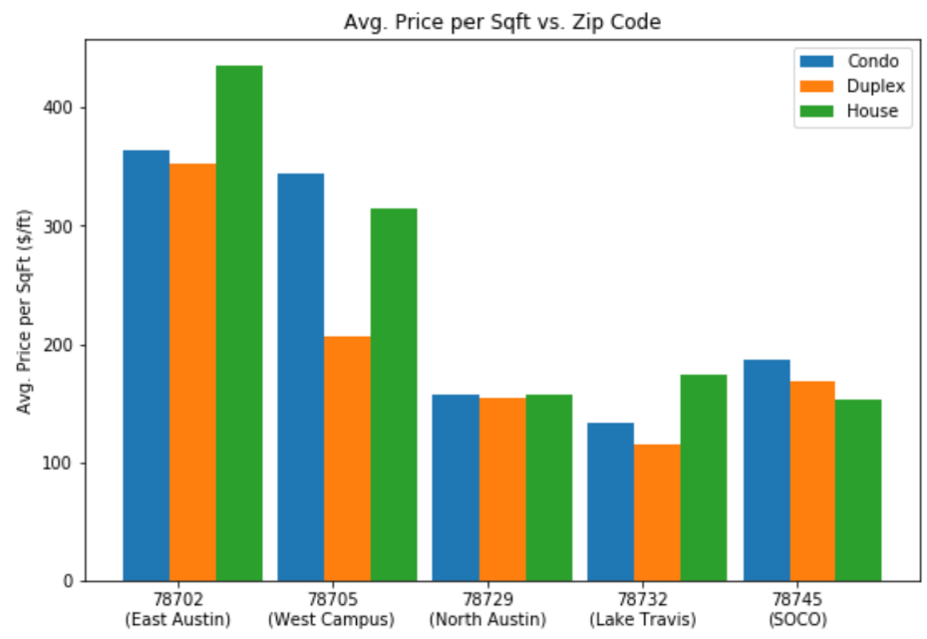

1. What are the different property types that make up each area?

From the data it is clear that houses (sfr) are the most common property type in all of the zip codes. Condominiums are the second most common property type, and duplexes are the least common.

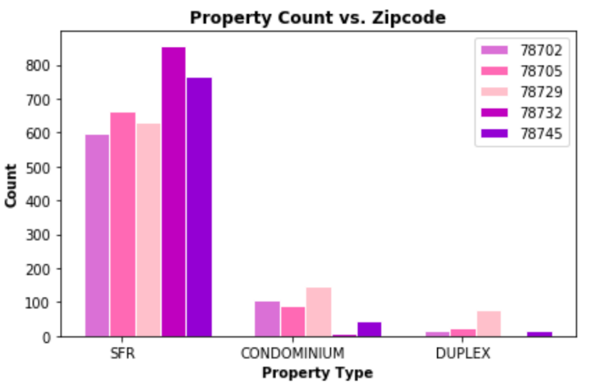

1. How does the decade a home was built affect current home value?

Houses built in the 2010’s have the highest market value compared to homes in built in previous decades. There has been a steady dip in market value starting from 1940s through to the 80’s when it started to increase exponentially to today.

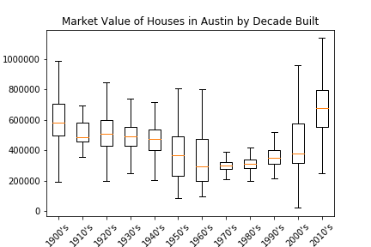

Market Value ($)

1. What decades had the largest increase in houses being built?

Most houses were built in the 2000’s. There was a slight increase in numbers of houses being built in the 30’s and 40’s and then a decrease until the 60’s. There was a drastic jump in number of houses being built in the 70’s until present day, with a dip in the 90’s.

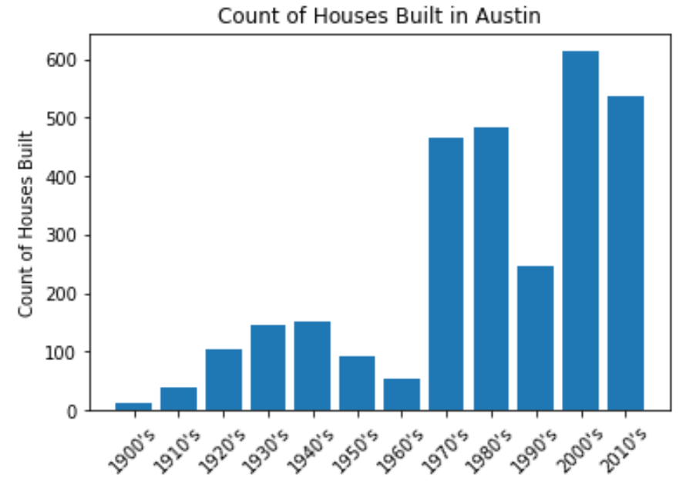

1. What outliers were found in the data?

Looking at the variance and outliers of each region gives insight into the more stable home markets in Austin. 78702 shows large variance in home prices across that region, while 78729 home prices are much more bunched together. If you were looking for a more consistent market in buying a home this could be useful information to have. Upper quartile outliers were more common than lower quartile outliers.

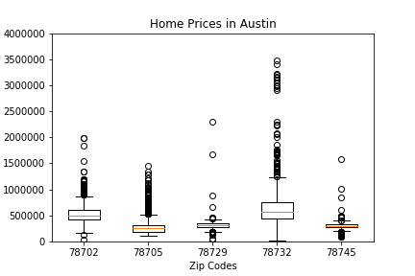

Home Prices ($)